Eastern Shore Regional Science Fair
April 20, 2024
Article written by Erin Morgan, Northampton Cooperative Extension 4-H Agent

On April 20, 2024 the Eastern Shore Regional Science Fair took place at the Virginia Institute of Marine Science (VIMS) in Wachapreague. Erin Morgan the 4-H Agent with Northampton Cooperative Extension and Julie Head Education Director with Eastern Shore Soil and Water Conservation District, spearheaded the event, which has not been held since 2019. The two felt strongly that shore students work hard on their science fair projects and the event needed to be brought back to showcase their efforts.
To be eligible to participate in the Regional Science Fair the students had to follow the scientific method of coming up with a question, researching their topic, developing a hypothesis to predict an outcome to the question, conducting an experiment to test the hypothesis, making observations/collecting data, analyzing the results, and developing a conclusion. The students then had to participate in their school’s science fairs and be one of the top five exhibits at their school. The students who participated in the regional science fair had a wide range of topics from the best fishing knots, which sunscreen is the most effective, to the effects of soda and juice on teeth, preventing apple oxidation, to investigating how human urine-based fertilizer affects the growth of peas, to name a few.
The Regional Science Fair had 40 students participate representing the following schools: Accawmacke Elementary, Arcadia High, Arcadia Middle, Broadwater Academy, Chincoteague Elementary, Homeschool groups, Kegotank Elementary, Kiptopeke Elementary, Metompkin Elementary, Nandua Middle, and Pungoteague Elementary. Congratulations to winners:
High School: 1st place the Team of Daniela Larrienaga and Aitana Pedraza-Mateos - Arcadia High School
Middle School Division: 1st place Nina Adler - Broadwater Academy, 2nd place Sidney Pierre - Arcadia Middle School, and 3rd place Aarav Patel - Broadwater Academy
Elementary Division: 1st place Walter Higgins - Broadwater Academy, 2nd place Liam Magee - Broadwater Academy and 3rd place a tie between Hayden Morgan - Accawmacke Elementary and Benjamin Byrd - Broadwater Academy.
Erin Morgan and Julie Head would like to thank the judges of Ms. Hélène Doughty, Dr. Doug Higgins, Mr. Joseph Pentason, Dr. Mark Reiter, and Dr. Richard Snyder, who spent their Saturday morning judging the 39 exhibits. Thank you to C.D Marsh Jewelers in Onancock for their support and for providing the trophies for the winners. A big thank you to VIMS for serving as the host site and setting up activities for the students to enjoy while judging was taking place. Finally thank you to all the teachers, school administrators, and parents who supported this event, and got the students to the event.
Erin and Julie are looking forward to making next year’s Regional Science Fair even bigger and better.

Pictures from the event:
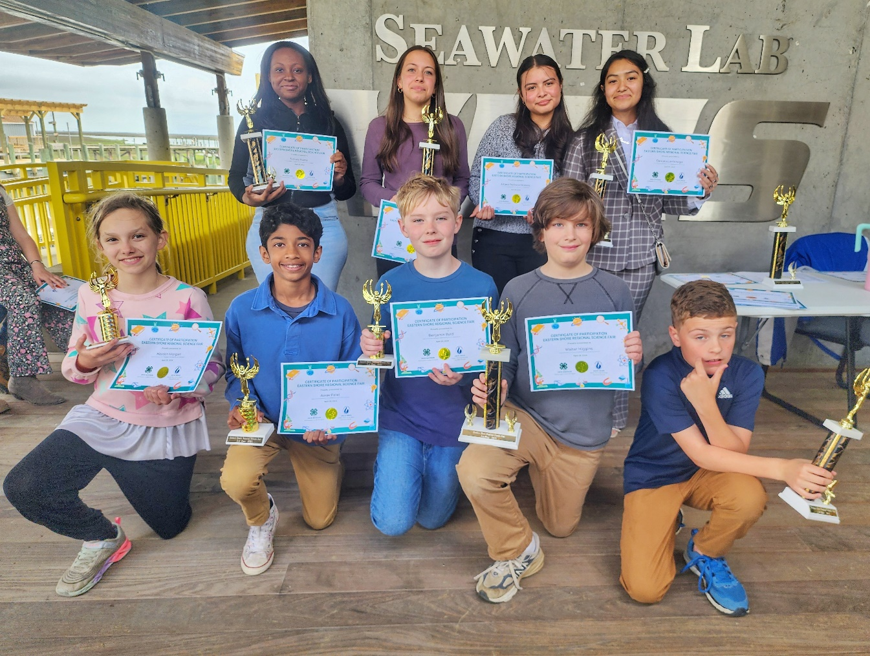

Pictured are the winners of the 2024 Eastern Shore Regional Science Fair. Bottom row: Hayden Morgan, Aarav Patel, Benjamin Byrd, Walter Higgins, and Liam Magee. Top Row: Sidney Pierre, Nina Adler, Aitana Pedraza-Mateos, and Daniela Larrienaga.

