Heifers – Assets or Liabilities?

Heifers are the future milking animals in your herd, but today they are just an expense that needs to be managed. There was a time when many herds had a 10% mortality rate in calves, today if that is over 2% it is atrocious. Combine that with the rapid acceptance of sexed semen and many farms are finding themselves overwhelmed with heifers. For a herd that is expanding this is a positive thing and allows expansion without purchase. For herds that are not expanding, this can force a higher cull rate in cows and overflowing heifer pens.
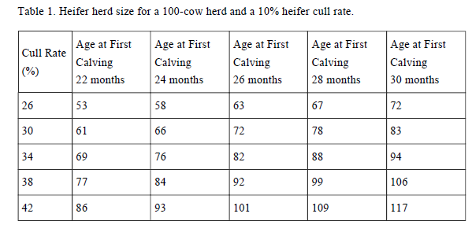
How a dairy should manage this depends some on their situation. First, it is important to know how many replacements are needed each year to maintain your herd size. Table 1 below shows the number of heifers needed per 100 lactating cows. As you can see, the cull rate and age at first calving can have a significant impact on how many replacements are needed. The extra needed replacements at a later calving age can have a significant impact on herd profitability.

Are you spending the money to raise heifers that are not needed? Perhaps it is time to start culling heifers before you have significant expenses in raising them. There are several ways to manage this. Start by culling heifers that have had a significant health event, pneumonia, scours, or just poor doing heifers. Cull calves out of poorer dams or sires. Genomics may be a tool that can be used to manage the culling of heifers. Why spend $1600 to raise a heifer that you do not need?

