

Immersive Simulation of Schizophrenia

CS 4624
Multimedia, Hypertext and Information Access
Virginia Tech, Blacksburg, VA 24061
May 12, 2023

Instructor: Dr. Edward A. Fox
Client: Dr. James Ivory
Team: Dillon Domnick, Katherine Fichera

Table Of Contents

Table of Figures 3
Table of Tables 5
Executive Summary 6
1 Introduction 7
1.1 Background 7
1.2 Client 8
1.3 Team 8
1.4 Problem 8
1.5 Objectives / Goal 9
1.6 General Approach 9
1.7 Deliverables 9
2 Requirements 10
2.1 Timeline 10
3 Design 11
3.1 Janssen Design 11
3.2 Initial Design 13
3.2.2 Visual Hallucinations 13
3.2.3 Auditory Hallucinations 13
3.3 Final Design 14
3.3.3 Graphic Design 14
3.3.3 Audio Design 14
4 Implementation 16
4.1 Alpha Version 16
4.2 Beta Version 17
4.3 Front-End 20
4.4 Back-End 21
4.5 Audio 21
4.5.1 Development 21
4.5.2 Licensing 23
5 Testing / Evaluation / Assessment 23
6 Users Manual 25
6.1 Setting Up the Headset 25
6.2 Starting the Application 26
6.3 Interacting with “Schizophrenia Simulation” 26
7 Developers Manual 30
7.1 Development Requirements 30
• Prerequisites 30
• Building 30
• Installation 30
7.2 Source Control 31
7.3 Project Structure 31
7.4 Workflow 32
7.5 Development Considerations 33
7.6 Further Development and Known Issues 34
8 Lessons Learned 35
8.1 Overall Lessons Learned 35
8.2 Issues with Model Purchases 35
9 Acknowledgements 36
References 37
Appendices 39
Appendix 1. Glossary 39

Table of Figures

Figure 1: Screenshot 1 - View of pharmacy counter with hallucination 11
Figure 2: Screenshot 2 - View of pharmacy with hallucination 12
Figure 3: Screenshot 3 - Bottle of pills that are viewed as poison 12
Figure 4: Initial Storyboard 13
Figure 5: Example Visual Hallucination 14
Figure 6: Unity Audio Customization 15
Figure 7: Checkout scene design 16
Figure 8: Initial Pharmacy scene 17
Figure 9: Reactive Figure Hallucination 18
Figure 10: Final Pharmacy Scene 19
Figure 11: Mixed Audio/Visual Hallucination 19
Figure 12: Grocery store model asset page 20
Figure 13: Character Customizer asset page 20
Figure 14: Some of the different voices included 22
Figure 15: Some of the emotions for a voice 22
Figure 16: Quest 2 Hardware Layout [17] 25
Figure 17: Starting the simulation [12] 26
Figure 18: Quest 2 Control Scheme [17] 27
Figure 19: View walking to grocery store 27
Figure 20: View inside grocery store 28
Figure 21: View in Pharmacy 28
Figure 22: Unity Engine development layout 31
Figure 23: Visual scripting reflection of C# code 33

Table of Tables

Table 1: Unity Packages 30
Table 2: Unity Assets 31

Executive Summary

Schizophrenia is a chronic mental disorder characterized by frequent psychosis and audiovisual hallucinations affecting 24 million people globally. Despite its prevalence, the varying degrees by which the symptoms present, combined with misguided media portrayal, make schizophrenia and related psychotic disorders among the most poorly understood and stigmatized mental illness diagnoses. Stereotypes and stigma can lead to mismanagement of treatment by first responders and other emergency personnel. To remedy this, we aim to create a pedagogical virtual reality simulation that depicts the symptoms of schizophrenia with a high degree of clinical accuracy. The research project’s principal investigator is providing guidance about content to ensure that the VR experience aligns with real-world symptoms of schizophrenia.

In the past, interactive media and television programs have been effective tools for spreading awareness about topics not widely discussed otherwise. Using virtual reality for our simulation offers the advantage of “surrounding” the user, creating a more immersive experience than a 2D game. Recent studies have shown that virtual reality simulations of psychosis can significantly reduce stigma and increase knowledge and empathy towards patients with psychotic experiences compared to traditional interventions. In a report cited in the National Center for Biotechnology Information studying the impact of virtual reality, it was found that “...VR was more effective at eliciting attitudes and knowledge change compared to the control group.” These findings suggest that our simulation has the potential to make a meaningful impact in promoting understanding and reducing stigma towards people with schizophrenia. We believe this level of immersion will be more effective than the video presentations the project is based on.

Our simulation is designed using Unity with custom models based on preexisting data from our client Dr. Ivory and research by Janssen Pharmaceuticals. The use of Unity as our frontend development platform allows the final simulation to be viewable on a variety of VR capable devices and smartphones, leading to our project's scalability to reach a wide audience. Additionally, the 3D platform lets us further portray the audiovisual hallucinations holistically, making these symptoms easier to understand by non-affected individuals. As opposed to the leading video-formatted simulations, the active game environment allows for interaction with hallucinations in real time - giving the viewer a chance to affect and then be affected by the game. The use of custom models and AI-generated voice acting further contribute to the overall realism of our simulation.

Schizophrenia and related psychotic disorders remain widely misunderstood and stigmatized, leading to mismanagement of treatment by emergency personnel. However, simulations such as ours offer a promising method of promoting a deeper understanding of the disease and reduce stigma towards people who are affected by schizophrenia. Our VR simulation aims to create a more immersive experience and accurately depict the symptoms of schizophrenia compared to 2D recreations. The scalability of our simulation to reach a wide audience and the potential to interact with audiovisual hallucinations in a virtual reality environment makes it a valuable addition to traditional teaching methods. We believe that our simulation has the potential to make a meaningful impact and we hope to continue to explore this technology as a tool for mental health education and awareness.

1 Introduction

1.1 Background

Schizophrenia comes from the Greek words “schizo” and “phrene” meaning split and mind. This name is not meant to mean split mind but rather to describe the fragmented thinking of individuals suffering with this illness. There is a common misconception, due to some symptoms and the definition of the name, that schizophrenia is the same as Dissociative Identity (or multiple personality) disorder. This is false as they are two completely different disorders. The term schizophrenia is fairly new, about 100 years old, and was identified by Eugen Bleuler, a Swiss psychiatrist [1].

Schizophrenia is a severe, chronic complex brain disorder affecting over 24 million people worldwide. The symptoms of schizophrenia impact essentially every aspect of a person’s life, influencing how they think, behave, and feel. One of the most prominent symptoms in schizophrenia is a patient experiencing episodes of psychosis, which is a mental state where a person may see, hear, feel or believe things that are not based in reality. This can include visual and auditory hallucinations, delusions, disordered thoughts and impaired perception or cognition. When not treated properly, schizophrenia can become disabling, causing damage to education, careers, and relationships. Additionally, the mortality rate for patients with poorly-treated schizophrenia is two to four times greater than the general population due to factors such as concomitant psychiatric disorders, substance use disorders, and high suicide risk. Most patient deaths are related to physical issues such as cardiovascular disease with concomitant renal disease, respiratory diseases, stroke, cancer, thromboembolic¹ events [2], diabetes, and liver disease. It is estimated that 4.9% of patients with schizophrenia die by suicide [11].

Schizophrenia is typically diagnosed for men in their late teens to early twenties and for women in their mid-twenties to early thirties. The cause of this illness is not completely understood, but it is believed to be linked to a combination of genetics, brain chemistry, and environmental contributors that alter the brain in early life. Some risk factors that increase the likelihood of developing schizophrenia include family history and pregnancy or birth complications [6].

The symptoms of schizophrenia are grouped into four categories: positive, negative, affective, and cognitive symptoms. Positive symptoms are not ‘good’ symptoms like the name suggests, but rather are behaviors and thoughts that do not naturally occur in healthy people. Some examples of positive symptoms include auditory and visual hallucinations, incoherent speech, or delusions. Negative symptoms are qualities that are diminished or missing in patients with the disorder, which include symptoms such as alogia (poverty of speech), avolition (lack of motivation), asociality (social avoidance), and anhedonia (lack of experiencing pleasure)¹ [2]. Affective symptoms refer to disruptions of emotion and include depressed mood, anxiety, loss of sleep and appetite, and even thoughts of death and suicide. Finally, cognitive symptoms affect attention, concentration, and working memory. These could include issues such as having difficulty focusing on tasks, paying attention to conversations or other information, and challenges with planning, organizing, and problem solving.

One of the primary treatments for schizophrenia is prescription for antipsychotic medications, which effectively reduce psychotic symptoms like hallucinations and delusions. Antipsychotic medications can help patients maintain a healthy level of functioning, and help mitigate long term disability that occurs when individuals are untreated. Patients typically need to continue medication for life, as relapses in symptoms can be common. On top of medication, patients are also encouraged to use psychosocial and psychotherapeutic (‘talk therapy’) treatments that help find solutions for everyday challenges while attending school or work, and working on relationships. These treatments can include behavioral therapy, behavioral skills training, supported employment, and cognitive remediation interventions including cognitive behavioral therapy [11].

1.2 Client
Our client is Dr. James D. Ivory, an Associate Professor in the Virginia Tech School of Communications. His research focuses on the social and psychological dimensions of new media and communication technologies, particularly on video games, virtual environments, and simulations. Much of his research examines the content and effects of technological features of new entertainment media such as video games. Dr. Ivory has founded the VT G.A.M.E.R Lab, which is a part of the School of Communication’s Digital Media Research Facility.

1.3 Team
The team consists of 2 senior Computer Science students: Katherine Fichera and Dillon Domnick. We have had prior experience with scripting and C# as used in Unity but no actual experience with 3D development. The team roles are listed below:
Katherine Fichera: Main contact, Front & Back-end Development, Testing
Dillon Domnick: Source Control, Back-end Development

1.4 Problem
Schizophrenia is a prevalent mental illness that remains poorly understood despite significant research. This knowledge gap often leads to a discrepancy between the reality of the illness for patients and their families and the public’s perception of it. This lack of understanding can lead to stigmatization, discrimination, and many negative consequences for those suffering. Such effects include, but are not limited to:
- Reduced support: If someone does not understand schizophrenia properly, they are unable to give the proper support for those with the disease. One of the many things that helps treat mental illness is the support from those around you.
- Ineffective emergency response: Psychotic symptoms that occur in schizophrenia can also be present in other types of mental health conditions, such as bipolar disorder or paranoid personality disorder, or could occur in response to taking drugs. Misinformed first responders and EMS personnel may be unable to identify schizophrenia before treatment, potentially resulting in ineffective emergency response.
- Crisis escalation: A common feature of psychosis (whether it occurs in patients with schizophrenia or another serious mental health disorder) is agitation - especially during crisis scenarios when a patient may not be on their medication. This may lead to situations where uninformed individuals or police officers interpret the agitation as anger or physical aggression and react defensively instead of de-escalating the situation.

Because of these consequences, it is important to develop innovative approaches that can help build understanding, awareness, and empathy towards schizophrenia and other psychotic disorders. Methods such as the one described by this paper have proved to be effective at reducing public stigma [16]. By increasing awareness and understanding of these illnesses, we can foster greater support for those who suffer from them, while reducing the negative effects of stigma and discrimination.

1.5 Objectives / Goal
With the issue of a lack of understanding about schizophrenia, our goal is to create an immersive VR application that simulates the auditory and visual hallucinations experienced by individuals with schizophrenia. Our aim is to leverage modern technology to increase awareness and understanding of this illness. While the VR application cannot replicate the full complexity of the experiences of schizophrenia, it can provide a unique perspective for those seeking to learn more about the illness. By conducting research with this innovative approach, we hope to shed light on the experiences of individuals with schizophrenia and other psychotic disorders and promote greater empathy and understanding towards them.

1.6 General Approach
The use of a virtual reality simulation that depicts the symptoms of schizophrenia with a high degree of clinical accuracy serves to inform the general public on the experiences of individuals with schizophrenia in order to promote greater understanding of the disorder. To this effect, it is essential to consult with medical professionals and individuals with lived experience of schizophrenia to ensure that the simulation accurately depicts the range of symptoms an individual might experience.

In addition to our research, we organized a meeting with Dr. Sarah Clinton, an Associate Professor in the Virginia Tech School of Neuroscience. Dr. Clinton provided valuable assistance by reviewing our research and implementation to ensure clinical accuracy. Throughout the semester, we were able to maintain contact with Dr. Clinton, providing her with updates on our progress and receiving feedback.

1.7 Deliverables
Our final deliverable will be a functional virtual reality program that simulates the symptoms of Schizophrenia. This program will be run on a PC connected to an Oculus Quest. This program will be accessible through the G.A.M.E.R Lab at Virginia Tech through our client Dr. Ivory. It will be accessed through a USB in the lab or through Dr. Ivory.

2 Requirements
From the project description: “Students will create an original simulation using the hardware and software applications of their choice, demonstrating the nature of visual and/or auditory hallucinations associated with schizophrenia (e.g., presentation viewable on Oculus Quest, 3D audio simulation, augmented reality smartphone experience), with the research's principal investigator providing guidance about content.”

2.1 Timeline
February:
- Meet with client
- Decide on simulation type
- Begin research of tools and topic
- Research on unity
- Research on schizophrenia
- Start on storyboard & wireframes
- Unity Workshop
March:
- Begin development
- Begin testing mid-month, test weekly
- Meet with professionals bi-weekly
- Review storyboards & wireframes
- Get feedback and continuously adjust
- Have storyboards by middle of month
- Alpha version by end of month
  - Bare bones outline, based on story board
  - Not much detail but basic interactions and hallucinations are involved
  - User can walk around world on path; cannot stray far from main path
  - Basic interactions with simple visual hallucinations (black blobs around, possibly things that are not actually there like family, animals, etc.)
  - Main story from storyboard is implemented
April
- Meet with professionals bi-weekly to get feedback on development
- Beta version by end of month
  - Main story should be finished from the alpha version.
  - Detail interactions between user and NPCs (non playable characters)
  - Detail world and visuals
- Test at least 2x a week
May
- Finished project
- Presentation

3 Design

3.1 Janssen Design
The design for this project was based on the Janssen Pharmaceuticals VR simulation. To keep our version as clinically accurate as possible, our scenario and interactions are derived from Janssen’s version.

Figure 1 shows a screenshot of the simulation of the user looking at the pharmacy counter. In this image one of the hallucinations is visible. In this simulation, the visual hallucinations are depicted as black blobs that appear in the users' sight on the ceiling.

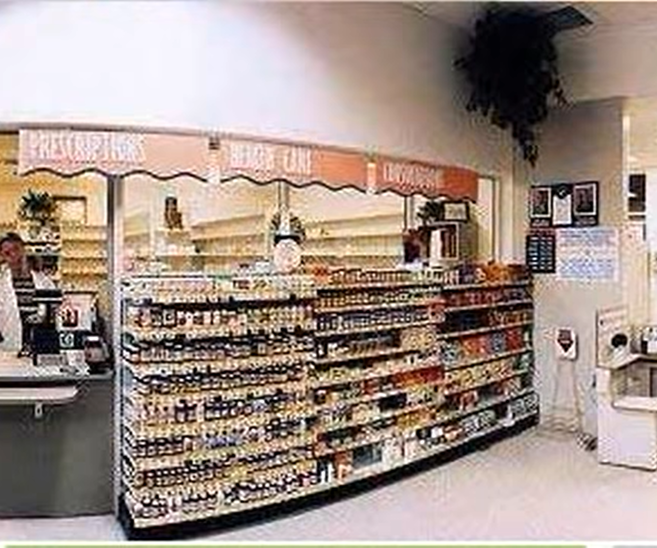

Figure 1: Screenshot 1 - View of pharmacy counter with hallucination [19]

Figure 2 shows almost the same as Figure 1, a visual hallucination in the pharmacy. In this image, it is looking towards the entrance of the pharmacy. In sight, there is a TV, shelves, the entrance, and also another hallucination similar to that in Figure 1.

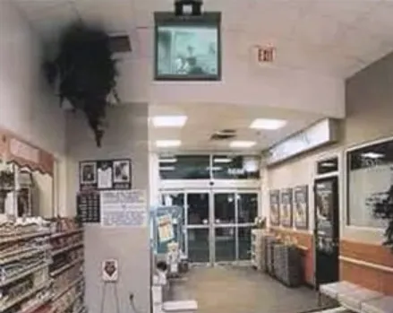

Figure 2: Screenshot 2 - View of pharmacy with hallucination [19]

Figure 3 shows one of the interactions between the pharmacist and user. The event happening in this photo is the pharmacist was able to get the user their schizophrenia medication. But the user is having visual hallucinations depicting the pills as poison.

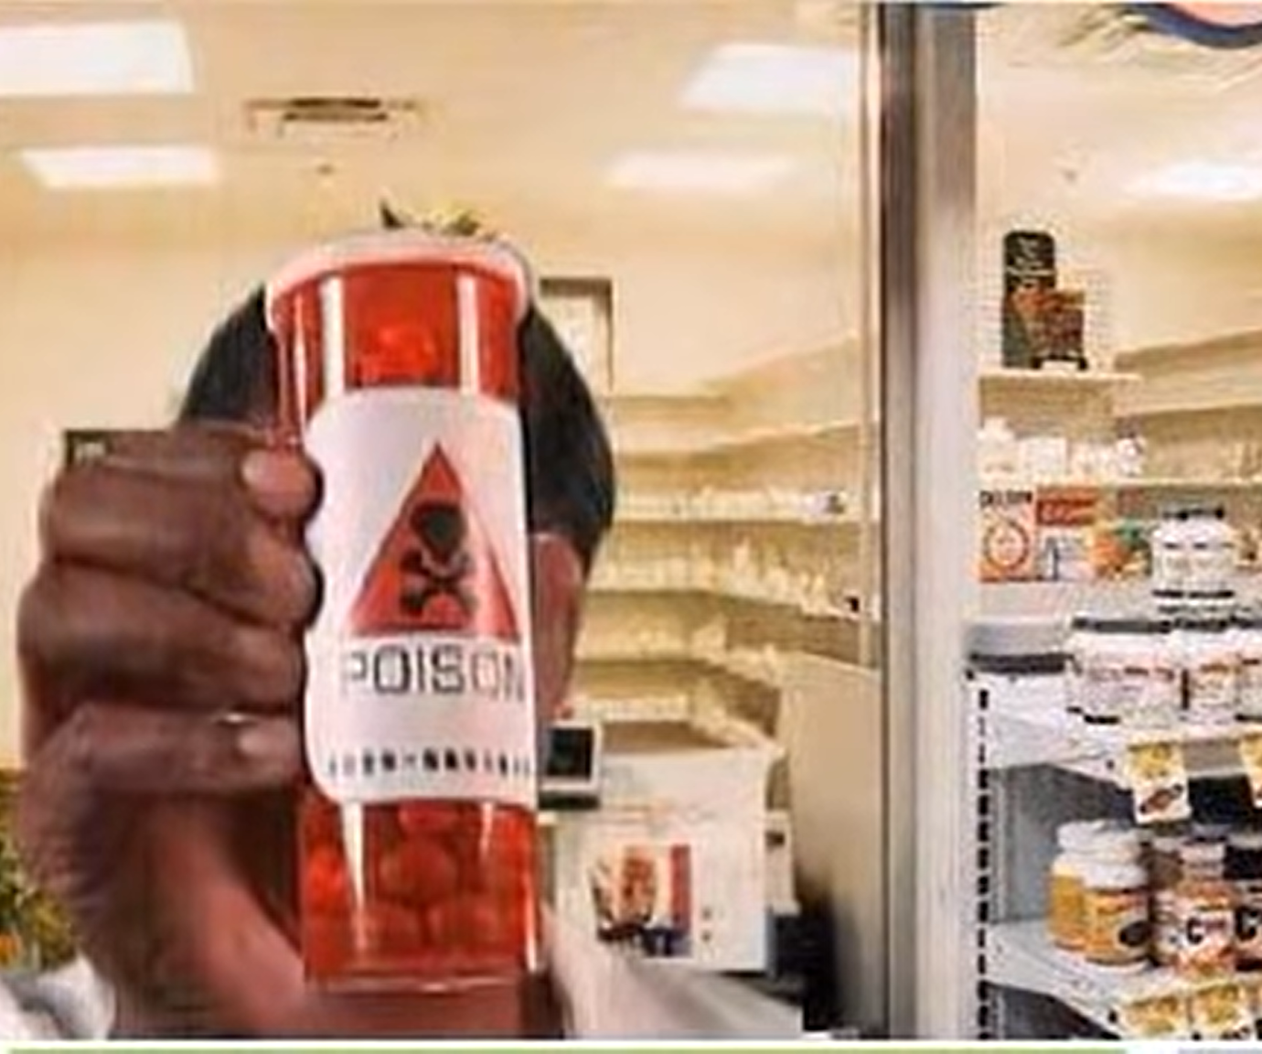

Figure 3: Screenshot 3 - Bottle of pills that are viewed as poison [19]

3.2 Initial Design

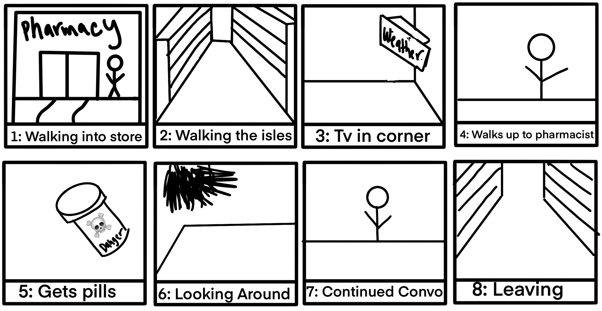

Figure 4: Initial Storyboard

Figure 4 displays the storyboard that we created to begin development. We wanted to follow Janssen as closely as possible to comply with clinical accuracy, without having to continuously make sure our story was accurate. By doing this, it allows us to enhance what is already created, which then increases development time.

3.2.2 Visual Hallucinations
Even though in this simulation the hallucinations are black blobs, visual hallucinations can range from being realistic animals, humans, or something similar to these blobs seen. On her YouTube channel, Lauren talks about her experience with auditory and visual hallucinations. In her video, My Experience with Hallucinations, Lauren explains that sometimes she would see things like spiders or bugs, but on one extremely rare occasion she hallucinated an elderly man [22].

3.2.3 Auditory Hallucinations
Auditory hallucinations are the most common symptom of those suffering with schizophrenia. They can range from many different types of sounds, but the one we have decided to focus on is the auditory verbal hallucination. Many times, these hallucinations can affect a person’s functioning. These hallucinations can range across demanding, angry, threatening, derogatory, or haunting [18]. Some examples of this are seen in the Janssen video we are basing the project on. Throughout the video there are multiple voices that speak to the viewer that range from angry, worried, crazy, and more.

3.3 Final Design
Following project development, the final design of the simulation does not deviate far from the initial storyboard. The tools presented in Unity made it possible to create an accurate reconstruction of the Janssen Pharmaceuticals video this project is based on. However, time constraints limited the design of our completed product to emphasize presentation over interaction. Scene elements are largely time based as opposed to trigger based, meaning the user must be virtually present for the hallucination to be effective. While there are tools in place to convert to a more interactive environment, the current design is more akin to a 3D movie than a video game. Development after the end of this capstone project may be suited towards increasing immersion through the addition of more interactive scene elements.

3.3.3 Graphic Design
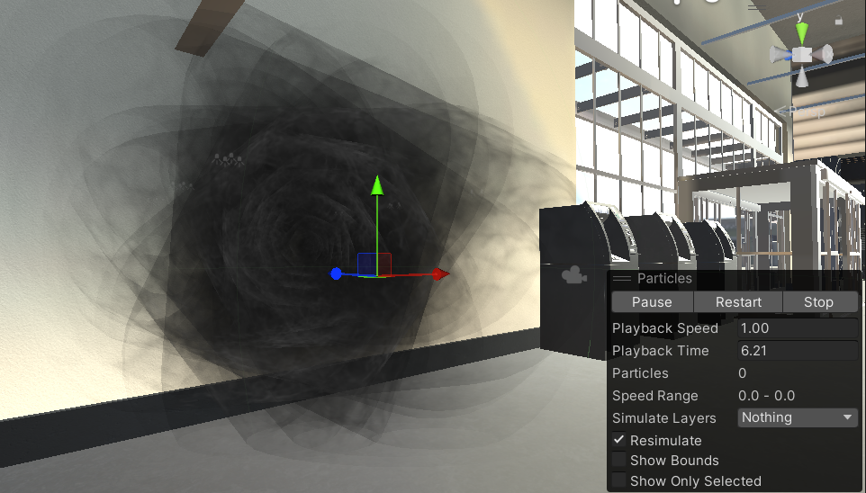

Figure 5: Example Visual Hallucination

As a significant part of Dr. Ivory’s research has been on the sociological effects of video games, the basis of our graphics design revolved around increasing empathy through experience. Recent studies have shown that virtual simulations of psychosis can significantly reduce stigma and increase knowledge and empathy towards patients with psychotic experiences compared to traditional interventions [5]. Virtual reality in particular has been effective at education about schizophrenia [23]. These findings suggest that our simulation has the potential to make a meaningful impact in promoting understanding and reducing stigma towards people with schizophrenia. As mentioned before we wanted to keep this design as clinically accurate as possible. Figure 5 above shows the visual hallucination we chose. We chose this design because it is very similar to the hallucinations seen in the Jannsen Video seen in Figure 1.

3.3.3 Audio Design
One of the main misconceptions we wanted to address with this simulation was the appearance of agitation due to auditory hallucinations. A person with schizophrenia may not hear what someone is saying (a police officer giving commands, for example) with the same credence or inflection as originally intended. They also may appear confused or could react to voices as if they were coming from the wrong direction, instead of from the actual source.
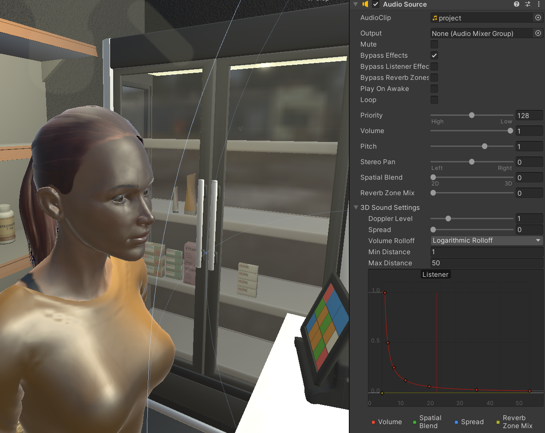

Figure 6: Unity Audio Customization

By using AI generated voices, we have more control over how a voice changes in pitch and tone over time in the simulation, as compared to a voice acted clip. Figure 6 shows some of the audio effects we can put onto the voices including volume, pitch, and priority. This lets us alter what the viewer hears as they move around the scene. One such example would be changing the tone of the pharmacist to be gradually more aggressive as the scene progresses, contrary to what the pharmacist would actually be saying. Additionally, voice lines may be played from different directions or angles relative to the virtual reality headset, making the experience immersive and overall more accurate to the real symptoms of schizophrenia.

4 Implementation
Our project is a VR application, meaning it needs a front-end, back-end, and story to follow. Our program will be created within Unity using C# for scripting.

For our timeline, we have decided to use the software release cycle. The software release cycle, SRLC, is a set of milestones that describe the stages in software development through a timeline [15]. The benefits of using a SRLC is that it allows us to have a clear plan and delivery date for our simulation. We are able to easily define what we need in each version and when that needs to be completed. In the SRLC there are 6 stages which include pre-alpha, alpha, beta, release candidate, general availability, and production release. Because we are not making this public, we decided we only needed to focus on alpha, beta, and finished versions.

4.1 Alpha Version
The alpha stage is the first stage of development for software. Generally, the alpha version is only seen and tested by developers within the organization. Coming after pre-alpha, it is sometimes considered feature complete but still contains bugs. Our alpha version is the bare bones of our simulation based on our storyboard. Within our timeline, we defined our alpha version to have not much detail, with very simple interactions. This includes the conversation with the pharmacist, the path the user takes, and simple hallucinations. Part of the alpha version included the initial asset acquisition and placement into the Unity engine.

One of the models used in the alpha version was the grocery store model, which provisioned several prefabricated assets that could be used to represent a typical convenience store. However, the scene shipped with the asset also included several superfluous models that only served to slow down execution and development of the running program. This led to significant time spent on removing unnecessary models and placing new models as required for our simulation in the scene. Figure 7 shows how the checkout scene was eventually set up.

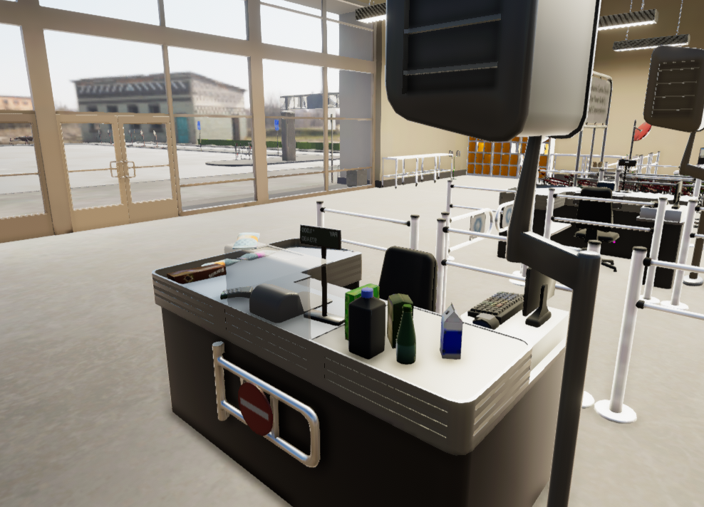

Figure 7: Checkout scene design

The second part of the alpha version, and what the storyboard scene is based on, is the pharmacy. The grocery store model was specifically chosen because it has a pharmacy built into the prefab, but the limited size of the space and lighting contractions made it difficult to place scene elements such as the pharmacist into the space. Changing the size of the model and adding new light elements was necessary to complete the alpha version, with further changes planned for the beta. Figure 8 shows the pharmacy within the grocery store model.

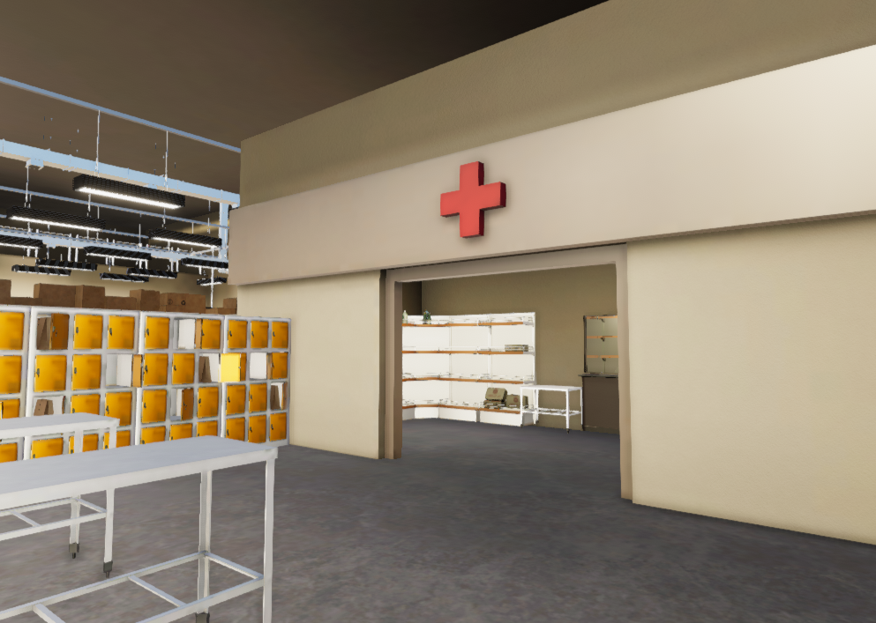

Figure 8: Initial Pharmacy scene

4.2 Beta Version
The beta version is going through the second phase of testing and continues to add on features. Sometimes, the beta version is released into the public for testing. The main features we are adding for our beta version are completing the story. This includes more detail in the interactions between the user and NPCs, the hallucinations, and detail in the scenes and visuals.

For this version, we wanted to highlight three main hallucinations that the user may experience. Many symptoms that a schizophrenic may experience reflect some of the conscious or subconscious thoughts they may be experiencing. The first hallucination - a reactive black figure - is representative of this fact. It’s purpose is twofold: both as an example of a real visual hallucination someone may see while dreading an upcoming event (such as a pharmacy visit) and as a method of instilling the same sense of doom in the user. This lends itself towards the goal of increasing empathy that this project aims to accomplish, but the practical effect of this remains to be tested. The hallucination was done by rotating a simple 2-dimensional spinning particle effect around a cube mesh that is also rotating in place itself. By repeating this effect multiple times, it appears almost 3-dimensional, despite being 2D with respect to the camera. The reactive figure is shown below in Figure 9.

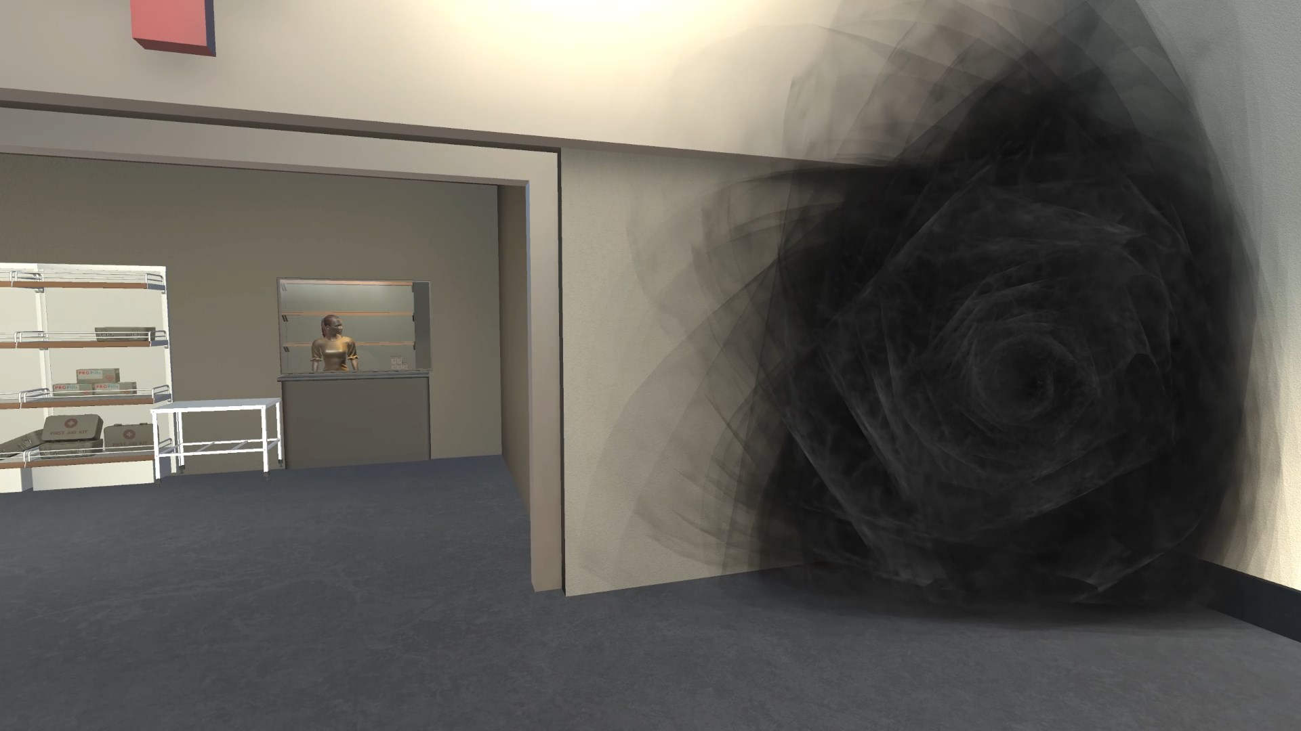

Figure 9: Reactive Figure Hallucination

Just like in the Janssen Pharmaceuticals video this project is based on, we wanted to include a pharmacy scene in our final beta. The pharmacist was designed using a custom character designer asset, which featured multiple different character assets and clothing options. This was difficult from an implementation perspective since the asset was made using a different rendering pipeline as the rest of the project. To remedy this, several of the materials both used on the character and the surrounding environment were modified to use a different pipeline. An unfortunate consequence of this fact was that the skin of the pharmacist had the indirect lighting from the window baked into its asset. This gave it the shiny appearance shown in Figure 10. Using a different character model or manually creating a new material with new lighting would fix this issue, but is beyond the scope of this project.

In addition to the character, there are two other elements of this scene. The first is the audio interaction with the pharmacist. The scene runs through a simple script where the pharmacist outlines the typical prescription pickup process, and some issues one may run into during this encounter. An AI generated voice model was chosen for this specifically in order to dynamically change the pharmacists’ tone and dialog as the scene progresses. Changing the audio to sound more aggressive or off-putting is just one example of an auditory hallucination someone with schizophrenia may experience. More on this topic is outlined in 4.5 Audio.

The second part of this scene is the physical pill bottle pickup. When the prescription is first presented to the user, it appears to be a generic antipsychotic. However, as the pharmacist’s tone becomes more and more aggressive, followed by auditory hallucinations of panic or distrust for what the pills actually are; the bottle’s label changes to read “Poison” along with a much less appealing bottle design. This was done simply by spawning a bottle in front of the user, tying it’s relative position to the movement of the camera - making it appear like the user is holding it. Changing the bottle is another C# script that destroys the existing bottle and replaces it with another identical model with the new label in the same position as the previous correct prescription.

Reactive Figure Hallucinations
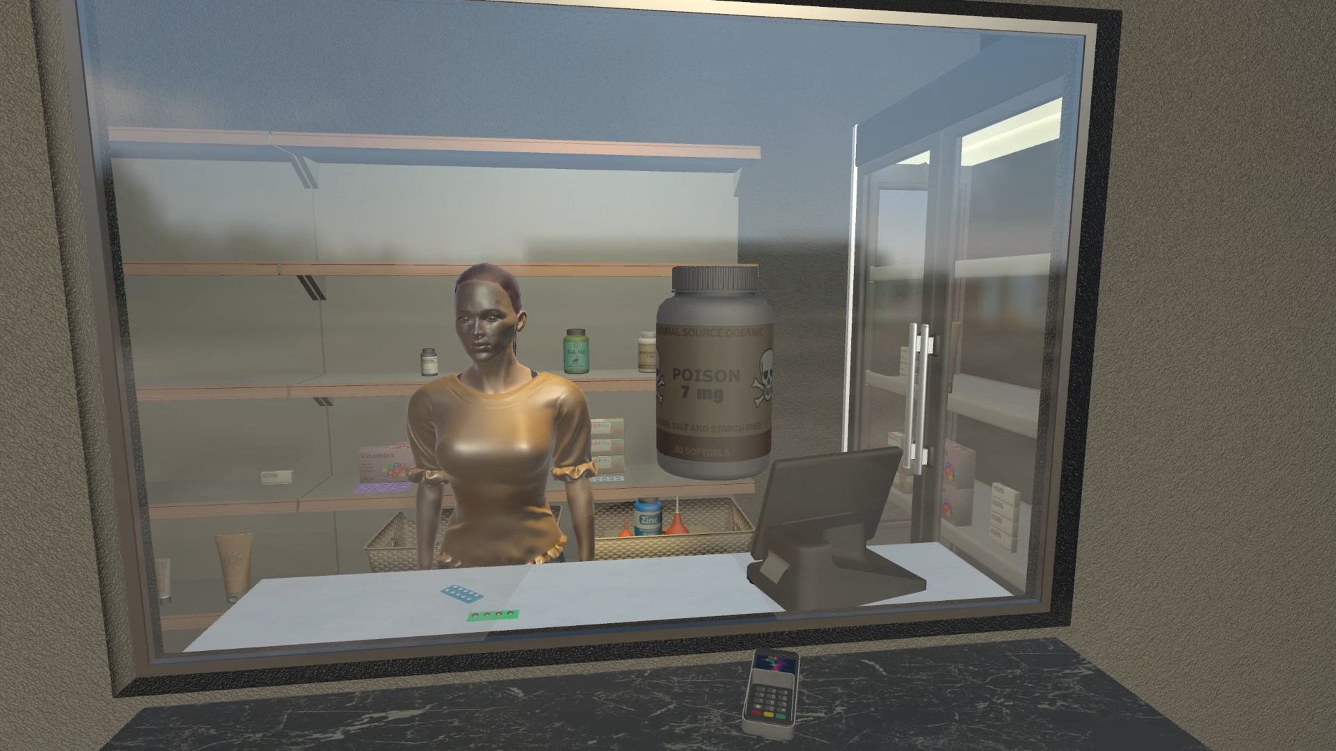

Figure 10: Final Pharmacy Scene

The last scene in the beta is a mixed auditory/visual hallucination modeled using a CRT TV broadcast of a typical newscast that suddenly changes into an Emergency Alert System (EAS) alert that only the user is able to hear. This was achieved through a combination of visual and auditory cues that are programmed into the simulation.
To achieve the visual component of the hallucination, a mp4 video of a typical newscast is projected onto a planar mesh wrapped around the outside of a CRT TV model (shown in Figure 11). This creates the illusion of a real TV broadcast within the virtual reality environment. Then, a C# script is used to switch the video feed to an mp4 of the EAS alert, replacing the newscast and triggering the auditory component of the hallucination. As the video feed switches to the EAS alert, the user hears a loud, urgent tone that is characteristic of an EAS alert. This tone is followed by a voiceover announcing a simulated emergency situation, such as a natural disaster or terrorist attack. The combination of the sudden change in video and audio, along with the potentially unsettling nature of the emergency announcement, creates a powerful mixed hallucination that simulates some of the symptoms of schizophrenia.
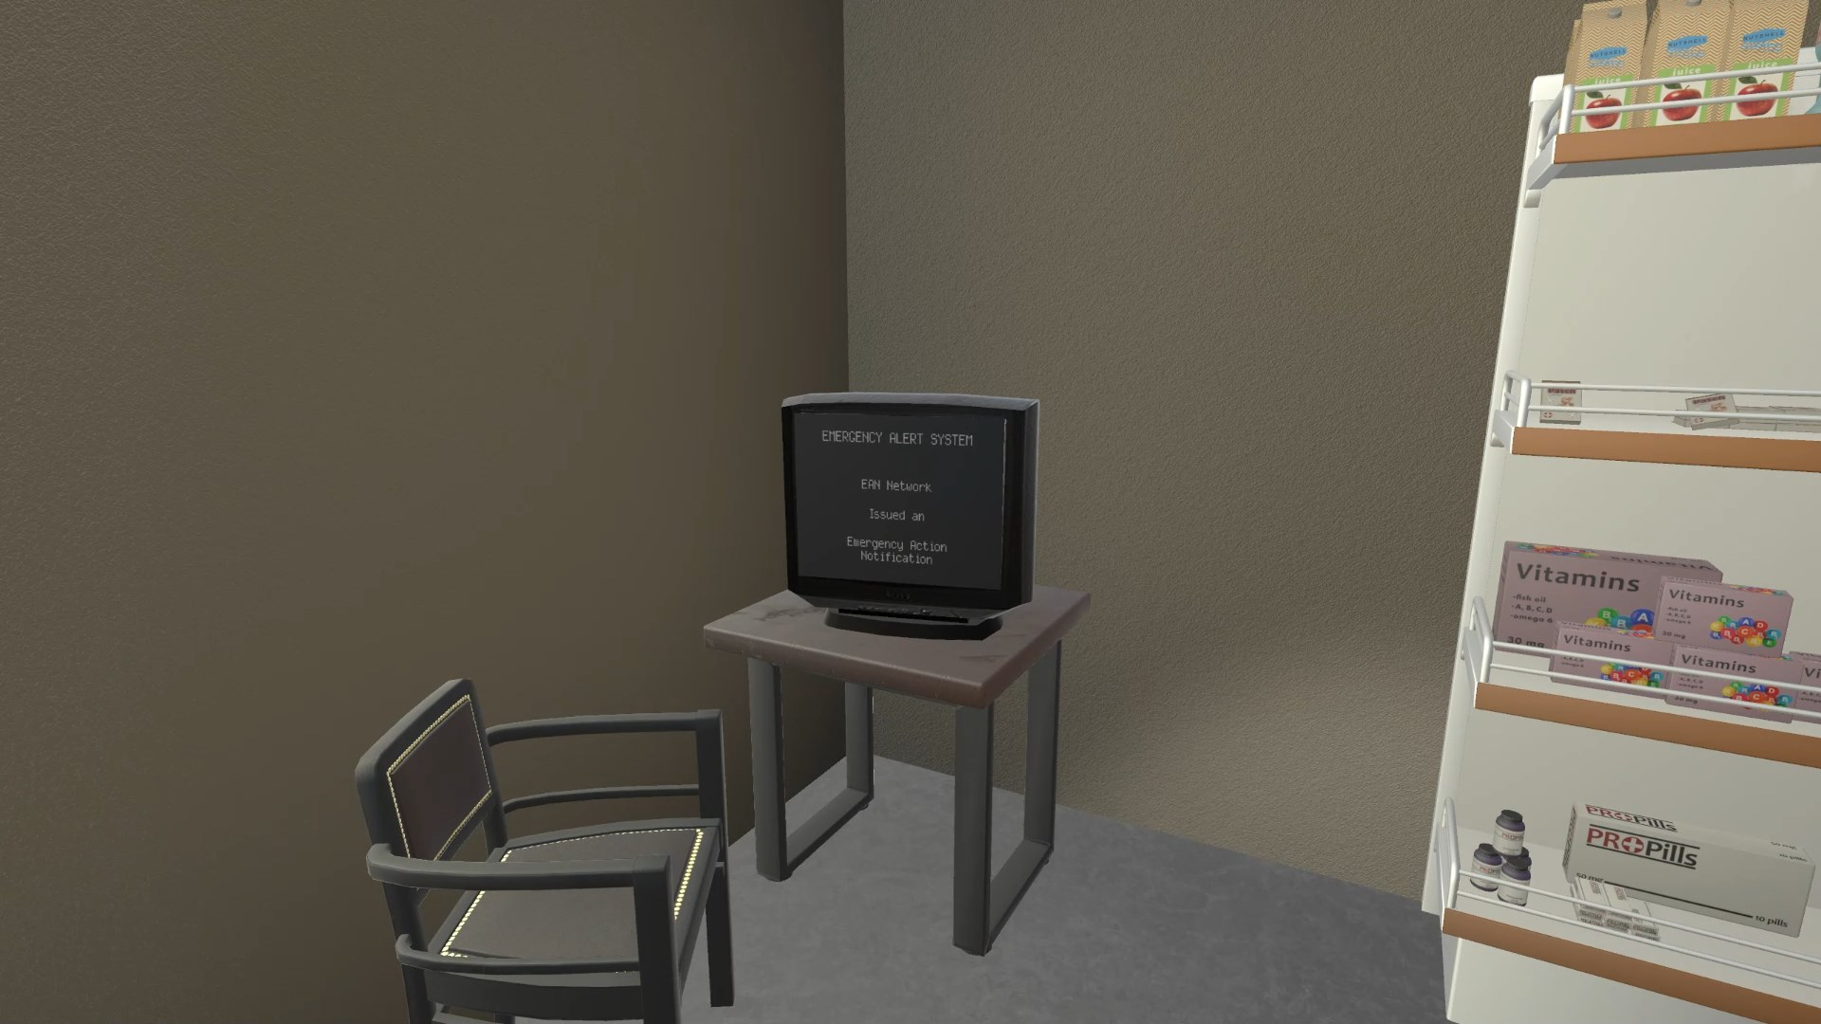

Figure 11: Mixed Audio/Visual Hallucination

4.3 Front-End
For our front-end we used two assets purchased from the Unity asset store: A grocery store model and a simple character customizer.



Figure 12: Grocery store model asset page

Figure 12 displays the grocery store model. It is used to create a virtual environment that accurately reflects the real-world setting in which many people with schizophrenia experience symptoms. This environment will enable students to understand the experiences of individuals with schizophrenia and develop empathy towards them.
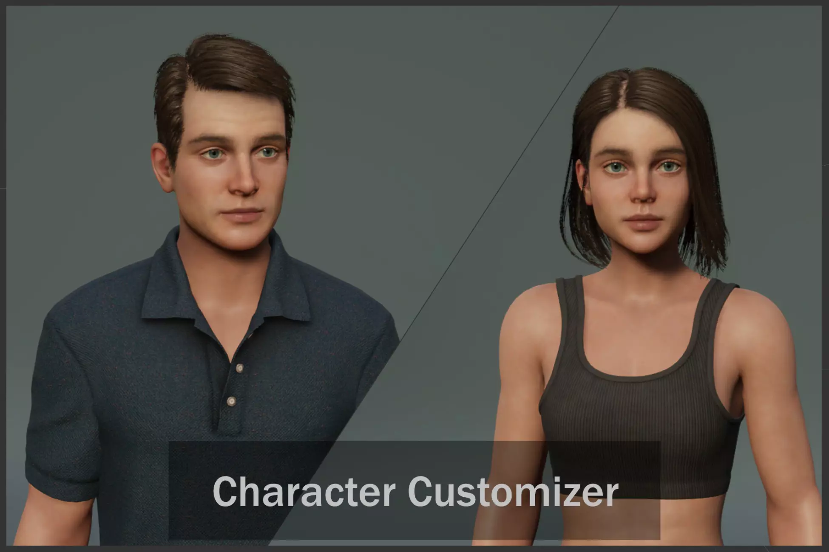

Figure 13: Character Customizer asset page

Figure 13 displays the customizable human model. These character models will be used throughout the simulation for the user to interact with. The models we decided to use allow us to create characters with different facial expressions and body movements that emulate how a person with this affliction experiences visual hallucinations. This will enable students to learn about the different types of symptoms, including delusions, hallucinations, and disordered thinking.

4.4 Back-End
For our simulation we decided to have the user be on a set continuously moving path. This allows the user to be fully immersed in the environment without having to worry about controls, getting lost, going in some place they are not supposed to be in etc. Originally our plan was to implement the use of Oculus controllers and allow the user to move within a set area through the story but we quickly realized that this introduces many bugs that can be encountered among other issues. We also realized that the main audience for this simulation was everyday people. This group might not have much experience with VR or video games in general and may find it difficult to use and become familiar with the controls. This would then remove them from the immersion of the experience and deter from what it was created for.

Also for our back end we had to implement our pharmacist interaction. The main component included for this interaction was the audio. The audio was created with Murf.AI which is described more in the Audio section. To implement the audio to activate at the proper time, we had to use C# scripting. The script mainly focused on creating a delay so that the audio would start when the user walked up to the counter. This was done using audio event listeners in Unity. These components allow audio to be played from a specific location or source in the game environment, modified to echo or drop off in volume with respect to the user. Some audio is also dependent on triggers such as entering an area or interacting with an object.

4.5 Audio

4.5.1 Development
For our audio we decided to use Murf ai. This application has a large range of voices to choose from with the ability to change the emotion, pitch, and speed. The first thing we looked at when looking for a program to use was the ability to have multiple voices with a wide range of emotion. On top of this, we also wanted them to sound realistic. This can be seen below in Figures 14 and 15. In 15, there are multiple different genders and ages to choose from. Each of these characters has their own distinct idiolect which greatly benefits the effects of using them for separate characters or hallucinations. As well, in Figure 14 below, it displays the different emotions the character Rachel has. Because of this wide range of emotions, we believed this would also be beneficial for a wide range of hallucinations.

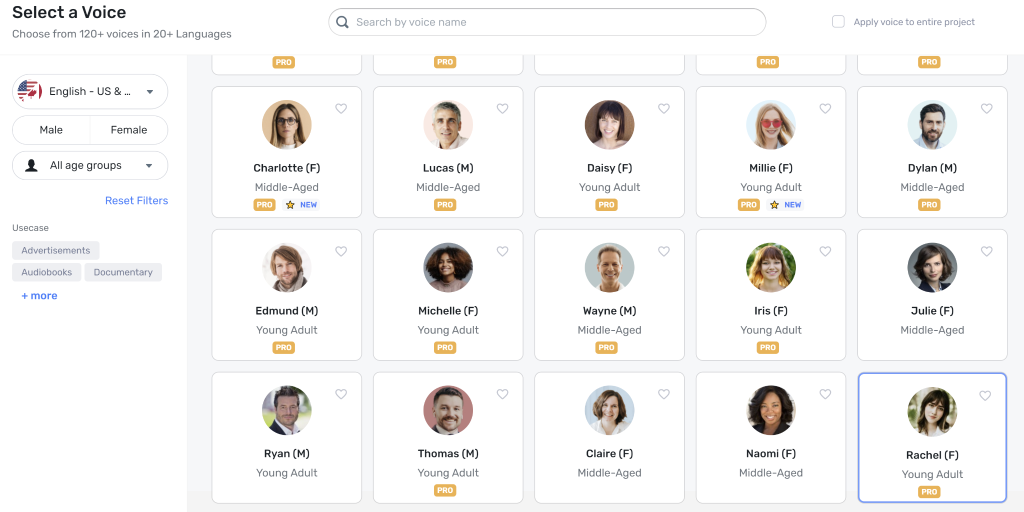

Figure 14: Some of the different voices included

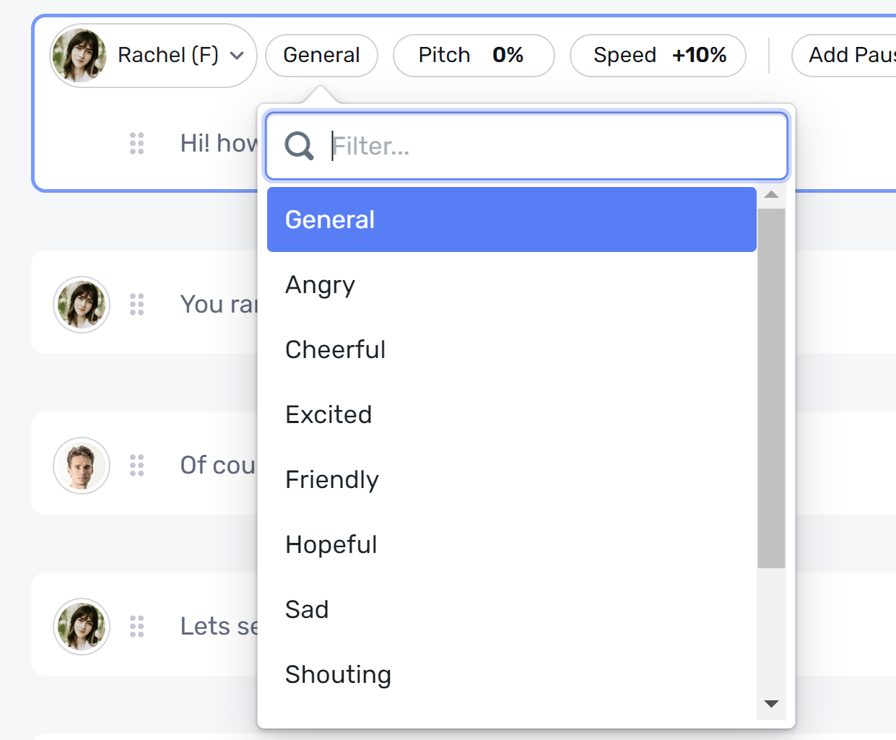

Figure 15: Some of the emotions for a voice

In our beta version, we initially developed a simple script that consisted of a brief interaction with a pharmacist, coupled with a few auditory hallucinations. The ai character we chose to play the pharmacist was Rachel, whose personality traits (as depicted in Figure 15) encompassed a diverse range of emotions. Rachel's default idiolect was friendly, cheerful, and easy to comprehend, as we believed that these tones would be best suited for a normal conversation with a pharmacist. However, when the voice is perceived by a hallucination, it should sound different, and could potentially come off as rude, dismissive, or angry.

Throughout the conversation, Rachel's tone gradually transitions from a friendly and cheerful one to a more aggressive and unfriendly one, particularly when talking to the doctor on the phone, as she judges the user. However, Rachel promptly reverts to her normal voice once the auditory hallucinations subside. When explaining how to take medication to the user, Rachel's tone quickly shifts to being more aggressive again, thus achieving the desired effect.

We were able to manipulate Rachel's tone, speed, and overall display of emotions from being cheerful to angry, unfriendly, and normal, by carefully crafting the text for the AI to read.

In addition to the auditory hallucinations present in the characters that the user interacts with, we also incorporated a few hallucinations that the user hears within their own head. Initially, we opted for three distinct voices, each with a unique tone: worried, aggressive, and whispering. The goal of the worried tone is to create anxieties and doubts within the user. To convey the worried voice, we utilized the character Nate. Although the character did not have a predefined worried tone, Nate did have the tone of terror which we thought would be fitting. As the user has their conversation with the pharmacist, Nate persistently whispers in their ear, inducing anxiety. For instance, when the user is given their medication, Nate interjects, warning them not to take it as it could be poisonous rather than therapeutic.

For the aggressive voice, we selected the character Ava, as we felt that her tone of anger would be suitable for the role. The purpose of the aggressive tone was to belittle and reject the user's actions. During the scene where the user receives the prescription, Ava harshly criticizes the user, insinuating that they are dumb for taking medication and that it will never solve their problems.

4.5.2 Licensing
In order to utilize Murf.AI, it was necessary to subscribe to their software program. Using such software for our audio has brought up concerns regarding legal and commercial rights. Addressing these concerns we have consulted Murf.AI’s FAQ page which includes information on commercial rights. According to this section: “You would have commercial rights to use the voiceovers generated for videos on YouTube or any other platform. You should be able to monetize that as well, as long as your text content is original and does not have any copyright conflicts.” [10]. As a result, we have ownership of the content we have generated due to our payment for the program.

5 Testing / Evaluation / Assessment
We will be leaving testing to the future students that want to work on this project. Unfortunately, we were not able to make the time ourselves to do the testing.

Some testing we would have liked to do included: Reaching out to Dr. Clinton and having her students interact with the simulation. We would have liked to see their reactions and thoughts on our project. This would be beneficial because Dr. Clinton has a schizophrenia lecture and this could not only add to their studies, they could give us feedback on the implementation of the symptoms from what they have learned in their lecture. This testing would mainly focus on our accuracy of the illness symptoms and how it affects the user.

Another way we would like to have implemented testing would have been having someone who is well rounded with VR applications mess with our project. They would be able to point out our shortcomings with our models, movement, rendering, scripting and other important parts of VR development. This is very important because we did not have much experience with VR or unity prior to this semester.

Finally one more test we would like to do would be to have a focus group of students to test our simulation. Preferably we would like to have a range of students with and without VR experience and a mix of students that have different knowledge levels on schizophrenia. We would like for this focus group to give feedback on many areas of the simulation including level of motion sickness, ease of use / comprehensibility of the story, and level of knowledge gained from experience.

Overall I think these three different areas of testing would create a well rounded and stronger simulation that would provide a greater understanding of schizophrenia and could even open doors to create empathy for not only schizophrenia but also mental health as a whole.

6 Users Manual

6.1 Setting Up the Headset
The following instructions outline how to set up the Oculus Quest 2 for first time use. Please note that the app will need to be sideloaded via a developer account before it is able to be run.

- Unbox the Oculus Quest 2 and ensure that you have all the components, including the headset, two controllers, the charging cable, power adapter, and any other accessories that may have come with your purchase.
- Charge the headset and the controllers using the included charging cable and power adapter. The headset should be charged fully before you begin the setup process.
- Place the headset on your head, using the adjustment straps on the top and back of the device to align the display with your eyes, ensuring a clear view of the display. See Figure 16 for a preview of the hardware features.
- Download the Oculus App on your mobile device from the App Store or Google Play Store. The app is available for both iOS and Android devices.
- Create an Oculus account or log in to your existing account.
- Turn on the Oculus Quest 2 headset by holding down the power button until it vibrates and the Oculus logo appears.
- Put on the headset and follow the on-screen instructions to connect it to your Wi-Fi network and complete the initial setup process. You will also be asked to pair the controllers with the headset.
- Once the initial setup is complete, you can start exploring the Oculus Quest 2 by browsing the available apps and games in the Oculus Store.

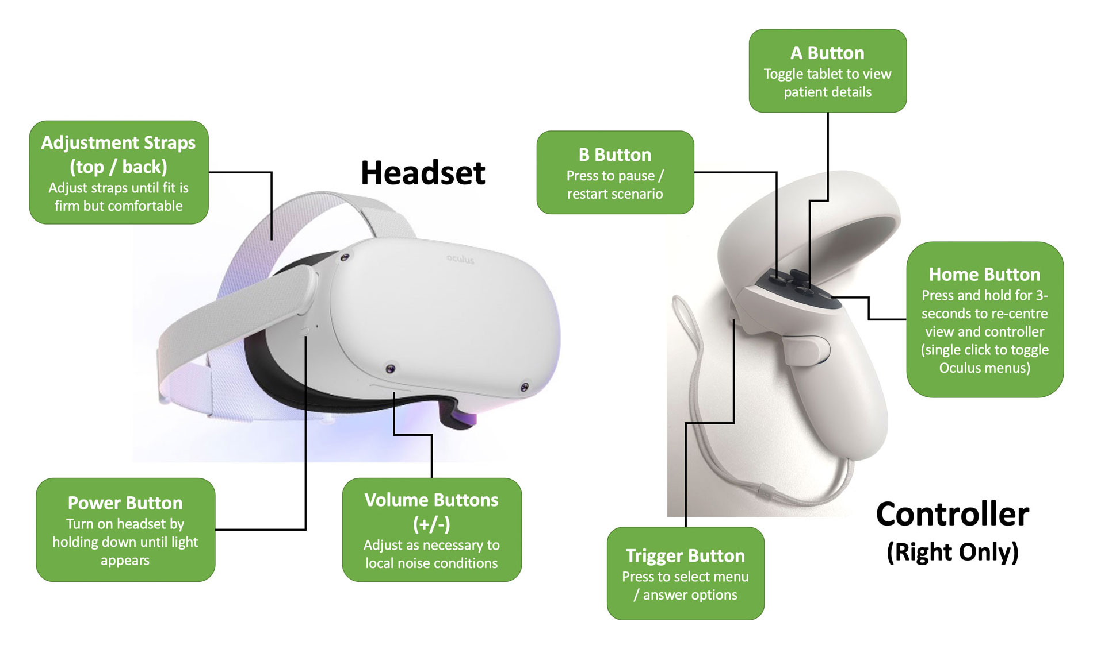

Figure 16: Quest 2 Hardware Layout [17]

6.2 Starting the Application
The current production of the simulation is shipped via a sideloaded Android app. Due to how Oculus handles non-licensed applications, this means that the app can only be run from the “Unknown Sources” subsection of the app folder. Navigating to this section is done via the top rightmost dropdown menu, as shown in Figure 17. The app is titled “Schizophrenia Simulation” and starts automatically once selected from the Oculus menu.

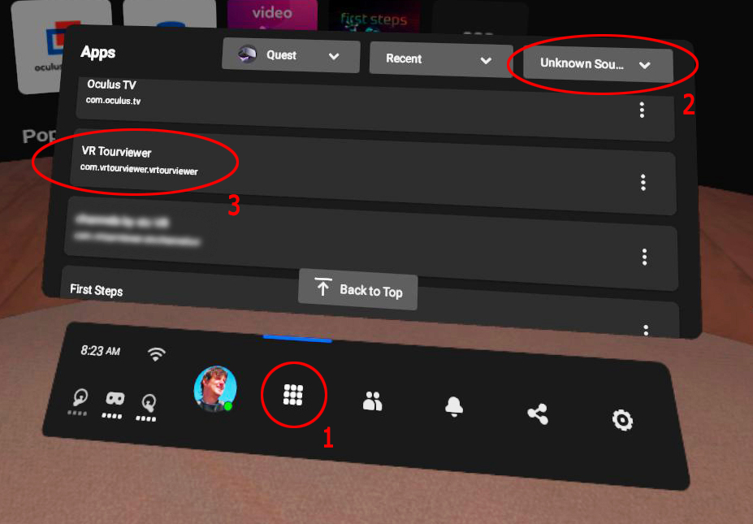

Figure 17: Starting the simulation [12]

For the user to be fully immersed in this simulation, it is recommended that they do not move around but they can look around at the scene around them. The user must make sure that the headset fits properly and is comfortable. This means that the headset is snug on the head. Not too tight that it is uncomfortable to wear but not too loose that it is falling down the users face.

6.3 Interacting with “Schizophrenia Simulation”
Movement in “Schizophrenia Simulation” follows the default joystick controls as outlined by Oculus XR standards. This includes using the left joystick for movement, the right joystick for incremental turns, and the trigger buttons for interacting with physics objects. This design was chosen to allow for small-scale play environments where the user may not be able to physically move around. Additionally, this can reduce the disorienting effects of VR for first time users. The controls are outlined as below in Figure 18
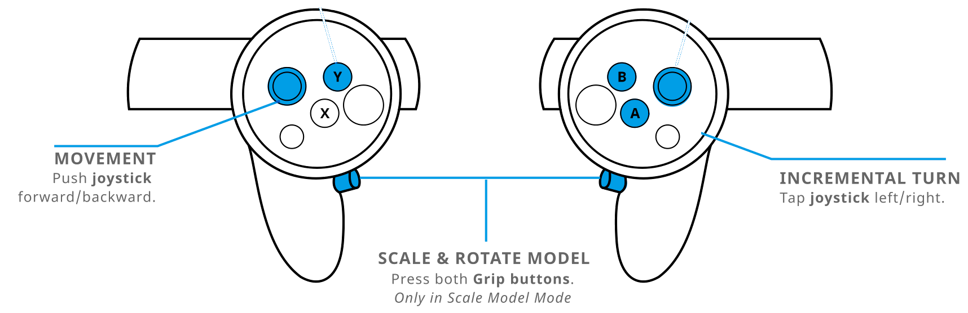

Figure 18: Quest 2 Control Scheme [17]

Once the program is running, the user will not walk around physically but rather stand still and observe the world around them while using joystick controls for movement. The user is also allowed to move their head to look at different things within the scene. The simulation is currently 115 seconds (1 minute 55 seconds) long and when it is finished the user can take off the headset. After this, the experience is over and they will be instructed by the proctor for possible next steps which could include a possible interview or quick summary explaining their experience or feelings.

Currently, the user is only limited by what areas they are able to access. Starting outside (as pictured below in Figure 19), the user may freely approach and enter the pharmacy. It is recommended that you use this time to become familiar with the controls and interacting with virtual reality before entering the pharmacy where the first scene begins.

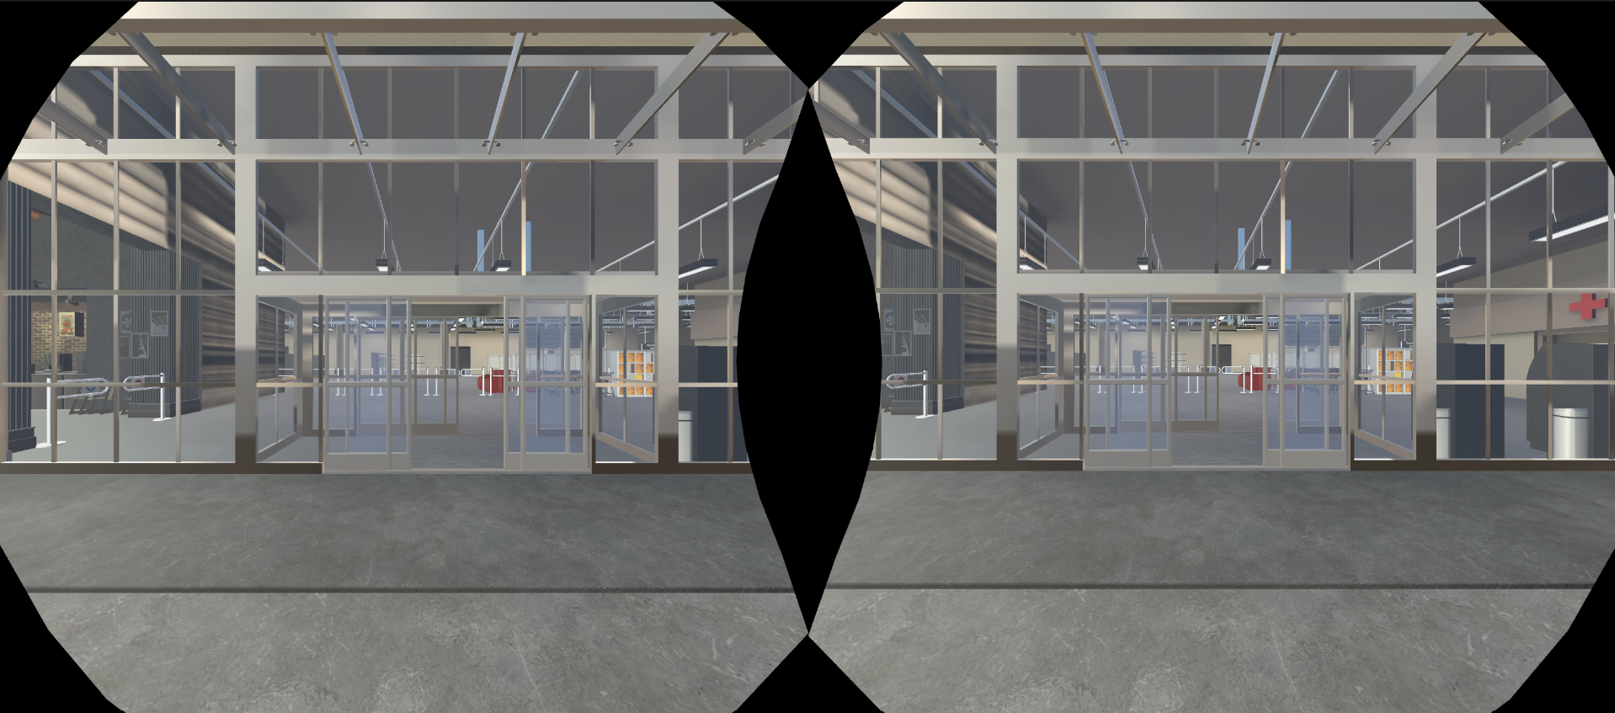

Figure 19: View walking to grocery store

The overall premise of the simulation is to increase understanding and empathy for individuals with schizophrenia by providing a firsthand experience of what it might be like to live with the condition. By using virtual reality technology, the simulation can provide a highly immersive and interactive experience that can help to break down stereotypes and stigma associated with mental illness, while also increasing awareness of the challenges faced by individuals living with schizophrenia. The scene shown in Figure 20 is an example of a visual hallucination one might experience during the simulation. Many shadows or objects may seem to be moving on their own, which may be disorienting to some users. Continuing through the simulation, Figure 21 shows what the user will see walking up to the pharmacy.

WARNING: Virtual reality content may cause disorientation, dizziness, or nausea. If you experience any of these symptoms, remove the headset immediately and take a break before using it again. Consult a doctor if symptoms persist.

WARNING: Virtual reality content may contain unsettling or disturbing topics, such as violence, horror, or graphic imagery. Users are advised to approach such content with caution and to stop using the headset immediately if they experience any discomfort or distress.

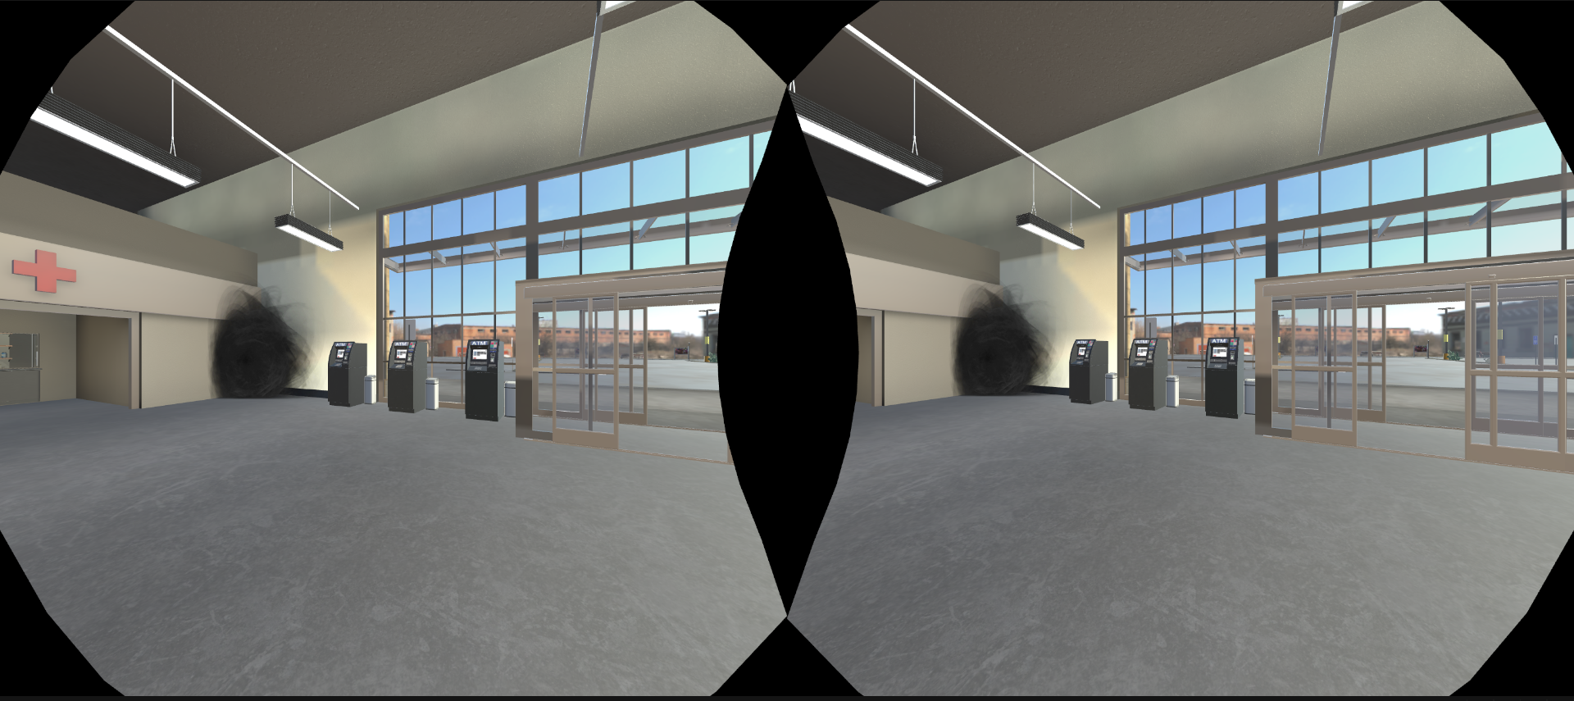

Figure 20: View inside grocery store
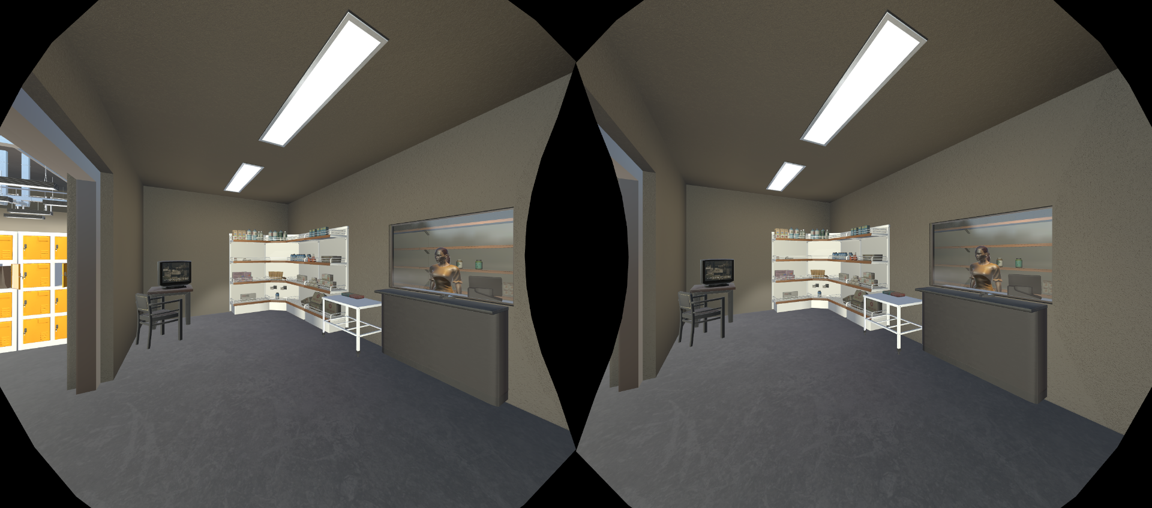

Figure 21: View in Pharmacy

7 Developers Manual
This project was built with further development in mind. As the final scope of the project can expand beyond what is possible during this semester, it is imperative that Dr. Ivory is able to continue work on the simulation following our final submission. This concept drove many of our design choices such as using Unity as a 3D backend and purchasing commercially licensed models. This section will outline the development process we followed, how it can be maintained, and what can be expanded upon.

7.1 Development Requirements

Prerequisites
  - Windows 10 or 11 with 3D hardware acceleration
  - Vulkan compatible GPU drivers
  - Oculus Development account
  - Unity 3D and Oculus Software with included packages:
Unity:
https://public-cdn.cloud.unity3d.com/hub/prod/UnityHubSetup.exe
Oculus:
https://www.oculus.com/download_app/?id=1582076955407037
Oculus Quest 2 ADB Drivers:
https://securecdn.oculus.com/binaries/download/?id=2987319634674616

Building
  - Build settings used for the project are included in the repository
    - Must be built as an android APK with ASTC texture compression
    - Vulkan rendering high recommended
  - Built via the Unity “Build Project” functionality
    - Located under File > Build Setting
    - Under Platform, select Android
    - Set Texture Compression to ASTC
    - From “ Run Device”, select the target Oculus headset. The device is listed only if it is connected to your computer over USB and is an optional step to test the app on a real headset.

Installation
  - Sideloading non-published applications requires enabling Developer Mode on the Oculus Quest 2
    - This must be done via the Oculus mobile application using an “Oculus Developers” account only
  - Unity’s “Build and Run” feature installs and loads the application via the ADB drivers
  - Sideloading via Oculus Link or “SideQuest” application is viable but not recommended

7.2 Source Control
The basis of any project’s scalability is good version source control. For 3D projects such as this one, it’s difficult to maintain the entire project in VCS as many sites such as GitHub have file size restrictions that limit large projects with several space-consuming models. In this case we used a version control scheme called “PlasticSCM” due to its integration into Unity. This allowed for the necessary settings and setup (such as the ignore file) required to maintain proper VCS principle to be shipped with the repository. Furthermore, attempting to source all of the models and associated configuration files for the entire project slows down development as storing/retrieving these changes takes significantly longer. To solve this issue, it’s important that a VCS ignore file is maintained to limit what’s stored. The ignore file we used is included in the project repository for consistency in further development.

For use in our development, we also used a Unity DevOps instance to maintain and ship development builds as they were being tested. This ended up being superfluous for our scope and would only be useful for maintaining this project on a much larger scale. Ultimately, the final changeset of the repository was shared as a zip file for further development by Dr. Ivory.

7.3 Project Structure
In addition to the default Unity packages for 3D development, the following packages are required:

Table 1: Unity Packages

Package | Justification
High Definition RP | HD scripting rendering pipeline used for project shaders and to light the character models
TextMeshPro | Provides improved control over text formatting for in-game elements
Unity UI | Used for developing UI elements
Visual Scripting | Visual, node-based behaviors to simplify development of non-scripted objects
Oculus XR Plugin | Provides display and input support for Oculus devices
OpenVR XR Plugin | Provides display and input support for OpenVR devices in Unity XR
Post Processing | A collection of effects and image filters used to improve visuals
To simplify the development process, the following assets are also used. They can be found on the Unity Asset Store and can be imported via the Unity client. Paid assets are associated with the V.T G.A.M.E.R. lab account which can be accessed through our client Dr. Ivory. Links are included in the references section of this report.

Table 2: Unity Assets

Asset | Justification
Dark Singularity - Free | Used as a package of particle effects and animations for various hallucinations [14]
Character Customizer - $99.90 | Provides a customizable human model and clothing assets/materials [4]
Grocery store - parking and supermarket - $99.99 | The main grocery store layout. Includes several items that would be found in a typical store [9]
Oculus Integration - Free | Development support for Oculus VR devices in addition to Oculus XR plugin [21]

7.4 Workflow

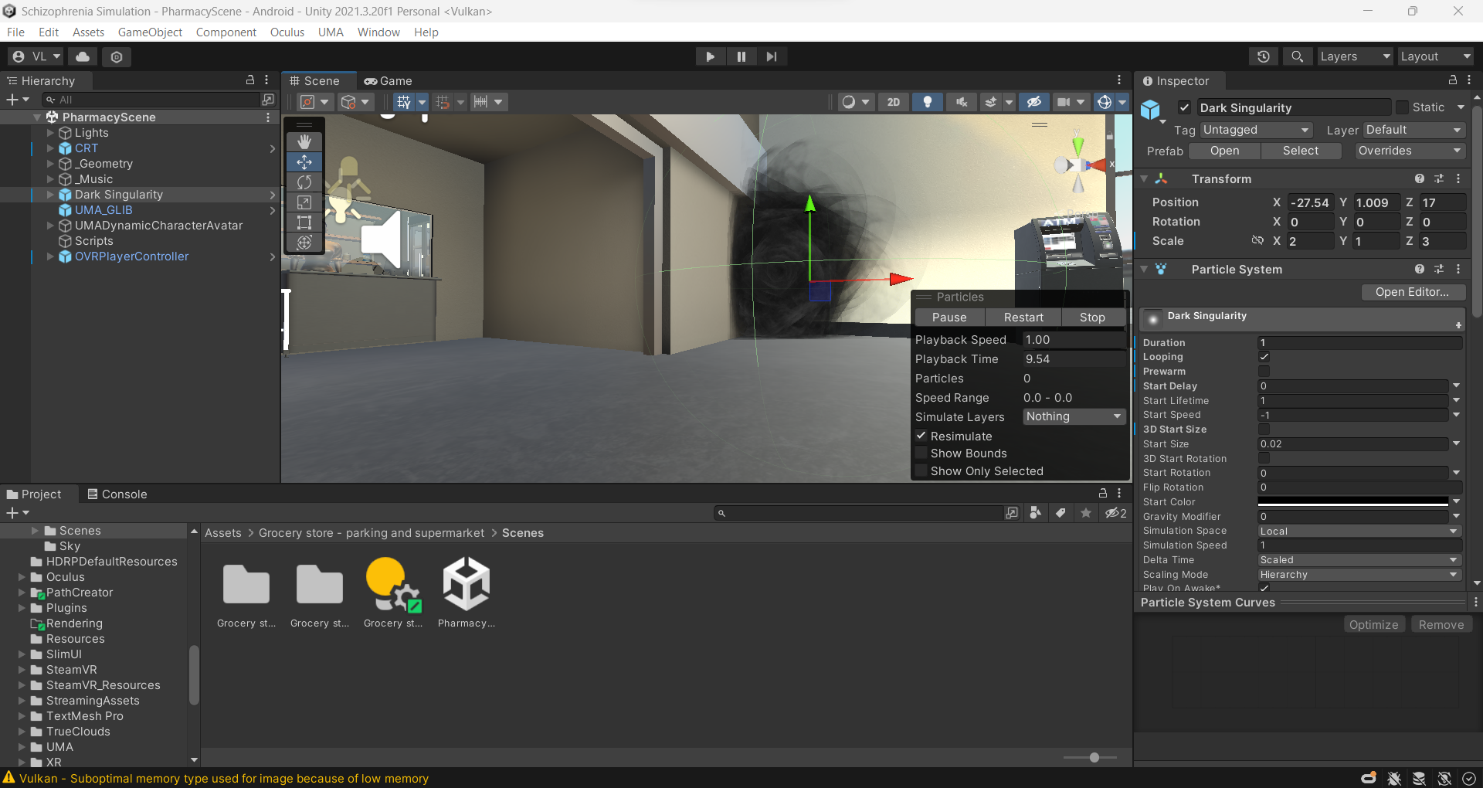

Figure 22: Unity Engine development layout

The general workflow of using the Unity engine for game development can be summarized in the following steps:
- Project setup: Start by creating a PlasticSCM repository using the provided code. This includes choosing a project name and location, setting the target platform, and adding team members. Members of the repository should be able to open a new “Remote Repository” in the Unity Hub client.
- Scene creation: The game world is created by adding objects, such as characters, props, and environments, to the game scene. Scenes are created by arranging these objects in the Unity editor and can be thought of as individual levels within the game. The scene developed for the beta version of the project can be located at Assets > Grocery store - parking and supermarket > Scenes > PharmacyScene.unity
- Scripting: Once the scene is created, gameplay mechanics are implemented through scripting. This involves writing code in C# which can be reflected as visual scripting as shown in Figure 22 for ease of development.
- Asset creation: Assets such as 3D models, textures, animations, and audio files are created using third-party software or integrated within the Unity engine. These assets are then imported into the Unity editor for use in the game.
- Testing and iteration: As the game is developed, it is regularly tested to identify and fix issues. Unity provides built-in tools for testing and debugging the game, and it is common to iterate on gameplay mechanics and other features based on feedback from testing.
- Building and deployment: Once development is complete, the game is built for the target platform. In this case, we are building an Android APK for the Oculus Quest 2. The resulting apk can then be published and distributed through various channels or sideloaded via the Unity engine or other ADB compatible applications.
Besides the assets acquired through the Unity store, each part of the development process, including model creation and audio scripting was done by our team. However it is also common to work with other team members, such as artists, designers, and sound engineers, who contribute to different aspects of the game's development. Unity provides collaboration tools and version control integration to facilitate teamwork and streamline the development process.

7.5 Development Considerations
Over the period of working on this project, we discovered some design principles that we were initially unaware of that may help further development:
- Unity has a built in visual scripting feature (Figure 23) which displays public C# variables in the editor panel. Taking advantage of this fact helped fine tune variables such as timer-based hallucinations.
- When using new models, materials, or assets; be sure that they are all using the same rendering pipeline. The pipeline used primarily in this project is the High Definition Rendering Pipeline. Cross-compatibility is possible but requires a significant amount of work.

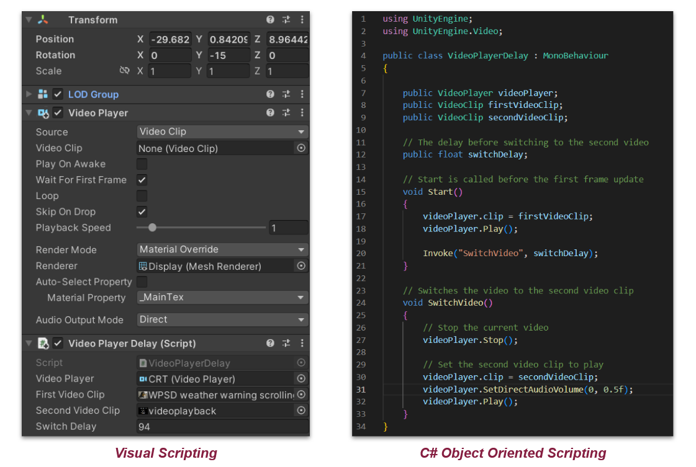

Figure 23: Visual scripting reflection of C# code

7.6 Further Development and Known Issues
To remain accurate to the clinical symptoms of schizophrenia, further testing and development is required outside of the scope of this project. As described earlier, this idea was critical to our development process. Every asset and package was chosen due to its long term support and documentation to lend towards continued development by another team. To that extent, every scene element and asset is included in the final repository, allowing for modification of any part of the final beta product.

Like most game development projects, this design is meant to be iterative with several updates as new features are added and new issues arise. The beta version shipped with this project is both a proof of concept necessitating further development and the first development version playable as it was shown during our ICAT presentation. Since potential project backers were the first to view this version, a smooth playing experience was paramount. That being said, there are a known number of issues with this version:
- There is no tutorial outlining controls outside of the Quest’s built-in guide. This makes repeated showcases difficult to present.
- The beta APK is not licensed with Oculus, meaning the application only appears in the hard-to-find “unknown sources” application folder.
- It is possible to intentionally clip through some scene elements and break scripted events, especially when the application is under heavy load.
- Occasionally low frame rates can cause character rotation to drift further than intended by the user. This can be very disorienting and cause dizziness to the user.

Solutions to these issues are possible with further development of the existing project. Adding a tutorial outlining controls and ensuring that the beta APK is licensed with Oculus are the next logical steps. Additionally, adding more scenes and optimizing the application to prevent users from intentionally clipping through scene elements or breaking scripted events will improve user experience. Finally, more development/optimizations to improve frame rates to ensure a smooth playing experience that does not cause disorientation for the user is necessary.

8 Lessons Learned

8.1 Overall Lessons Learned
Before starting this project, neither of us had any experience with 3D development in Unity. Despite understanding C# and other scripting languages, the transition to modeling 3D physics using this medium was a significant learning experience. This resulted in taking longer to set up the project than initially projected. We also did not anticipate the difficulty in purchasing the models necessary for the project. If we had known the process behind acquiring university funding for software, it would have been our first priority. Additionally our lack of experience led to purchasing a model incompatible with the rendering pipeline of another model. Luckily, the software required for upgrading model rendering protocols is built into the Unity engine [20].
Additionally we learned the significance of promptly establishing precise expectations and requirements with our client. We had some unresolved questions with our client regarding the final deliverables expected from us that were answered during the first few weeks of meeting. During several of our initial meetings, we encountered issues surrounding team communication which has affected our progress. This was remedied via more meetings and check-ins throughout the rest of the semester and keeping up with communication regarding work in progress and work completed, to help correct our progress when needed.

8.2 Issues with Model Purchases
As previously mentioned, we encountered some issues when purchasing our models. Due to their high cost of about $200 combined, we decided to have our client purchase them for us. However, we were unaware that the funding was provided from the state leading to a longer process to purchase. It took over a week for us to get our models approved. Once we gained approval, we met with our client and Ms. Wendy Hodge, who handles purchases. Unfortunately another issue was that unity did not allow us to make our purchase. This was because Unity requires an account's first purchase to be under a set amount and we were over this amount. This caused another delay but thankfully it was resolved quickly.

9 Acknowledgements
We would first like to thank our professor, Dr. Fox, for helping guide us through our project throughout the semester. Next, we would like to thank our client, Dr. Ivory, for giving us this opportunity and encouraging us to do our best.
We would also like to thank Dr. Clinton, a professor within the Neuroscience department, for reviewing our work and encouraging our progress.

References
- Cowan N. (2014). Working Memory Underpins Cognitive Development, Learning, and Education. Educational psychology review, 26(2), 197–223. https://doi.org/10.1007/s10648-013-9246-y. Accessed 31 March 2023.
- Crawford, P., & Go, K. V. (2022). Schizophrenia. American Family Physician, 106(4), 388+. https://link-gale-com.ezproxy.lib.vt.edu/apps/doc/A721079057/PPCJ?u=viva_vpi&sid=bookmark-PPCJ&xid=fab84488. Accessed 2 March 2023.
- Gorwood, P. (2008, September 8). Neurobiological mechanisms of anhedonia. Dialogues in clinical neuroscience. https://www.ncbi.nlm.nih.gov/pmc/articles/PMC3181880/#:~:text=Anhedonia%20refers%20to%20the%20reduced%20ability%20to%20experience%20pleasure.,psychiatric%20disorders%20and%20maladaptive%20behaviors . Accessed 3 March 2023.
- Jordbugg. (2023, January 28). Character customizer: Game toolkits. Unity Asset Store. https://assetstore.unity.com/packages/tools/game-toolkits/character-customizer-24186. Accessed 20 March 2023.
- Marques, et al., (2022, April 8). Impact of a virtual reality-based simulation on empathy and attitudes toward schizophrenia. Frontiers. https://www.frontiersin.org/articles/10.3389/fpsyg.2022.814984/full. Accessed 31 March 2023
- Mayo Clinic Staff. (2020, January 7). Schizophrenia. Mayo Clinic. https://www.mayoclinic.org/diseases-conditions/schizophrenia/symptoms-causes/syc-20354443 Accessed 2 March 2023.
- Merriam-Webster. (2023). Renal. In Merriam-Webster.com dictionary. https://www.merriam-webster.com/dictionary/renal. Accessed 12 March 2023.
- Merriam-Webster. (2023). Thromboembolism. Merriam-Webster. https://www.merriam-webster.com/dictionary/thromboembolism. Accessed 12 March 2023.
- Mixall. (2022, June 2). Grocery store - parking and supermarket: 3D environments. Unity Asset Store. https://assetstore.unity.com/packages/3d/environments/grocery-store-parking-and-supermarket-224033. Accessed 20 March 2023.
- Murf.AI. (2023, May 3). Who will have the commercial rights to the content created in Murf Studio?. FAQs. https://murf.ai/faq/who-will-have-the-commercial-rights-to-the-content-created-in-murf-studio. Accessed 1 May 2023.
- National Institute of Mental Health. (2023). Schizophrenia. National Institute of Mental Health. https://www.nimh.nih.gov/health/statistics/schizophrenia. Accessed 2 March 2023.
- ono.hosaka. (2021, April 1). Cannot find “unknown sources.” Home - Meta Community Forums. https://communityforums.atmeta.com/t5/Oculus-Quest-2-and-Quest/Cannot-find-quot-unknown-Sources-quot/td-p/858709. Accessed 15 March 2023.
- Pasadena Villa. (2014, February 28). The history of schizophrenia. Pasadena Villa. https://www.pasadenavilla.com/resources/blog/the-history-of-schizophrenia. Accessed 2 March 2023.
- Pathiral. (2019, November 4). Dark singularity: Particles/effects. Unity Asset Store. https://assetstore.unity.com/packages/tools/particles-effects/dark-singularity-156548. Accessed 8 May 2023.
- Pierce, M. (2023). Software release life cycle (SRLC): Understand the 6 main stages. The Product Manager. https://theproductmanager.com/topics/software-release-life-cycle. Accessed 31 March 2023.
- Rodríguez-Rivas1, et al., (2022). Innovative Technology–based interventions to reduce stigma toward people with mental illness: Systematic review and meta-analysis. JMIR Serious Games. https://games.jmir.org/2022/2/e35099. Accessed 2 March 2023.
- Tactics VR. (2022, November 1). Getting started - tactics VR - virtual reality training. Tactics VR. https://tacticsvr.com.au/getting-started. Accessed 22 March 2023.
- Thanur, T., & Gupta, V. (2023). Auditory hallucinations. National Center for Biotechnology Information. https://pubmed.ncbi.nlm.nih.gov/32491565. Accessed 2 April 2023.
- tiredjoker. (2010, June 17). Janssen Pharmaceutica - Schizophrenia Simulation. YouTube. https://www.youtube.com/watch?v=T14neSm599g&amp;ab_channel=tiredjoker. Accessed 31 March 2023
- Unity Technologies. (2020, December 12). Upgrading an existing project to use HDRP - 2019.2. Unity Learn. https://learn.unity.com/tutorial/upgrading-an-existing-project-to-use-hdrp-2019-2 . Accessed 20 March 2023.
- Unity. (2017, July 13). Oculus integration: Integration. Unity Asset Store. https://assetstore.unity.com/packages/tools/integration/oculus-integration-82022. Accessed 20 March 2023.
- West, L. K. (2022, March 18). My experience with hallucinations | schizophrenia symptoms. YouTube. https://www.youtube.com/watch?v=v1JUzzmctDA&amp;ab_channel=LivingWellwithSchizophrenia. Accessed 31 March 2023.
- Zare-Bidaki, et al., (2022, March 23). Evaluating the effects of experiencing virtual reality simulation of psychosis on mental illness stigma, empathy, and knowledge in medical students. Frontiers. https://www.frontiersin.org/articles/10.3389/fpsyt.2022.880331/full. Accessed 31 March 2023.

Appendices

Appendix 1. Glossary

Term | Definition
Alogia | Lack of speech, reduction in quantity of words spoken [2]
Anhedonia | Inability or reduced ability to experience pleasure from activities usually found enjoyable [3]`
Asociality | Lack of motivation to engage in social interaction
Avolition | Lack of motivation to care for personal hygiene or participate in activities [2]
Renal Disease | Kidney disease [7]
Thromboembolic | The obstruction of a blood vessel by a blood clot [8]
Working Memory | The small amount of information that can be used in the execution of cognitive tasks [1]

See glossary for definition
See Appendix 2: Unity Assets for links and references
All packages can be found in the Unity Package Manager and do not require additional configuration.

