Title:

Multi-Year Soil Response to Conservation Management in the Virginia Coastal Plain

Authors:
Sophie A. Nicholakosª, W. Hunter Frameª, Mark S. Reiterª, Ryan D. Stewartª

Affiliations:
ª School of Plant and Environmental Sciences, Virginia Tech, Blacksburg, VA 24060, United States

Corresponding Author: Sophie Nicholakos
Email: sophn96@vt.edu
Phone: (703) 965-2640
Postal Address: Smyth Hall, 185 Ag Quad Lane, Blacksburg, VA, 24061

Abstract
In the coastal plain region of the United States, conservation agriculture practices are being implemented to improve soil health, minimize environmental impacts, and improve farm profitability. Common practices include cover cropping and conservation tillage using strip tillage, minimal tillage, or no tillage. However, the soil response to specific combinations of conservation tillage and cover crop rotations remains poorly quantified. The objective of this research was to evaluate changes in soil properties from different combinations of conservation management. Four tillage systems – conventional, strip, minimal, and no tillage – and three winter cover rotations – fallow, winter cash crop, and high-biomass cover crop – were tested in a split-plot design. Bulk density, depth to a root-restrictive layer, soil carbon concentration, soil carbon stock, saturated hydraulic conductivity, and yield were measured over a seven-year period. Bulk density and saturated hydraulic conductivity showed greater temporal variation in the strip tillage and conventional tillage practices. Depth to root-restrictive layer was consistently highest in the strip and minimal tillage treatments, which both included implements designed to alleviate subsoil compaction. Treatments that combined conservation tillage with a winter cover (i.e., cash crops or high-biomass cover crops) had greater increases in soil carbon concentrations and carbon stock. Summer cash crop yield was significantly increased following the high-biomass cover crop treatment in 2 out of the 7 years. Altogether, soil carbon showed a more consistent response to conservation management than the other soil properties, which tended to show greater variability based on the time since disturbance (e.g., tillage). Conservation management practices therefore need to be consistently applied for multiple years in order to improve soil properties such as bulk density and saturated hydraulic conductivity.

1.1 Introduction
Row crop agriculture has been a prominent industry in the southeastern Coastal Plain of the United States for hundreds of years. Traditional agricultural practices include tilling fields in both fall and spring and leaving the soil fallow over winter. These practices have collectively contributed to enhanced soil carbon losses via mineralization and topsoil loss, along with a decline in other soil physical properties (Farmaha et al., 2022; Lal, 2015; Franzluebbers, 2010; Novak & Busscher, 2013a). The continued use of heavy machinery has also led to increased soil compaction and the formation of a hardpan layer 30-40 cm deep in the subsurface of many agricultural soils, which can inhibit root penetration and water infiltration through the soil profile (Gorucu et al., 2006).
Conservation practices such as conservation tillage and cover cropping can reverse soil degradation (Alletto & Coquet, 2009; Farmaha et al., 2022; Franzluebbers, 2010; Indoria et al., 2017; Lal, 2020; Novak et al., 2020; Spargo et al., 2008). Conservation tillage leaves at least 30% of the soil surface undisturbed and requires less frequent or no tillage (Wade et al., 2015). In a no-tillage system, soil is left completely undisturbed before planting. While there are environmental benefits to using no tillage, such as decreased runoff and erosion and increased soil organic carbon (Dang et al., 2020; Huggins & Reganold, 2008; Pittelkow et al., 2015), there are also challenges, including compaction in the initial years of implementation, increased weed pressure, and cooler soil temperatures (Huggins & Reganold, 2008). Furthermore, certain crops grown in the Coastal Plain, particularly peanuts, cannot be grown using no tillage due to soil disturbance during harvest of the belowground crop. Therefore, other conservation tillage systems like strip tillage or minimal tillage are being explored for their ability to maintain some of the soil and ecological benefits of no tillage while avoiding such limitations.
In addition to tillage systems, cover crops are also used as a conservation agricultural practice. Cover crops are grown to restore soil nutrients, increase soil organic matter, and improve soil water retention (García-González et al., 2018). Another practice commonly used in Virginia is double cropping, or planting a winter cash crop, which can be used to increase farm profits while also keeping the soil covered in the winter (Holshouser, 2014; Spargo et al., 2008). Corn-winter wheat-soybean double cropping systems are especially common in the Virginia Coastal Plain (Spargo et al., 2008), and tend to be more profitable than growing either crop alone (Holshouser, 2014).
Working in the Coastal Plain, Novak et al. (2009 and 2020) and Spargo et al. (2008) found that soil carbon increased and bulk density decreased through time after implementing conservation management. However, these changes were localized to the upper 5 cm of the soil profile, due to the stratification that often occurs when tillage is reduced or eliminated (Franzluebbers, 2002; Jian et al., 2020; Minasny et al., 2017; Novak et al., 2007, 2020). Similar studies outside of the Coastal Plain have examined the change in soil properties such as bulk density, penetration resistance, and saturated hydraulic conductivity. These studies have shown inconsistent responses to conversation management, with reports of improvement, decline, or initial decline followed by improvement (Blanco-Canqui et al., 2017; He et al., 2009; Indoria et al., 2017). For instance, soil compaction and infiltration capacity may take 5-10 years or longer to improve after implementing conservation practices (Blanco‐Canqui & Ruis, 2020; Indoria et al., 2017; Obi & Nnabude, 1988). Several studies have reported yield declines after initial implementation of no tillage practices, followed by gradual improvements over 5-10 years to either match or surpass yield from conventional tillage (Huggins & Reganold, 2008; Pittelkow et al., 2015).
This lack of substantial, consistent evidence demonstrates the need for a better understanding of the expected response of soil to management through time. In particular, the temporal effects of specific combinations of conservation tillage and cover cropping systems remains poorly quantified in the U.S. Coastal Plain. While the influence of conservation agriculture for mid-Atlantic grain cropping systems is well documented (Franzluebbers, 2010; Holshouser, 2014; Novak et al., 2007; Spargo et al., 2008), there has been little effort to understand if these practices have similar benefits or drawbacks in the cotton and peanut production systems that are common to the region.
This study was implemented to evaluate the changes in soil properties in response to conservation management in different cropping system-types over a 7-year period. The cropping system included all of the major row crops grown in this part of the Coastal Plain, including corn (Zea mays L.), soybeans (Glysine max), cotton (Gossypium hirsutum L.), and peanuts (Arachys hypogaea). By testing how soil properties change from these conservation management practices over time, this research aims to provide an improved understanding of how the soil will function in response to management, and its subsequent ability to support crop growth in the long term. A better understanding of region-specific and cropping system-specific effects on soil properties and processes will support Coastal Plain farmers' in maintaining production and profitability while improving soil and environmental health for greater sustainability and resiliency.

1.2 Materials and Methods

1.2.1 Site Description
This study was conducted at the Tidewater Agricultural Research and Extension Center in Suffolk, VA (36.663812, -76.737126). The soil is mapped as a Eunola loamy fine sand, 0 to 2 percent slopes. The Eunola series is fine-loamy, siliceous, semiactive, thermic Aquic Hapludults (USDA Web Soil Survey, 2021). Prior to 2017, the site had a rotation of field corn and upland cotton that was managed using strip tillage.

1.2.2 Experimental Design
The experimental design was a split-plot design with tillage as the whole-plot factor and winter cover as the sub-plot factor. There were four tillage treatments and three winter cover treatments for a total of twelve treatments, with four replicated blocks (Figure A.1). The field showed considerable texture differences based on particle size (Table 1), so the four field blocks were arranged to account for texture. Each row was 0.9 m in width by 12.2 m in length, each sub-plot was four rows wide, and each whole-plot consisted of 3 sub-plots. The four tillage treatments were, in order from most to least intensive, conventional tillage via disc plow to 20-30 cm depth, strip tillage using a sub-soil rip 30 cm wide and 40 cm deep, minimal tillage using a sub-soil rip 5 cm wide and 40 cm deep, and no tillage (Table 2). Note that the latter three treatments were considered to represent different conservation tillage practices. The tillage treatments were first implemented in 2017 (Figure 1).
The three winter cover treatments were, listed in order of highest to lowest expected biomass input, a high-biomass cover crop, a winter cash crop, and fallow (Table 3). The high biomass cover crop changed between years but was a mix of legume and non-legume cover crops including cereal rye (Secale cereale L.), hairy vetch (Vicia villosa), crimson clover (Trifolium incarnatum), rapeseed (Brassica napus var. napus), winter oats (Avena sativa), triticale (Triticosecale Wittmack), and daikon radish (Raphanus sativus var. Longipinnatus). In the years where a legume summer cash crop was planted (i.e., soybeans or peanuts), a grass monoculture of rye or winter wheat was planted to avoid potential detrimental effects from successively growing two crops in the same plant family (Reddy, 2017). In 2022, there was an exception due to a delay in planting date: soybeans followed a legume/grass cover crop mix because soybeans have a later planting time than cotton, which was originally planned for the next rotation. No cover crops were planted in winter 2020-2021 due to complications from the COVID-19 pandemic. Cover crops were terminated using glyphosate and glufosinate about 2-3 weeks before summer cash crop planting. The winter cash crop changed throughout the years, but was winter wheat (Triticum aestivum), rapeseed (Brassica napus var. napus), and cereal rye (Secale cereale L.). In the fallow treatment, no winter crops were grown other than weeds. The winter cover treatments started in the winter of 2017-2018 and were maintained until 2023 (Figure 1).
The summer cash crops were rotated each year (Table 4). Field corn was planted in 2017 and upland cotton was planted in 2018. In 2019, soybeans were planted in the no-tillage and minimal tillage plots, and peanuts were planted in the conventional and strip tillage plot, since peanut production is incompatible with continuous no-tillage or minimal tillage systems. Cotton was planted in 2020 but was not harvested due to yield loss from weather. Field corn was planted in 2021 and soybeans were planted in 2022. The field was managed to Virginia Cooperative Extension recommendations every year.
1.2.3 Soil Measurements
All field tests for bulk density, penetration resistance, and field-saturated hydraulic conductivity (K_{sat}) occurred each summer, approximately 1 month after tillage. Therefore, we expected that those measurements were likely to be strongly influenced by the recent tillage implementation. We collected a second set of measurements in March 2023, 9 months after tillage, to examine soil physical properties after a longer post-tillage interval (Figure 1).
Soil bulk density was measured using intact cylindrical cores (5 cm diameter by 5 cm height) from each plot at depths of 0-5 cm, 5-10 cm, and 10-15 cm. Samples were oven-dried at 105 °C for 24 h. Bulk density was then calculated as dried soil mass (g) divided by core ring volume (98.2 cm³). Particle density was assumed to equal 2.65 g cm⁻³. Bulk density was sampled in June 2019, July 2022, and March 2023.
Soil penetration resistance was measured with an analog dial penetrometer (DICKEY-john, Auburn, IL, U.S.). Two measurements were taken from each plot at 0 cm, 15 cm, 30 cm, and 45 cm perpendicular to the row center. The measurements were taken in July 2018, 2019, 2021, 2022, and March 2023. Samples were taken after large precipitation events when the soil water content was at approximately field capacity (Busscher et al., 1987); however, the soil moisture was not recorded in 2019-2021. Since soil moisture affects penetration resistance (Busscher et al., 1987; Vaz et al., 2011), we compared penetration resistance between treatments for each year, but did not compare between years.
Field-saturated hydraulic conductivity (K_{sat}) was measured in July 2022 and March 2023 using 15 cm diameter single-ring infiltrometers. Four rings were inserted a depth of about 4 cm into every plot except the winter cash crop subplots, which were excluded due to time constraints. Water was added in 100 mL increments (designed to maintain a relatively constant head), until either the total volume added equaled 1000 mL or an hour had passed since the first addition of water. Initial volumetric water content was estimated using a ΔT Profile Probe (Delta-T Devices Ltd, Cambridge, UK) and final volumetric water content was assumed to be equal to the soil porosity. K_{sat} was estimated using the single ring infiltration model described in Stewart & Abou Najm (2018) for steady state conditions:
$K_{sat}=\frac{m(d+r/2)}{λ+h_{source}+d+r/2}$ (2)
where m is the slope of the regression line between cumulative infiltration (I) and time (t), fit to the final 3-4 data points, d is the depth of the ring inserted in the ground, r is the ring radius, h_{source} is the height of single-ring water source pressure head, and λ is the capillary length, a measure of the capillary force acting on the soil water.
The capillary length was calculated using:
$λ= \frac{4cb\left(1-a\right)\left(h_{source}+d+\frac{r}{2}\right)- h_{source}(θ_{s}-θ_{i})(d+\frac{r}{2})}{\left(θ_{s}-θ_{i}\right)\left(d+\frac{r}{2}\right)-4c_{3}b\left(1-a\right)}$ (3)
where θ_{s} is the saturated soil water content, θ_{i} is the initial soil water content, and c₃ is a constant, a is a constant assumed to be 0.45 and b is a constant assumed to be 0.55 (Stewart & Abou Najm, 2018). Whenever the calculated λ was < 1 cm, we assumed that λ = 1 cm.
Soils were sampled for total carbon measurements in summer 2018, fall 2021, and fall 2022. The samples were taken at depths of 0-5 cm, 5-10 cm, 10-30 cm. Total soil carbon was measured on dried and powder-ground samples using an element analyzer (Elementar VarioMAX CNS Element Analyzer; Elementar Americas Inc., Ronkonkoma, New York). The analyzer heated soil to 1,200°C, combusted the carbon to CO_{2,} and measured the concentration with an infrared spectrometer (Stott, 2019).
Carbon stock was also calculated using 2022 soil samples and 2022 bulk density measurements. Though soil was sampled to a depth of 30 cm, the bulk density was measured on soil to a depth of 15 cm. Therefore, carbon stock is reported to a depth of 15 cm. Carbon stock, C_{stock} (in Mg ha⁻¹) was calculated as:
$C_{stock}=0.1×D×TC×ρ_{b}$ (1)
where D is the soil depth (in cm), TC is total soil carbon (in g kg⁻¹), and ρ_{b} is the soil bulk density (in g cm⁻³).
1.2.4 Winter Cover Biomass
Winter cover biomass was measured in 2018 and 2022 to determine how much biomass was returned to the field in those years. The biomass was sampled by laying a 0.5 m x 0.5 m quadrat in a random location in each plot and harvesting all aboveground biomass. The biomass was calculated by converting the dry mass (g) per sampling area (0.25 m²) to mass (kg) per hectare (ha). Winter cash crop residue returned to the surface (Residue) was estimated based on measured grain yield using:
$Residue=\frac{(1-Harvest Index)}{Harvest Index}×Grain Yield$ (2). Winter wheat was assumed to have Harvest Index = 0.45 (Dai et al., 2016). Rapeseed was assumed to have Harvest Index = 0.24 (Luo et al., 2015).
1.2.5 Cash Crop Yield
Each year, the center two rows per plot were harvested to determine summer cash crop yield. Crop yield was taken in every year (2017-2022) except in 2020. Cotton lint yield and peanut yields were calculated by converting the mass (kg) per plot to the mass (kg) per hectare. Corn and soybean yield were calculated by adjusting the harvest mass to a standard moisture (15.5% for corn and 13% for soybean), and then converting the mass (kg) per plot to the mass (kg) per hectare.

1.2.6 Statistical Analyses
We used a split-plot two-way ANOVA to determine if winter cover, tillage, or their interaction had a significant effect on soil properties. The Tukey-Kramer’s HSD method was used for mean separation, with α = 0.05 as the level of significance. A Shapiro-wilk test was run on data to test for normality. Both years of the K_{sat} data and all years of the carbon concentration data were log-transformed prior to statistical analysis. However, non-transformed values were reported in figures. All statistical analyses were performed using R Version 4.1.3 (R Development Core Team, 2022.)

1.3 Results and Discussion

1.3.1 Winter Cover Biomass
The amount of biomass returned to the soil differed between winter cover treatments in both 2018 and 2022 (p < 0.0001; Figure 2). In 2018, the winter cash crop had significantly higher biomass (9,819 kg ha⁻¹) than the cover crop (5,836 kg ha⁻¹), and both had significantly more biomass than the fallow (933 kg ha⁻¹). In 2022, the cash crop (4,338 kg ha⁻¹) again had significantly more biomass than the cover crop (1,781 kg ha⁻¹), and both were significantly greater than the fallow (436 kg ha⁻¹). The increased biomass in the winter cash crop treatments was likely because the cash crops were fertilized, whereas the cover crops were not.
Since the winter cash crop biomass was sampled before grain harvest in both 2018 and 2022, we also estimated biomass values using a harvest index for each crop (rapeseed in 2018 and winter wheat in 2022; Table A.2). In 2018, using the harvest index resulted in an estimated biomass return of 1,698 kg ha⁻¹ (for rapeseed), which was lower than either the harvested cash crop biomass (9,819 kg ha⁻¹) or the cover crop biomass (5,836 kg ha⁻¹). Using the harvest index for 2022 (winter wheat) resulted in an estimated winter cash crop biomass of 2,729 kg ha⁻¹, which was also lower than the harvested biomass, but still higher than the cover crop biomass (1,781 kg ha⁻¹). Therefore, the mean winter cash crop biomass values estimated with the harvest index were lower than the mean harvested biomass values in both years. This discrepancy was likely because the harvested biomass included the wheat grain, which would have been removed before residue return.

1.3.2 Bulk Density
Temporal variability in bulk density was greater in the conventional and strip tillage systems than the minimal and no tillage systems (Figure 3). While all bulk densities measured in 2019 were not significantly different from each other, in summer 2022 the bulk density values for soils under conventional and strip tillage were significantly lower than the other two tillage treatments both at the 0-5 cm (p = 0.004) and 10-15 cm (p = 0.022) depths (Table A.1). The bulk densities measured in March 2023 for strip tillage and conventional tillage both increased from the summer 2022 values, and bulk density was once again not significantly different between treatments. Nonetheless, bulk densities decreased through time in the upper 5 cm of the minimal tillage and no tillage treatments. This decreasing pattern was not seen in the subsurface depths (5-10 cm and 10-15 cm).
The significant differences between treatments in 2022 can be explained by the recent tillage implementation. Tillage was conducted about a month before the 2022 measurements were taken in July, whereas the March 2023 measurements were taken about 9 months after the last tillage event. The lack of significant differences between treatments in 2023 indicate that soil structure reconsolidated in the nine months since tillage was implemented for the strip and conventional tillage plots. Alletto & Coquet (2009) measured the temporal change in bulk density between conventional and conservation tillage treatments and found that soils significantly increased in bulk density by 51 days after tillage, and that there was greater variation in conventionally tilled soils. Taken together, these results suggest that while tillage can decrease bulk density for a brief period, soils are likely to reconsolidate to bulk densities that are similar to or even greater than the initial bulk density.
We observed a decreasing bulk density in the top 5 cm of no tillage and minimal tillage systems over time (Figure 3). This result matches the outcome observed by Spargo et al. (2008), who found decreasing bulk density in the upper 2.5 cm of a Coastal Plain soil. That study found that 22% of the variation in bulk density was explained by duration of no tillage, which the authors attributed to increased soil surface carbon when using no tillage.

1.3.3 Penetration Resistance
The depth to the uppermost root-restrictive layer (i.e., with penetration resistance ≥ 2,068 kPa) varied between treatments, distance from row center, and years (Figure 4). Across all years, depth to the root-restrictive layer was greatest in the row center (0 cm) for strip tillage and increasing for minimal tillage. There was an exception in 2019, when the conventional tillage and strip tillage had significantly deeper root-restrictive layers (Figure 4). This same trend was generally seen at 15, 30, and 45 cm from the row middle. While there was an influence from winter cover in 2018, there was no other year where the depth to the root-restrictive layer was significantly different from winter cover.
When measured in the spring of 2023, the soil under strip tillage and minimal tillage treatments maintained a significantly deeper depth to root-restrictive layer in the row middle, and the strip tillage remained significantly deeper than other treatments at 15 cm, 30 cm, and 45 cm from the row. That measurement took place nine months after the last strip tillage implementation and twenty-one months after the last minimal tillage implementation. Previous work has differed on whether annual deep tillage is necessary in row cropping systems in the Coastal Plain. Busscher et al. (1986) found no significant difference in soil strength between treatments that had not been subsoiled in a year or more, which indicates that the soils had reconsolidated after tillage. However, Busscher et al. (2000) found residual effects from deep tillage on root growth for two years, but not in the third year. The results from our study likewise suggest that it may not be necessary to implement deep tillage every year to break up a plow pan, but it is not known if consolidation would eventually happen after a longer absence of deep tillage (e.g., 3-4 years).

1.3.4 Field-Saturated Hydraulic Conductivity (K_{sat})
Tillage significantly influenced K_{sat} in 2022 (p = 0.017). The strip tillage treatment had significantly higher K_{sat} (0.009 cm/s) than the minimal tillage (0.003 cm/s) and no tillage treatments (0.002 cm/s; Figure 5). By spring of 2023, however, K_{sat} values had decreased in the strip till and conventional tillage treatments and had numerically, but not significantly, lower means than the minimal and no-tillage treatments. It is likely that the temporary decrease in bulk density seen after tillage for the strip and conventional tillage treatments led to greater K_{sat} values, but the soil consolidation observed in those treatments by spring of 2023 also had the effect of reducing soil permeability.

1.3.5 Soil Carbon
In 2018, near the beginning of the experiment, total soil carbon was not significantly affected by tillage (Figure A.2) or winter cover (Figure A.3) at any depth. By 2021, however, the strip tillage plots had a significantly greater soil carbon concentration at 0-5 cm than the conventional tillage plots (mean of 11.3 g kg⁻¹ versus 8.4 g kg⁻¹). In 2022, both tillage and winter cover had significant effects on soil carbon at 0-5 cm. Soil carbon concentration was once again significantly greater in the strip tillage compared to the conventional tillage plots (mean of 16.1 g kg⁻¹ versus 10.9 g kg⁻¹). Moreover, the cover crop (15.1 g kg⁻¹) and cash crop (14.6 g kg⁻¹) treatments had significantly greater carbon concentrations than the fallow treatment (13.3 g kg⁻¹). Tillage also affected total carbon at the 5-10 cm depth in 2022, with the strip tillage treatment having significantly greater carbon concentration than no tillage (mean of 12.1 g kg⁻¹ versus 8.3 g kg⁻¹).
We also calculated the change in carbon concentration from 2018 to 2022 to better understand the effect of management on the magnitude of change in those 4 years (Figure A.4). Though the treatments were not significantly different from each other at any depth, there were notable numeric differences. The strip tillage treatment had a mean carbon increase of 0.67% in the upper 5 cm, similar to the increase in the no tillage plots (0.68%), whereas the conventional tillage treatment had a change of only 0.18%. At the 5-10 cm depth, carbon increased in the conventional tillage treatment by 0.51%, by 0.47% in the strip tillage plots, by 0.42% in the minimal tillage plots, and by 0.33% in the no tillage treatment. At the 10-30 cm depth, the mean carbon increase in strip tillage was 0.63%, versus 0.34% for the no tillage, 0.54% for the minimal tillage, and 0.40% for the conventional tillage. No notable differences in carbon concentration changes were observed for any of the winter cover treatments.
The no tillage treatment had its greatest carbon concentrations near the surface, likely due to stratification (Franzluebbers, 2002; Hunt et al., 1996; Novak et al., 2020). In contrast, the conventional tillage plots had less carbon near the surface but some possible enrichment in the 5-10 cm depth. The strip tillage had an overall carbon increase of 0.61% (depth-weighted mean for 0-30 cm) between 2018 and 2022, which is an average of ~ 0.15% per year and a relatively large value compared to the rates measured in other studies. For example, Novak et al. (2007) estimated a carbon sequestration rate of 0.045 % per year in in the top 5 cm over a 24-year period when implementing conservation tillage with a subsoiler once per year. However, there were no cover crops grown, which may explain why the increase was not as large as seen in our study. Furthermore, soils depleted of soil organic matter are shown to accumulate carbon more rapidly in the initial years after switching to conservation practices, and then experience a lag as the practices continue (Machmuller et al., 2015; Novak et al., 2020). These results presented here may therefore represent a best-case scenario, and likely do not represent long-term rates of carbon sequestration in these systems. Nonetheless, these results emphasize that strip tillage is a practice that may combine advantages of both no tillage (e.g., less surface disturbance) and conventional tillage (e.g., carbon incorporation to depth), and should be further evaluated for its potential to enhance climate-smart agriculture.
1.3.6 Carbon Stocks
We used the 2022 carbon concentration and bulk density values to calculate soil carbon stocks for that year (Figure 6). Both tillage (p = 0.001) and winter cover (p = 0.049) practices had significant effects on carbon stock at the 0-5 cm depth. The conventional tillage treatment had a mean carbon stock of 6.76 Mg ha⁻¹ in the top 5 cm. This amount was significantly less than those measured in the no tillage (11.19 Mg ha⁻¹), minimal tillage (10.66 Mg ha⁻¹), and strip tillage plots (10.33 Mg ha⁻¹), all of which were not significantly different from one another. Mean carbon stock in the cash crop plots was 10.29 Mg ha⁻¹, which was significantly higher than the fallow (9.17 Mg ha⁻¹). We also calculated carbon stock for the 0-15 cm depth and found that in both deep (strip and minimal) tillage plots, carbon stock was ~ 25 Mg ha⁻¹, which is numerically higher than in the no till (22.61 Mg ha⁻¹) and conventional till plots (19.51 Mg ha⁻¹). However, there were no statistically significant differences among both winter cover and tillage treatments at 0-15 cm depth (Figure 6).
The lack of significant difference from treatments in carbon stocks below 5 cm is somewhat expected as there was a relatively smaller difference among treatments for soil carbon concentrations and bulk densities at depths lower than 5 cm (Figure 3, Figure A.2). Though studies have seen significant increases in carbon stocks from conservation management to a 30 cm depth, results have been inconsistent due to variation in climate, soil type, and duration of management (Jian et al., 2020; Poeplau & Don, 2015). The warm, humid climate and course soil texture found in the coastal plain may have limited the capacity of soil carbon storage for the first 7 years of this study. With the soil carbon concentration data showing an increasing trend particularly in the strip tillage treatments (Figure A.2), it is possible that more time is needed to see significant differences in carbon stock at depths lower than 5 cm (Poeplau & Don, 2015).

1.3.7 Yield
Summer cash crop yield was calculated in every year except 2020 (Figure A.5). The yield measurements from 2017, at the start of the study, did not significantly differ between tillage treatments. Therefore, the common observation of a summer cash crop yield decrease in the first year of switching to no tillage (e.g., Huggins & Reganold, 2008; Pittelkow et al., 2015) did not occur in this study. Sandy soils characteristically have a low water holding capacity, and the absence of tillage may have led to increased soil water, contributing to increased yield relative to outcomes seen in studies conducted in finer-textured soils (Pittelkow et al., 2015).
Treatment effects were observed in 2018 and 2022 (Figure 7). In 2018, there was a significant influence of winter cover on cotton yield, as the cover crop treatment (1,019 kg ha⁻¹) was significantly higher than the cash crop (736 kg ha⁻¹) treatment (p < 0.0001). In 2022, there was a significant effect from winter cover: average yield in the cover crop treatments (2,441 kg ha⁻¹) was significantly higher (p = 0.04) than in the cash crop treatments (2,117 kg ha⁻¹).
Several potential reasons may explain the greater yields detected in the cover crop versus the cash crop treatments in those years. In 2018, cotton was planted later following the winter cash crop treatments than the other winter cover treatments; therefore, the lower summer cash crop yield measured that year was therefore likely due to the shorter growing season. Another possibility is that the legume species included in the cover crop mixtures in 2018 and 2022 helped to reduce the C:N ratio of the soil, whereas the monocrop rye (a grass species) that was planted in 2019 and 2020 did not (and no cover crop was planted in 2021). Previous work has found that cover crop mixtures can increase yield of the subsequent cash crop compared to monoculture grasses (Jian et al., 2020), and that cover crop C:N and cash crop yield are negatively correlated (Finney et al., 2016).
The results from this study demonstrate tradeoffs between the use of a winter cash crop versus a cover crop as a winter soil cover strategy. If the farmer’s goal is to maximize summer cash crop yield, then using a cover crop mixture that includes legumes may be the best strategy. However, if the goal is to maximize farm profitability, then it may be better to plant a winter cash crop grass, such as rye or winter wheat. Another consideration is the length of the growing season of the summer cash crop, which can be reduced in double cropping systems (i.e., a winter cash crop grown to harvest). Also, if farmers decide to use a monoculture grass species as a cover crop, then removing some of the residue could benefit yield by potentially reducing nitrogen immobilization in the soil during the summer growing period. Residue removal may have some additional drawbacks in terms of other aspects of soil health, e.g., greater erosion due to less soil cover (Du et al., 2022) so these factors should all be considered together when deciding on the exact planting strategies to use during the winter.

1.4 Conclusion
In this study we examined soil physical properties (i.e., bulk density, penetration resistance, K_{sat}), soil carbon, and summer cash crop yield during 7 years of different tillage and over-winter crop management practices. Outcomes varied between years and soil depths, but a few patterns clearly emerged from the results. Bulk density and K_{sat} of the upper soil profile were both modified when using conventional and strip tillage. These effects were mostly temporary, as the differences disappeared by nine months after tillage. Soil carbon also was variable through time, but carbon stock of the 0-5 cm depth were significantly greater in the conservation tillage treatments compared to conventional tillage by the end of the study. The winter cover treatments (i.e., cover and cash crops) likewise had increased soil carbon in the upper 5 cm by the end of the study. These findings demonstrate that Coastal Plain agricultural soils have the potential to act as a carbon sink when using conservation agriculture practices.
Depth to the root-restrictive soil layer was fairly consistent through time. The deep tillage treatments (strip tillage and minimal tillage) had significantly deeper depths to root-restrictive layers in every year that penetration resistance was measured (2018-2023). Residual effects from deep tillage also persisted for more than a year. Finally, summer cash crop yield did not significantly decline from the implementation of no tillage, and yields were significantly improved when using cover crop mixtures that included legume, brassica, and grass species.
Altogether, conservation management can be used to improve soil properties in row cropping systems commonly used in the Coastal Plain of the U.S. In particular, strip tillage can provide benefits such as greater soil carbon accumulation deeper than the first 5 centimeters and a greater depth to root-restrictive layer than under no-till. These improvements can lead to agronomic benefits such as increased yield. Reduced tillage and winter cover crops practices may help to improve soil resilience to environmental stressors such as droughts and heavy precipitation events, which are becoming increasingly common. Farmers should therefore continue to integrate practices such as strip tillage and cover cropping into their agronomic systems.

Acknowledgments
The authors acknowledge the support provided by the U.S. Department of Agriculture NRCS Conservation Innovation Grant # 69-33A7-17-086. Funding for this work was provided in part by the Virginia Agricultural Experiment Station and the Hatch Program of the National Institute of Food and Agriculture, U.S. Department of Agriculture.
References
Alletto, L., & Coquet, Y. (2009). Temporal and spatial variability of soil bulk density and near-saturated hydraulic conductivity under two contrasted tillage management systems. Geoderma, 152(1–2), 85–94. https://doi.org/10.1016/j.geoderma.2009.05.023
Blanco‐Canqui, H., & Ruis, S. J. (2020). Cover crop impacts on soil physical properties: A review. Soil Science Society of America Journal, 84(5), 1527–1576. https://doi.org/10.1002/saj2.20129
Blanco-Canqui, H., Wienhold, B. J., Jin, V. L., Schmer, M. R., & Kibet, L. C. (2017). Long-term tillage impact on soil hydraulic properties. Soil and Tillage Research, 170, 38–42. https://doi.org/10.1016/j.still.2017.03.001
Busscher, W. J., Frederick, J. R., & Bauer, P. J. (2000). Timing Effects of Deep Tillage on Penetration Resistance and Wheat and Soybean Yield. Soil Science Society of America Journal, 64(3), 999–1003. https://doi.org/10.2136/sssaj2000.643999x
Busscher, W. J., Sojka, R. E., & Doty, C. W. (1986). Residual Effects of Tillage on Coastal Plain Soil Strength. Soil Science, 141(2), 144–1848.
Busscher, W. J., Spivey, L. D., & Campbell, R. B. (1987). Estimation of soil strength properties for critical rooting conditions. Soil and Tillage Research, 9(4), 377–386. https://doi.org/10.1016/0167-1987(87)90062-6
Dai, J., Bean, B., Brown, B., Bruening, W., Edwards, J., Flowers, M., Karow, R., Lee, C., Morgan, G., Ottman, M., Ransom, J., & Wiersma, J. (2016). Harvest index and straw yield of five classes of wheat. Biomass and Bioenergy, 85, 223–227. https://doi.org/10.1016/j.biombioe.2015.12.023
Dang, Y. P., Dalal, R. C., & Menzies, N. W. (Eds.). (2020). No-till Farming Systems for Sustainable Agriculture: Challenges and Opportunities. Springer International Publishing. https://doi.org/10.1007/978-3-030-46409-7
Du, X., Jian, J., Du, C., & Stewart, R. D. (2022). Conservation management decreases surface runoff and soil erosion. International Soil and Water Conservation Research, 10(2), 188–196. https://doi.org/10.1016/j.iswcr.2021.08.001
Farmaha, B. S., Sekaran, U., & Franzluebbers, A. J. (2022). Cover cropping and conservation tillage improve soil health in the southeastern United States. Agronomy Journal, 114(1), 296–316. https://doi.org/10.1002/agj2.20865
Finney, D. M., White, C. M., & Kaye, J. P. (2016). Biomass Production and Carbon/Nitrogen Ratio Influence Ecosystem Services from Cover Crop Mixtures. Agronomy Journal, 108(1), 39–52. https://doi.org/10.2134/agronj15.0182
Franzluebbers, A. J. (2002). Soil organic matter stratification ratio as an indicator of soil quality. Soil and Tillage Research, 66(2), 95–106. https://doi.org/10.1016/S0167-1987(02)00018-1
Franzluebbers, A. J. (2010). Achieving Soil Organic Carbon Sequestration with Conservation Agricultural Systems in the Southeastern United States. Soil Science Society of America Journal, 74(2), 347–357. https://doi.org/10.2136/sssaj2009.0079
García-González, I., Hontoria, C., Gabriel, J. L., Alonso-Ayuso, M., & Quemada, M. (2018). Cover crops to mitigate soil degradation and enhance soil functionality in irrigated land. Geoderma, 322, 81–88. https://doi.org/10.1016/j.geoderma.2018.02.024
Gorucu, S., Khalilian, A., Han, Y. J., Dodd, R. B., & Smith, B. R. (2006). An algorithm to determine the optimal tillage depth from soil penetrometer data in coastal plain soils. Applied Engineering in Agriculture., 22(5), 625–631.
He, J., Kuhn, N. J., Zhang, X. M., Zhang, X. R., & Li, H. W. (2009). Effects of 10 years of conservation tillage on soil properties and productivity in the farming-pastoral ecotone of Inner Mongolia, China. Soil Use and Management, 25(2), 201–209. https://doi.org/10.1111/j.1475-2743.2009.00210.x
Holshouser, D. (2014). Double Cropping Soybeans in Virginia [Extension Publication]. Virginia Cooperative Extension. https://vtechworks.lib.vt.edu/bitstream/handle/10919/80596/CSES-102.pdf?sequence=1
Huggins, D. R., & Reganold, J. P. (2008, July). No Till: The Quiet Revolution. Scientific American, Inc. https://www.ars.usda.gov/ARSUserFiles/20902500/DavidHuggins/NoTill.pdf
Hunt, P. G., Karlen, D. L., Matheny, T. A., & Quisenberry, V. L. (1996). Changes in carbon content of a Norfolk loamy sand after 14 years of conservation or conventional tillage. Journal of Soil and Water Conservation, 51(3), 255.
Indoria, A. K., Rao, S., Sharma, K. L., & Sammi Reddy, K. (2017). Conservation Agriculture—A Panacea to Improve Soil Physical Health. Current Science, 112(1), 52. https://doi.org/10.18520/cs/v112/i01/52-61
Jian, J., Du, X., Reiter, M. S., & Stewart, R. D. (2020). A meta-analysis of global cropland soil carbon changes due to cover cropping. Soil Biology and Biochemistry, 143, 107735. https://doi.org/10.1016/j.soilbio.2020.107735
Lal, R. (2015). Restoring Soil Quality to Mitigate Soil Degradation. Sustainability, 7(5), 5875–5895. https://doi.org/10.3390/su7055875
Lal, R. (2020). Soil organic matter content and crop yield. Journal of Soil and Water Conservation, 75(2), 27A-32A. https://doi.org/10.2489/jswc.75.2.27A
Luo, X., Ma, C., Yue, Y., Hu, K., Li, Y., Duan, Z., Wu, M., Tu, J., Shen, J., Yi, B., & Fu, T. (2015). Unravelling the complex trait of harvest index in rapeseed (Brassica napus L.) with association mapping. BMC Genomics, 16(1), 379. https://doi.org/10.1186/s12864-015-1607-0
Machmuller, M. B., Kramer, M. G., Cyle, T. K., Hill, N., Hancock, D., & Thompson, A. (2015). Emerging land use practices rapidly increase soil organic matter. Nature Communications, 6(1), 6995. https://doi.org/10.1038/ncomms7995
Minasny, B., Malone, B. P., McBratney, A. B., Angers, D. A., Arrouays, D., Chambers, A., Chaplot, V., Chen, Z.-S., Cheng, K., Das, B. S., Field, D. J., Gimona, A., Hedley, C. B., Hong, S. Y., Mandal, B., Marchant, B. P., Martin, M., McConkey, B. G., Mulder, V. L., … Winowiecki, L. (2017). Soil carbon 4 per mille. Geoderma, 292, 59–86. https://doi.org/10.1016/j.geoderma.2017.01.002
Moraru, P., & Teodor, R. (2012). Influence of Soil Tillage Systems on Soil Respiration and Production on Wheat, Maize and Soybean Crop. 1119.
Novak, J. M., Bauer, P. J., & Hunt, P. G. (2007). Carbon Dynamics under Long-Term Conservation and Disk Tillage Management in a Norfolk Loamy Sand. Soil Science Society of America Journal, 71(2), 453–456. https://doi.org/10.2136/sssaj2005.0284N
Novak, J. M., & Busscher, W. J. (2013). Selection and Use of Designer Biochars to Improve Characteristics of Southeastern USA Coastal Plain Degraded Soils. In J. W. Lee (Ed.), Advanced Biofuels and Bioproducts (pp. 69–96). Springer New York. https://doi.org/10.1007/978-1-4614-3348-4_7
Novak, J. M., Frederick, J. R., Bauer, P. J., & Watts, D. W. (2009). Rebuilding Organic Carbon Contents in Coastal Plain Soils Using Conservation Tillage Systems. Soil Science Society of America Journal, 73(2), 622–629. https://doi.org/10.2136/sssaj2008.0193
Novak, J. M., Watts, D. W., Bauer, P. J., Karlen, D. L., Hunt, P. G., & Mishra, U. (2020). Loamy sand soil approaches organic carbon saturation after 37 years of conservation tillage. Agronomy Journal, 112(4), 3152–3162. https://doi.org/10.1002/agj2.20184
Obi, M. E., & Nnabude, P. C. (1988). The effects of different management practices on the physical properties of a sandy loam soil in Southern Nigeria. Soil and Tillage Research, 12(1), 81–90. https://doi.org/10.1016/0167-1987(88)90057-8
Pittelkow, C. M., Linquist, B. A., Lundy, M. E., Liang, X., van Groenigen, K. J., Lee, J., van Gestel, N., Six, J., Venterea, R. T., & van Kessel, C. (2015). When does no-till yield more? A global meta-analysis. Field Crops Research, 183, 156–168. https://doi.org/10.1016/j.fcr.2015.07.020
Poeplau, C., & Don, A. (2015). Carbon sequestration in agricultural soils via cultivation of cover crops – A meta-analysis. Agriculture, Ecosystems & Environment, 200, 33–41. https://doi.org/10.1016/j.agee.2014.10.024
Reddy, P. P. (2017). Crop Rotation. In P. P. Reddy, Agro-ecological Approaches to Pest Management for Sustainable Agriculture (pp. 229–242). Springer Singapore. https://doi.org/10.1007/978-981-10-4325-3_15
Spargo, J., Alley, M., Follett, R., & Wallace, J. (2008). Soil carbon sequestration with continuous no-till management of grain cropping systems in the Virginia coastal plain. Soil and Tillage Research, 100(1–2), 133–140. https://doi.org/10.1016/j.still.2008.05.010
Stewart, R. D., & Abou Najm, M. R. (2018). A Comprehensive Model for Single Ring Infiltration II: Estimating Field‐Saturated Hydraulic Conductivity. Soil Science Society of America Journal, 82(3), 558–567. https://doi.org/10.2136/sssaj2017.09.0314
Stott, D. E. (2019, November). Recommended Soil Health Indicators and Associated Laboratory Procedures. USDA NRCS.
UC Sustainable Agriculture Research and Education Program. (2017). Conservation Tillage.
USDA Web Soil Survey. (2021). USDA Web Soil Survey. https://websoilsurvey.sc.egov.usda.gov/App/WebSoilSurvey.aspx
Vaz, C. M. P., Manieri, J. M., de Maria, I. C., & Tuller, M. (2011). Modeling and correction of soil penetration resistance for varying soil water content. Geoderma, 166(1), 92–101. https://doi.org/10.1016/j.geoderma.2011.07.016

Tables

Block | Sand (%) | Silt (%) | Clay (%)
1 | 30.6 | 44.7 | 24.7
2 | 36.3 | 41.5 | 22.2
3 | 60.8 | 25.8 | 13.4
4 | 65.1 | 23.0 | 11.9

Table 1: Mean sand, silt, and clay percentages measured for each block 0 - 30 cm (n = 12 replicates).
Tillage Type | Summer Tillage | Fall Tillage
Conventional | Y | Y
Strip | Y | N
Minimal | Y | N
None | N | N
Table 2: List of tillage treatments and timing of each tillage implementation each year. “Y” indicates tillage was implemented, and “N” indicates tillage was not implemented. This pattern was repeated each year between 2017 and 2022 except for 2022, where summer tillage was not implemented for the minimal tillage treatment and fall tillage was not implemented for the conventional tillage.

Winter Cover Strategy | 2018 | 2019 | 2020 | 2021 | 2022
Fallow | Fallow | Fallow | Fallow | Fallow | Fallow
High Biomass | Rye, HV, Clover, Rapeseed | Rye | Rye | Fallow | Rye, HV, Clover, WO, Tr, DR
Cash Crop | Rapeseed | Rye | Rye | Fallow | Winter Wheat

HV = hairy vetch, Clover = crimson clover, WO = winter oats, Rye = cereal rye, Tr = triticale, DR = daikon radish.

Table 3: List of winter cover rotation planted through the study period. Each winter cover strategy was repeated for each tillage treatment (n = 4 replicates).

2017 | 2018 | 2019 | 2020 | 2021 | 2022
Corn | Cotton | Soybean/  Peanut | Cotton | Corn | Soybean
Table 4: List of summer cash crops planted through the study period. Each summer cash crop was grown for all treatments except in 2019 when soybeans were planted in minimal and no tillage plots and peanuts were planted in strip and conventional tillage plots.

Figures
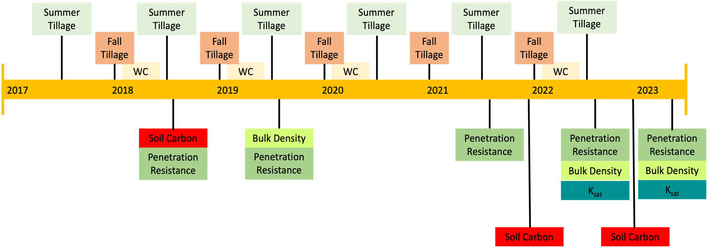
Figure 1: General timeline of tillage implementation, winter cover planting (WC), and parameter measurement timing.
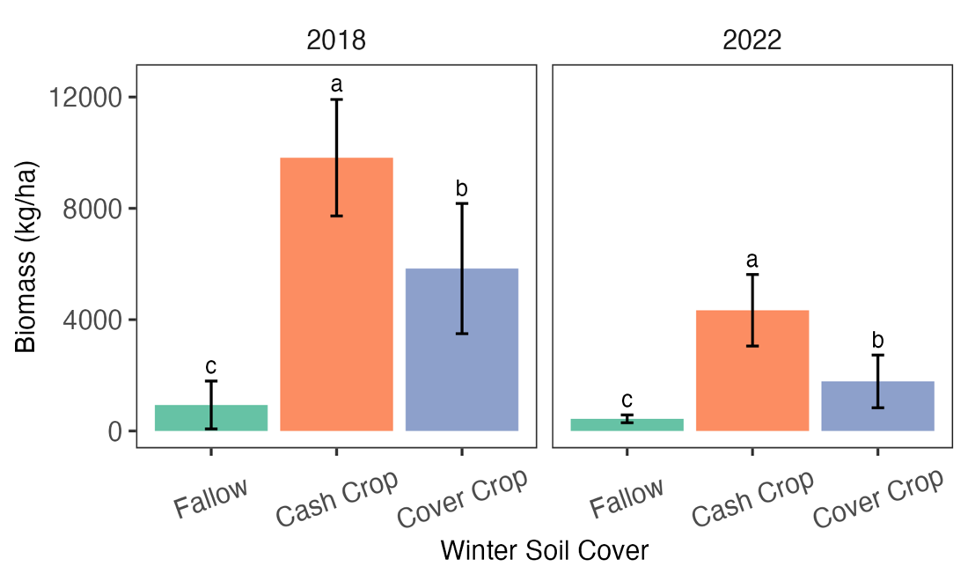
Figure 2: Winter cover biomass (kg ha⁻¹) measured in 2018 (left panel) and 2022 (right panel). Columns represent the mean of each winter cover treatment, error bars represent the standard deviation, and different letters represent significantly different means between treatments for a given year (p ≤ 0.05; n = 16).
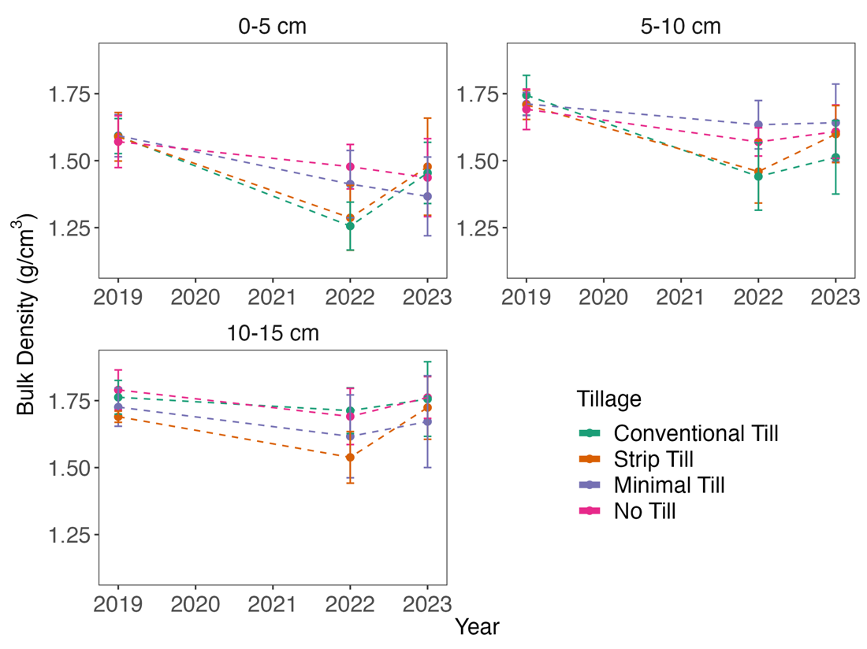
Figure 3: Bulk density of each tillage treatment over a 7-year period at 0-5 cm (top left), 5-10 cm (top right), and 10-15 cm (bottom left) depths. Colors represent different tillage treatments, error bars represent the standard deviation, and asterisks represent significantly different means between treatments in a particular year (p ≤ 0.05; n = 12).

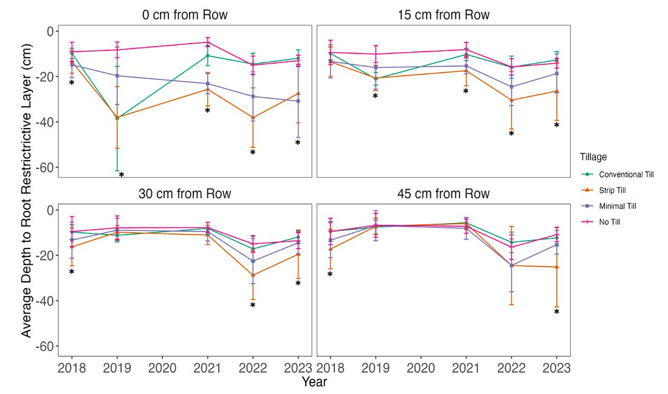
Figure 4: Depth to the uppermost root-restrictive layer (2,068 kPa) for the four tillage treatments, as measured in the row center (top left), 15 cm from row center (top right), 30 cm from row center (bottom left), and 45 cm from row center (bottom right). Colors represent different treatments, points represent means, error bars represent the standard deviation, and asterisks indicate significant difference between treatments (p ≤ 0.05; n = 12).

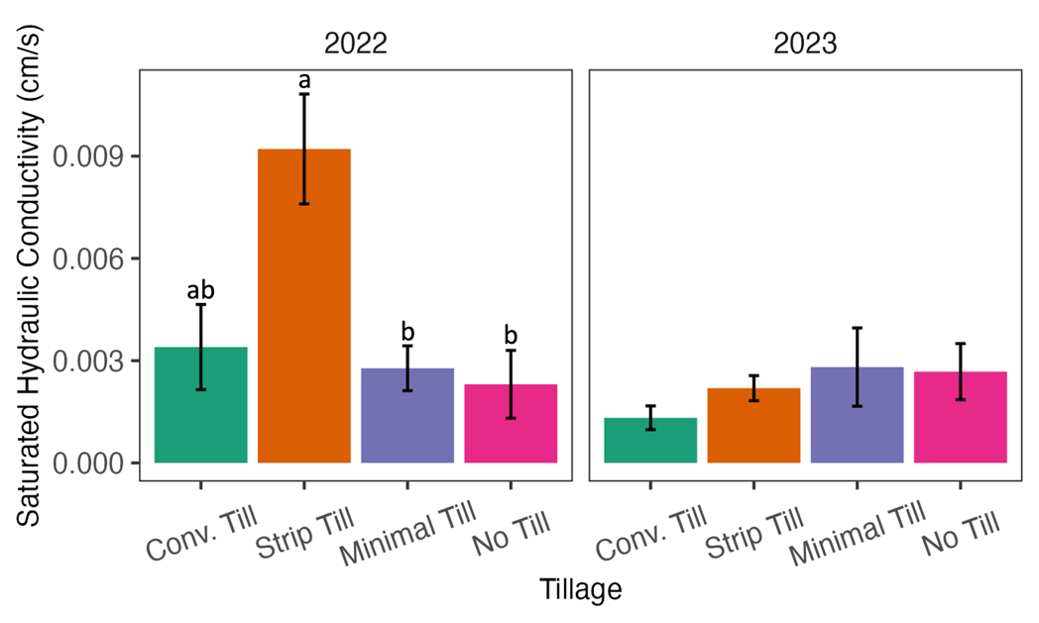
Figure 5: Field-saturated hydraulic conductivity (K_{sat}) measured in the different tillage treatments in 2022 (left panel) and 2023 (right panel). Columns represent the mean of each tillage treatment, error bars represent the standard error of the mean, and different letters represent significantly different means between treatments for a given year (p ≤ 0.05; n = 8).

a)
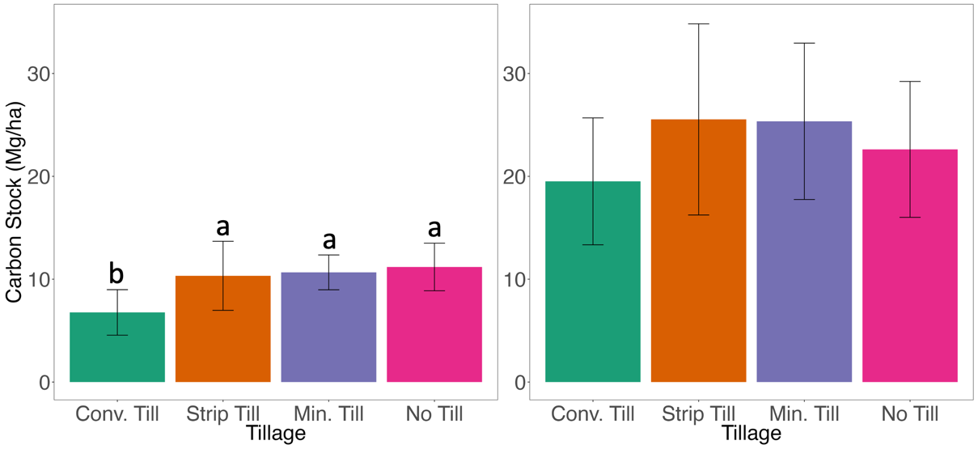
b)
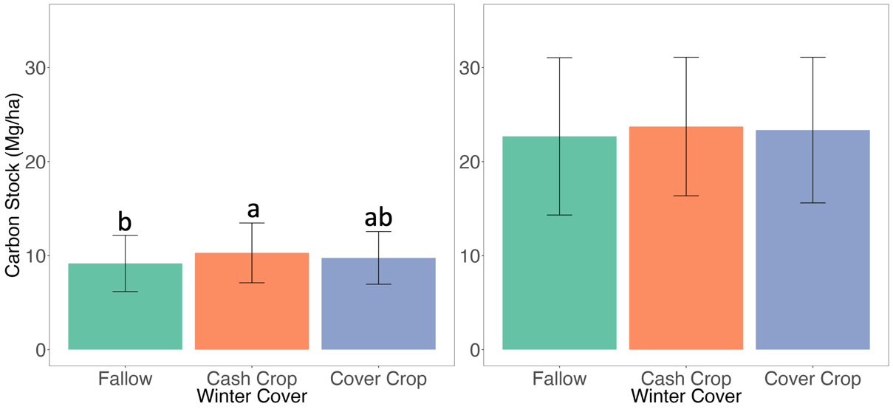
Figure 6: Carbon stock (Mg ha⁻¹) measured in 2022 for the different a) tillage and b) winter cover treatments for 0-5 cm (left), and 0-15 cm (right). Columns represent the mean of each treatment, error bars represent the standard deviation, and different letters represent significantly different means between treatments (p ≤ 0.05; n = 12 for the tillage treatments and n = 16 for the winter cover treatments).
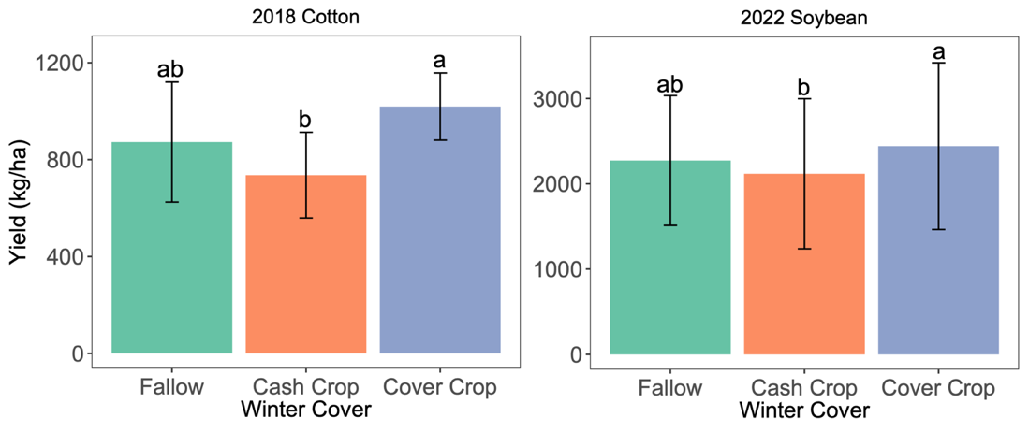
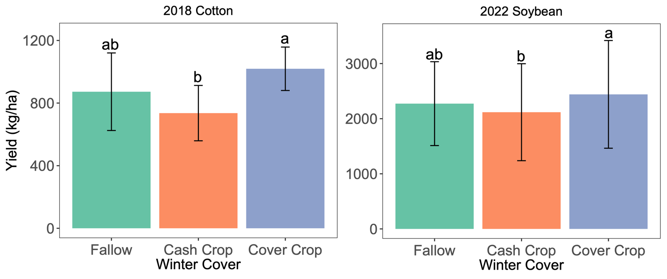
Figure 7: Soybean yield (kg ha⁻¹) measured in 2018 (left) and 2022 (right). Columns represent the mean of each winter cover treatment, error bars represent the standard deviation, and different letters represent significantly different means between treatments for a given year (p ≤ 0.05; n = 16).

Appendix A
Tables

Bulk Density (g cm⁻³)
Year |  | 2019 | 2022 | 2023
Depth | 0-5 cm
Tillage Treatment | CT | 1.59 ± 0.07 | 1.26 ± 0.09 bc | 1.45 ±0.17
Tillage Treatment | ST | 1.59 ± 0.09 | 1.29 ± 0.12 c | 1.47±0.18
Tillage Treatment | MT | 1.59 ± 0.08 | 1.41 ± 0.13 ab | 1.37±0.15
Tillage Treatment | NT | 1.57 ± 0.10 | 1.47 ± 0.08 a | 1.43±0.12
Tillage Treatment | F-value | - | 9.37 | -
Tillage Treatment | p-value | - | 0.004 | -
Depth | 5-10 cm
Tillage Treatment | CT | 1.74 ± 0.07 | 1.44 ± 0.13 | 1.51 ±0.17
Tillage Treatment | ST | 1.71 ± 0.05 | 1.45 ± 0.11 | 1.47±0.18
Tillage Treatment | MT | 1.71 ± 0.04 | 1.63 ± 0.09 | 1.37±0.15
Tillage Treatment | NT | 1.69 ± 0.07 | 1.57 ± 0.05 | 1.43±0.12
Tillage Treatment | F-value | - | - | -
Tillage Treatment | p-value | - | - | -
Depth | 10-30 cm
Tillage Treatment | CT | 1.76 ± 0.06 | 1.71 ± 0.09 a | 1.76 ± 0.10
Tillage Treatment | ST | 1.69 ± 0.02 | 1.45 ± 0.10 b | 1.72 ± 0.11
Tillage Treatment | MT | 1.72 ± 0.07 | 1.62 ± 0.15 ab | 1.67 ± 0.14
Tillage Treatment | NT | 1.79 ± 0.07 | 1.69 ± 0.10 a | 1.76 ± 0.09
Tillage Treatment | F-value | - | 5.33 | -
Tillage Treatment | p-value | - | 0.0219 | -
Table A.1: Mean Bulk Density Values by tillage treatment in 2019, 2022, 2023, at the 0-5 cm depth, 5-10 cm depth, 10-15 cm depth. Different letters represent significantly different means between treatments for a given year (p ≤ 0.05).

Year | Grain Yield (kg ha⁻¹) | Harvested Biomass  (kg ha⁻¹) | HI-Estimated Biomass (kg ha⁻¹) | R² | Slope
2018 | 1390 | 9819 | 1699 | 0.31 | 1.39
2022 | 2364 | 4338 | 2889 | 0.59 | 1.28
Table A.2: Mean Grain Yield, Harvested Biomass, Harvest Index (HI) -estimated Biomass, and the linear relationship statistics between the two metrics in 2018 and 2022 (R² and slope).

Year |  | 2018 | 2021 | 2022 | 4 yr. Change (%)
Depth | 0-5 cm
Tillage Treatment | CT | 10.0 ± 1.2 | 8.3 ± 1.0 b | 10.9 ± 1.8 b | 0.18 ± 0.08
Tillage Treatment | ST | 11.0 ± 1.5 | 11.3 ± 1.0 a | 16.1 ± 1.3 a | 0.67 ± 0.43
Tillage Treatment | MT | 11.4 ± 0.8 | 10.0 ± 1.5 ab | 15.2 ± 1.3 ab | 0.48 ± 0.31
Tillage Treatment | NT | 9.9 ± 1.1 | 9.7 ± 1.2 ab | 15.2 ± 0.8 ab | 0.68 ± 0.61
Tillage Treatment | F-value | - | 4.83 | 4.6 | -
Tillage Treatment | P-value | - | 0.028 | 0.032 | -
Depth | 5-10 cm
Tillage Treatment | CT | 5.8 ± 1.3 | 7.1 ± 0.9 | 10.2 ± 1.1 ab | 0.51 ±0.15
Tillage Treatment | ST | 9.2 ± 0.8 | 8.6 ± 1.1 | 12.1 ± 1.3 a | 0.47 ± 0.21
Tillage Treatment | MT | 7.6 ± 1.0 | 6.8 ± 1.9 | 10.3 ± 1.2 ab | 0.42 ± 0.20
Tillage Treatment | NT | 6.3 ± 0.9 | 6.8 ± 1.2 | 8.3 ± 1.3 b | 0.33 ± 0.20
Tillage Treatment | F-value | - | - | 5.43 | -
Tillage Treatment | P-value | - | - | 0.021 | -
Depth | 10-30 cm
Tillage Treatment | CT | 3.0 ± 0.7 | 4.2 ± 1.0 | 6.4 ± 1.1 | 0.40 ± 0.22
Tillage Treatment | ST | 3.6 ± 0.4 | 6.1 ± 0.9 | 8.3 ± 1.6 | 0.62 ± 0.28
Tillage Treatment | MT | 3.6 ± 0.4 | 5.8 ± 1.1 | 7.6 ± 1.6 | 0.55 ± 0.29
Tillage Treatment | NT | 3.1 ± 0.5 | 4.7 ± 1.1 | 5.8 ± 1.4 | 0.34 ± 0.25
Tillage Treatment | F-value | - | - | - | -
Tillage Treatment | P-value | - | - | - | -

Table A.3: The mean Total Organic Carbon (g kg⁻¹) values based on tillage for 2018, 2021, and 2022, and the difference between 2022 and 2018 (% change over 4 years) at the a) 0-5 cm, b) 5-10 cm, and c) 10-15 cm depths. Different letters represent significantly different means between treatments for a given year.

Figures

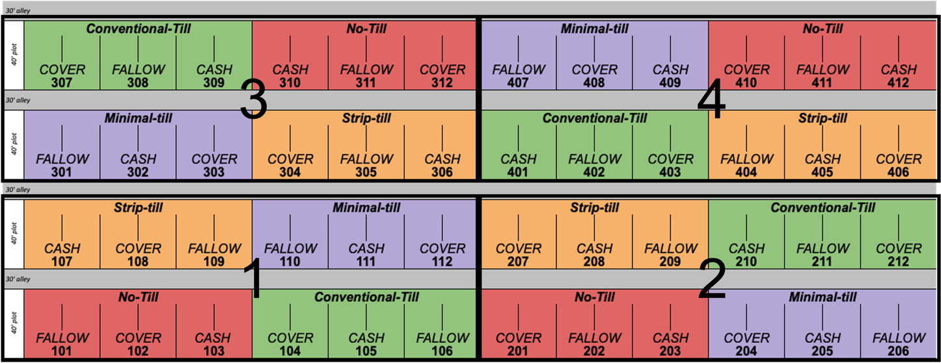
Figure A.1: Field layout of tillage and winter cover treatments.
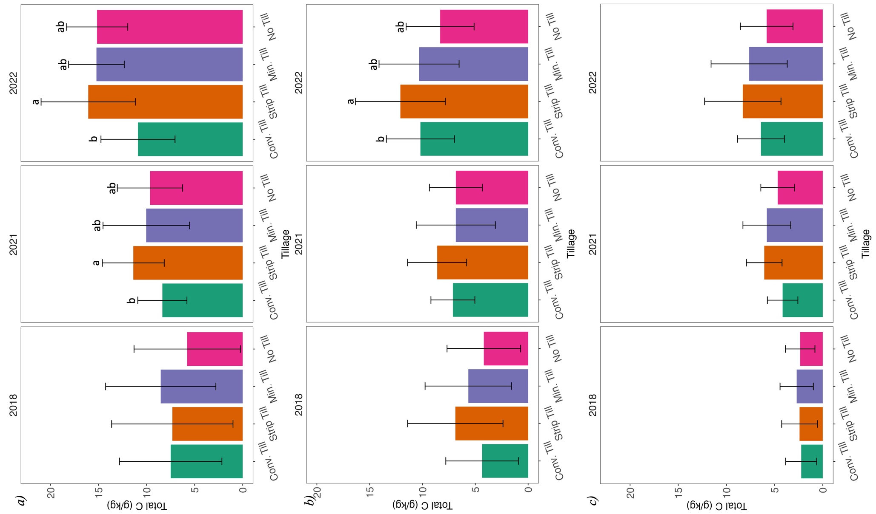
Figure A.2: Total Organic Carbon (g kg⁻¹) measured in the tillage treatments at the a) 0-5 cm depth, b) 5-10 cm depth, and c) 10-30 cm depth (n = 12). Columns represent the mean of each tillage treatment, error bars represent the standard deviation, and different letters represent significantly different means between treatments for a given year (p ≤ 0.05).

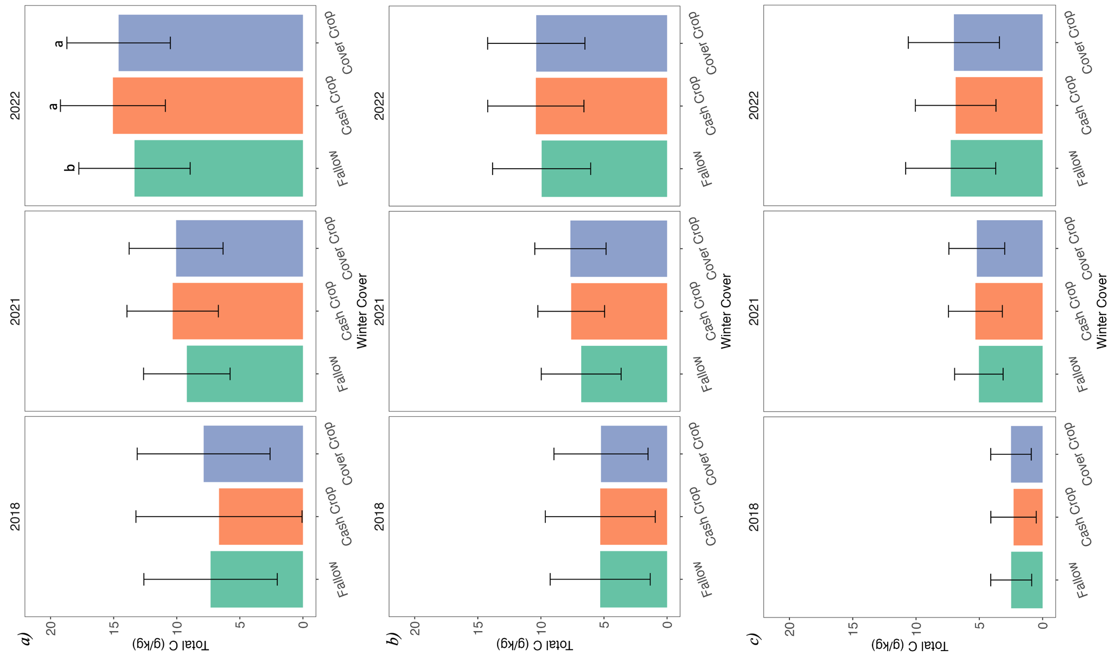
Figure A.3: Total organic carbon (g kg ⁻¹) based on winter cover treatments at the a) 0-5 cm depth, b) 5-10 cm depth, and c) 10-30 cm depth (n = 16). Columns represent the mean of each winter cover treatment, error bars represent the standard deviation, and different letters represent significantly different means between treatments for a given year (p ≤ 0.05).

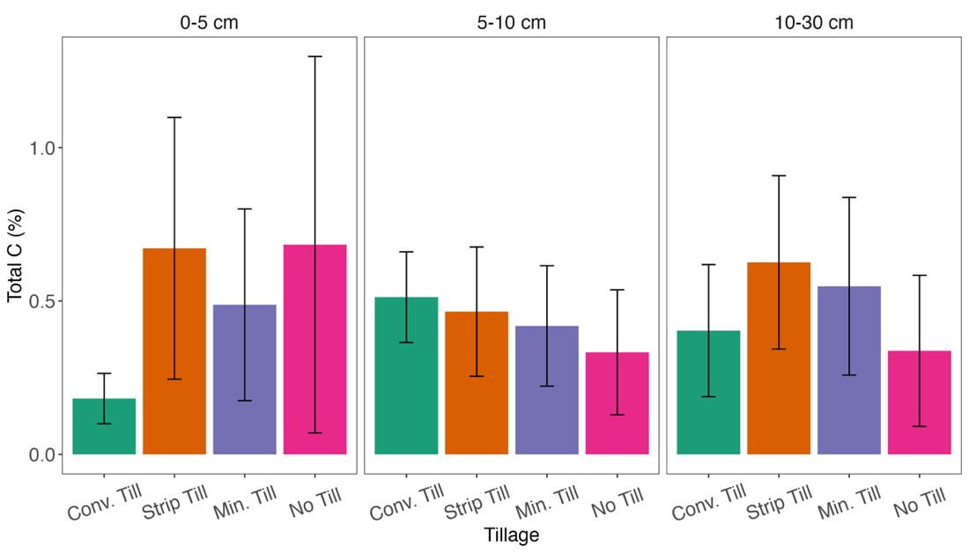
Figure A.4: Change in total organic carbon (%) based on tillage treatments at the 0-5 cm, 5-10 cm, and 10-30 cm depths (n = 12). Columns represent the mean of each winter cover treatment, error bars represent the standard deviation, and different letters represent significantly different means between treatments for a given year (p ≤ 0.05).

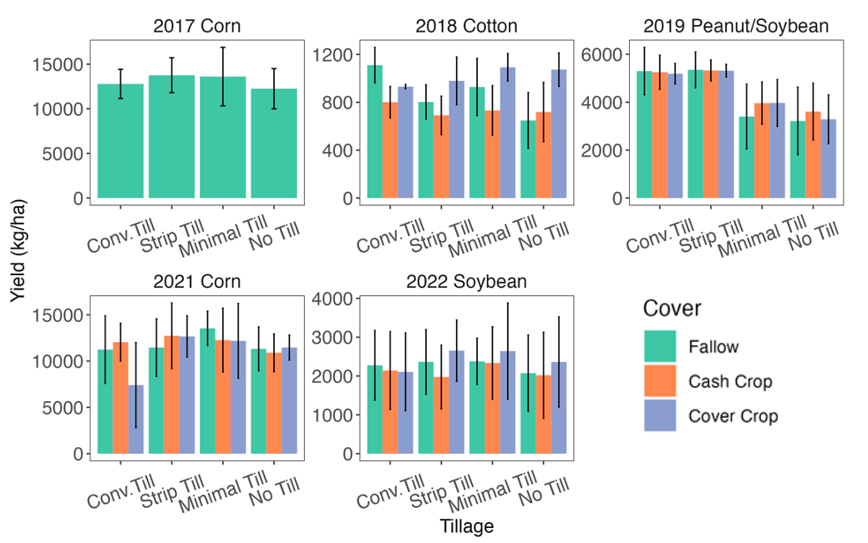
Figure A.5: Summer cash crop yield (kg ha⁻¹) from 2017-2022 (n = 4), excluding 2020 due to pandemic-related research restrictions. Columns represent means and error bars represent standard deviation.

