Rhythmatical: A Game to Combine Music and Mathematics for Mobile Devices

Heather Moorefield-Lang
Virginia Tech Newman Library, Virginia Tech, Blacksburg, VA, USA

Michael A. Evans
Department of Learning Sciences & Technologies, School of Education, Virginia Tech, Blacksburg, VA, USA

Rhythmatical was designed to be an educational application for the iPhone and iPod Touch that conveyed mathematical topics via musical, rhythmic, or movement interactive techniques. Created by a team of professors, a librarian, students, and members of game development industry this iPhone and iPod Touch application connects music and math for fourth to eighth grade students. This article describes the history of the application, the creation of the new deliverable, as well as gives insights into new ideas for the future.

KEYWORDS arts integration, iPod and iPhone applications, games, software, math, music

Hathor, or the “Lady to the Limit” (“limit” referring to the edges of the known universe), is the Egyptian goddess for joy, dance, and music. Hers was the inspiration for this project to merge the arts (music, rhythm, movement), creative technologies (mobile, wireless devices, web-based services), and education (mathematics). Our goal was to deliver a standalone educational application for the iPhone and iPod Touch that encourages learners in grades 4-8 to explore creatively the world in collaborative ways.
PROJECT HISTORY
Learning Without Boundaries (LWB), a project sponsored by the Virginia Department of Education, through the Governor’s Productivity Investment Fund, provided impetus for the current project, establishing the basis for research, development, and testing to guide students in the exploration of language arts and mathematics using the iPod Touch for this initiative. The research and policy goals of LWB was to understand the social, political, and technological ramifications of combining instructional multimedia and communication software with highly mobile devices. In a demonstration project for LWB, Evans and Gracanin, targeted fourth, sixth, and eight grade classrooms in rural, southwest Virginia focusing on language arts topics including context clues, synonyms, and antonyms. For mathematics, the project targeted division of decimals, the relative magnitude of two decimal numbers, and mean, median, mode for mathematics. These content areas were chosen because they had been identified by supervisors and teachers as high needs areas. For LWB, investigators began with a small set of standards-based “lesson plan instances” of difficult to teach standards in language arts and mathematics, for instance comparing the numerical value of fractions, to gain administrator buy-in and to demonstrate the potential of proposed intervention. The learning scenarios developed by instructional designers incorporated technologies and learning strategies popularized by video games, personal broadcasting platforms, and Web 2.0 technologies (blogs, photo sharing, social networks). A goal of LWB was to assist elementary and secondary teachers and students to develop appropriate strategies and sufficient practice to improve fundamental knowledge in targeted mathematical and language arts areas to increase problem-solving and collaboration skills using emerging technologies for communication, computation, and exchange. The team, made up of a learning scientist, computer scientist, and instructional designers, provided teachers the support and tools through focus-group meetings and professional development workshops to continue developing lesson plans and requirements for custom-built software applications that served their needs. From this initial work, the Hathor project was born.
The Hathor project was positioned to promote an ideal that technology-enhanced active learning in combination with collaborative exchanges might have profound impact on primary and secondary classroom teaching and learning. From evidence collected on the initial Learning Without Boundaries Project and, now Hathor, it is clear that innovate instructional interventions must have support from content experts, teachers, and instructional technology resource teachers, and technical support staff. Consequently, a professional development model, developed in previous efforts, has been built into the project to ensure teachers and students successfully leverage devices and applications.
MERGING MUSIC, CREATIVE TECHNOLOGIES, AND EDUCATION
Hathor is focused on finding creative ways to combine music, technology, and mathematics. The team consisted of members from three departments from Virginia Tech and an industry partner. Dr. Michael A. Evans, from the Department of Learning Sciences and Technologies provided expertise in interface design and multimedia development for mobile devices. Students in his multimedia design course contributed to teaching and learning materials and any web-based products. Dr. Heather Moorefield-Lang, Education and Applied Social Sciences Librarian served to assist with the creative, artistic, and musical aspects of the project. Dr. Betti Kreye, Clinical Assistant Professor, Department of Teaching and Learning, served assist with the mathematics education aspects, ensuring the integrity of content and applicability in the classroom. Dr. C. Vernon Burnsed, Professor, Department of Music, served to provide direction on the musical features and content and Mr. Thomas K. Vaidhyan, CEO of Aten, Inc provided software development services for the educational application. The current deliverable, Rhythmatical, was designed to be an educational application for the iPhone and iPod Touch that conveyed mathematical topics via musical, rhythmic, or movement interactive techniques that the devices provide. The iPhone and iPod Touch was ideal for this application because it has the ability to be tapped, shook, and was all in all very interactive for the user. Students would be able to create, tap out rhythms and beats, as well as learn about math through these engaging devices.
Rhythmatical took one year to design, develop, test, and release to the iTunes App Store. Rhythmatical is available for free to librarians, pre-service educators, teachers, students, and parents to use on the iPhone and iPod Touch. The design and creation process started with a decision between three different music and math game ideas. Two activities were not chosen but are still being considered for future development. After the choice was made to develop a game that focused on the concept of the greatest common divisor, designs had to be created in a still image format and a technology design company had to be chosen. Once the software development company was decided meetings began and many conversations were held about how the game would proceed, how the math and music would be integrated, and what the design and overall technology would look like. Once the team had a working prototype then alpha (internal) testing of the game began. If timing was off of a drum then it was corrected, the game originally did not have drum sounds, so they were added in, music and transitional beats were added as students progressed through rounds to make the activities more challenging and engaging for users. For the team creating Rhythmatical, this was an informative process as educators and librarians rarely experience this process. Testing game-based software for productive learning in classroom settings was a new and interesting experience.

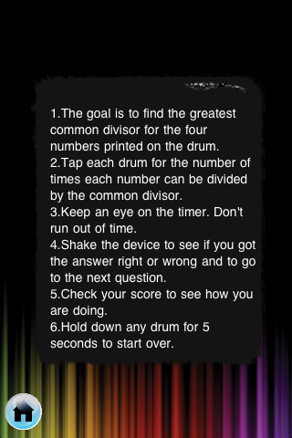
Figure 1 Help Screen for Rhythmatical.
The final product Rhythmatical, is an iPhone and iPod Touch game-based, educational application developed for to students to work with mathematics and music in creative ways. When the user first opens the game they can choose a new game, a help option, or if they have played before they can see who has had the high score. The help option was also designed so that teachers in math, music, or technology and librarians who were teaching students how to use Rhythmatical would have a location to go, so that demonstrations could be shown (Figure 1). If students are new to using the the iPhone and iPod Touch the Help feature can give assistance to the students and the teacher. The ideal situation would be a room with a classroom document camera where the teacher could show the students all at once how the game could be played. The educator would be able to take the students step by step through the rules and idea of Rhythmatical. If students each had their own the iPhone and iPod Touch then they would be able to follow along. Once students are ready to work on their own they press the button for a new game.

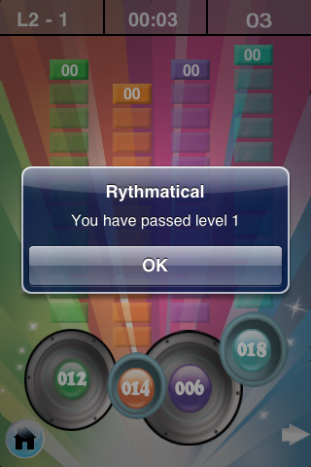
Figure 2 Game play screen in Rhythmatical
When a new game opens students have four drums given to them on the screen (Figure 2). On each drum is a number. These four numbers have a common denominator. The student figures out the common devisor between the four numbers and then strikes the drums the number of times the common denominator goes into each drum. For example in this figure, on the right side, the common denominator is seven. Seven would divide into 28 four times and that is how many times the student would tap the drum on the screen. Students have multiple chances per round. Players have the opportunity to play many rounds in the game. Rhythmatical takes advantage of the iPhone and iPod Touch screen capabilities, sounds, and shaking movements toprogress to the next round.
To enhance Rhythmatical the design team also worked with a team of local elementary and middle school teachers from southwest Virginia to create lesson plan ideas of how the game could be used in classrooms. An example of one lesson plan idea was to have early middle school students interact with Rhythmatical, play the application, and from that game, create ideas for their own iPhone and iPod Touch application. Then students from high school technology classes would then write computer programs for the new game ideas. A website was created for teachers and librarians to use for integration and instruction. The first author, a former middle school librarian, asked teachers what they would need to feel comfortable using the iPhone and iPod Touches in their classrooms. Common responses were training, a person to contact at school for questions, and professional development. The website for Rhythmatical has tools for learning about the iPhone and iPod Touch, how to use it, instructions on how to download applications, how the iPhone and iPod Touch work, and much more. Included are also lesson plans, future ideas, strategies, resources and scope (https://sites.google.com/site/rhythmaticalthegame/)
There are more ideas and plans for the website and for iPhone and iPod Touch applications like Rhythmatical. The opportunities for technology and arts integration are expansive. Rhythmatical is not only for those teachers and librarians who are already in the classroom but for pre-service educators as well. Music education students can use this application to teach their students about rhythm and beat. Pre-service math educators can instruct their students on most common divisor through technology and music. There are many possibilities for this application that merges music, technology and education for the classroom. The authors and designers would like to further investigate the use of grading and database use with the Rhythmatical application. Along with expansion of more games, activities, and iPhone and iPod Touch applications that could be based on the website through library and classroom computers. We hope to explore more opportunities with music and iPhone and iPod applications.

NOTES

Learning Without Boundaries Project: http://lwbva.org/

BIBLIOGRAPHY

Evans, Michael, and Gracanin, D. “Learning Without Boundaries: Developing mobile learning scenarios for elementary and middle school language arts & mathematics.” Journal of Educational Technology 5, no.4 (2009):38-44.

