Event Toolkit - Fair Use Week 2016 at Virginia Tech, University Libraries
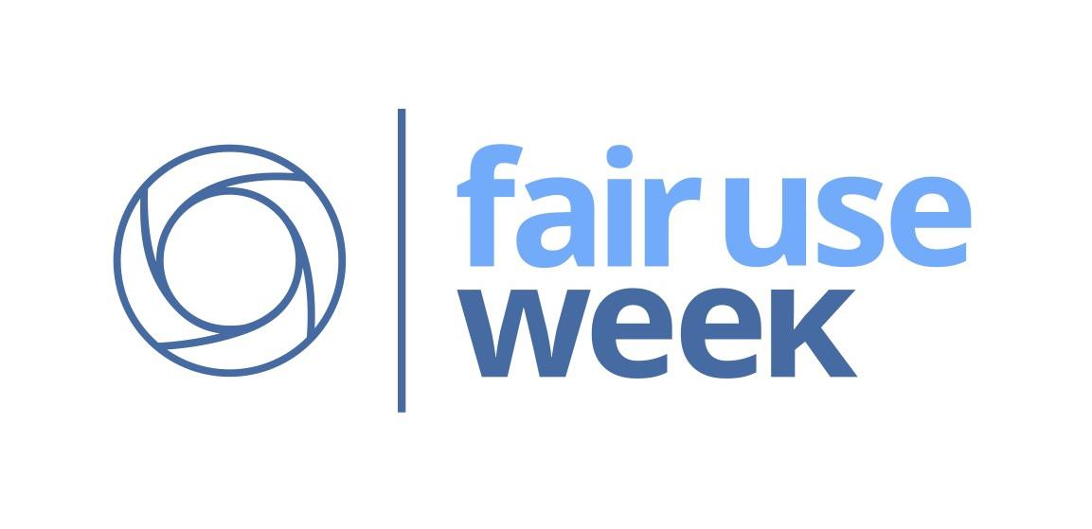
In Fall 2015, the Open Knowledge Committee of Virginia Tech’s University Libraries decided to participate in Fair Use Week 2016. This was our first time participating. We put a call out and gathered a planning group. Our week-long event included an interactive exhibit, an exhibit reception, three workshops, a website, and a blog post. Our goals for this event were to: (a) raise awareness of the nature and application of the Fair Use provision in U.S. Copyright law, and to (b) provide interactive components to engage participants in thinking about copyrights and their choices when: 1. considering the use of copyrighted materials for research, education, creative, commercial, or other purposes, and 2. creating and sharing copyrightable works in various contexts. We took a broad view of our target audience - aiming to provide in-person and online opportunities for interactive engagement by VT students, employees, instructors, researchers, and the general public. We reused resources from others, and want to share our content for further reuse.

Event Planning Team
Virginia Pannabecker, Health, Life Sciences, & Scholarly Communication Librarian
Anita Walz, Open Education, Copyright & Scholarly Communications Librarian
Robert Sebek, Discovery Services Specialist, Collections and Technical Services
Scott Fralin, Exhibit Specialist and Event Operations Coordinator
Keith Gilbertson, Technology Development Librarian
With support from: Research & Informatics, Scholarly Communications Department; Sita Williams, Special Events Coordinator; University Libraries Creative Services: Liz McVoy, Digital Media Specialist, Kimberly Bassler, Communications Coordinator; Elisabeth Givens, Director, Digital Strategy and Outreach; and Amanda French, Director, Digital Research Services

Note: Materials created for this event are openly licensed and shared below for reuse.

Event Toolkit - Description and Materials

Exhibit Files and installation guide are available via the VTechWorks Institutional Repository,
http://hdl.handle.net/10919/70924, including:
- This description document
- Exhibit content, design files, and installation information
  - Planning, Design, Installation, Photos, Budget, Timeline, and more - pages 3-7 of this document
  - Design files (PDF and Adobe InDesign formats):
  - Handout
- Event flyer - PDF and customizable PDF Template

Workshop materials available via VTechWorks institutional repository and Google Drive folders:
- Workshop 1: “Is It a Fair Use? A Hands-On Discussion”
  - VTechWorks archived version: http://hdl.handle.net/10919/70970
  - Google Drive Folder of materials: http://tinyurl.com/IsItAFairUse-Wrkshp-2016
- Workshop 2: “Behind the Scenes of the Fair Use Week Exhibit: How We Made Our Copyright Decisions”
  - VTechWorks archived version: http://hdl.handle.net/10919/70971
  - Google Drive Folder of materials: http://tinyurl.com/BehindScenesFairUseWeek2016
- Workshop 3: “The New International Movement to Standardize Rights Statements -- and How We're Participating in it at Virginia Tech” provided by Amanda French, Director, Digital Research Services, University Libraries, Virginia Tech

NOTE: The Fair Use Week website includes resources to use in events. Fair Use / Fair Dealing Week is an event held by many organizations, primarily in U.S. and Canada, since 2014.
- Fair Use / Fair Dealing Week website: http://fairuseweek.org/
- Resources: http://fairuseweek.org/resources/ - we used the following:
  - Infographic: http://fairuseweek.org/wp-content/uploads/2016/02/ARL-FUW-Infographic-r5.pdf
  - Logo Branding Guide: http://fairuseweek.org/wp-content/uploads/2015/02/FUW-2015-Style-Guide.pdf
  - Logo Image Files: https://drive.google.com/a/vt.edu/folderview?id=0B0uScvh-XFA_fkpReGdfN2lGYVE1ZGRJd2FPQWpSTTdONVBqWGJNekREUHFRUm9ud3BBT28&usp=sharing#

VT University Libraries, Fair Use Week 2016
Exhibit Design and Implementation

Components of our week-long event
Event Planning and Exhibit Implementation
Event and Exhibit Planning
The Physical Structure
The Assembly
The Logistics and Equipment
Designing the display
The Book Display
Exhibit Display Book List
Exhibit Opening Reception
Website Development
Timeline
Budget and Materials
Impact

Components of our week-long event
- An interactive exhibit
- Programming
  - Exhibit Reception
  - Workshop 1: “Is It a Fair Use? A Hands-On Discussion” Repository / Google Drive
  - Workshop 2: “Behind the Scenes of the Fair Use Week Exhibit: How We Made Our Copyright Decisions” Repository / Google Drive
  - Workshop 3: “The New International Movement to Standardize Rights Statements -- and How We're Participating in it at Virginia Tech”
- A page on the VT University Libraries website
- An introductory blog post

Event Planning and Exhibit Implementation

Pages 3-7 below describe Event Planning, Exhibit Design and Installation; as well as Website Design, Overall Timeline, and Budget

Event and Exhibit Planning

Meeting 1
- Event
  - Draft titles, dates, times for overall event, exhibit, and programming; decide who would plan and implement events
- Exhibit
  - Define project
  - Figure out intent of project
  - Create basic outline of content for the project

Meeting 2 - Exhibit focused
- Start thinking about layout of content, shape it will take
- Do mockups / sketches / prototypes of possible ways to share content
- Consider ways to draw in an audience
  - We chose a local copyright case that people may relate to or recall;
  - The copyright case was visual in nature, which added non-text interest;
  - Included artifacts (a pint glass featuring the image in question) related to the case to add interest and depth, literally;
  - We developed a visual way to present content from several openly licensed resources. One of which was the 5-step Copyright framework which is often used in Copyright instruction and consultation.
  - We planned to include an iPad to feature ALA’s Digital Copyright Slider as part of the first step in the 5-step framework, but decided to omit it because the iPad could not access the interactive Adobe Flash-based site.
  - Several clear plastic holders on two sides of the exhibit provided 8.5x11 handouts with more detailed information about the events of the week and the tools and processes presented on the panel.
  - We ultimately chose to include two interactive elements
    - See photos and interactive element descriptions on the next page

    - One was a flip up section where visitors read a brief case about copyright then lifted up the case to see the actual decision below.
    - The second laid out the details of the local copyright case, which was a focal point of the exhibit, and asked visitors to decide whether they thought it was Fair or Infringing.

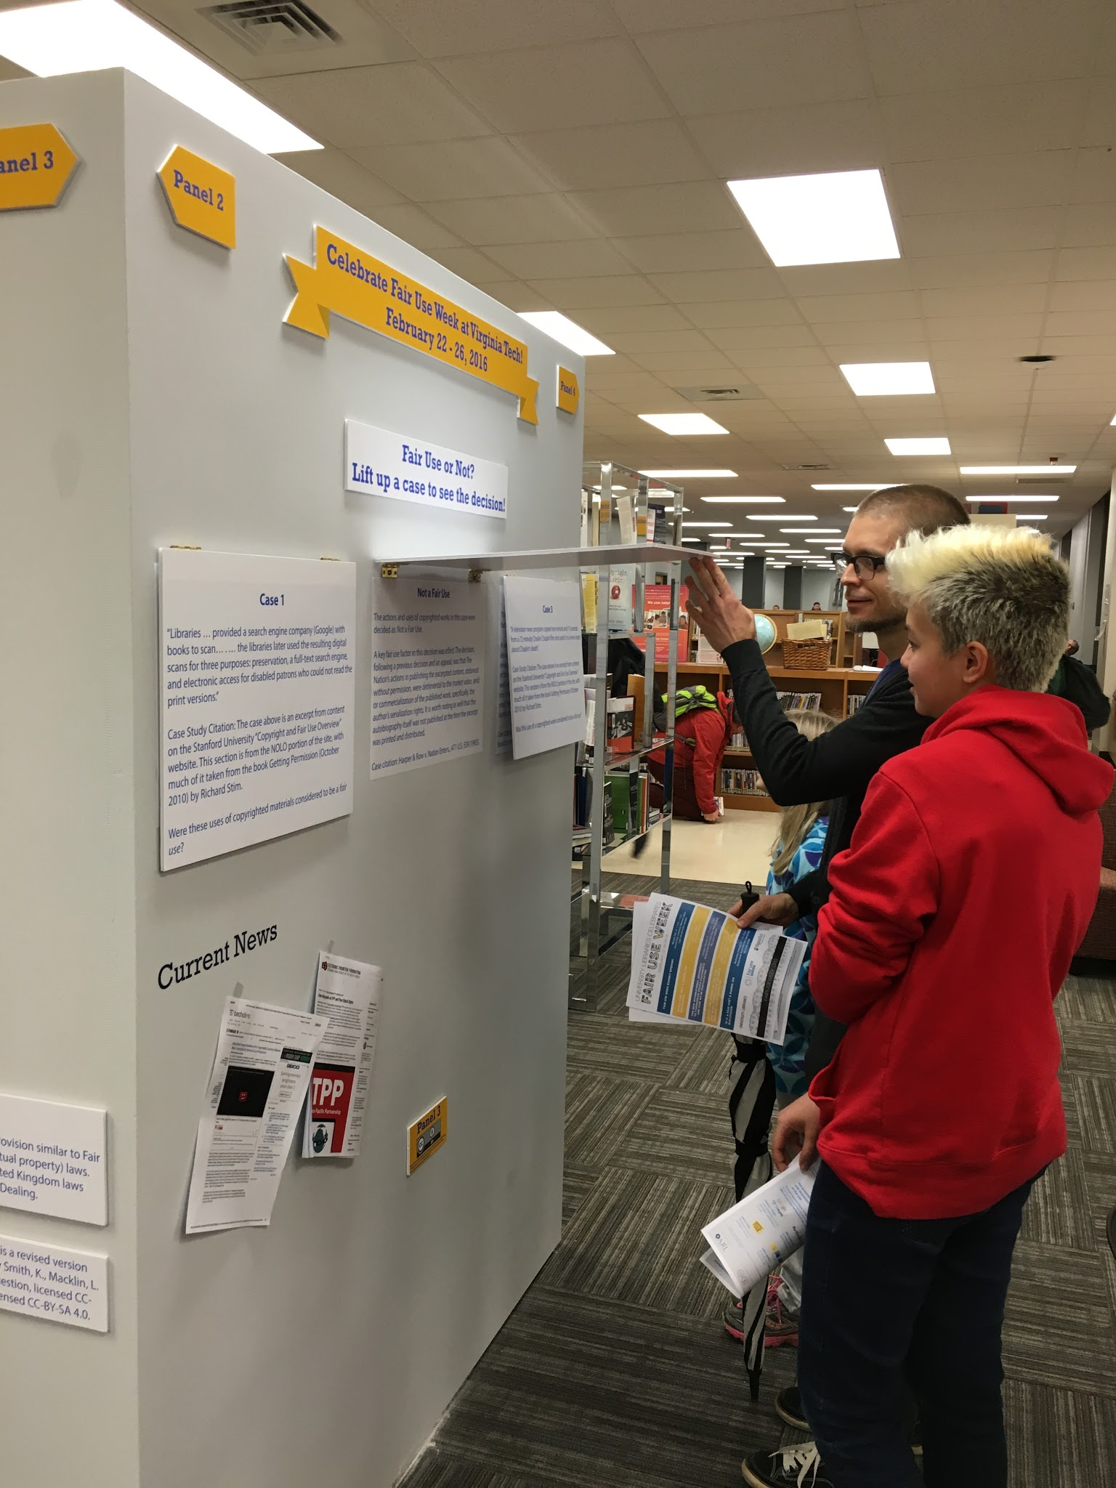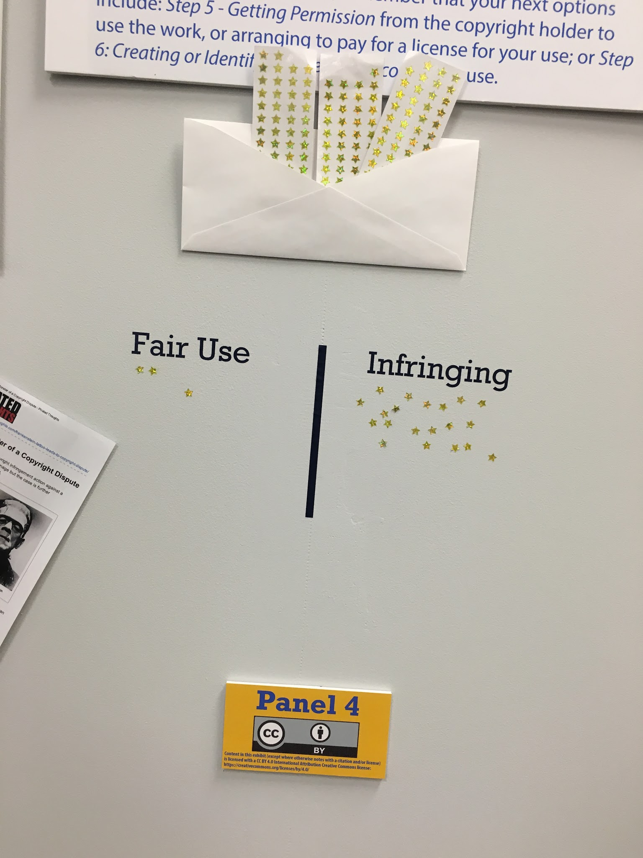

Meeting 3 - Exhibit focused
- Make decision on structure to be used for displaying the content
- Refine the content
- Edit content down to manageable size
- Keep content to 100 - 200 words per panel, not including figures, photos, and citations.

Once content was ready, we laid out how the panels would look in InDesign and got all the content ready. We then printed it on a large format printer and mounted it to foam board. See below for details.

The Physical Structure

The physical structure of the exhibit was made from rectangular panels that were attached to each other to form a square. It was then painted and finished.

Each side of the 4-sided cube was: 80 inches tall X 60 inches wide.

It was placed in a highly visible area of the library chosen for the amount of traffic that passes by each day. Over 2,000 people passed by the exhibit each day during the two weeks while it was up.

This space is also a shared student space so students using the library as normal were very close by. It became a part of their study environment, not simply a display off in the corner. We did this intentionally so it would be hard for students in the library to miss. But, we also made sure that it was not in their way as they tried to study. It was in their line of sight, but not in their way.

The Assembly

The assembly of the structure from start to finish took about 20 hours. This includes time spent assembling the structure, painting it, printing the content, mounting the content to foam board, and attaching the mounted content to the structure.

The Logistics and Equipment

- Panels were made from low cost doors from Lowes that were attached to each other for stability
- Drywall tape and spackling was used to cover the cracks where the doors met to make a smooth finish.
- The exhibit was painted to give a uniform look to each side of the cube.
- Mounted foam board to panels with 3M mounting tape
- All other materials (pint glass, hinges) were attached directly to the panels using screws

Designing the display

We knew we would use the two-page ARL infographic as a central part of the display, so we used several design elements from it:
- Recreated the yellow banner graphic for the heading
- Colors were selected from the infographic
- Images for the local copyright dispute story were placed inside circles to duplicate multiple infographic elements
- Dotted lines were used throughout the display
- The scale graphic was used on panel 4

The Book Display

While an increasing amount of the library’s holdings are electronic, the library owns a large number of physical books which have direct relevance to copyright and fair use. We searched the library catalog, created, and retrieved over 50 books to exhibit alongside the exhibit. Books in the display were marked in the library catalog as being on “exhibit” and could be checked out like any other book in the library. We also purchased one additional book on our wish list specifically for this exhibit.

Exhibit Display Book List
http://www.lib.vt.edu/copyright/fair-use-week/bibliography.html

Exhibit Opening Reception
For this event, we kept things simple: we planned the time and location in advance to include on the event flyer, provided light refreshments (water, soda, cheese, crackers, cookies, dried fruit), and the exhibit team was on hand to answer questions for those who attended. About 30-40 people attended.

Website Development
Fair Use Week at VT Libraries Website: http://www.lib.vt.edu/copyright/fair-use-week/index.html

We already had a recently updated copyright section on the library’s website which was the logical place to include Fair Use Week Content. Some content from the display was copied and formatted for the web. We built a bibliography using most of the print books we included in the physical display along with several ebooks in our collection.(Print books without a book cover from Syndetics were left out of the online bibliography.) Finally, the design files used for the exhibit panels were added to the website for others to download and reuse under a Creative Commons license.

Timeline
Preparation
January 6 - February 22, 2016
Event
February 22-26, 2016

Budget and Materials
Events
$90.00 - Food, Drinks, plates, cups, utensils, etc. for 2 events
Exhibit
$240 - Doors from Lowes (used for panels) (8 at $30 each)
$35 - Paint
$50 - Foamboard
$50 - Other supplies like glue, tape, misc hardware
$30 - Plastic flyer holders (3 at $10 each)
$12 - Macado’s pint glass - exhibit artifact
________________________

Total: $507.00

Impact
- Exhibit interactions of substantial length: Based on observations and stickers placed on the exhibit panel 4, we estimate 60+ direct substantial interactions with the exhibit (reading panels, engaging in activities, viewing or checking out related books)
  - Including 30+ during the exhibit opening event
- Exhibit views: Estimated at ~2,000+ / day; total estimated views = ~28,000 during installation
- Website views: [not gathered yet - this line may be updated at a later time]
- Workshop attendance (three workshops): 38
- Total views and interactions: estimated at 28,098

