SIMobile:

Addiction Support Through the Mobile Web

Final Report

Amy Vogrig
Emily Croeber
Tyler Collins

CS 4624
April 28, 2016
Virginia Tech, Blacksburg, VA 24061

Table of Contents
Table of Figures |  |  |  | 3
Section 1: Executive Summary |  |  |  | 5
Section 2: User Manual |  |  |  | 6
 | 2.1: Application Information |  |  | 6
 |  |  | 2.1.1: Overview | 6
 |  |  | 2.1.2: Objectives | 6
 |  |  | 2.1.3: Business Process | 6
 |  |  | 2.1.4: User Roles and Responsibilities | 7
 |  |  | 2.1.5: Interactions with Other Systems | 8
 |  |  | 2.1.6: Replacement of Legacy Systems | 8
 |  |  | 2.1.7: Production Rollout Considerations | 8
 |  |  | 2.1.8: Terminology | 8
 | 2.2: Functional Requirements |  |  | 9
 |  |  | 2.2.1: Statement of Functionality | 9
Section 3: Developer’s Manual |  |  |  | 10
 | 3.1: Design |  |  | 10
 |  |  | 3.1.1: Two Potential Design Approaches | 10
 |  |  | 3.1.2: Desktop to Mobile User Interface Translations | 11
 |  |  | 3.1.3: Restrictions, Limitations, and Constraints | 12
 |  |  | 3.1.4: Testing and Testing Issues | 12
 | 3.2: Implementation |  |  | 14
 |  |  | 3.2.1: Programming Languages To Be Used | 14
 |  |  | 3.2.2: Tool and Libraries Used | 15
 |  |  | 3.2.3: Phases | 15
 |  |  | 3.2.4: Timeline | 15
 |  |  | 3.2.5: Development Roles and Responsibilities | 16
Section 4: Lessons Learned |  |  |  | 17
 | 4.1: Prototype |  |  | 17
 |  |  | 4.1.1: Approach | 17
 |  |  | 4.1.2: Failures, Successes, and Known Issues | 19
 | 4.2: Refinement as of 3/31/2016 |  |  | 22
 |  |  | 4.2.1: Modification to Implemented Navigation | 22
 |  |  | 4.2.2.: Modification to Site Content | 23
 | 4.3: Testing the Prototype |  |  | 24
 |  |  | 4.3.1: Restatement of Goals | 24
 |  |  | 4.3.2: Initial Approaches | 25
 |  |  | 4.3.2: Selendroid | 26
 | 4.4: Refinement as of 4/19/2016 |  |  | 30
 |  |  | 4.4.1: Updates | 30
 |  |  | 4.4.2: Next Modifications | 33
 | 4.5: Refinement as of 4/27/2016 |  |  | 33
 |  |  | 4.5.1: Updates | 33
 |  |  | 4.5.2: Final Known Issues | 36
 |  |  | 4.5.3 Future Plans | 36
Acknowledgements |  |  |  | 37
References |  |  |  | 38

Table of Figures
Figure # | Page # | Description
Figure 1 | 7 | Screenshot of the current desktop website
Figure 2 | 11 | Wireframe of the layout that corresponds to the mobile version of the website
Figure 3 | 13 | An example of a test class to be used by the Galen Framework
Figure 4 | 14 | The beginning of the nav.tpl file that aids in structuring the HTML document.
Figure 5 | 17 | Screenshot of Mobile Login Page
Figure 6 | 18 | Display of Push-Drawer Navigation
Figure 7 | 19 | Reduced Navigation Content
Figure 8 | 21 | Rearrangement and Additions to default.php
Figure 9 | 22 | Navigation Content Hidden by Site Content
Figure 10 | 24 | Red Boxes Indicate Parts of the Refinement Implementations
Figure 11 | 26 | @BeforeClass in Java
Figure 12 | 26 | Android Studio output of Selendroid being started
Figure 13 | 27 | Available methods of a WebElement (org.openqa.selenium.WebElement)
Figure 14 | 28 | A retrieval of a HTML element in Selendroid
Figure 15 | 28 | Logging into the website and testing displayed navigation
Figure 16 | 29 | The results of running a loading test on both site versions
Figure 17 | 30 | Formatted Login Page
Figure 18 | 31 | Navigation shows all of the app
Figure 19 | 31 | Some modifications have been made to enhance readability
Figure 20 | 33 | Link color has been changed to be black with an underline; Visited links are slate gray with an underline
Figure 21 | 33 | Layout of the Photos page has been updated
Figure 22 | 34 | Users have the option of uploading photos; Font size has been increased on this page
Figure 23 | 34 | Link color changes can be seen in the navigation menu
Figure 24 | 35 | Attend Video page is incompatible with the mobile version
Figure 25 | 36 | Recent Stories page does not allow scrolling

Section 1: Executive Summary
The Friendica project is a new and emerging alternative to social media, which puts the privacy of its users front and center. Friendica refers to itself as “a world-wide consortium of software developers creating decentralised social platforms and technology for the coming post-Facebook world” [1].

Social media in the modern world has very little regard for the privacy of its users. Most people join social networking sites in order to be closer to family and friends, but this also makes it easier for unwanted strangers to see you photos and personal information. Many of these sites even sell the information of their users to whomever will give them the most profit. Friendica aims to provide social networking with the user’s best interests in mind.

The Friendica project is broken up into three separate projects; Friendica, Hubzilla, and The Friendica Directory. The Friendica project allows for the connection of networks in a way that allows the user’s information to remain private. Hubzilla is “a powerful platform for creating interconnected websites featuring a decentralized identity, communications, and permissions framework built using common webserver technology” [2]. The Friendica Directory is a system used for searching for the various members of Friendica.

Social Interactome (SI) is a research project through the Addiction Recovery Research Center (AARC) at the Virginia Tech/Carilion Research Institute. This center and institution is located in Roanoke, Virginia.

Those recovering from addictions are constantly faced with temptations, and it can be difficult for them to find the support that they need at various times throughout the day. Current programs, such as Alcoholics Anonymous, can only provide this struggling community with resources and support at determined times with limited communication techniques. The purpose of SI is to provide support at all hours.

The idea is to have an anonymous, online social networking support system that can be accessed by participants whenever they deem necessary. Currently, the system has a user-friendly desktop version that is running a modified version of the Friendica API. It has a minimalistic design that provides the appropriate functionality.

Currently,the SI project has several 16-week studies that host 256 participants. During each of these studies, several styles of social networking techniques are being tested.

Section 2: User Manual

2.2: Application Information

2.1.1: Overview

Our section of the Social Interactome project is known as SIMobile. This project is being performed for our client, John Crawford, Research Computer Programmer for the Addiction Recovery Research Center at Virginia Tech’s Carilion Research Institute. For our part in the Social Interactome project, we are addressing the problem of recreating the project in a mobile browser.

People are very busy in today’s society, so convenience is key in most people’s lives. The average person is much more likely to complete a task if it can be quickly done from a mobile device, as opposed to being constrained to a laptop or desktop computer.

When viewed on a mobile phone, the Social Interactome site is presently very difficult to read and work with. The simply designed site works well for a laptop or desktop experience, but it has not been designed for a mobile browser. The goal of the SIMobile project is to fix the Social Interactome site so that it appears on mobile phone browsers in a way that is easier and more appealing.

2.1.2: Objectives

The goal is to provide a mobile-friendly solution that the participants can access at any time. This will make it easier for users to engage in this resource without regard to the device that it is being accessed from. The woulld is allow mobile users to participate, especially those who do not always have access to desktops.

Within the scope of the overall Social Interactome project objectives, the Addiction Recovery Research Center (AARC) anticipates that this will increase active user participation.

2.1.3: Business Process

At the current time, there is an existing business process. The user can access the Social Interactome (SI) system via a desktop website (Figure 1). From a mobile browser, the user can access the website, but the system is not built for mobile devices. Basically, this version is the desktop version being displayed in a zoomed-out view. The desktop version was created with complete disregard of responsive web design for the size of mobile screens.

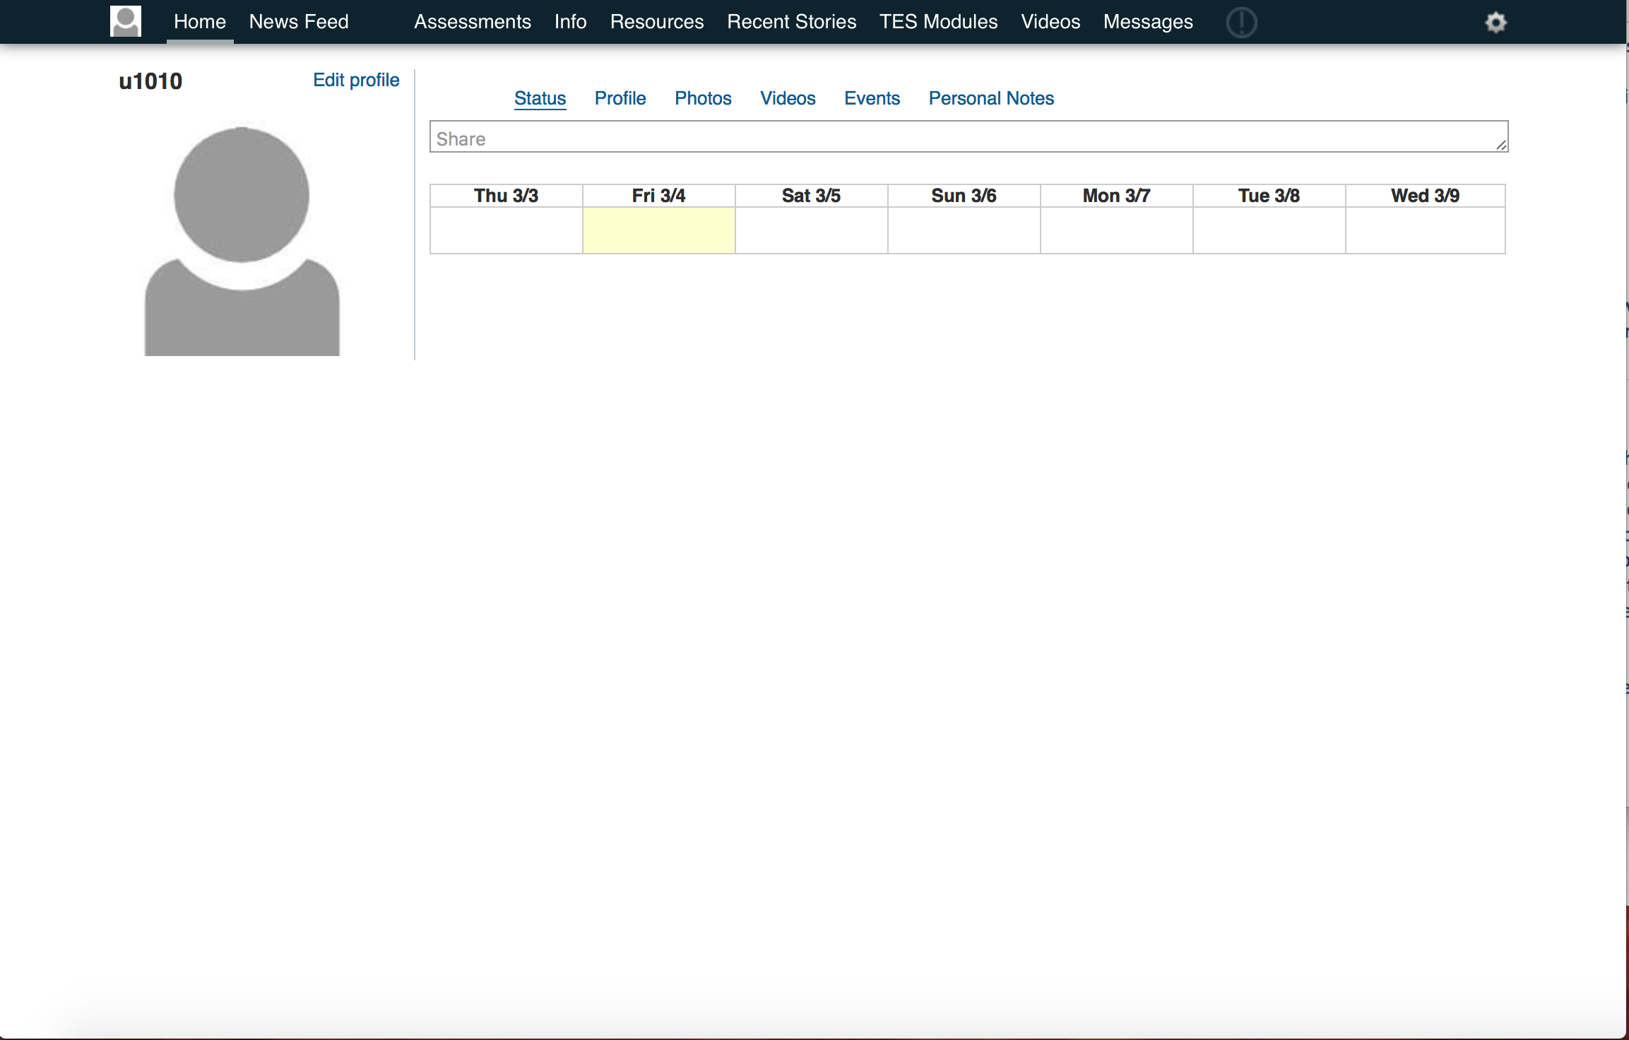

Figure 1: Screenshot of current desktop website

2.1.4: User Roles and Responsibilities

For this project, and the overall Social Interactome (SI) project, there are three different users.

The primary user of this system is a participant who is a part of the study. This user group consists of people who are recovering from addictions. They will be performing all of the tasks that are associated with the user-end of the system, which is anything available to them through the navigation of the website.

As with any system, there are administrators who have elevated privileges. They maintain the participant accounts and the content of the website.

Because SI is research project, there are researchers or observers who are analyzing the data that is being collected. They will conduct their research by monitoring what the users are doing and when they are doing it within the system.

2.1.5: Interactions with Other Systems

The current desktop system is running a modified version of Friendica. Friendica is an open source, free social web server. Their mission was to create a decentralized/federated social platform and the technology to go alongside. It has been in development for over two years, and it has a large selection of connectors to legacy and many other social network systems. With Friendica, if a post is private, then it is guaranteed to be private.

2.1.6: Replacement of Legacy Systems

This project has no intention to replace a legacy system. The purpose of this project is merely to modify an existing desktop website to include a mobile browser version.

2.1.7: Production Rollout Considerations

This project well be developed in a separate virtual machine (VM) from the actual system. This VM will have a copy of the desktop version of the system that the team will be able to work with. The team will explore two different types of design, which will be discussed in a later portion of this document. After implementation, the mobile version will be thoroughly tested before being released to the participants.

2.1.8: Terminology

Social Interactome (SI): This is the name of the research project that is being conducted by the AARC.

HTML: A type of markup language used in web development.

Responsive Web Development: Web development that changes the user interface based on the screen size detected.

API: (Application Program Interface) The set of routines, protocols, and tools used to build software applications.

Friendica: Friendica is an open source, free social web server. Their mission was to create a decentralized/federated social platform and the technology to go alongside.

Virtual Machine (VM): Emulation of a particular computer system that can be used for development.

2.2: Functional Requirements

2.2.1: Statement of Functionality

This section will focus on the requirements for the functionality of this project. The requirements will only focus on the primary user, which is the participant/recovering addict. This is due to the fact that this user is the only one who interacts with the part of the system that will be modified and developed in this project.

Functional Requirements
All of the following requirements shall be with respect to the mobile version of the website:
- The user shall be able to
  - Navigate to and complete Limesurvery assessments.
  - View and browse the News Feed.
  - View and browse profile pages.
  - View and browse private messages.
  - Attend, view, and browse video meetings.

Non-Functional Requirements
- The user shall be able to
  - Navigate to the page that they wish within two selections.
  - Feel confident in their ability to navigate the mobile version of the site.
  - Perform interactions with the mobile version in time comparable to the non-mobile version.

Section 3: Developer’s Manual

3.1: Design

3.1.1: Two Potential Design Approaches

For this project, there are two potential design options that will be explored.

The first option involves researching the Friendica API themes that already exist. The client has suggested that it would be worthwhile to explore the current themes to see if one has been designed with the potential for mobile usage. If a mobile-friendly option is available, that theme would be implemented and then modified to fit the requirements of the system.

If the first design option is not feasible after research, the plan will be to pull down the source code for the desktop version of the website. The team will then assess the HTML/CSS/PHP, as well as the documentation, and then develop and modify the code to consider responsive web design. The goal is to be able to add different CSS methods that will allow us to modify the user interface based on the detected screen size of the device.

The second option was selected and used as the basis of the prototype. The initial changes were to bring the navigation bar to the bottom of the page and have it be formatted as a bullet-style list as opposed to the desktops horizontal navigation menu. This approach was sufficient for a intermediate prototype design, but the goal was to use a compressed “accordion” button in the top left corner of the screen (also known as a hamburger).

3.1.2: Desktop to Mobile User Interface Translations

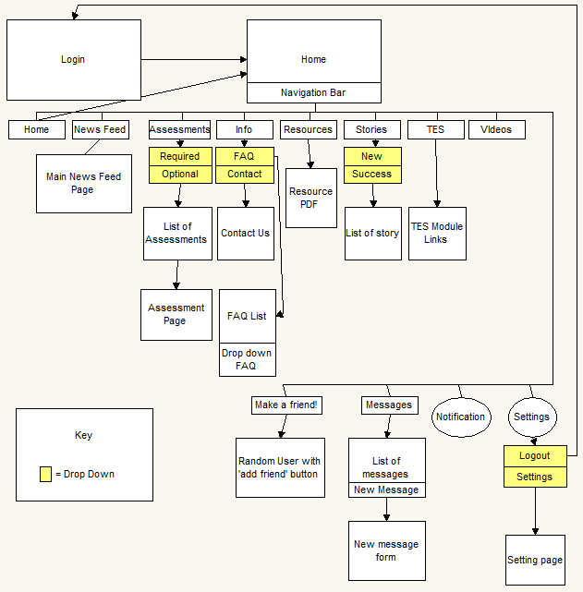
Figure 2: Wireframe of the layout that corresponds to the mobile version of the website

The main difference in the design of the mobile version of the system and the desktop version of the system will be the navigation. Currently, the navigation is displayed across the top with minimal cascading menus. The design plan is to have a hidden menu that can be easily accessed by a button on the top of a simplified navigation heading. Within that hidden navigation, there will be cascading menus that can direct a user to any page that they wish to access. The user will still be able to see their profile/profile name and have direct access to it via the navigation heading bar.

All of the main content of the pages shall be a modified version of what is currently in the desktop website. For embedded systems, the team shall research if there is code for mobile versions of the embedded program. The content for each page shall be modified to produce an aesthetically-pleasing display.

Overall, the mobile interface shall have the same look and feel as the desktop version of the system, just in a simplified fashion.

3.1.3: Restrictions, Limitations, and Constraints

All of the following are restrictions, limitations, or constraints that could potentially cause problems to be overcome in the project:
- Mobile devices have much smaller screen sizes than a traditional computer.
- There are a variety of mobile devices available, with a large range of screen sizes.
- A legacy system is already in place, so there may be unforeseen problems with the current system.
- The mobile version of the site must maintain the same general look and feel of the web version.
- Most web pages have elastic scrolling, which is a known issue when styling.
- The web version uses embedded systems such as Limesurvey, which could be difficult to implement on the mobile version
- Testing and receiving full feedback from active participants may prove difficult due to the time constraints of the project.

3.1.4: Testing and Testing Issues

The testing plan is to compare our mobile implementation versus the desktop implementation. The user should be able to perform the same actions across any device. The team also plans on performing usability testing in conjunction with the AARC researchers. We hope to be able to gain feedback on the mobile version after it is run through one of their study trials.

There is an open source software called Galen Framework that can be installed on the same server that can run inline commands. This framework allows the user to simulate a responsive design website and use a unit-test like environment. The GitHub README on Galen Framework explains that the best way to use the framework is to write tests that expect elements to be in certain relation to other elements. Figure 3 illustrates a test class for the framework that makes use of the relational testing

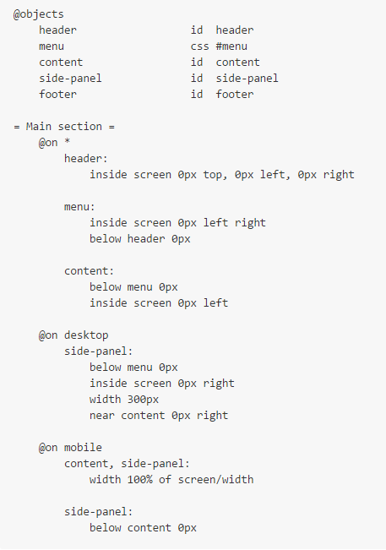
Figure 3: An example of a test class to be used by the Galen Framework

This feedback will then be taken into consideration in order to redevelop any issues that may arise. We also plan to have the developers of the desktop version perform a usability test on the mobile version and will take into consideration their feedback.

An issue that may arise is a time constraint of receiving the feedback within the term of this project.

Throughout the development process, we plan to use a cross-browser testing tool that will also allow for responsive design testing. Amongst our development team, we will compare the functionality to that of the desktop version.

We will use coding standards that allow for detailed commenting. This will enable future development teams to easily perform the required maintenance.

The overall design should be approved by the researchers and technological researchers of the AARC that are involved with the SI project.

3.2: Implementation

3.2.1: Programming Languages To Be Used

PHP and .tpl Files
PHP is a server-side scripting language designed for web development that has its basis in the C language (also some C++). The majority of Friendica is written in PHP.

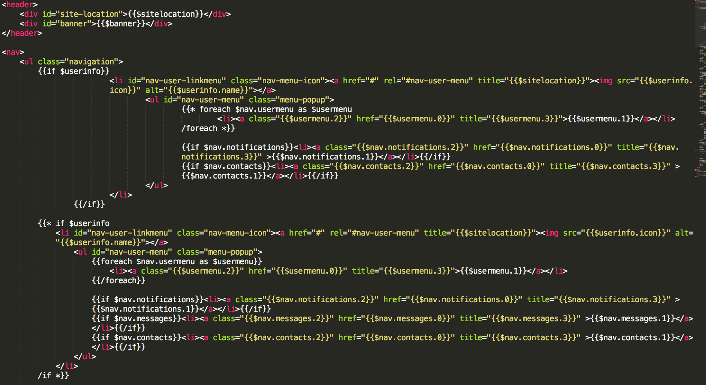
The Friendica system starts with .tpl files, which are template files. They allow each component that comprises the entire structure of the website. Figure 4 shows an example of the nav.tpl file, which our team analyzed to obtain the structure and outline of the main navigation. This file contains many of the HTML tags that are necessary in the creation of the HTML document.
Figure 4: The beginning of the nav.tpl file that aids in structuring the HTML document.

The PHP files that are located in the include directory are the files that are used to pull the correct information to populate the HTML document. The default.php file then pulls all of the PHP files that are in the include directory and uses them to create the structure and to populate the complete HTML document.

HTML/CSS
Hyper Text Markup Language (HTML) is the basic building block of all web pages. The HTML files that are created for the SI website are generated by PHP files. In order to change or add to the structure of the HTML files, the edits have to be made in the corresponding PHP files. The tags and elements that are generated are then styled by the CSS file. The CSS file uses media queries to detect screen size, and then the stylings are defined for both desktop and mobile media. HTML and CSS files will be used to create the appearance for our project.

3.2.2: Tools and Libraries Used

The quattro_remix theme is used to create the web page. It is a pre-defined theme produced by Friendica that is being modified to fit a mobile version. The library that we are working with is the dark library, as that is the theme that is implemented. We also utilized the PHP files in the include directory to maintain the structure of the site. Otherwise, all of the changes are done purely in CSS.

3.2.3: Phases

The following is the general phase plan for implementation:

- Accurately detect a mobile screen
- Adjust navigation to be appropriate
- Scale the pages to fit within the screen size
- Modify and adapt any of the outside sources (i.e., Limesurvey)
- Perform usability testing

3.2.4: Timeline

The following timeline will be used to carry out the intended project:

- Method of implementation research complete, Finalized UI design: Friday, March 4
- Design implemented, Basic functionality, Progress check to ensure we are meeting client goals/ideas: Friday, March 18
- Mostly functioning prototype: Wednesday, March 30
- Begin testing, Mostly-Finalized Prototype: Friday, April 15
- Complete mobile solution, Testing complete: Friday, April 29

3.2.5: Development Roles and Responsibilities

Each individual member of the development team will have specified roles and responsibilities. They are as follows:

- Amy Vogrig
  - UI design
  - Implementation research
  - Responsive web design
- Emily Croeber
  - HTML/Javascript/CSS coding and development
  - UI design
  - Implementation research
- Tyler Collins
  - Backend configuration and management
  - Testing

Section 4: Lessons Learned

4.1: Prototype

4.1.1: Approach
Within the styles.css file, the desktop and mobile styles are categorized based on media queries that detect the device’s screen width. The size that is being checked for the desktop web page is a minimum width of 960 pixels, and the size that is being checked for the mobile/tablet web page is a maximum of 959 pixels.

After the correct screen size is detected, the styling for each is separated and designed appropriately for its display. Since the CSS styling was given for the desktop version, a minimal amount of this stylesheet needed to be edited. The first modification that was made was to style the font to match the desktop version and to increase the size, so that it was readable to the mobile user.
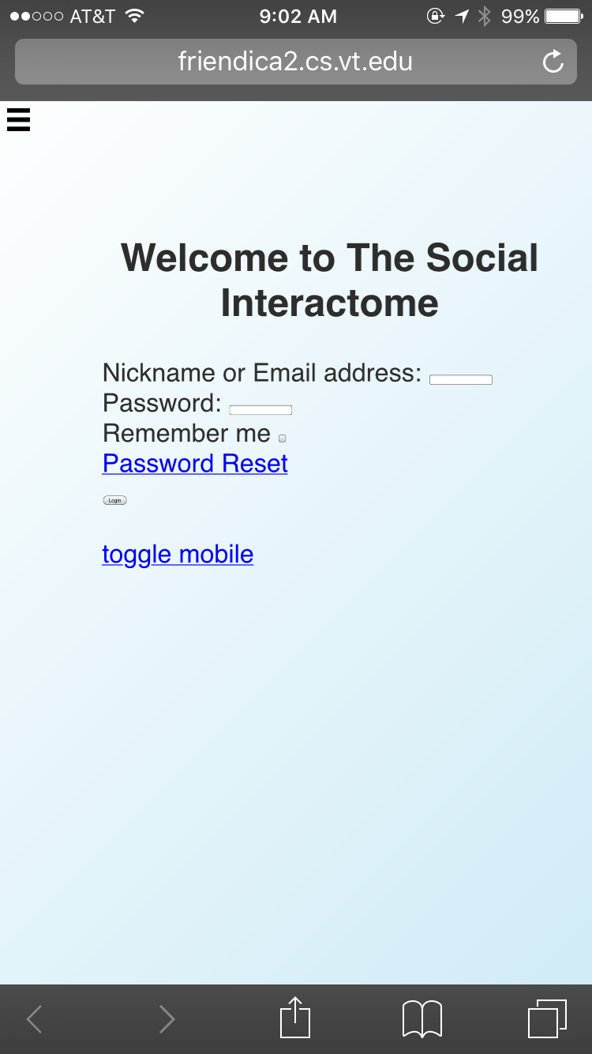
Figure 5: Screenshot of Mobile Login Page

The most critical aspect that needed to be designed and implemented was the navigation. After several design failures, a hamburger menu was successfully implemented. This menu acts as a push drawer that is hidden unless the designated navigation menu button is selected or toggled.

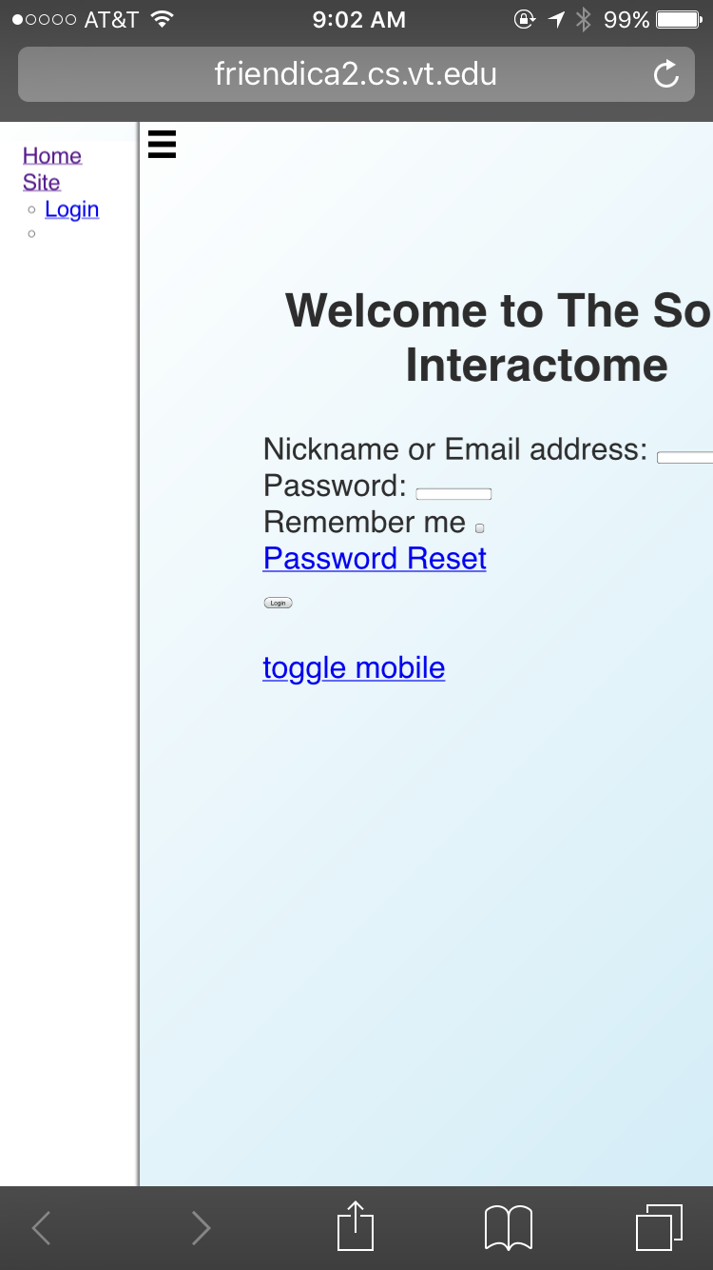
Figure 6: Display of Push-Drawer Navigation

Many navigation items were not necessary for the functionality of the mobile web version of Social Interactome. The display of these items were set to be none, which hides them from the mobile version, but they are still visible in the desktop version. The menu items that were hidden are Info, Resources, TES Models, Make a Friend!, and the notifications menu.

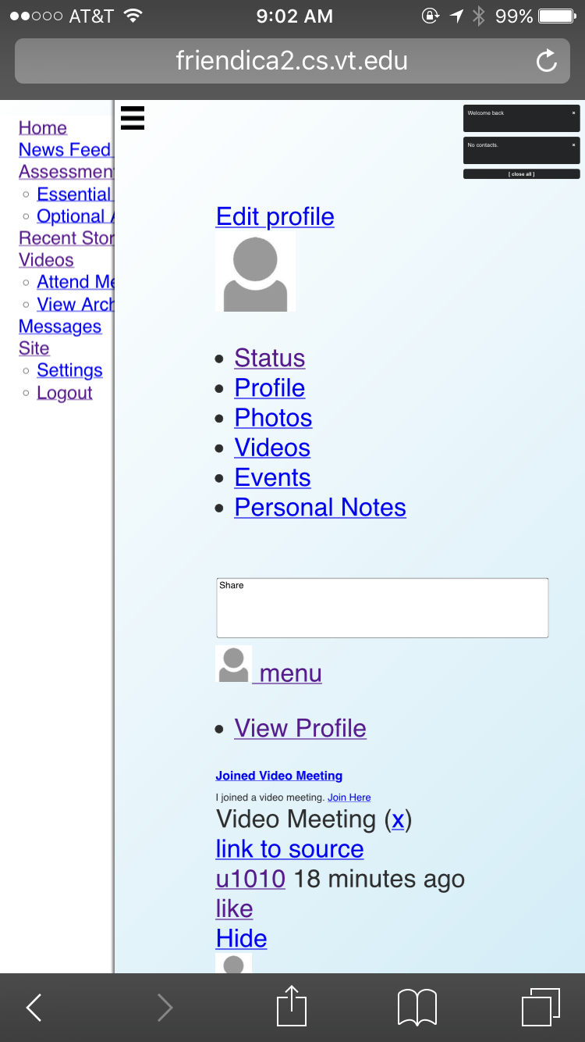
Figure 7: Reduced Navigation Content

After the navigation was in place, the main heading font size was adjusted to be aesthetically-pleasing and readable to the user.

Since the implementation of the new navigation, there are some issues that have arisen that will be corrected in future implementation.

4.1.2: Failures, Successes, and Known Issues

During the first stages of this prototype, most of the failures and successes that have occurred have been in relation to the navigation.

In the original desktop version, the navigation menu was a banner that stretched across the top of the page. During an early implementation of the prototype, the navigation menu was moved to the bottom of the page. The styling of this menu included indented blocks to show a cascading hierarchy. The idea of positioning the navigation at the bottom of the page was to ensure that the user did not have to scroll back to the top of the page to navigate to a different page.

This implementation of the bottom navigation displayed and functioned nicely on the login screen. Once a user navigated to any other page, the navigation floated in the middle of the screen and made it difficult to scroll the rest of the page.

After further investigation, it was found that the navigation elements were located near the top of the HTML document. This made it difficult to accurately position the navigation at the bottom of the page relative to the other HTML elements.

In the default.php file, the HTML elements were rearranged to order the navigation to be at the end of the document. Even after the re-ordering was done, the navigation was touchy and would jump to the middle of the screen once the user scrolled to the complete bottom of the page.

After the initial failed attempt of the bottom navigation, a hamburger (push-drawer toggle) menu was successfully implemented.

The method of implementing this was complex. The navigation element is hidden behind the main content of the web page. A menu toggle button is in a fixed position in the upper left-hand corner, and it only moves when it is toggled. This button is a pseudo-element, as actual implementation is a checkbox that is then hidden by a label. The navigation then pushes the main content off of the right-hand side of the screen.

As seen in Figure 7, the default.php file had to be rearranged and additional content had to be added to ensure that this implementation was successful. An input checkbox and label had to be included to provide the functionality of the toggle menu. The rest of the content, with the exception of the navigation, had to be enclosed within a div element that acts as a wrapper. This wrapper allows us to overlay the main content with the navigation, which gives us our navigation functionality.

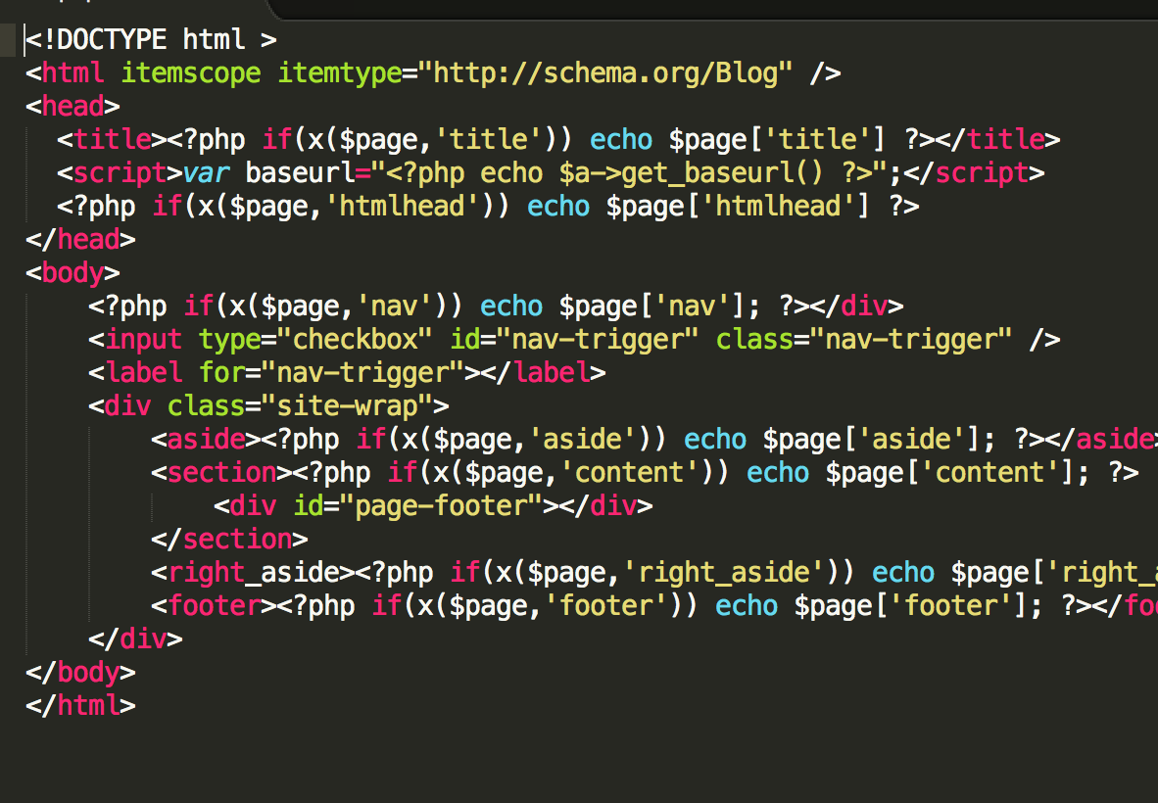
Figure 8: Rearrangement and Additions to default.php

There is a known issue with the collapsing of submenus within the cascading menu format. The plan is to disable the parent menu item when there are children menu items. The submenus will always be displayed. Another styling issue that needs to be fixed is to push the site content further to the right in order to display all of the menu items.

Although this menu’s functionality is mostly complete, there are some minor issues with the functionality of the entire page, such as overscrolling and unnecessary moving and scrolling. This issue may fix itself with the future styling and positioning of other elements in the body of the HTML.

Another known issue is within the Attend Meeting tab. The plugin that the desktop website uses to implement video meetings is incompatible with mobile browsers. Since this plugin is successful with the desktop version, this feature may not be feasible for the mobile version. This issue will be discussed with the client before removing the functionality or finding an alternative. After discussing this issue with our client, the client wants us to leave the issue as it is, even though it is beyond the scope of our project.

When a user clicks on a textbox, the page automatically zooms-in. This zooming characteristic causes the screen to go completely white to where the user can only see the cursor. Pinching the screen to zoom-out allows the box and the page to come into view again. Because some of the elements are not positioned correctly on the screen yet, this could be an issue that fixes itself after continued implementation.

The progress-to-date on this functioning prototype has been successful. The navigation layout is consistent across the entire site, which helps with the formatting and design of the individual page content.

4.2: Refinement as of 3/31/2016

4.2.1: Modification to Implemented Navigation

For the prototype, the design and layout of the navigation is appropriate for mobile or tablet versions of our responsive web design. It is not in the plan to modify the functionality of the push-drawer concept, although there are parts of the navigation content that need to be modified.

The first modification involves adjusting the push of the drawer navigation so that all of the content of the navigation is visible when toggled. As seen in Figure 8, half of the content of the navigation is hidden behind the content page.
Figure 9: Navigation Content Hidden by Site Content

The next modification involves the expansion of the submenus when the parent menu is selected. This will be fixed by disabling the link on the parent menu and having all of the submenus expanded by default.

The final modification of the menu involves the actual styling of the links. The plan is to change the background color of the menu to match the color scheme of the navigation menu on the desktop site. The on-hover, the background for that navigation link will become a lighter hue of the background color. The text decoration and color that currently exists will be changed to mimic the desktop version.

4.2.2: Modification to Site Content

As seen in Figures 4, 5, and 6, the content of the website displays correctly, but it is not aesthetically-pleasing. The content is being shown in plain HTML text, and the elements are not formatted and sized correctly to be displayed on a mobile browser.

The first step in our refinement plan is to hide unnecessary information, such as the toggle mobile and connect links. The background color of the site content will also be changed to white to flow in relation to the desktop version.

The next step is to format submenus that are located within the page. These menu options will be formatted and styled to be inline with each other. They will be displayed near the top of the page.

The third step in the plan is to format all of the labels and text entry boxes to be correctly sized and formatted to fit the mobile page correctly. These boxes and labels will be positioned relative to other elements on the screen.

The next step will be to ensure that image upload is possible. This step is a final extension of this project, and will only be completed if feasible.

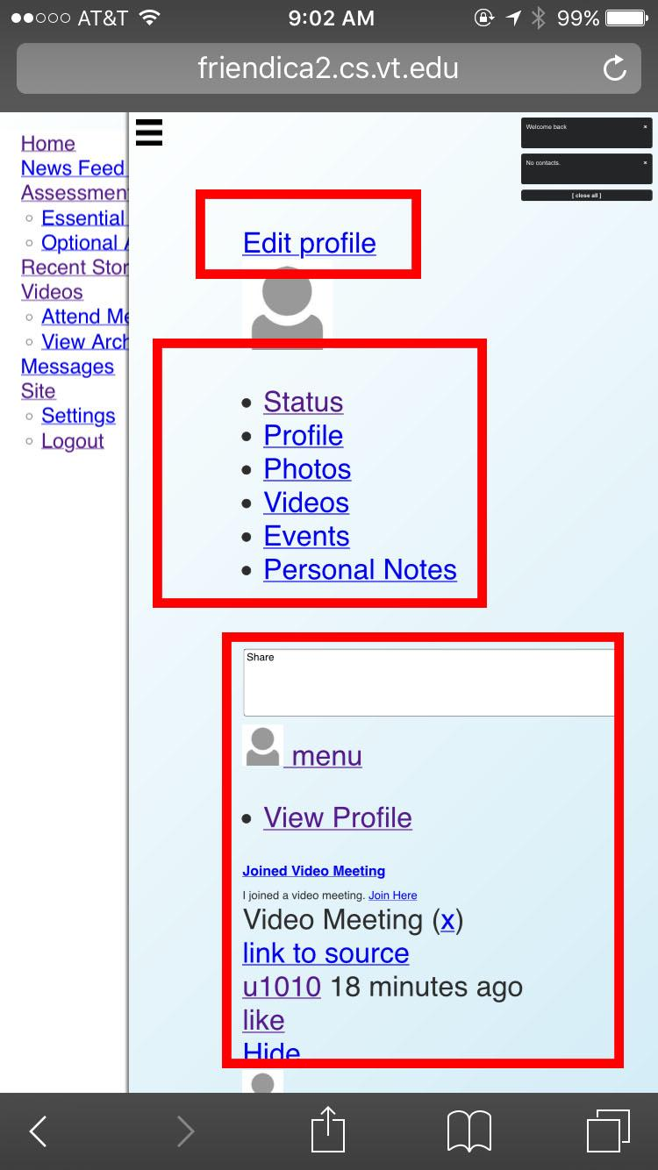
Figure 10: Red Boxes Indicate Parts of the Refinement Implementations

The final step will be to format, style, and position the other elements to be relative to the major elements on the page.

4.3: Testing the Prototype

4.3.1: Restatement of Goals
SIMobile’s primary focus was to make a usable mobile version of the Social Interactome. This need arose from users of the website requesting a “more mobile friendly” version in order to do self assessments and interact with other users wherever they are, as opposed to being tied down to a laptop or desktop (which also requires a network). The first and most prominent goal was to change the navigation from its rigid banner style to a form that suits mobile phones/tablets. The second goal was to modify the CSS to make the mobile site look visually appealing.

4.3.2: Initial Approaches

There were many options when it came to the initial and final testing of SIMobile. During the first stage of development, trial and error testing was used to get a good grasp on what was effective when it came to editing the CSS file to produce a change when connected with a mobile device. A good example of this style of testing was including the “@media (max-device-width)” tag at the top of the style.css. After this was written, we tested its functionality by making the default font size to be unreasonably large to make sure that the mobile phone connecting to the site was detected and the proper style was delivered to the device. This sort of testing continued as we decomposed the problem into smaller pieces such as the navigation change (which was the backbone of this project). The original version of the navigation was a navigation bar at the top of the screen, which is not effective for a much smaller mobile phone. The mobile version of the Friendica site now uses a sidebar navigation which can be viewed via a toggle button.

After the large portion of the site was changed to be very obviously mobile responsive and friendly, the initial method of ‘testing’ was no longer sufficient. In order to find a more technical approach to test the mobile site, the Galen Framework was found through research of responsive design testing. As stated previously, Galen Framework allows the user to simulate a responsive design website and use a unit-test like environment. Galen Framework would work amazingly for a website/project that does not need to support a mobile view. This framework was installed directly to the Linux webserver and was tested and configured to determine if it would be the testing method that we would employ. The main problem with the Galen Framework was that it required a GUI interface (it tests responsive design by opening a Firefox instance) and even more fundamentally, the Galen Framework did not simulate a mobile connection to the webserver whatsoever. This was unacceptable because the mobile site functionality was not tested at all.

Through even more research into testing mobile friendly sites, a simple ‘solution’ was discovered. Google Chrome has an extremely useful tool built into it; after right-clicking the desktop version of the website and choosing the “Inspect” option, the usual inspection window appears at the right of the screen. However, there is a button at the top left of this window titled “Toggle device mode” that reopens the website as the mobile version. This view has the option to simulate seven default devices, including recent versions of the Nexus and iPhone. This device mode allows us to view the website on the desktop as the mobile version, so we are able to inspect each element and look at its CSS properties; device mode gives us the ability to manually test the website. However, this method did not meet the full scope of our testing needs. There is no way to write test cases to ‘expect’ a result and then test it against the actual results from the website’s elements.

4.3.3: Selendroid
The final software solution that we settled on (because it meet all of our testing needs) is called Selendroid. Selendroid is a test automation framework which is based off of the UI of Android native and hybrid applications (apps) and the mobile web. Tests are written using the Selenium 2 client API (selendoird.io). Selenium (which is what Selendroid uses) is a testing framework for automating browsers, which is a perfect complement/solution to our testing needs.

Selendroid must have a connected device in order for it to run tests against an app or website. Before an emulator is used, however, a Selendroid server must be started and listening on the localhost. This sounds very easy to accomplish in theory. The pitfalls of executing this task are listed in the Testing Problems section. Initially, a Selendroid server was started and then a test class was ran through an Android emulator in Android Studio. This turned out to be inefficient and awkward, so the server starting event was moved to a “@BeforeClass” in the Java class, which is shown in FIgure 11:

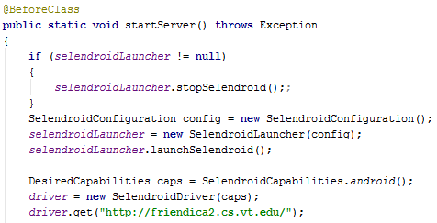
Figure 11: @BeforeClass in Java

The Selendroid Server is tested to see if it is already running, and the test class restarts the server. Selendroid listens on port 4444 and translates an Android device’s (or emulator’s) connection to receive the mobile version of a website. At the bottom of this method, there is a .get() call that gets a large amount of information from the website (most notably: parsable HTML). Below is an example of the output when the Selendroid server starts, which requires a connected device. The list of connected Android devices can be seen at the top of Figure 12, which has more information a few lines below that.

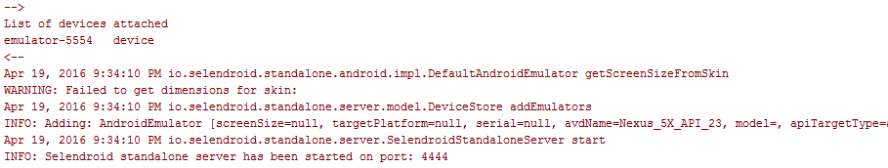
Figure 12: Android Studio output of Selendroid being started

Each test in the test class finds elements in the website by its ID. For example, if the login button at the home screen were to be involved in a test, the process of obtaining that element from the webpage is a “one-liner” because of Selendroid’s power. The login button must be referenced by creating a new WebElement object and finding the matching element through its ID:

WebElement login_button = driver.findElement(By.id(“login-submit-button”);

Once this object is created (assuming that the object exists and can be found through the ID provided), there are a large number of attributes that can be tested against. A small sample of these options are shown in Figure 13:
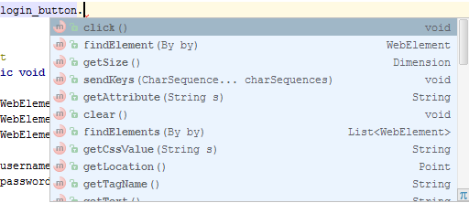
Figure 13: Available methods of a WebElement (org.openqa.selenium.WebElement)

Almost all of the main methods were used in test cases. The most reoccurring assert statement dealt with testing the size of the element, because that was a vital part of converting a strictly desktop site to be mobile friendly.

The majority of the tests involved the new navigation’s functionality. Overall, there are about 20 tests with 1 to 10 assert statements in each one. The ‘hamburger’, which is referenced in the test class as “nav-trigger”, was tested by finding the element, testing the location of the main site wrapper, clicking the hamburger, and checking if the site wrapper’s X value had changed to the expected location. This expected location was found through manually testing the site through the Device Mode in Chrome and then basing the expected result of a similar phone (Nexus 6P vs. Nexus 5X) from the screen size of the phone that the emulator was using. The emulator was running an emulated Nexus 5X, while we were looking at the actual values of the fetched website for a Nexus 6P through the Device Mode in Chrome.
Another useful and simple test was to check if certain elements were displayed or not. The team decided against including all of the navigational links that are shown on the desktop version for a sleeker look with the same amount of functionality. For example, the “Make a Friend!” navigation link was excluded from the login screen of the mobile version (in design). Through the snippet of the test class below, the “Make a Friend!” option is asserted to not be hidden:

Figure 14: A retrieval of a HTML element in Selendroid

A similar test is used to test the main navigation after logging in, which in turn tests entering text into the username and password fields on the login page. After the user is logged in, the navigation elements that are deemed priorities (shown earlier in this document) are check in the exact same fashion as “Make a Friend”. An example showing logging in is shown in FIgure 15:

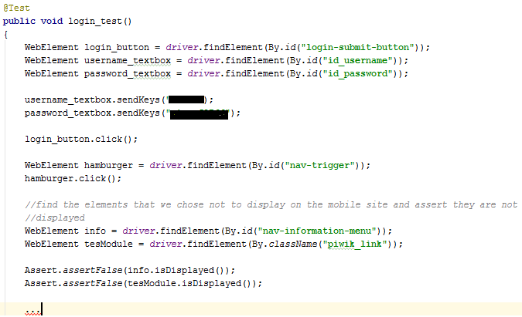
Figure 15: Logging into the website and testing displayed navigation
Sample outputs of running the tests are not included because they are deemed to be trivial. Any test that ‘failed’ in Android Studio was debugged and remedied, so the sample test outputs would simply be a list of green arrows next to a list of test method names.
The main focus of this project was to add functionality to the Social Interactome, but some other aspects of the mobile site were also tested. Loading times of the mobile version were compared to loading times of the desktop. Page Load Time, a Google Chrome extension, was used in junction with the Device Mode in Chrome as well. In Figure 16, the left table is the result of the load time of the mobile site, while the right table is the result of the desktop load time, both have detailed information. As shown in the top right of each screenshot, the mobile version is .04 seconds faster than the desktop version in this test. This is most likely due to the relation of requests and the response from those requests.
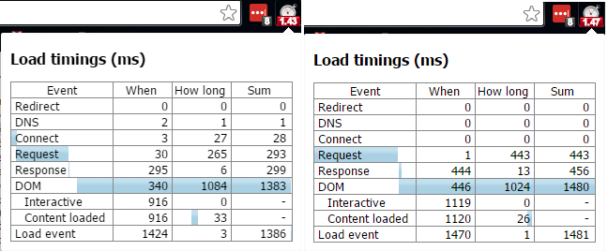
Figure 16: The results of running a loading test on both site versions
Besides discovering that the prior methods of testing were inadequate, there were a few glaring testing issues. Selendroid requires the local machine to set three different environment variables (when using Windows), which can easily cause issues with running Android Studio at the same time. This is because Android Studio and Selendroid (standalone server) both need to point to a JAVA_HOME environment variable. Initially, Android Studio easily installed itself and pointed to a Java version. However, Selendroid has hardcoded variable names that cannot have JAVA_HOME pointing at a JRE folder (which Android Studio can use). The solution to this was to point both applications at the newest update of a JDK. The PATH environment variable was also required to be appended with an %ANDROID_HOME% variable that pointed to Android’s SDK.
The most prominent technical problem that we ran into while testing was an UnsupportedException thrown by Android Studio/Selendroid when calling .getCssValue(“css tag here”). It appears that Selendroid is fairly new and this method is not yet implemented. If this method were to be implemented, we could have tested things like font-size from the CSS tag as opposed to a pixel size of the element. However, the CSS testing could be done manually, such as changing the color of a header and checking the Device Monitor to see if the header did change color..

As seen in the initial refinement section, the sidebar navigation did not shift the site’s content far enough over. This was shown to be technically true as well in testing.

4.4: Refinement as of 4/19/2016

4.4.1: Updates
For this refinement period, many updates and changes have been made the SIMobile project.

First, the login page has been formatted to appropriately fit a mobile screen. The background colors of all aspects have been changed to white to be consistent across the desktop browser, as well as all pages of the mobile version.
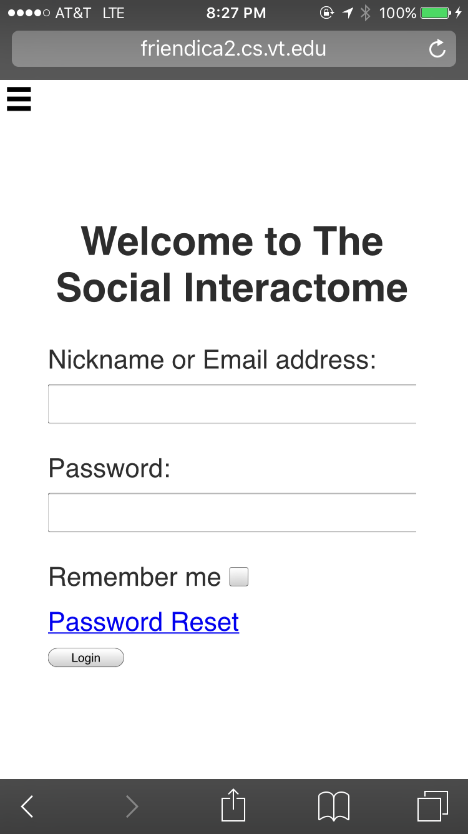
Figure 17: Formatted Login Page

The next modification that was made was to the navigation. When the menu button is toggled, the push-drawer navigation is pushed far enough to display all of the content within the navigation.

The next modification that was made was to attempt to fix the overscrolling of the pages. This is fixed when the user tries to scroll up or to the sides of the page, but it is still showing the hidden content when the user scrolls all the way to the bottom. Various solutions are being explored to fix this issue.

The final modification that was made was to the home page that is displayed once the user logs in. The menu at the top was changed to be a list that did not contain bullets, and the contact information was moved to the upper right hand corner. The news updates background color was updated to be consistent with the desktop version. Unnecessary information was removed from the page to make it seem less cluttered.
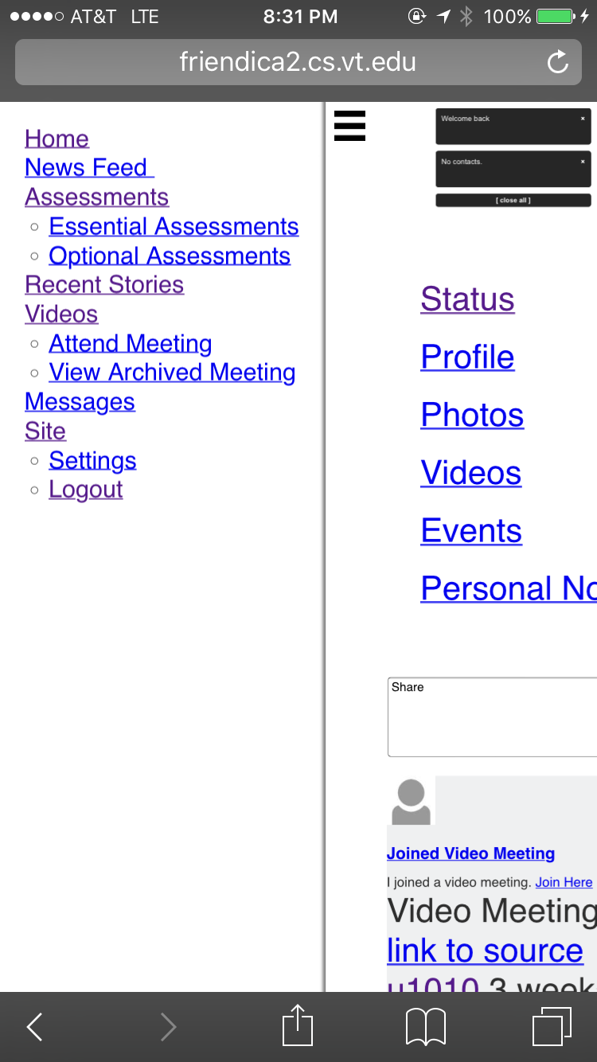
Figure 18: Navigation shows all of the text
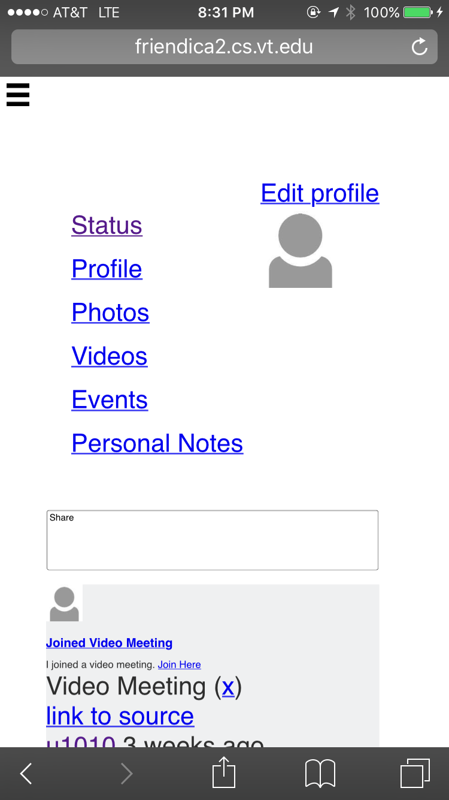
Figure 19: Enhanced readability modifications

4.4.2: Next Modifications
The next set of modifications should complete this team’s scope of the project.

The team plans to format more of the text to be consistent across all parts of the site. The links in the navigation, as well as on all of the pages, also are styled to be aesthetically-pleasing.

All of the input boxes will be formatted to fit appropriately on the screen. Solutions to the overscroll and zooming on input box focus will continued to be researched.

4.5: Refinement as of 4/27/2016

4.5.1: Updates
Many of the previously mentioned future modifications have been made to the SIMobile project.

The first modification was to change the harsh blue and purple color combination for the links on the mobile version of the site. They links were changed to be black in color, and after the links have been visited, the color of the links change to be slate gray in color. The underline text decoration has remained to differentiate the links from other text.

The next modification that was made included some layout issues that had been noticed through usability testing. The size of the font was increased to provide better readability for the user. In some places, the font size could not be changed because of HTML and CSS restrictions on the element types.

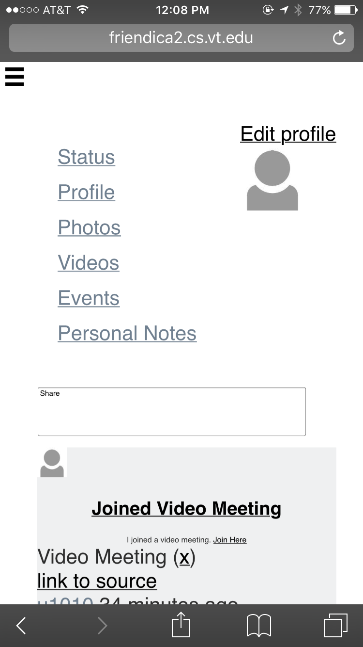
Figure 20: Link color has been changed to be black with an underline; Visited links are slate gray with an underline
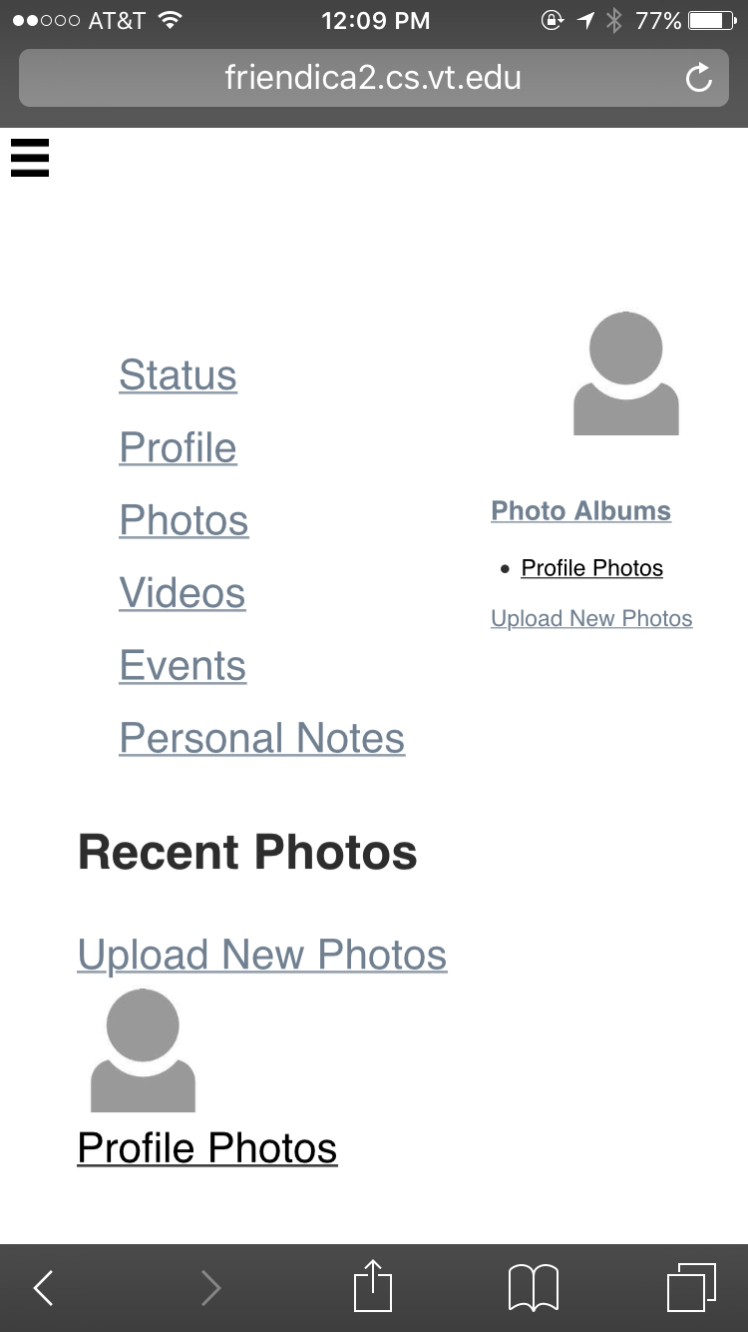
Figure 21: Layout of the Photos page has been updated
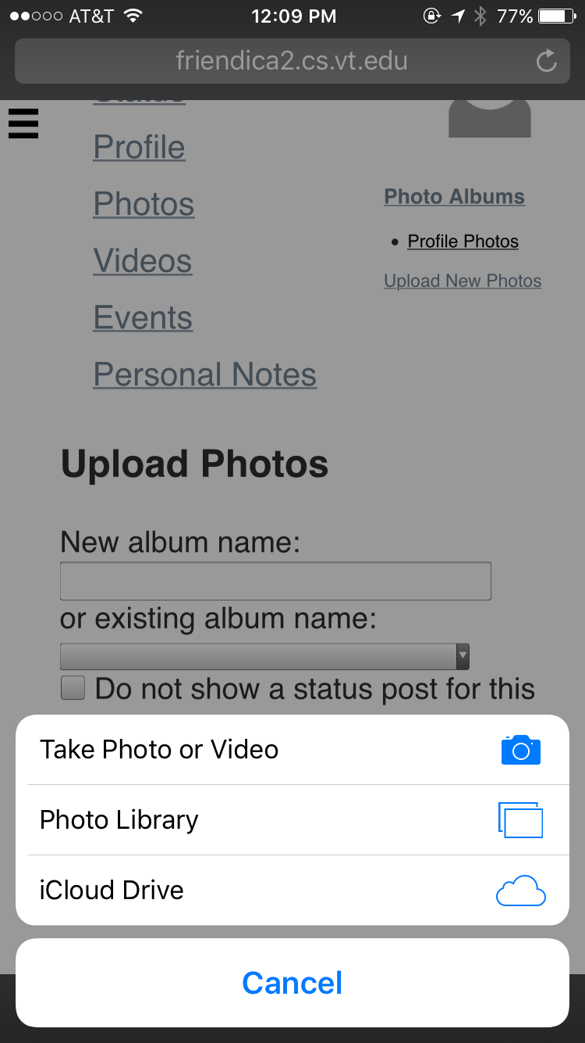
Figure 22: Users have the option of uploading photos; Font size has been increased on this page
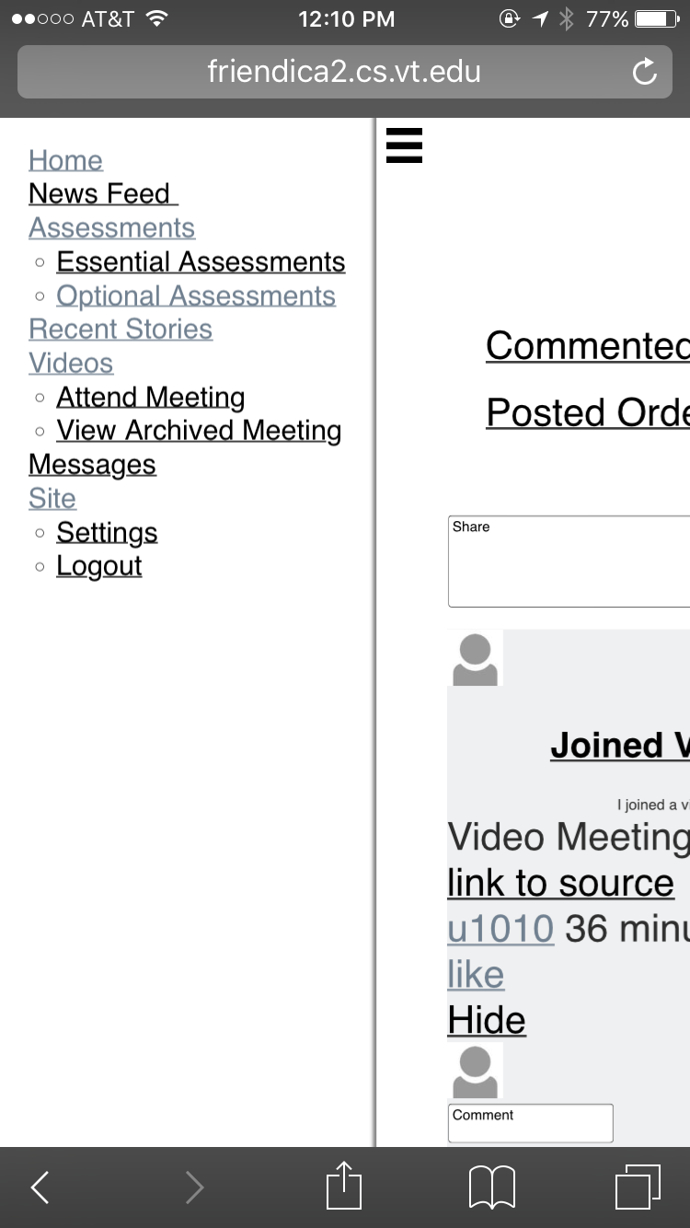
Figure 23: Link color changes can be seen in the navigation menu

4.5.2: Final Known Issues
After all of the possible modification were made, there are minimal known issues that are beyond the scope of this project.

The first known issue is the Attend Video page. After discussing this with our client, he told us to leave it as it is as it something he will look into at a later time.
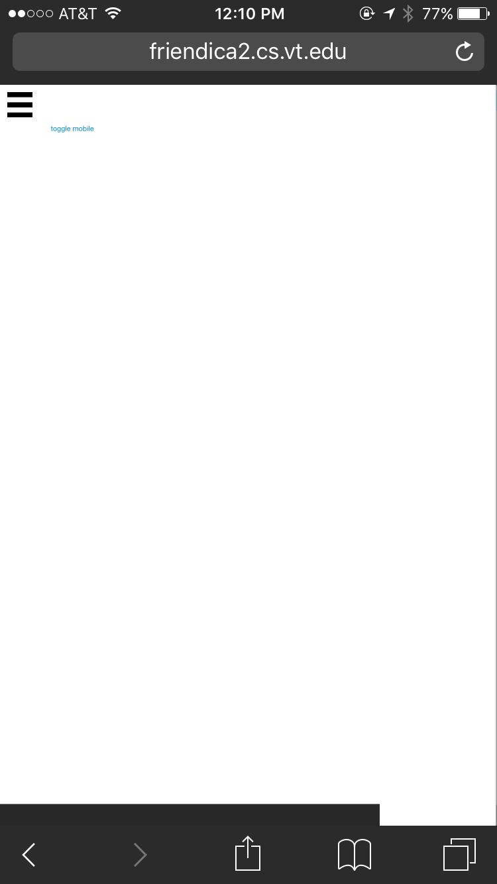
Figure 24: Attend Video page is incompatible with the mobile version

The second known issue is related to the Recent Stories page. We believe that there is a javascript component working on the desktop version of the website that is not working in complete compatibility with the mobile version of the website.

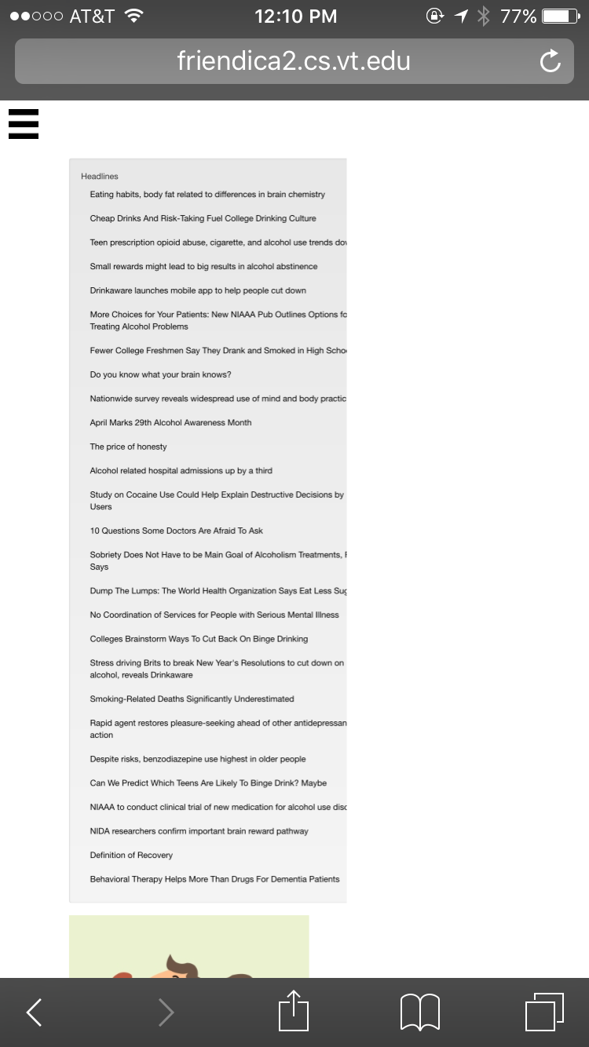
Figure 25: Recent Stories page does not allow scrolling

The final known issues are the overscroll that occurs at the bottom of the page and the zoom focus when a input box is selected. After researching these issues, working solutions have not been found at this time.

4.5.3: Future Plans
Several issues are beyond the scope of this project, but could be fixed in the future.

Issue | Potential Fix
Various plugins used by the mobile version are not compatible with mobile browsers. | Change the plugins on the mobile, and possibly the desktop, version to ones that are mobile email.
Overscrolling occurs at the bottom of the page. | This is an issue with the mobile browsers and not the actual website, so any fixes would have to be done by the developers of the mobile browsers.

Acknowledgements

John Crawford
jcrwfrd@vtc.vt.edu
Research Computer Programmer
ARRC (Addiction Recovery Research Center) at Virginia Tech/Carilion Research Institute
Roanoke, Virginia

References

- "Friendica." The Internet Is Our Social Network. Web. 30 Mar. 2016. http://friendica.com/
- "Hubzilla." Hubzilla. Web. 30 Mar. 2016. http://hubzilla.org/

