To whom it may concern:
In accordance with Virginia Tech Graduate School requirements for the ETD submission, I hereby grant Virginia Tech a non-exclusive license to use my copyrighted dissertation entitled “interdisciplinary teamwork, partnerships, federal land management planning, NEPA, natural resources, recreation management, U.S. Forest Service, National Park Service”. The license shall include the right to use, archive, distribute, and reproduce the dissertation by Virginia Tech and its agents. I retain all ownership rights to the copyright of my dissertation. Moreover, I retain the right to use all or part of this dissertation to write articles or books in the future.
Signed
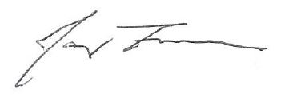

James Freeman
04/25/2024

