Tweet Categorization
CS 4624 Multimedia/Hypertext/Information Access
Virginia Tech, Blacksburg, VA 24061
4.27.2016

Author: Stephen Won
Client: Sunshin Lee

Table of Contents
Table of Tables ……………………………………………........................................................... 2
Table of Figures …………………………………………….......................................................... 2
Executive Summary …………………………………………….................................................... 3
Part I: User Manual ……………………………………………..................................................... 4
1.1 Project Description ………………………………………….…................................... 4
1.1.1 Project Background ................................................................... 4
1.1.2 Objectives ………………………………………………………….…..…............. 5
1.2 Target Audience …………………………………………..…....................................... 6
1.2.1 End Users ……………………………………………….................................. 6
1.2.2 People Maintaining ……………………………………………….................. 6
1.2.3 People Extending the Project ..………………………….......…............. 7
Part II: Developer’s Manual …………………………............................................................ 7
2.1 Design ……………………………………………………….............................................. 7
2.1.1 Current Design …………………………………………............................... 7
2.1.2 New Design ………………………………………....................................... 9
2.1.3 Tools ……………………………….......................................................... 10
2.2 Implementation .………………………………………………………...….………............... 10
2.2.1 Overview …..………………………………………………………………............. 10
2.2.2 Description ……………………………………………………....……….............. 10
2.2.3 Major Tasks ……………………………………………………....………............. 10
Part III: Refinements …………………………………............................................................... 12
3.1 Refinement 1 ……………………………............................................................... 12
3.1.1 Prototype …………………….............................................................. 13
3.1.1.1 Modelling the Prototype ………..................................... 13
3.1.1.2 Diagram (Tweet Categorization) ................................. 14
3.1.1.3 User Interface ……………….............................................. 15
3.1.1.4 Diagram (User Interface) ..…………….............................. 15
3.1.1.5 Prototype Process …………..…………................................ 17
3.2 Refinement 2 ……….…………………………......................................................... 19
3.2.2 Interface …….……………………………................................................. 20
3.3 Refinement 3 ……….…………………………......................................................... 24
3.3.1 Categorization ............................................................................ 24
Part IV: Testing …………………….…….……………………………................................................ 25
4.1 Tested Functionalities ……………………......................................................... 25
4.2 Items Not Tested …….…………………………….................................................. 26
4.3 Types of Testing Performed ……………………................................................ 26
4.4 Results …………………………............................................................................ 26
Part V: Lessons Learned …………………………................................................................... 26
5.1 Implementation Schedule …….…………………………….................................... 27
5.2.2 Future Work …….……………………………....................................................... 27
Part VI: Acknowledgement ………………………………………………….............…………............. 28
References …………………………………………………..........................................………............. 29

Table of Tables
1 1,135,844,043 of tweets archived ……..........................................…………................ 4
2 tweet collection table .………………………..........................................………................... 5
3 Three Objectives ….……………………………..........................................………................... 6
4 refinements .……………………………………….........................................………................... 12

Table of Figures
1 fields in current design of tweet collections ................................………................... 8
2 current design of collection table .……..........................................………................... 9
3 Prototype of the database ………..……………....................................………................... 16
4 Current page using original yourTwapperKeeper UI……...............………................... 18
5 Table using DataTables jQuery Plug-in .........................................………................... 19
6 Table search with keyword "shooting".........................................………................... 19
7 DataTables integrated with yourTwapperKeeper css ..................………................... 20
8 The new interface ……………………………...........................................………................... 21
9 Most general categorization view in the Interface…….................………................... 21
10 how it shows in the interface when categories are clicked .........………................ 21
11 enlarged image of the interface …..…..........................................……….................. 22
12 interface after "shooting" category is clicked ………....................……….................. 23
13 Enlarged view of table after "shooting" category is clicked…........………............... 23
14 Excel file with new tag and taxonomy system .….........................……….................. 25

Executive Summary
One of the main goals of Integrated Digital Event Archiving and Library (IDEAL) is to collect tweets and archive them in collection bases based on keyword. The Tweet Categorization project is to discover the suitable categorization schemes so that the users of the tweet collections will be able to understand each collection’s general description such as what the keyword is, when and where it happened.
The project has been refined several times. First, the categorization scheme has been refined. In the beginning, the categorization scheme was to use a taxonomy scheme based on the event types. Also the GUI was to change the original static table that shows all tweet collections, to have search bar, and column ordering functions. Then the categorization scheme was changed to use a tag system. It would contain an event tag that describes the event type, place tag that shows the place where the event happened, and date tag that displays the date the event occurred. After that there was also a refinement that changed back to use a taxonomy scheme again but with a better GUI system that will show all the categories. Clicking the category will filter the tables to only show the related tweet collections. After that there was final refinement that uses a tag system, but also contain a taxonomy scheme for each tag. During the final refinement, the project was shifted to focus on creating a categorization scheme and applying it to the data file.
In this report, we discuss all the ideas and work undertaken these refinements. While others explain just descriptions, some are actual implementations.

User Manual
Project Description
Project background
One of the major goals of the Integrated Digital Event Archiving and Library (IDEAL) project is to collect tweets and Web-based content from social media and the general Web. As well as collecting data, the IDEAL project team also archives these materials permanently, and ensures access to these archives. The IDEAL team has collected tweets and Web collections about many events for many years, and archived Web collections using Internet Archive (IA) software, and tweet collections on local servers. These collections have been stored, organized, indexed and made available for searching, browsing, and other services. On the local server, currently there are 1,135,844,043 tweets archived. These tweets are divided into several databases. In these databases, the tweets are grouped into collections based on keyword or hashtags of general events (e.g., accidents, community activities), specific events (e.g., California shooting, chemical spill in West Virginia), places (e.g., California, Virginia Tech) and so on.
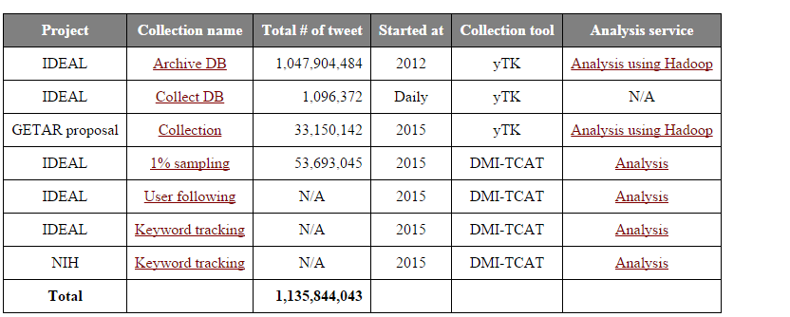
Table 1 1,135,844,043 of tweets archived
Currently the database of these tweet collections contains seven fields: Archive ID, Keyword / Hashtag, Description, Tags, Screen Name, Count, and Create Time. The Archive ID field shows the ID number of a collection. In “Archive DB” the ID ranges from 1 to 705. The Keyword / Hashtag field shows the keyword or hashtag used to collect the tweets. The Description field gives specific details about the tweet collection. The tags field shows what type of collection it is. The count field shows the number of tweets in a collection. The create Time field shows the date a collection was created, or when collection began. Overviews of collections are made into Tables (Table 2) in the website, http://hadoop.dlib.vt.edu/.

id | keyword | description | tags | screen_name | count | create_time
1 | #egypt | Tweets for Egyptian revolution |  | Sslee77 | 13,136,418 | 07/10/2012
2 | #libya |  |  | dlrl | 2,799,862 | 07/10/2012
3 | #blacksburg |  |  | dlrl | 212,139 | 07/10/2012
4 | #jan25 |  |  | dlrl | 1,141,723 | 07/10/2012
5 | #bahrain |  |  | dlrl | 22,010,557 | 07/10/2012
6 | #yemen |  |  | dlrl | 3,190,421 | 07/10/2012
7 | japan earthquake |  |  | dlrl | 1,273,463 | 07/10/2012
8 | #syria |  |  | dlrl | 16,860,208 | 07/10/2012
9 | OccupyWallStreet |  |  | dlrl | 1,006,610 | 07/10/2012
10 | #nrv | new river valley (blacksburg) related tweets |  | dlrl | 1,006,610 | 07/10/2012
…
Table 2 tweet collection table
However with so many collections of tweets, it may take a long time to search/browse for a specific collection, especially since few have text in the Description. Also, looking at collections by keywords or hashtags makes it hard to recognize connections with other collections. For example, “storm” collections and “earthquake” collections are both natural disasters, but from hundreds of collections, it is hard to recognize that in one look.
Also the user interface of the table is not made to be interactive so that the data can be organized in such a way the user wants. For example, from the table, even if the user wants to alphabetically order the collections by Keyword / Hashtag, there is no way of doing that.

Objectives
The major goal of the Event Based Categorization of Tweet Collections project is to help the IDEAL team’s research by accessing tweet collections easily. Client information is listed below.
Client name | Email
SunShin Lee | sslee777@vt.edu
Categorizing over 1,000 collections will make accessing a lot easier. Therefore from this project we will categorize the collections. The original method for categorization was to use a taxonomy scheme, but that was refined to use a tag system. This way the users will be able to see all the collections in organized categorizations. Although the object of the project was refined to focus on categorization of tweet collections, in the original planning, in addition to the categorizing, we planned to implement a user interface of the table so that it becomes more interactive, which will help the users’ searching and browsing.
With the Event Based Categorization of Tweet Collections project, we will undertake three specific objectives: analyzing and identifying tweets collections, researching the most suitable categorization scheme for the collections, and categorizing them in a consistent fashion.
Analyzing & Identifying | As mentioned above, there are currently 1,047,904,484 tweets and 705 collections in “Archive DB” alone.  We will analyze each tweet collections by its keywords, and study each keyword to find what they are.  (for example, if the keyword is an event, we would search the event online and learn what incident occurred)
Researching | Using the information gathered from the analysis we will research and identify suitable categorization scheme that will fit well with the data and will best help the IDEAL team.
Categorizing | Using the categorization schema we will categorize the collections and a suitable user interface for the web application will be developed.
Table 3 Three Objectives
Target Audience
End Users
The project will serve mainly the IDEAL team. It will help them search and browse through tweet collections. When they need all the collections for a specific category, they could select the collections using a category that we have created, making the process easier and faster.
Not only the team, but also other viewers of the tweet collection table will have an easier time searching and browsing the collections by using the categories. In addition to that, they will have easier and more custom ways of organizing the table using interactive orderings of table columns.

People Maintaining
When the new tweet collections get ingested, the people who are maintaining them could fill the category fields when they are adding collections to the database.
People extending the project
One way the developers can extend upon the project is to add more layers to the taxonomy categorizations for each tag to make it more specific, or take out a layer to make it more broad and simple.

Developer’s manual
Design
Current Design
Collections
- Tweets are grouped into collections based on keyword/hashtag, which were used for collecting.
- Currently there are seven fields in the collections database
  - Archive ID: shows numbered ID of each collections. This gets incremented as new collections are created.
  - Keyword / Hashtag: shows keyword or hashtag used to collect the tweets. Generally the keyword or hashtags indicate events, or places.
  - Description: shows brief descriptions of each keyword or hashtag. For example, the description of tweet collections of keyword “#PrayForKorea” is “North and South Korea exchanged fire, Aug 2015”.
  - Tags: shows category of collections. For example, tags of “#Tunisia” and “wdbj7 shooting” collections are both “shooting”.
  - Screen Name: shows the screen name of each collection.
  - Count: shows the number of tweets in a collection.
  - Create Time: shows the date of the collection creation.
- Although the tags somewhat categorizes the collections, only few of the collections have the field filled.
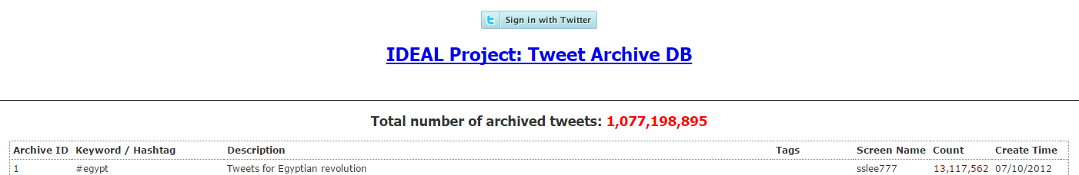
Figure 1 fields in current design of tweet collections

Web Table
- One of the table of tweet collections can be found on http://jingluo.dlib.vt.edu/twitter/
- At the top of the page, it shows the project name and the database name the tweets are archived in.
- The header of the table shows the total number of archived tweets.
- The tweet collections are shown in a table.
  - Columns: displays all fields of the collections.
  - Rows: displays all the collections in the database.
- Currently, the table is not interactive, so it is only for displaying the table (no ordering, no searching).
- The tool that the current design is using is “yourTwapperKeeper” (https://github.com/540co/yourTwapperKeeper).
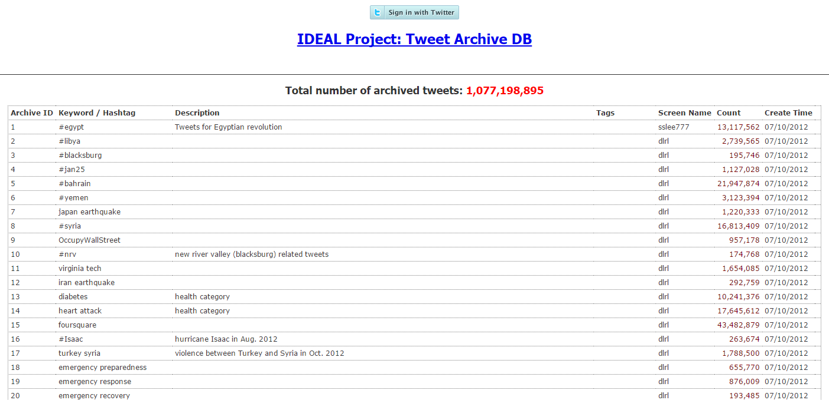
Figure 2 current design of collection table

New Design
Collections
- We kept all the fields that are originally there.
- We added new fields for event type, place and date tags.
- Each tag contains taxonomic layers.
Event Type:
Event Type 1 | Most general event types.  Ex., Man-Made Disaster, Natural Disaster
Event Type 2 | More specific event types.  Ex., Shooting, Climate Change
Event Type 3 | Most specific event types.  Ex., School Shooting, Storm

Place:
Country | Country the event has occurred
State | State the event has occurred
City | City the event has occurred

Date:
Year | Event occurred year
Month | Event occurred month
Day | Event occurred day

Web Table
Although the project has been refined to focus on categorization, our already created GUI can be used later.
- We use “yourTwapperKeepper” tool.
- Using yourTwapperKeepper tool, we added search boxes for searching by categories.
- Each columns will be made clickable for ordering of the table.
- We created a view that will show all the categories, and by clicking the category will filter the table to display only the related collections.

Tools
- yourTwapperKeeper
- MySQL Database
- PHP
- JQuery
- DataTables JQuery plug-in
- JavaScript
- CSS

Implementation
Overview
For the implementation there are three major phases: Research and Design, System Implementation, and Testing. The Research and Design phase includes meetings and discussions with the IDEAL team to find the right solution for categorization schemes. The system Implementation phase includes implementation of the database and web application. Testing includes testing and verifying.

Description
The first step of Implementation of the Tweet Categorization project involves researching for the suitable categorization schemes based on requirements and conveniences of the IDEAL team, especially Mr. Lee. Therefore listening to the IDEAL team’s opinions is required. During the IDEAL meetings, we discussed alternative categorization schemes. From the outcomes of the discussion, the right categorization scheme was selected, and the system implementations proceeded. The system implementation includes a database of over 1,000 tweet collections. The collections were manually analyzed and assigned into the correct categorizations. Then the yourTwapperKeeper tool, which the current Virginia Tech server is using for tweet collections, was modified. First the new search function was added to enable searching. Not only that, an order by columns function was added to the application. Also, the separate view was added that displayed all the categories, and we implemented so that clicking on the category will filter the table to show related collections.

Major Tasks
This subsection will show detailed tasks for the implementations.
Phase 1. Research and Design:
There are over 1,000 tweet collections that are assigned to us. The topics of these collections are various. Also there are many ambiguous topics that could belong to several or no categorization. Meetings and discussions was required to resolve these issues based on the needs and convenience of IDEAL team. Then the Excel file containing all the tweet collections was implemented based on the chosen categorization as a prototype and reference.
yourTwapperKeeper is the current tool that displays tweet collections to the web application. However, yourTwapperKeeper contains already set fields and provides limited functionalities. This tool was implemented so that searching functionality and ordering functionality are added. However, before making an actual implementation on the Virginia Tech server, it needs to be installed on a local server. The design will be implemented on the local server first. This will protect the current application from possible bugs.
- Preparation of several initial rough categorization schemes
  - These rough categorizations will later be shown to the IDEAL team and Mr.Lee, so if there is one from the choices that suits best for the IDEAL team’s goal, that scheme will be used.
- Meetings and Discussions to pick out optimal scheme
- Implementation of the tweet collections Excel file
- Installation of yourTwapperKeeper to local server
  - creation of local dummy server
  - creation of local dummy database
  - integration of yourTwapperKeeper to dummy server and database
Phase 2. System Implementation:
After the research and design of the categorization scheme is finalized, the next step is actual implementation to the system. The first implementation is to the database. The new categorization fields will be added to the database. Finally, yourTwapperKeeper tool will be implemented. First it will be implemented in the local server. yourTwapperKeeper tool implementation will include implementing a search algorithm to add search functionality, and implementing a sorting algorithm to add sorting by column functionality.
- Implementation of yourTwapperKeeper
  - Implementation of GUI
  - Implementation of search functionality
  - Implementation of sort functionality
  - Adding separate view that shows all clickable categories that will filter the table.

Phase 3. Testing:
Although the categorization scheme has been changed, and our focus changed to categorize the tweet collections Excel file, the already created GUI was tested using the dummy database. It was tested and verified in a local server, so that if any bug or misbehaving functionality is occurred it will be fixed. Then the implementations and modifications could bedocumented.
- Testing and Verification
- Documentation
Refinements
Throughout the several meetings and discussions, there have been some refinements made to the project. The refinements are organized in table 4.
Original Plan | Categorization: Use topology scheme to the event type only.  GUI: Create interactive table that will filter the collections from the search box, and that will enable users to use column ordering.
Refinement 1 | Categorization: Use tag system for event type, place and date.
Refinement 2 | Categorization: Use topology scheme to event type.  GUI: Create a categorization view that will display all categories, and enable clicking the category will filter the table to only show related collections.
Refinement 3 | Categorization: Use tag system for event type, place and date. And each tag will contain topology scheme.  GUI: Focus on categorization implementation.
Table 4 refinements

Refinement 1
The original implementation plan of the tweet categorization was to create a taxonomic structure so that the user can go down through the taxonomic order to search and browse. However through the IDEAL group meeting, the topological categorization scheme plan was changed to call for using a tag system.
Prototype
Purpose
The goal of our project, Tweet Categorization, is to help IDEAL team’s research. Therefore through multiple discussions and meetings, the project’s goal has been refined multiple times. However, in this section we would like to show the prototype made for refinement 1.
The two main parts of our project, for refinement 1, consist of categorizing tweet collections, and implementation of a User Interface for the table of yourTwapperKeeper. The categorization of tweet collections will enable users to group them based on the categorization so that the users can search for desired keywords or terms and show the results more easily, while the refined user interface of the table will make the features of the categorization feasible. The section will focus on the prototypes of the two main parts of our project: Database Implementation prototype and User Interface Implementation prototype.
Modelling the prototype
Tweet Categorization
The tag system will consist of three new tags: event type, place, and date. Each tag may contain zero to many keywords that are related to each tag type.
Event Type | Types of event
Place | Place where the event happened, or related places of the event
Date | Date the event has occurred

Through these tags, the users may search for collections. When the user searches for a keyword of a tag, all the collections that contain the keyword in the tag will be gathered, which will help the users see the related collections of the specific keyword.

Diagram (Tweet Categorization)
Searching for keyword in event type tags
Keyword | Event type | Place | Date
Hurricane sandy | Hurricane | Carolinas, Virginia, Washington D.C, USA … | October, November, 2012
Hurricane issac | Hurricane | Arkansas, Mississippi, Alabama, Louisiana, USA … | August, September, 2012
Oregon shooting | Shooting | Clackamas, Oregon, USA | December, 2012
Hurricane | Hurricane
#Tucson shooting | Shooting | Tucson, Arizona, USA | January, 2011
…

Event Type | Hurricane
Search tag & keyword


Searching for keyword in place tags
Keyword | Event type | Place | Date
Hurricane sandy | Hurricane | Carolinas, Virginia, Washington D.C, USA … | October, November, 2012
Hurricane issac | Hurricane | Arkansas, Mississippi, Alabama, Louisiana, USA … | August, September, 2012
Oregon shooting | Shooting | Clackamas, Oregon, USA | December, 2012
Hurricane | Hurricane
#Tucson shooting | Shooting | Tucson, Arizona, USA | January, 2011
…

Place | USA
Search tag & keyword

Keyword | Event type | Place | Date
Hurricane sandy | Hurricane | Carolinas, Virginia, Washington D.C, USA … | October, November, 2012
Hurricane issac | Hurricane | Arkansas, Mississippi, Alabama, Louisiana, USA … | August, September, 2012
Oregon shooting | Shooting | Clackamas, Oregon, USA | December, 2012
Hurricane | Hurricane
#Tucson shooting | Shooting | Tucson, Arizona, USA | January, 2011
…
Searching for keyword in date tags

Date | 2012
Search tag & keyword

New tags

The prototype of the database looks like this.
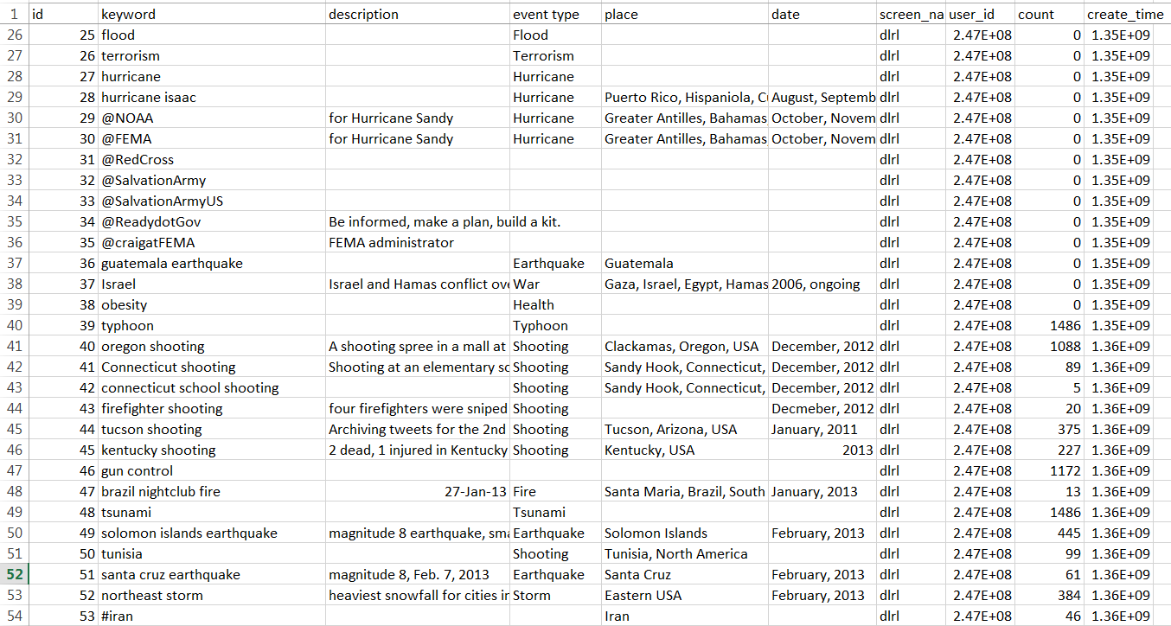
Figure 3 Prototype of the database
User Interface
The purpose of the user Interface portion of the project was to enable the users to interact with the data table, so that the user can sort the table by column or search by keyword. If the new categorization (new tags) shows what features could be added, then the user interface part is making those features feasible.
Diagram (User Interface)
Keyword | Event type | Place | Date
#Tucson shooting | Shooting | Tucson, Arizona, USA | January, 2011
Hurricane | Hurricane
Hurricane issac | Hurricane | Arkansas, Mississippi, Alabama, Louisiana, USA … | August, September, 2012
Hurricane sandy | Hurricane | Carolinas, Virginia, Washington D.C, USA … | October, November, 2012
Oregon shooting | Shooting | Clackamas, Oregon, USA | December, 2012
…

User sort by keyword

Keyword | Event type | Place | Date
Hurricane | Hurricane
Hurricane issac | Hurricane | Arkansas, Mississippi, Alabama, Louisiana, USA … | August, September, 2012
Hurricane sandy | Hurricane | Carolinas, Virginia, Washington D.C, USA … | October, November, 2012
#Tucson shooting | Shooting | Tucson, Arizona, USA | January, 2011
Oregon shooting | Shooting | Clackamas, Oregon, USA | December, 2012
…

User sort by Event type

Keyword | Event type | Place | Date
#Tucson shooting | Shooting | Tucson, Arizona, USA | January, 2011
Oregon shooting | Shooting | Clackamas, Oregon, USA | December, 2012
…

User search “shooting”

Keyword | Event type | Place | Date
Hurricane issac | Hurricane | Arkansas, Mississippi, Alabama, Louisiana, USA … | August, September, 2012
Hurricane sandy | Hurricane | Carolinas, Virginia, Washington D.C, USA … | October, November, 2012
#Tucson shooting | Shooting | Tucson, Arizona, USA | January, 2011
Oregon shooting | Shooting | Clackamas, Oregon, USA | December, 2012
…

User search “USA”

Prototype Process
In order to make the table interactive, we used the DataTables plug-in. DataTables is a plug-in for jQuery Javascript library. It is very flexible and allows developers freedom of modifying table to match their purposes.
In order to integrate DataTables, we modified the existing index.php file from yourTwapperKeeper sources. Figure 5 shows the prototype of DataTables integrated into yourTwapperKeeper. Notice how column headers include marks besides them which shows if a column was sorted. Also there is search bar at the top right corner. Figure 6 shows how it only shows collections that contains the keyword “shooting”.
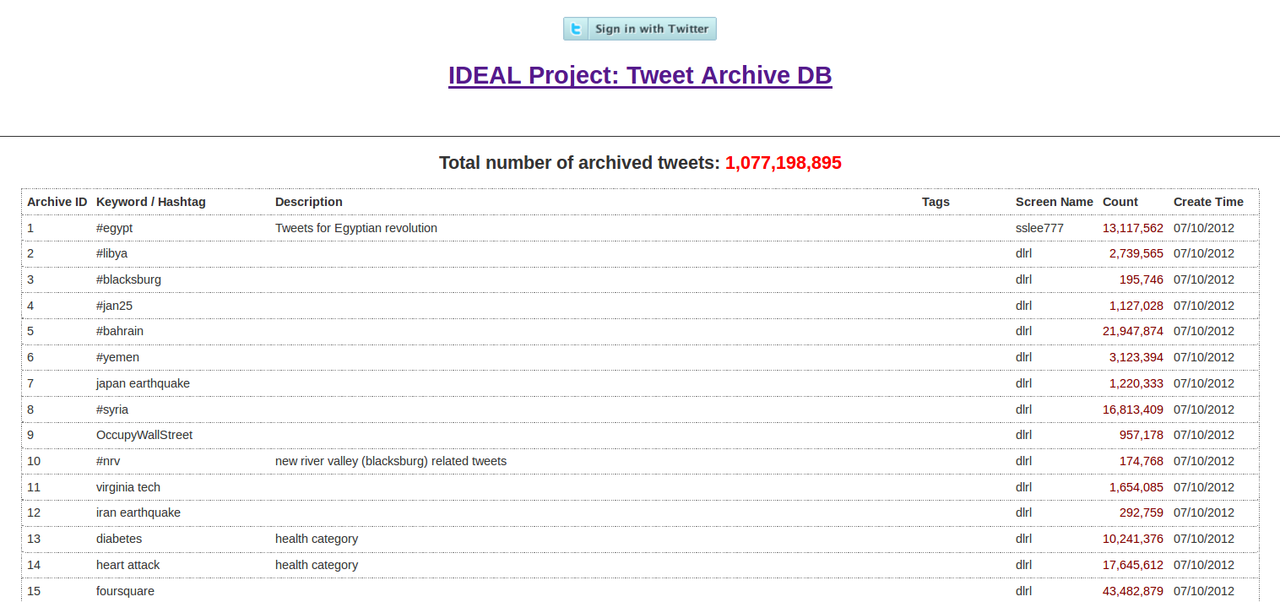
Figure 4 Current page using original yourTwapperKeeper UI
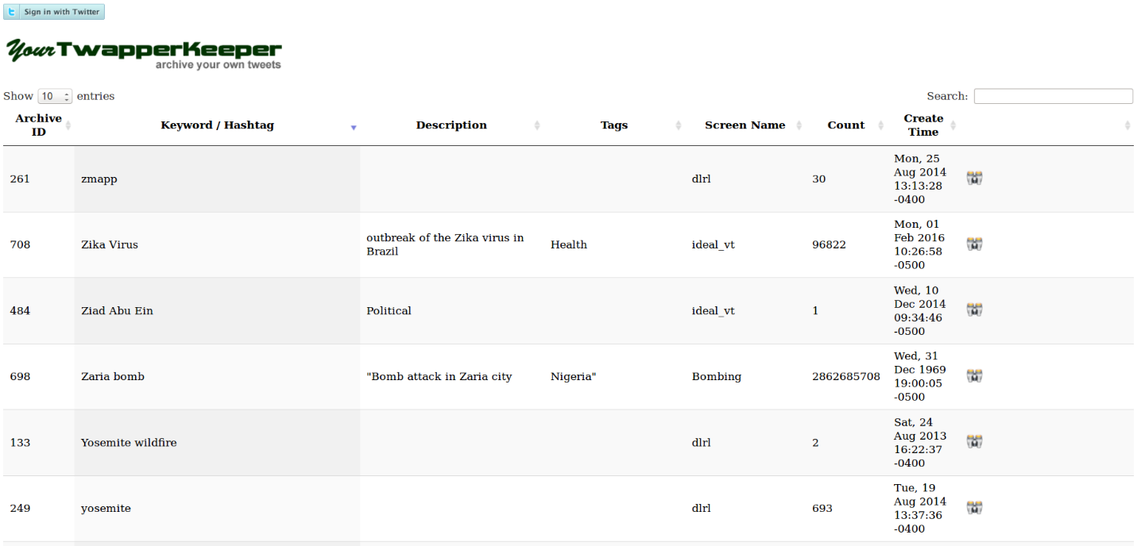
Figure 5 Table using DataTables jQuery Plug-in
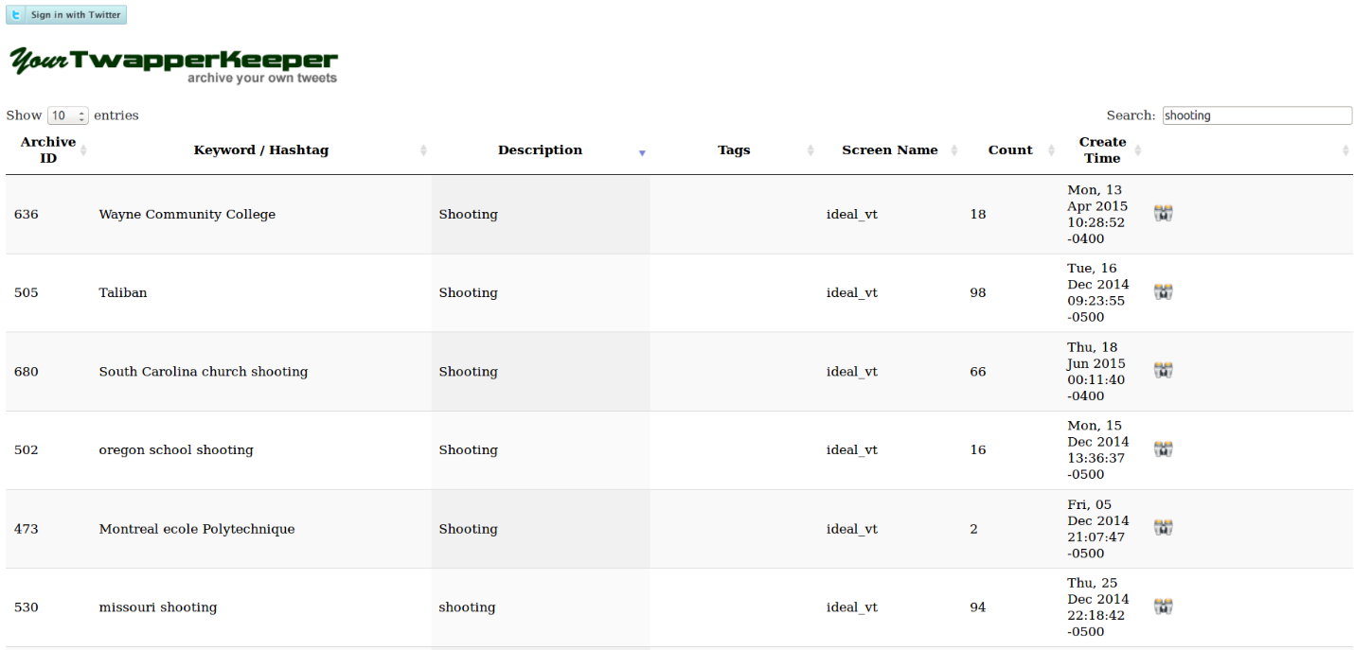
Figure 6 Table search with keyword "shooting"
After that the DataTables was integrated with the modified yourTwapperKeeper CSS file so that it becomes consistent with other pages in yourTwapperKeeper. Figure 7 shows the data table with yourTwapper background and containing sorting, and searching features.
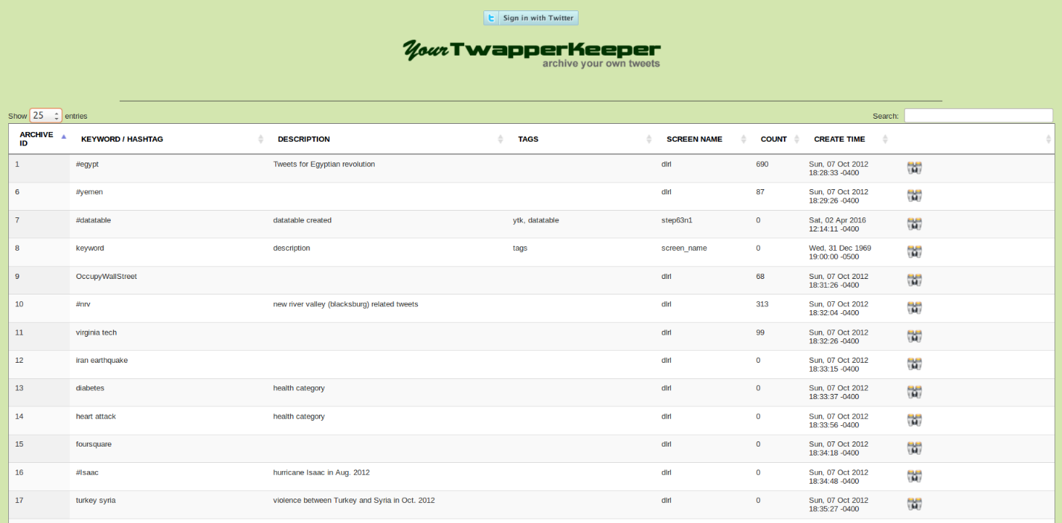
Figure 7 DataTables integrated with yourTwapperKeeper css
Refinement 2
From the meetings, the client wanted to have a database with categorization that uses the taxonomy scheme from the original project plan. Also in addition to the interface that allows users to search and order columns from the table, the client wanted an interface that will also allow users to view what types of categorizations there are. Clicking on that category will show all related tweet collections.

Interface
For refinement 2, we have created an interface that shows the users with categorizations that allows users to view what categories are available. Also each category in the view is made clickable, and clicking the category will show the related collections.
The interface will first show the most general categorization, as shown in Figure 8 and Figure 9.
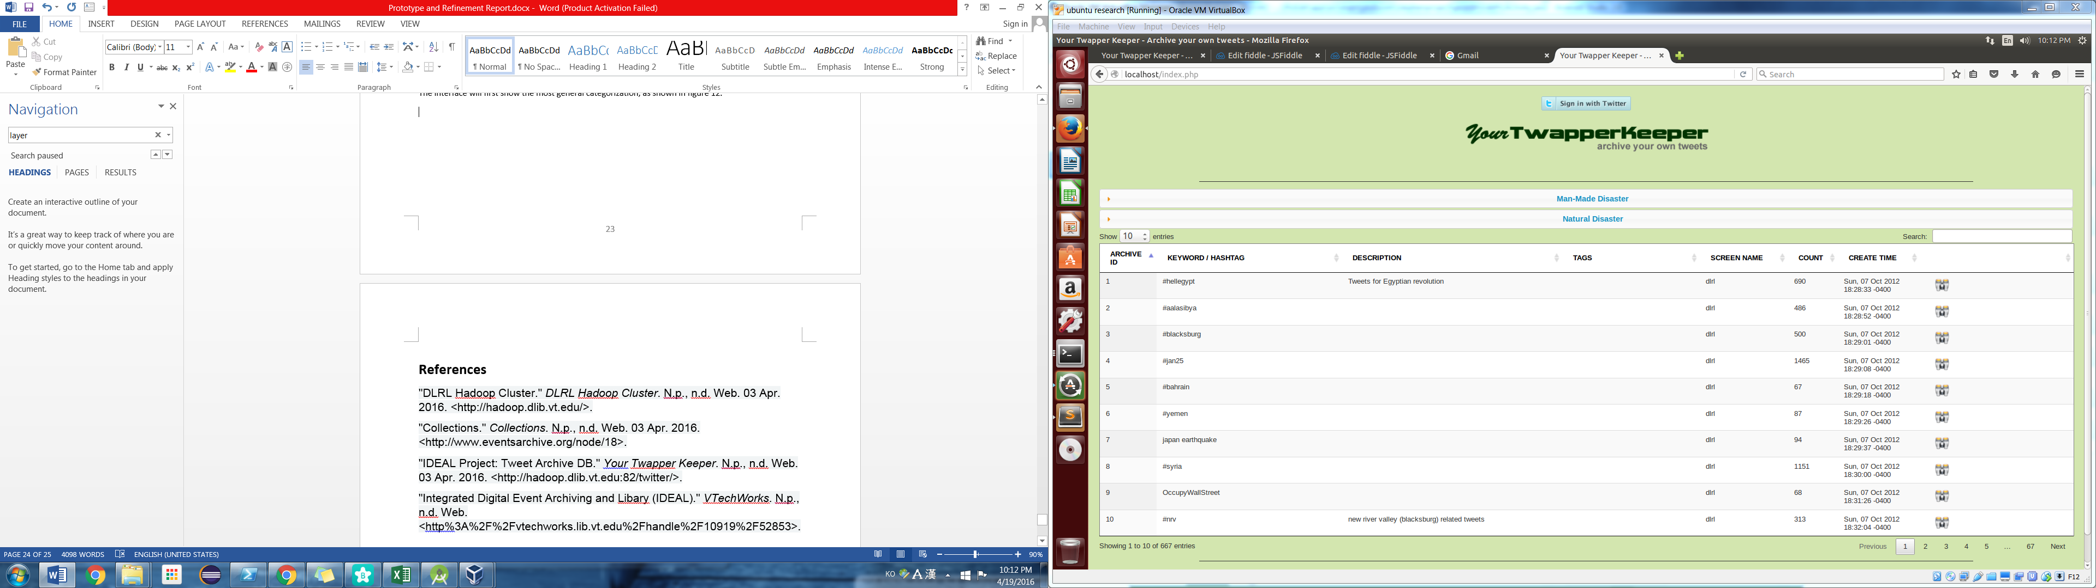
Figure 8 The new interface
Figure 9 Most general categorization view in the Interface
When the category is clicked the sub-categories will be shown to the users. Using the same method, when the sub-category is clicked the more specific categorizations will appear.
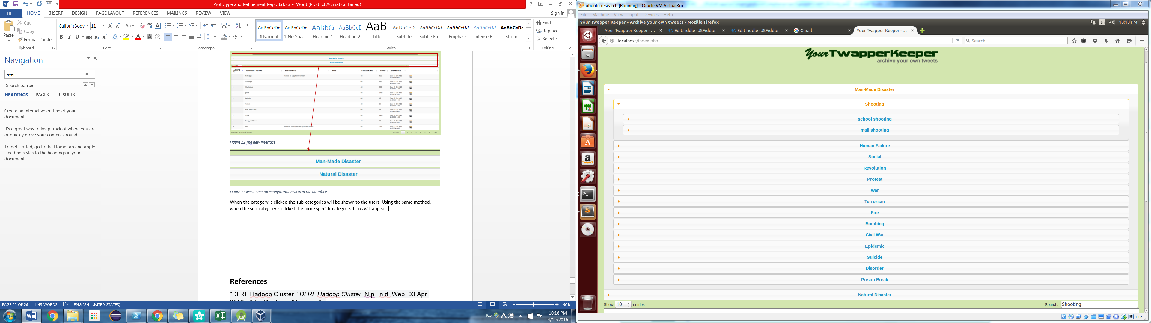
Figure 10 how it shows in the interface when categories are clicked
Figure 11 enlarged image of the interface
Also when each category is clicked it will list related collections. Figure 13 shows results of the table after clicking on the “Shooting” category.
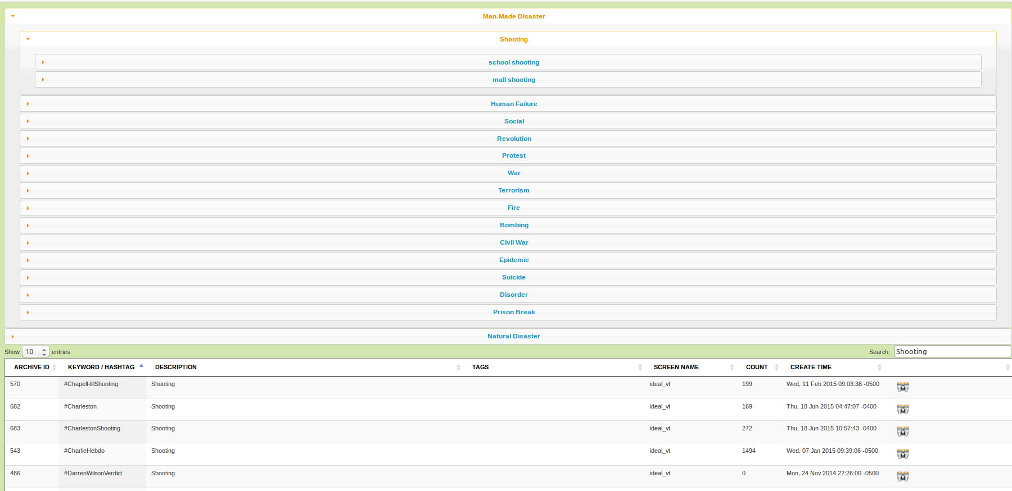
Figure 12 interface after "shooting" category is clicked
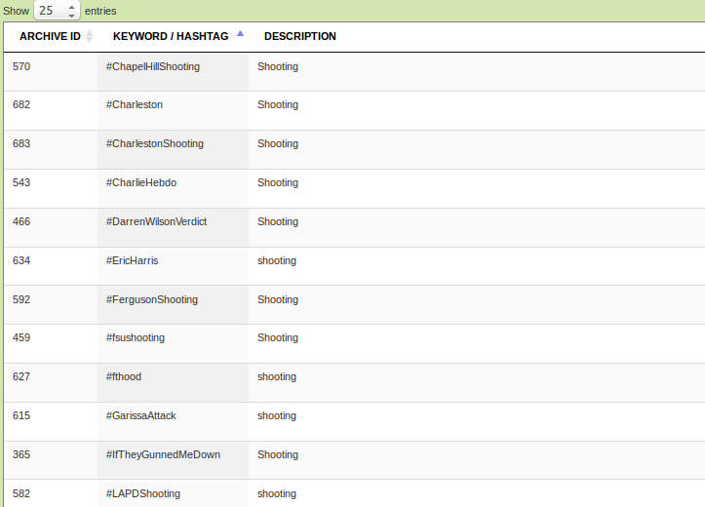
Figure 13 Enlarged view of table after "shooting" category is clicked

Refinement 3
However, from the later meetings the client wanted to change the categorization to use tagging system, and with the taxonomy for each tag. The detailed taxonomy explanation is explained later. Also from these meetings the project was shifted to put more weights on creating Excel files with the mentioned categorization system, instead of on the interface.
Categorization
Like in the previous tagging system introduced in refinement 1, there will still be three main tags, Event Type, Place, and Date. However, each tags will have its own topological system.
The Event Type tag uses a taxonomy scheme with three layers that is similar to the taxonomy scheme introduced in refinement 2. The first topological layer will be the general categories. The general categories will contain tags such as “Natural Event”, “Man-made Event”. The next layer will be the sub-categories with tags such as “Shooting”, “Human Failure”, and “Climate Change”. The last layer will be the specific categories that contain tags such as “School Shooting”, “Mall Shooting”, “Hurricane”, “Storm”, and so on.
The Place tag also contains three topological orders. The first field is country. If the event occurred across multiple countries, all the countries will be added in this field. The second field is state. Same as the country if the event occurred across multiple states, all the states will be included as tags in this field. Also if the country does not have states, then this field will be ignored. The last field is city. Also if the event occurred or happened among or across multiple cities, all cities will be added to this field. If the event happened in the entire country or state, this field may be ignored.
The last tag is Date. Date tag will contain three fields, year, month, and day. If the date tag is not required, for collections such as “Blacksburg” the tag may be left empty. If the event occurred in many days, months or years, all the appropriate years and months and days will be added to each field.

Event Type Tag
Place Tag

Date Tag

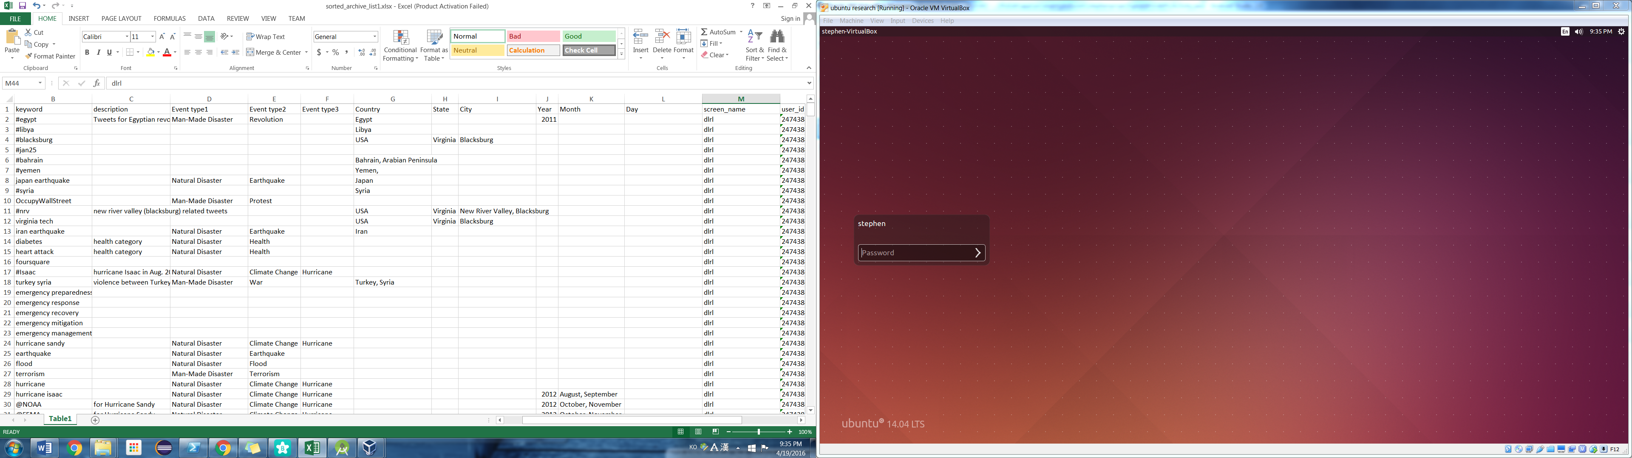
Figure 14 Excel file with new tag and taxonomy system

After creating an Excel file with the tagging system, this file will be moved into the database, and using search platforms such as SOLR, the interface and search function will be added in a different project.

Testing
Tested Functionalities
Functional testing for the following modules are in Scope of Testing
- searching
- column ordering
- category view expanding
- searching related tweet collections based on the clicked category from category view

Items Not Tested
Since the goal of the project has been altered, the integration of the new categorization database to the interface was not performed. However, when the interface testing was performed we used the Archive DB from the IDEAL project.
Types of Testing Performed
- Smoke Testing
- Integration Testing
1. Smoke Testing
Whenever new modules or functionalities are created, we made sure the major functionality is working fine. We made sure all the functionalities work correctly from the local Apache HTTP server before any database was integrated with the functionality. During this phase, we tested searching and, column ordering.
2. Integration Testing
We tested that the interface was working using the database “Archive DB” from http://hadoop.dlib.vt.edu/.
During this testing, we recognized that the database was not correctly showing on the page. We fixed the issue by fixing the CSS file that is imported to index.php file.
Results
From the tests, we found that the table works as intended. The search finds the keyword from the table. The column ordering orders the columns by its spelling or numbers. Also, the “Archive DB” was integrated correctly and shows on the table.

Lessons Learned
Throughout the semester long project, we have learned a great deal.
First I learned the importance of understanding the goal of the project. Although from the first meeting with the client we learned about the project, we were more focused on the tasks that are given to us than understanding the users’ needs and the purpose of the project. This resulted in several refinements.
Another lesson learned was the requirements of constant communication. In the beginning, before we had any knowledge about the tools, we took many hours to try to use and fix the problems that occurred with the tools. However when we met our client Sun Shin Lee, it was easily fixed. If we had contacted him earlier about the problem, we would have saved much time.

Implementation Schedule
Date | Description
February 26 | yourTwapperKeeper tool installation to our local machine in order to learn its functionalities, and user interface.
March 4 | Preparation of several categorization schemes to present to the IDEAL team. If there is a best fit scheme, the scheme will be used in the implementation
March 11 | Meeting with IDEAL team to show the prepared categorization and get feed backs.
March 20 | Implement Database using the new categorization
March 27 | Implement Graphical User Interface to allow users to search and order by column
April 3 | Implement refinement 1 and Create prototype
April 15 | Implement refinement 2 and Test
April 19 | Implement excel file with categorization from refinement 3

Future work
For the future work of the project, there are several advances for categorization and GUI that could be added.
Categorization:
- It could be applied to SOLR for search and interfaces.
- More topological layers could be added to each tag to be more specific.
  - more detailed event types
  - more specific region
  - time of the day
GUI:
- Instead of SOLR, the implemented GUI page could be used to display the collections
- Columns for each tag could be added.

Acknowledgements
I would like to express gratitude to Dr. Edward Fox for all the help, guidance, encouragement, and suggestions. His moral support helped me get through the project well.
I am grateful for Sun Shin Lee for taking time and providing guidance through the project. I appreciate very much for all the help he tried to provide when there were problems.
I would also like to thank the IDEAL team for valuable opinions and feedbacks.
Thanks Also go to NSF for support of grant IIS – 1319578: III: Small: Integrated Digital Event Archiving and Library (IDEAL)

References
Sunshin Lee. "DLRL Hadoop Cluster." 2016. Web. 03 Apr. 2016. http://hadoop.dlib.vt.edu/.
IDEAL project team. Collections page on Events Archiving website. 2016. Web. 03 Apr. 2016. http://www.eventsarchive.org/node/18.
IDEAL project team. "IDEAL Project: Tweet Archive DB." Your Twapper Keeper. 2016. Web. 03 Apr. 2016. http://hadoop.dlib.vt.edu:82/twitter/.
IDEAL project team. "Integrated Digital Event Archiving and Library (IDEAL) Annual Report." 2014-07-09. Web. http://vtechworks.lib.vt.edu/handle/10919/52853.

