Copyright Release Form
May 26, 2023
Graduate School
Virginia Tech
Blacksburg, VA

In accordance with Virginia Tech Graduate School requirements for the ETD submission, I hereby grant Virginia Tech a non-exclusive license to use my copyrighted dissertation entitled “Age of Information: Fundamentals, Distributions, and Applications”. The license shall include the right to archive the dissertation by Virginia Tech. I retain all ownership rights to the copyright of my dissertation. Moreover, I retain the right to use all or part of this dissertation to write articles or books in the future.

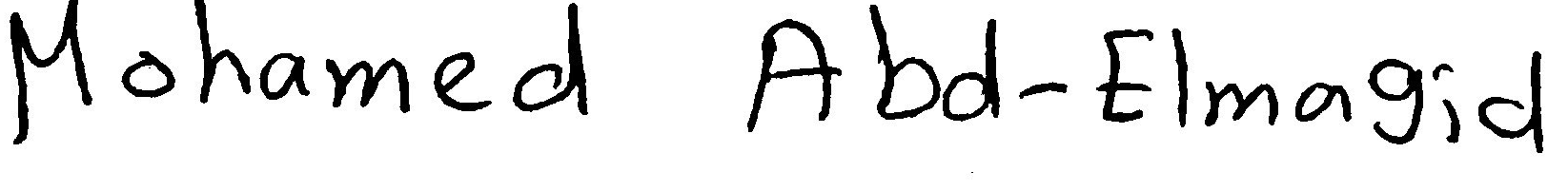
Mohamed Abd-Elaziz Abd-Elmagid Ali.

