Unpacking Creative Commons Licenses
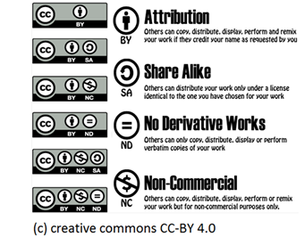
http://www.creativecommons.org

The six CC licenses permit varying types of uses. The following
chart illustrates the permissions, requirements, and restrictions of the CC licenses, from the least restrictive, to the most restrictive.

 | Users may | Users must | Users must not
CC BY | Copy, distribute, display, perform, and remix the work. | Attribute or credit the author as requested. Indicate any changes.
CC BY-SA  (CC BY Share Alike) | Copy, distribute, display, perform, and remix the work. | Attribute or credit the author as requested. Apply the same CC license used by the author to the derivative work. Indicate any changes.
CC BY-NC  (CC BY Non-Commercial) | Copy, distribute, display, perform, and remix the work. | Attribute or credit the author as requested. Indicate any changes. | Copy, distribute, display, perform, and remix the work for commercial purposes.
CC BY-ND  (CC BY No Derivative Works) | Copy, distribute, display, and perform verbatim (unchanged) copies of the work. | Attribute or credit the author as requested. | Remix or create derivatives of the work.
CC BY-NC-SA  (CC BY Non-Commercial, Share Alike) | Copy, distribute, display, perform, and remix the work for non-commercial purposes. | Attribute or credit the author as requested. Apply the same CC license used by the author to the derivative work. Indicate any changes. | Copy, distribute, display, perform, and remix the work for commercial purposes.
CC BY-NC-ND  (CC BY Non-Commercial, No Derivative Works) | Copy, distribute, display, and perform verbatim (unchanged) copies of the work for non-commercial purposes. | Attribute or credit the author as requested. | Remix or create and share derivatives of the work, nor copy, distribute, display, perform, and remix the work for commercial purposes.

