Exploration of Engaged Practice in Cooperative Extension and Implications for Higher Education

Karen A. Vines
Continuing Professional Education Specialist
Agricultural, Leadership, and Community Education
Virginia Tech
Blacksburg, Virginia
kvines@vt.edu

Introduction and Purpose
Calls for greater engagement of Cooperative Extension have been documented since the early 1960s (Fessler, 1964; Vines, Watts, & Parks, 1963) and continue today (Henning, Buchholz, Steele, & Ramaswamy, 2014; Reed, Swanson, & Schlutt, 2015). There are also calls for greater engagement in Higher Education (APLU Task Force on The New Engagement Planning Team, 2016; Byrne, 1998/2016 ; Fear & Sandmann, 2016). There is opportunity for Extension to provide leadership in guiding higher education in this charge because of its long history of connection in local communities (Kellogg Commission on the Future of State and Land Grant Universities, 1999; King & Boehlje, 2013; McDowell, 2003; Mitchell & Gillis, 2006; Peters, Alter, & Schwartzbach, 2010; Reed et al., 2015).
Although there has long been interest in greater engagement of Cooperative Extension, there has not been an operationalized definition of what engagement is or how it is to be achieved. Further, there is no indication of what Extension needs to do specifically to move to greater engagement. The purpose of this study was to define engagement within the context of Cooperative Extension, to increase understanding of how and why engagement is implemented by educators at the local level, and to identify barriers and drivers associated with the adoption of an engaged model for program delivery. The findings are useful for increasing understanding of the engaged model of program delivery for Cooperative Extension and for defining engagement within Cooperative Extension. They also provide guidance for increasing engagement of higher education in local communities. This study was unique in that the primary emphasis was placed on the use of expert and engaged models of program delivery at the local level.

Conceptual framework
Three components contributed to the development of the conceptual frameworks that describe the expert and engaged models of program delivery for Cooperative Extension used for this study. They are: 1) the educational approaches used by Extension (Franz and Townson, 2008), 2) theories of change associated with Extension work, and 3) normative traditions that describe the work of Extension professionals (Peters et al., 2010). The conceptual frameworks for this study were used to develop the initial definitions and primary theories (Yin, 2009) used as basis for the study.
Component 1: Educational approaches - The educational approaches used by Cooperative Extension are defined based on their emphasis on content and process (Franz and Townson, 2008). These include facilitation, transformative education, service and content transmission. Based on a review of the literature, I associated the approaches that are low in process, service and content transmission, with the more traditional, expert model of program delivery. I determined that the approaches that are high in process, facilitation and transformative education, are more consistent with the engaged model of program delivery (Figure 1).
Figure 1.
The Educational Approaches used in Cooperative Extension as related to Expert and Engaged Models of Program Delivery.
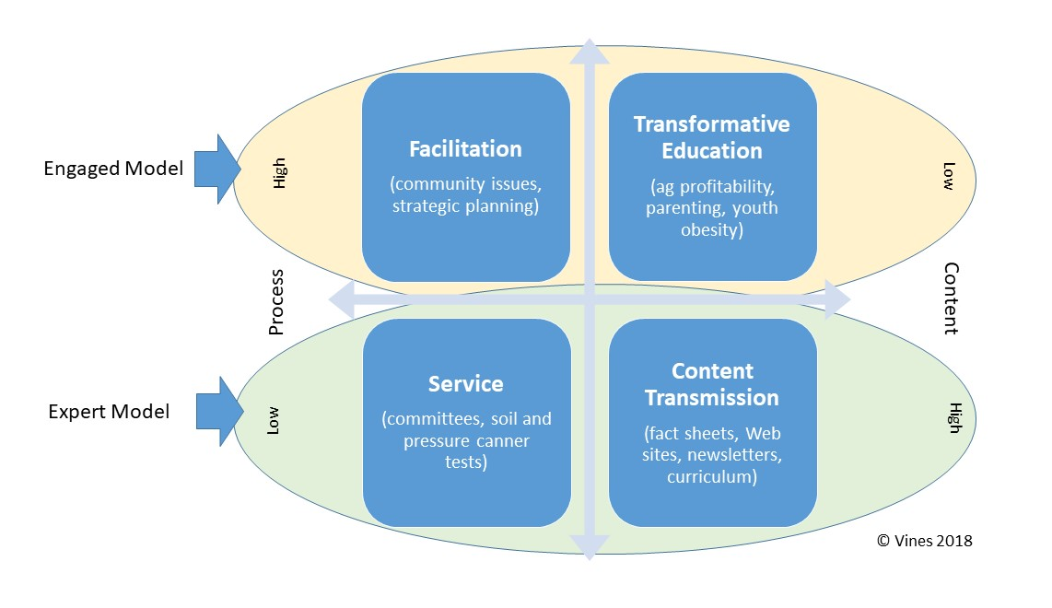
Component 2: Theories of Change – I identified theories of change related to the expert and engaged models of program delivery. The traditional theory used to describe the work of Cooperative Extension has been Rogers’s theory for diffusion of innovation (Foley, 2004; Franz, Piercy, Donaldson, Richard, & Westbrook, 2010; Seevers & Graham, 2012). This theory is consistent with the expert model of program delivery. It is based on education that targets innovators to adopt innovations that improve processes or products (Figure 2). Development and delivery of new technologies and innovations to clientele at the local level occurs through a hierarchical process (Rogers, 1995).
Figure 2.
The Expert Model of Program Delivery Based on Rogers's (1995) Diffusion of Innovations Theory.
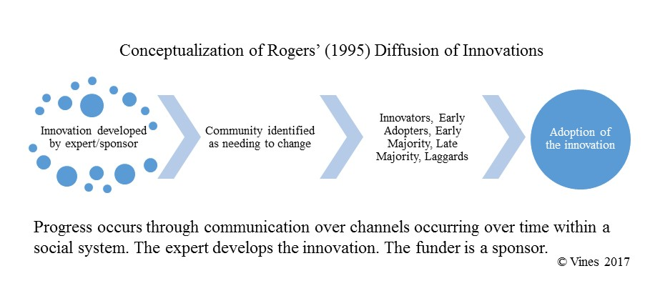
Collective impact theory has been used to describe work in adult education intended to strengthen communities and is consistent with engaged models for Cooperative Extension (Niewolny & Archibald, 2015). This theory describes how communities solve complex social issues involving multiple parties and provides for social change that cannot be achieved through the limited activities of individual organizations (Figure 3). Five conditions necessary for the achievement of collective impact are “a common agenda, shared measurement systems, mutually reinforcing activities, continuous communication, and backbone support organizations” (Kania & Kramer, 2011The Five Conditions of Collective Success section, para 1). Strong local connections and networks of resources help communities develop solutions. Responsibility for identifying the problem and solution is shared.
Figure 3.
The Engaged Model of Program Delivery Based on Kania and Kramer's Collective Impact Theory.
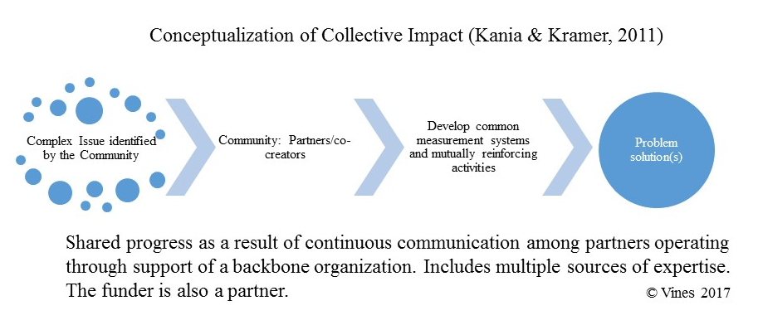
Component 3: Normative Traditions – This component focuses on faculty roles in society associated with the two models (Peters et al., 2010). Peters et al. (2010) defined four normative traditions related to these roles. For this study, I used the service intellectual tradition and the combined action researcher (AR), public scholar (PS), education organizer (EO).
The faculty member using the service intellectual tradition sees their work in society as responding to questions and providing services (Peters et al., 2010). As a service intellectual, the public role of faculty is “limited to the provision of facts, knowledge, technical assistance, and technologies” (Peters et al., 2010, p. 52). This tradition is consistent with the role of Extension professionals as change agents using the diffusion of innovations theory in the expert model of program delivery.
A faculty member using the AR/PS/EO tradition plays the multiple roles encompassed in the tradition, valuing shared expertise through ongoing two-way communication between the university and local citizens (Peters et al., 2010). Citizens are involved in identifying needs, developing and implementing programming to address those needs and evaluating achievements (Peters et al., 2010). These attributes define engagement (Beaulieu & Cordes, 2014; Bridger & Alter, 2006; Byrne, 1998/2016 ; Sandmann, Furco, & Adams, 2016). Their use in connecting the local community to the University exemplifies the use of an engaged model of program delivery and provides mutual benefits of shared learning to all parties (Bridger & Alter, 2006; Byrne, 1998/2016 ; Peters, Jordan, Alter, & Bridger, 2003; Sandmann et al., 2016). The University is a desirable partner because of the breadth of expertise it represents that can be applied to address a wide range of unique, complex challenges in communities.
Overarching Frameworks: Using these components, I developed overarching conceptual frameworks for the expert model (Figure 4) and the engaged model (Figure 5) of program delivery for Cooperative Extension. The overarching framework for the expert model emphasizes one-way communication and demonstrates the role of the university through Extension in providing expertise through technological innovations. The overarching framework for the engaged model demonstrates two-way communication and shared expertise as the partners work collectively to develop culturally relevant, contextual solutions.
Figure 4.
Overarching Conceptual Framework for the Expert Model of Program Delivery for Cooperative Extension.
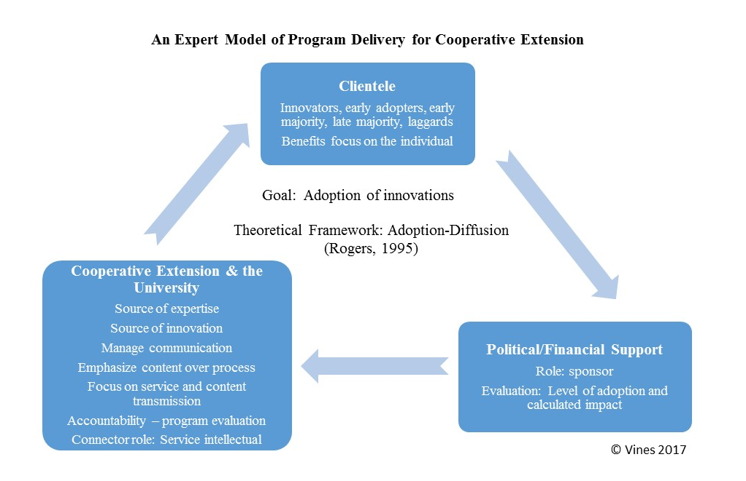
Figure 5.
Overarching Conceptual framework for the Engaged Model of Program Delivery for Cooperative Extension.
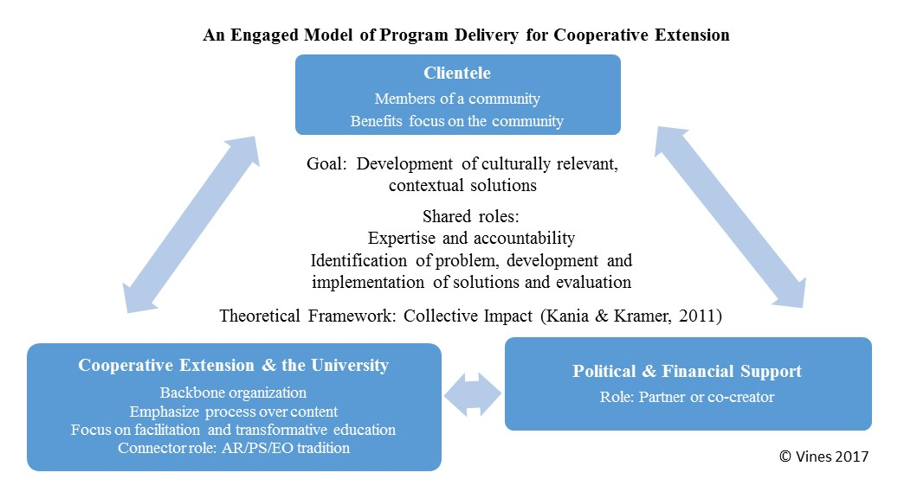

Methods and Data Sources
Three primary theories were used in development of the research questions and to determine data collection methods for the study (Yin, 2009). The primary theories are: 1) Definitions of engaged and expert models of program delivery exist and are operationalized within Cooperative Extension, 2) Extension educators use both engaged and expert models of program delivery dependent on the situation they are trying to address, and 3) There are organizational supports and barriers, beyond but including that of program area assignment which may encourage use of one model over another. The research questions are 1) How is an engaged model of program delivery defined within Cooperative Extension? 2) How is engagement implemented and more specifically when and why is an engagement method used as opposed to an expert model? and 3) Are there barriers and drivers associated with Extension’s move towards a more engaged model? Data were collected initially through an online survey of a panel of experts, followed by semi-structured interviews of Extension Educators and unstructured interviews with Extension directors in each of the selected states.
My purposes for this study were to define engagement within the context of Cooperative Extension, to increase understanding of how and why engagement is implemented by educators at the local level, and to identify barriers and drivers associated with the adoption of an engaged model of program delivery. I used a qualitative research approach because of the exploratory nature of the study. Through an embedded case study, I sought to describe the phenomena of expert versus engaged models of Extension program delivery within the context of two state Extension organizations. States and program areas used in this study were selected based on survey responses from a panel of experts through critical case sampling. I used purposeful random sampling to identify successful Extension educators in program areas thought to emphasize the expert and engaged models of program delivery. I conducted semi-structured interviews with 35 Extension educators in the two state Extension organizations. I collected additional data by survey of a panel of experts and from unstructured interviews with the state Extension directors for the selected states.

Results and Conclusions
The definitions for the expert and engaged models of program delivery of Cooperative Extension developed through the study are as follows:
The expert model of program delivery in Cooperative Extension emphasizes a one-way flow of information, although interaction with clientele exists in the form of discussion, questions and feedback. The university, through Extension, serves as the expert. In this role, Extension provides guidance and information and responds to questions. Expertise provided by the university is research-based, and the providers of expertise are carefully vetted representatives of the university. The community may be involved in the identification of program needs. Program planning, implementation and evaluation are internal activities of Extension. Other terms used to refer to this model are outreach, a bucket-filler approach, and top-down programming.
The engaged model of program delivery in Cooperative Extension is characterized by community involvement in all aspects of program development, sharing in the identification of issues to be addressed, developing a process for implementation and development of knowledge, evaluation and securing funding. Expertise and learning processes are shared. In the engaged model, Extension serves as a conduit between the community and the university. The engaged model is based on relationships with the community developed through continual interaction, partnerships and collaborations. Relationships and learning extend beyond traditional program boundaries. Learning experiences involving an engaged model are robust and rich, as the community works in both formal and informal settings to identify problems and develop solutions.
In this study, a third model of program delivery emerged and is identified as a hybrid model. The proposed definition for this model follows.
The hybrid model of program delivery in Cooperative Extension is used to involve clientele in the delivery of programming that meets local needs. The model emphasizes shared expertise that comes from the university, stakeholder organizations, and individual stakeholders. Stakeholders are also considered to be partners. Partners are involved in multiple aspects of programming, and their role may vary based on location. There is emphasis on continual interaction between Extension and the community throughout the programming process. In this model, the university provides state interest teams, data on trends and research while the local community is responsible for application. The community is defined by interest rather than geography. In this model, an expert approach may be used initially to increase community awareness in a subsequent, more engaged programming approach.
Educators participating in the study were asked to describe how they used the different models. Their responses are summarized in Table 1 related to the specific models based on: (a) reasons for use, (b) sources of expertise, (c) program delivery methods, (d) venues for program delivery and (e) partner roles.
Table 1.
Summary of Findings Provided by the Educators Related to Their Use of the Three Models.
 | Model
 | Expert | Engaged | Hybrid
- Reasons for use
Because of the attributes of the educator or topic - time management, personal preference | X
To allow co-creation with partners |  | X | X
To achieve better learning outcomes |  | X
To address specific types of topics |  | X
To build and strengthen relationships and social networks |  | X
To develop and improve program support |  | X
To develop solutions in complex situations |  | X | X
To introduce engaged programming | X
To introduce other Extension programming | X
To meet needs based on Extension’s role |  | X
To meet specific audience or community needs | X
To provide education for specific purposes - mandated programs, research presentation, answer specific questions, provide specific types of information, to address statewide themes, to provide professional service | X
To provide information | X
To provide sustainable solutions |  | X
To use both expert and engaged models |  |  | X
To include active learning experiences with audiences |  |  | X
To improve learning and retention |  |  | X
- Sources of expertise identified by educators
4-H Advisers/officers/teen leaders |  | X
Chamber of Commerce |  |  | X
Clientele |  | X
Community members/groups |  | X
Extension advisory committee |  | X
Extension educator | X | X | X
Information from neighboring universities | X
Learners |  | X
Legislators | X
Medical community |  |  | X
Scientific literature | X
State specialists | X
University | X |  | X
Youth |  | X
- Program delivery methods
Demonstrations | X | X
Face-to-face interaction | X | X | X
Facilitated meeting with moderated question session | X
Flipped classrooms |  | X
Lecturing – PowerPoint presentations | X
Net facts or guides for online download | X
Newsletters | X
Online interaction: social media discussions, email |  | X | X
Panel discussions |  | X
Personalized interaction | X |  | X
Phone calls | X
Press releases | X
Producer presentations, peer-instructors |  | X
Site assessments | X
Small groups |  | X
Social media posts | X
Technology-enhanced polling |  | X
Tours |  | X
Trouble-shooting | X
Use of open-ended questions |  | X
Video presentations | X
Webinars | X
- Venues for program delivery
Conference or exposition |  |  | X
Television | X
Internet | X | X | X
- Partner roles
Data analysis |  | X
Delivery method recommendations | X
Development of solutions |  | X | X
Financial support, programs and personnel |  | X | X
Identifying other potential partners |  | X
Implement research |  | X
Needs assessment | X |  | X
Presentation, including research findings |  | X | X
Problem identification |  | X
Program implementation |  | X
Program planning |  | X | X
Program promotion |  |  | X
Research data collection |  | X
Site selection for research projects |  | X

Finally, through the study, I identified barriers and drivers associated with Extension’s move toward an engaged model of program delivery. The barriers that were identified are summarized below with those mentioned most frequently at the top of the list.
- Time – Educators indicated that it took more time to use an engaged approach because of the multiple interactions that take place with clientele.
- Coordination – Educators indicated that it was difficult to coordinate their schedules and those of members of the community to create opportunities for ongoing interaction.
- Timeliness – Educators indicated that sometimes they needed to respond to an issue quickly and that the engaged model did not accommodate this.
- Existing expertise – Educators felt they had more experience and were more comfortable using an expert approach.
- Unwilling collaborators – Educators said that other educators and specialists were not always willing to use an engaged approach because they had not mastered it.
- Loss of control – Educators were concerned that if they used an engaged approach, they lost control of content and the quality of the educational programming.
- Expert knows best – Some educators felt that they knew what their communities needed and did not need them to be involved in the programming process.
- Clientele that just want answers – Educators said that sometimes people just want an answer to the question, not an education on a topic.
- Evaluation metrics – Educators said that their performance was evaluated based on the number of activities and contacts they reported. With an engaged approach there were fewer of both of these.
- Environmental limitations – Educators said that sometimes interaction with clientele was not possible because of large audiences or online presentations.
- Emphasis on being unbiased – Educators were concerned that by involving clientele they may be seen as supporting sides in various issues.
The drivers associated with use of the engaged model are summarized below with those mentioned most frequently at the top of the list.
- Local program support – Educators found use of an engaged model of program delivery increased program support.
- Organizational support – The Extension Director in both states was seen as supportive of using an engaged model of program delivery by the educators.
- Stronger programs – Educators said their program was more responsive to the community needs, and were more sustainable when using an engaged model of program delivery.
- Better outcomes – Educators witnessed more behavior change leading to long term outcomes when using an engaged model. In addition, they found it much easier to identify these outcomes because of the ongoing nature of the programs and the strong relationships that developed.
- Supporting the future of Extension – Educators stated that the engaged model of program delivery was the only model that provided long term support for the future of Extension because of the increased support and impact this provided.

Significance for Theory, Research, and Practice
Through this study operationalized definitions of the expert, engaged and hybrid models of program delivery were developed for Cooperative Extension. This fills a void and will improve conversations around engagement by providing a common meaning. The definition for the engaged model is consistent with, although more detailed than the definition of engagement provided by the Carnegie Classification for Community Engagement used in higher education in general (New England Resource Center for Higher Education, n.d.). Both expert and engaged models of program delivery are used in Cooperative Extension, and there is agreement on what they entail. These may more appropriately be combined to form the hybrid model of program delivery which may provide greater representation of what is used and what is desirable because of the way in which it provides accommodation for shared expertise.
Examples of the use of the expert and engaged models are consistent with the educational approaches for Extension described by Franz and Townson (2008) and as classified as expert or engaged in this study. Degree of interaction with clientele and desired outcomes may contribute to defining these approaches, in addition to process and content. Being able to identify the educational approaches used within the Extension organization will be useful connecting resource allocation and delivery methods.
The theory of collective impact (Kania & Kramer, 2011) is consistent with the engaged work being carried out by educators at the local level. Educators generally involve their communities in needs assessment regardless of the model used. However, there is opportunity for many Extension programs to move to a more fluid model of problem solving depicted by collective impact. This can be accomplished by adapting program planning processes and evaluation of programs and performance to encourage greater engagement. Examples of ongoing communication and evaluation methods identified by communities using this process will provide insight into how this theory may be more fully implemented. The characteristics that Extension organizations look for when selecting Extension professionals and administrators may change as Extension moves to greater engagement.
The model of engaged program delivery found in this study indicates that Cooperative Extension has developed strong relationships on which universities can build as they seek greater engagement. This is especially true when considering the research and outreach missions of the land-grant universities. Greater attention needs to be paid to how students are incorporated into the engaged work of Cooperative Extension. Also, interaction between Extension professionals at the local level and on the University campus must be planned to provide for development of relationships that can provide opportunity for collaboration based on areas of expertise.
There are barriers and drivers associated with use of the engaged model. However, these may not be based on program area. Many of the barriers can be overcome by building on existing organizational and community support. Extension educators need to be given assurance that the time investment in an engaged model is recognized and appreciated. Changes in evaluation processes need to be made throughout the university to reflect emphasis on community engagement with attention to the different roles of local and campus faculty. The emphasis for faculty evaluation at the university level may be more related to content, while at the community level in an engaged model, evaluation may relate more to process. University organizations need to accept this and support measures that are most appropriate to the work that is expected based on the faculty role.
Further exploration is recommended to explore the perspectives of Extension stakeholders, specialists and administrators related to the shift to an engaged model of program delivery. There may be room for revision in the definition of the engaged model as Cooperative Extension works with communities more toward achieving collective impact that encompasses all aspects of developing solutions to community issues rather than focuses solely on educational programs. As previously mentioned, there is also need for further study to describe the hybrid model. This blending of the models seems to provide opportunity to combine expertise from multiple sources within the local context to provide more appropriate, sustainable solutions.

Acknowledgments
I would like to express appreciation to the two state organizations and educators who participated in this study. In addition, I acknowledge and extend thanks to my dissertation committee chair, Connie Baggett, and committee members Ted Alter, Linda Caldwell, and Ed Yoder from The Pennsylvania State University and committee member Eric Kauffman from Virginia Tech.

Recommendation for Further Reading
This overview is derived from my doctoral dissertation titled Engagement through Cooperative Extension: Towards understanding meaning and practice among educators in two state Extension systems published at The Pennsylvania State University. The dissertation is available in its entirety at https://etda.libraries.psu.edu/catalog/13816kav11.

References
APLU Task Force on The New Engagement Planning Team. (2016). The new engagement: Exploring the issues across the spectrum - a framework for thought and action by the Task Force on The New Engagement. Retrieved from http://www.aplu.org/library/the-new-engagement-exploring-the-issues-across-a-spectrum/File
Beaulieu, L. J., & Cordes, S. (2014). Extension community development: Building strong, vibrant communities. Journal of Extension, 52(5). Retrieved from http://www.joe.org/joe/2014october/pdf/JOE_v52_5comm1.pdf
Bridger, J. C., & Alter, T. R. (2006). Place, community development, and social capital. Community Development, 37(1), 5-18. doi:10.1080/15575330609490151
Byrne, J. V. (2016). Outreach, engagement, and the changing culture of the university. Journal of Higher Education Outreach and Engagement, 20(1), 53-58. (Original work published 1998)
Fear, F., & Sandmann, L. R. (2016). It's time for a second-wave movement Journal of Higher Education Outreach and Engagement (Vol. 20, pp. 113-126).
Fessler, D. R. (1964). Alternative to Extension's future. Journal of Extension, 170-172. Retrieved from Journal of Extension website: http://www.joe.org/joe/1964fall/1964-3-a7.pdf
Foley, G. (2004). Dimensions of adult learning: Adult education and training in a global era. Maidenhead: Open University Press.
Franz, N. K., Piercy, F., Donaldson, J., Richard, R., & Westbrook, J. (2010). How farmers learn: Implications for agricultural educators. Journal of Rural Social Sciences, 25(1), 37-59.
Franz, N. K., & Townson, L. (2008). The nature of complex organizations: The case of Cooperative Extension. In M. T. Braverman, M. Engle, M. E. Arnold, & R. A. Rennekamp (Eds.), Program evaluation in a complex organizational system: Lessons from Cooperative Extension (Vol. 120, pp. 5-14): New Directions for Evaluation.
Henning, J., Buchholz, D., Steele, D., & Ramaswamy, S. (2014). Milestones and the future for Cooperative Extension. Journal of Extension, 52(6COM1). Retrieved from http://www.joe.org/joe/2014december/pdf/JOE_v52_6comm1.pdf
Kania, J., & Kramer, M. (2011). Collective impact. Stanford Social Innovation Review. Retrieved from http://ssir.org/articles/entry/collective_impact
Kellogg Commission on the Future of State and Land Grant Universities. (1999). Returning to our roots: The engaged institution. Third report. Retrieved from Washington, DC: http://eric.ed.gov/?id=ED426676
King, D. A., & Boehlje, M. D. (2013). A return to the basics: The solution for eXtension. Journal of Extension, 51(5). Retrieved from http://www.joe.org/joe/2013october/comm2.php
McDowell, G. R. (2003). Engaged universities: Lessons from the land-grant universities and Extension. The Annals of the American Academy, 585(January), 31-50. doi:10.1177/0002716202238565
Mitchell, M., & Gillis, B. (2006). Perceptions of Extension's desirable future and the role of IT. Journal of Extension, 44(3). Retrieved from http://www.joe.org/joe/2006june/a1.php
New England Resource Center for Higher Education. (n.d.). Carnegie community engagement classification. Retrieved from http://www.nerche.org/index.php?option=com_content&view=article&id=341&Itemid=92
Niewolny, K. L., & Archibald, T. G. (2015). Collective impact in/for adult education: A framework for collective action to address community complexity and resilience. Paper presented at the Adult Education Research Conference, Manhattan, KS. http://newprairiepress.org/aerc/2015/roundtables/12/
Peters, S. J., Alter, T. R., & Schwartzbach, N. (2010). Democracy and higher education: Traditions and stories of civic engagement. East Lansing, MI: Michigan State University Press.
Peters, S. J., Jordan, N. R., Alter, T. R., & Bridger, J. C. (2003). The craft of public scholarship in land-grant education. Journal of Higher Education Outreach and Engagement, 8(1), 75-85.
Reed, A. S., Swanson, L., & Schlutt, F. (2015). Timberline manifesto: Seven concepts linking Extension and engagement. Journal of Extension, 53(4). Retrieved from http://www.joe.org/joe/2015august/comm1.php
Rogers, E. M. (1995). Diffusion of innovations (4th ed.). New York: The Free Press.
Sandmann, L. R., Furco, A., & Adams, K. R. (2016). Building the field of Higher Education engagement: A 20-year retrospective. Journal of Higher Education Outreach and Engagement, 20(2), 1-14.
Seevers, B., & Graham, D. (2012). Education through Cooperative Extension (3rd ed.). Fayetteville, AR: University of Arkansas.
Vines, C. A., Watts, L. H., & Parks, W. R. (1963). Extension's future. Journal of Extension, 239-246. Retrieved from https://joe.org/joe/1963winter/1963-4-a7.pdf
Yin, R. K. (2009). Case study research: Design and methods (4th ed.). Thousand Oaks, CA: SAGE Inc.

Abstract
Greater engagement has been emphasized as a need for Cooperative Extension for decades. Today this need is also seen in higher education. There is need for clarity regarding the definition and community implementation of engagement. This study sought to address this need through semi-structured interviews with 35 Extension educators in two state Extension organizations. Emergent in the study was the use of a hybrid model of program delivery in Cooperative Extension. A conceptual framework, definitions, and an overview of implementation for expert, engaged, and hybrid models is provided. Related implications for greater engagement in Cooperative Extension, higher education are presented.

Keywords
Extension engagement, Higher Education Engagement, Expert Model, Engaged Model, Hybrid Model

