The Post-public City: Experiences from Post-socialist Europe
PLEASE CITE AS: Hirt, S. 2014. The Post-public City: Experiences from Post-socialist Europe. Globalizing Architecture: Flows and Disruptions. Refereed Proceedings of the 102nd Annual Conference of the Association of Collegiate Schools of Architecture, 123-129.
Public space has become an increasingly important focus in the work of architects, urban designers, philosophers, geographers, sociologists and others interested in promoting a more civil and democratic society. This vigorous attention to public space as an object of design and scholarly inquiry is likely driven by two factors. The first factor is the strong purported connection between vibrant public space as a material arena and a vibrant public sphere as a social condition. Space is not just a blank canvas on which social phenomena are imprinted. Rather, it is one of the very “constructive dimensions” of social life. Open, accessible, inclusive public space may serve as venue of social interactions that teach the values of tolerance, engagement and citizenship—values that are an “essential precondition for building a public world.” Lack of such spaces may lead to the opposite: a “trained incapacity for public life.” The second factor is the recent erosion of public space. Despite its importance, public space has in recent years been increasingly replaced by explicitly private or quasi-public spatial forms that are easily accessible only to select segments of the population. Examples include malls, gated communities, exclusive suburbs, office parks, new or gentrified urban districts, etc. Ellen Dunham-Jones and June Williamson make a useful distinction between the values of community (i.e., exclusivity, membership, belonging to a group) transmitted in quasi-public spaces of the type mentioned above and those of civility (i.e., openness, inclusion, respect for otherness) transmitted in truly public spaces. This trend toward the privatization of urban space as a part of the broader privatization of the public sphere was initially highlighted in the United States and other parts of the “Western” world by scholars such as Michael Sorkin, Edward Blakeley and Nan Ellin but has by now been documented around the globe.

Of course, even the most open public spaces are not necessarily wonderful material enablers of an inclusive public realm. On the contrary, there are countless examples of spectacular public spaces created by various regimes for the purpose of disciplining or even penalizing the public: executions were a common function in medieval town squares; Haussmann-type boulevard-building had much to do with solidifying imperial control over urban space; Victorian-era public parks and City-Beautiful-era civic centers were meant to endow the downtrodden urban masses with a middle-class morality, etc. And many public spaces throughout history—from the Roman Forum to the Soviet-style People’s Palace—were envisioned as places where an obedient public would celebrate the power of its rulers. Even in such cases, however, the original controlling function of the public space was challenged by later generations, as evidenced by the fact that many democracy-seeking revolutions have started precisely from the public spaces that were once built to glorify autocratic regimes. As James Holston and Arjun Appadurai put it, “there is something irreducible and nontransferable, necessary if not quite sufficient, about the city’s public street and square for the realization of a meaningfully democratic citizenship.”

In this essay, I discuss the evolution (or, more precisely, devolution) of public spaces in cities in the former Eastern-bloc countries. Consistent with Soviet theory on the importance of public space for the construction of a new “socialist man,” during the period of state socialism cities in these countries were endowed with massive public spaces, such as parks and plazas, whose purpose was ceremonial and disciplinary than democratic. But regardless of their flaws, these spaces became sites of rich interactions between multiple publics across class and other traditional social distinctions. Over the last quarter of century, since the fall of state socialism, these spaces have been under intense attack by private capital; many have vanished. The major newly constructed spaces are often proudly private. The paper’s thesis is that Michael Sorkin’s and other influential theorists’ noir predictions of the “end of public space” in the global-North cities (e.g., LA) may actually have come to pass to a much greater extent in the East European cities where a once-exaggerated public sphere suddenly collapsed circa 1990.

The essay is inspired by recent scholarly calls to “provincialize” the much-studied cities of the global North as centers of urban theory-building. Thus, it looks to “ordinary cities” in the Central-East European countries that are often categorized as “developing,” “emerging” or “transitional” as potential loci in which radical public-space transformations may occur.

The essay is organized as follows. I first contrast the space-building practices during the socialist and post-socialist periods within the context of the political economies and the ideological priorities of the socialist and post-socialist regimes. Next, I explore case studies from the Bulgarian capital of Sofia, which may epitomize a new paradigm of public-space building.

Public Space in the Socialist City
During the half century (1945-1990) that communist regimes ruled Central and Eastern Europe, the construction of monumental public spaces—parks, plazas, boulevards, generous greenery organized in housing super-blocks—was a key component of the regimes’ aspirations to consolidate power and transform the basic structure of society. Of course, monumental public spaces were also used as an expression of state control and an instrument of social restructuring in many societies dominated by modernist ideologies: e.g., in the various Haussmann- and Corbusier-inspired design schemes that spread around the globe in the 19th and 20th centuries. Yet, arguably, in no other world region were such schemes so grand and so systematically employed to convey the primacy of collectivist and egalitarian values. Since the official position of socialist governments was that the “structure of our [socialist] culture must be based on collectivist ideals,” and architecture and urbanism were commonly presented as the “material synthesis of culture,” it followed that they had a key role to play in transforming society and culture. This transformation was enabled by the political economy of state socialism; specifically, the fact that the state had nationalized the majority of urban land, real estate and means of production and could therefore exert near-complete control over spatial production without much interference or opposition from private actors. Massive demolitions in the downtowns of large cities could then occur so that vast and ceremonial plazas could be built (see Figure 1).

Fig. 1. Downtown Sofia in the 1950s. The newly built House of the Communist Party towers above some shabby homes soon to be demolished for a large ceremonial plaza (the Largo). Such ceremonial plazas were a spatial hallmark of socialist regimes and were meant to convey their triumph over petty private interests. Source: http://www.stara-sofia.com
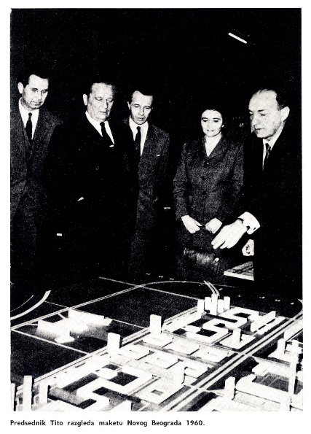
Fig. 2. Marshall Josip Tito, ruler of Yugoslavia, admires a 1960 model of the future New Belgrade: the largest mass-housing district erected in the Yugoslav capital during the socialist period. The similarities with other modernist districts constructed in the mid-20th century around the world are obvious. Yet, socialist regimes distinguished themselves in the scale and ambition of such projects and in the extent to which they employed public space as a mechanism for transforming society. Source: Town Planning Institute of Belgrade.

Public parks and other public green spaces in socialist conditions were especially generous. Compare, for example, Budapest with Vienna, two major European cities that until 1918 were part of the same empire. Circa 1990, public green space per capita in Budapest was nearly four times that in Vienna. Even in the poorer countries of the Eastern Bloc, such as Bulgaria, investment in public space was massive. Between national independence in 1878 and World War II, a period of sixty years, the Bulgarian capital of Sofia acquired about 130 hectares of public greenery; however, during forty-five years of socialism, that number increased twenty-one times to reach 2750 hectares, making socialist Sofia one of the greenest capitals in Europe. Housing patterns reflected the same pro-public ideology. Single-family living was perceived as inexcusably individualist and strongly discouraged in the large cities. The majority of the urban population was concentrated in mass-housing buildings situated among generous stretches of green space accessible to all (see Figure 2). In Bucharest, Romania, for instance, no less than 80% of the population lived in such buildings: a number well exceeding that of any West European capital.

It could well be argued that the lavish public spaces produced between 1945 and 1990 became one of the most positive material legacies of the otherwise authoritarian communist regimes. Throughout the socialist decades, the parks and gardens that they built were full of all sorts of people at all hours of the day. Public behavior in the ceremonial plazas was tightly controlled, yet the demonstrations that brought the regimes down during the eventful years of 1989 and 1990 began often in these very same plazas.

Disappearing Act: Public Space after Socialism
Socialist-style generosity in public-space building could not continue after the Velvet Revolutions. In most countries, urban land was re-privatized in a few short years after 1990, thus becoming a financially precious commodity. As the state lost its near-monopoly on city-building and the private sector took the initiative, competition to convert open spaces to built structures and their accessories (e.g., parking) intensified sharply, especially in gentrifying central-city neighborhoods, the socialist-era mass-housing complexes, and the periphery of large cities (e.g., on agricultural fields and greenbelts). Systematic cross-national data on the disappearance of public space during the post-socialist years is not available, but individual cases indicate the intensity of the process. In two years, from 1999 to 2001, Moscow lost about 750 hectares of forests located in its once-lush metropolitan greenbelt. Between 1991 and 2001, forests in the Russian capital declined by 15 percent, and grassy areas shrunk by 55 per cent. At the same time, impervious surface increased by 26 percent. Poland registered a much larger decrease in farmland during the first 14 years of the post-socialist transition (1990-2004) than in the 52 years between 1938 and 1990. In the Bulgarian capital of Sofia, an estimated 30% of all public green spaces were “lost in transition,” with a similar amount tied up in legal disputes between municipal authorities and the private owners who have submitted development applications. This process of public-space loss occurred in the context of the much-weakened position of public authorities during the post-socialist period, including the near-complete collapse of municipal design strategies and planning efforts in the 1990s. During this time, most new development occurred on an ad-hoc basis through piecemeal amendments of the existing design and regulatory plans. These amendments were almost always initiated by the private sector: a design/planning paradigm accurately referred to as “investor urbanism” (i.e., developer-led as opposed to public-led urbanism). Similar decline in publically driven urban design and plan-making has also been reported in “Western” cities, but not to the extent observed in the post-socialist world, where during the 1990s comprehensive, public-led planning was considered a vestige of the old communist system, and privatization of space was celebrated, even in public-policy documents, as evidence of becoming “Western.”

Much of this spatial privatization has been led by multinational capital. Large cities in the region began to participate in the “go global” competition by offering various incentives to multinational capital to take the lead in city-building and help them ditch their old, grey images for those of glittering tourist-friendly “global cities”—a trend cleverly dubbed “capitalist realism.” The most monumental spaces constructed in the aftermath of socialism, from Berlin’s Potsdamer Platz to Moscow’s International Business Centre, are anchored by the headquarters of elite global business and entertainment players. Both projects have been critiqued for creating primarily inward, exclusive and consumption-oriented spaces (i.e., spaces concentrated in atriums and shopping malls) rather than open, accessible ones. A similar reorganization of space has been documented in everyday housing landscapes. Once sites for the creation of the mythically selfless “socialist man,” the socialist-era mass-housing districts are increasingly occupied by members of the lower and lower-middle classes. Elites have moved to gentrifying central-city neighborhoods and to the periphery of cities, in suburbs dominated by luxury single-family homes. A characteristic feature of the new housing complexes—one that distinguishes them sharply from their socialist-era predecessors—is that they are gated and guarded and include various facilities (from green spaces to spas and sports centers) that are accessible to residents only. Not surprisingly, the literature on gated communities in Central-East European settings is one of the fastest-growing branches of the literature on such communities globally.

In the following section, I explore the recent reconfiguration of public space in an “ordinary city,” the Bulgarian capital of Sofia. I use two recent large-scale projects located at the edge of the city, Business Park Sofia and Residential Park Sofia, as examples of the new public space.

Fortress Sofia: Gated and Guarded after Socialism
Lacking the resources available to Central-East Europe’s grandest cities such as Berlin and Moscow, the capital of Bulgaria was a bit slow to join the “go-global” image-remaking process. But with the return to economic stability in the late 1990s and especially since the country joined the European Union in 2007, Sofia’s elites have enthusiastically embraced discourses on the virtues of transforming Sofia into a truly “European” capital. This fuzzy label is used to mean virtually anything: from genuine improvements that would benefit the large majority of the urban population (e.g., a new subway) to projects with much narrower social impacts. The latter category includes the official incentivization of further development in the burgeoning upper-class suburban periphery and of gated residential and business communities throughout the city.

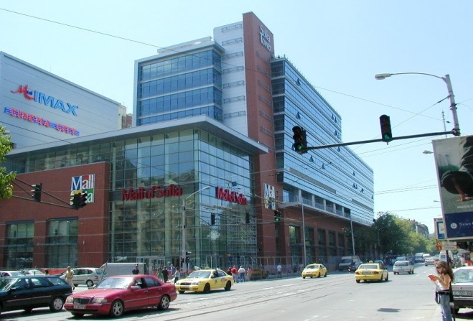
Fig. 3. Mall of Sofia. Source: Author.

Over the last twenty years, Sofia has seen the construction of some twenty malls and seventy gated communities, with smiling municipal and national-level officials (the city Mayor and the country’s Prime Minister) presiding over the ribbon-cutting opening ceremonies. These new spaces, many located in the city periphery and surrounded by massive parking lots, are clearly inspired by foreign models. Foreign capital sponsored many of them, and even their names are foreign (mostly English) and written in the Latin alphabet rather than the official Cyrillic one. Examples include the Mall of Sofia (see Figure 3), Paradise Center, Sky City Mall, and The Mall. The same is true of gated communities: here, we see names such as Bright Light, Cherry Gardens, Crystal Bell, Delta Hills, Green Village, Golden Valley, Mountain View Village, etc. The most ambitious effort to globalize the image of the Bulgarian capital was the attempt to construct a second administrative city center—one that would rival the existing administrative one (called The Largo), which is framed by several monumental neoclassic buildings from the Stalin era. A design competition launched in 2008 attracted some world-class firms, including those headed by Norman Foster, Massimiliano Fuksas and Zaha Hadid. The entries touted their environmentally friendly qualities in addition to their starchitecture. The winning proposal, by Dominique Perrault, received the jury’s nod on several grounds, from being the most democratic (the proposal envisioned building shells that could be filled by specific designs by other architects) to being the most sustainable (Perrault’s detailed calculations on how many LEED points the new administrative center would gather were unmatched by others). Despite much publicity, however, shortly after the competition, the project’s implementation was tabled by the city administration, which cited a shortage of funds in the wake of the Global Recession.

But even without the construction of an official second administrative center, the focus of activities in the city has moved to its periphery. Because of its attractive natural environment, the southern rim of the city has for years attracted intensive single-family development and, more recently, a number of oversized structures (malls, auto dealerships, etc.) to serve the growing number of suburban residents. The two most significant new developments in the area are Residential Park Sofia, a gated community with nearly fifteen hundred dwelling units and a number of privately accessible services; and Business Park Sofia, often advertised as the most advanced high-tech business park in Southeast Europe, which includes 300,000 square feet of built space and employs about 10,000 people. Both are large projects for the scale of Sofia (a city with about 1.5 million residents). Both were funded by the German company Lindner, were designed under the lead of Steidle Architekten Munich, and received various local awards, including awards for “green architecture” and economic development. That current elites consider the urban district of Residential Park Sofia and Business Park Sofia to be a model, flagship district is not too hard to prove. Note that from 2003 to 2006, the General Manager of the project was the successful Bulgarian businessmen R. Plevneliev, who represented Lindner in Bulgaria and was a key figure in envisioning both the Residential and the Business Park. In 2009, he became Bulgaria’s Minister of Regional Development and Public Works; his career as developer and manager of both “parks” was counted as strong evidence of his talent and expertise. In 2011, the accomplished Mr. Plevneliev was elected President of the Republic of Bulgaria—a post he holds to this day, with a fairly high approval rating.

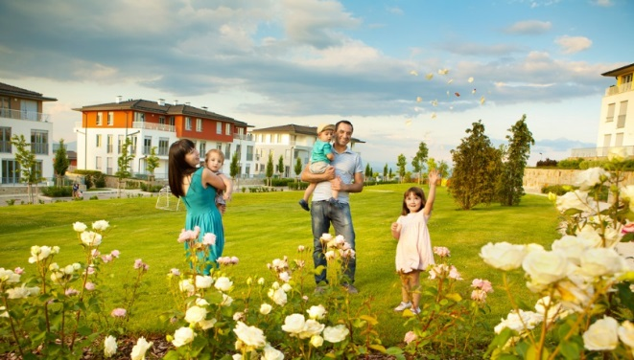
Fig 4. Image of idyllic family life from the website of the gated community Residential Park Sofia. Source: http://www.residentialpark-sofia.com/bg/gallery.html.

Residential Park Sofia’s website advertises it as a “city within a city” (see Figure 4). Insiders can obtain a number of vital services within the Residential Park, whereas outsiders have limited access. Security is a top priority and there are four controlled access points. In addition, security automobiles circle throughout the day to make sure there are no unwelcome visitors. Each dwelling is equipped with a video system that allows residents to monitor their front doors. Entering the complex as a visitor is a peculiar experience: not only must one stop at the barrier, talk to the guard and provide an adequate explanation for one’s visit, but one must also submit an ID, of which the guard makes a copy, and obtain an entry permit. The process is not much different from crossing the border between Bulgaria and a neighboring country, say Greece, except that at the gates of Residential Park Sofia, one does not have to go through Customs. Like security, the “community” aspect of the development is heavily touted. The management company organizes many events ostensibly offered as opportunities for residents to bond: tennis tournaments, children’s parties, etc. The first “community” Christmas celebration was reportedly a great success. Clarifying the point of the event and the meaning of “community,” the website explained: “On the eve of the warmest family holiday Christmas, the owners of a secure home in Residential Park Sofia will experience the community spirit of the complex celebrating together the first Community Christmas of Residential Park Sofia…. Residential Park Sofia not only unites and brings its residents closer as neighbors, but also links them with common aims, endeavors and high living standards” (note that even in the Bulgarian version of the website, the word “community” was in English).

Business Park Sofia, the commercial counterpart of the residential development, presents a similar case of spatial privatization. With its 22 hectares of carefully manicured landscape, the district is commonly presented as the largest publicly accessible green space produced in the city after the end of socialism. But this is not an accurate portrayal. Like Residential Park Sofia, the Business Park has a few controlled entry points. Employees must show IDs to get in. The claim for the project’s openness is based on the fact that outsiders can enter relatively easily (certainly more so that in the Residential Park) because the number of employees alone is insufficient to support the district’s shops, cafes and restaurants. Reportedly, hundreds of outsiders, from pleasant elderly couples to nicely dressed parents pushing children in strollers, do visit every day—not just to shop but also to walk around and enjoy the nicely maintained alleys, greenery and views of the artificial lakes (see Figure 5).

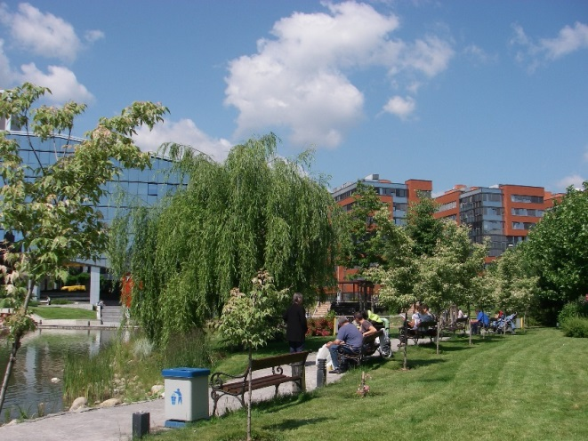
Fig. 5. Seemingly public space in Business Park Sofia. The development is commonly visited by casual strollers. However, they get there by passing through a few controlled entry points. Source: Author.

But the gates close at the end of working hours, and even during the day, the guards have the authority to question visitors who do not fit their image of respectable (i.e., middle- or upper-class) visitors—a practice that carries the sinister label “face control.” Any public activity that could proceed in a genuine public space but is perceived as rowdy, from skate-boarding to protesting, would undoubtedly attract the attention of the security personnel, and perpetrators would be forced to leave the otherwise bustling scene of the Business Park.

Discussion and Conclusion
In the shadow of the large cities of the Global North and a select few in the wealthier parts of the fast-urbanizing Global South, second-tier cities in small countries around the world have received limited scholarly attention. We also hear little about them in architectural discourses: stararchitects rarely grace them with their presence for the obvious reason that big money for shiny new projects is not usually in play. Yet in such cities, profound transformations of public space are underway—transformations that have gone under the scholarly radar but may suggest an especially dire future for public space globally. This is true for the cities of post-socialist Europe for several reasons. First, after 1990, the once relatively egalitarian cities of this world region became homes to extreme wealth and poverty within a few short years. Poverty and segregation fueled crime, which in turn fueled the new elites’ obsession with security and physical separation from the masses. Second, the traditional guardians of public space—public institutions—have been in a weak position to constrain spatial privatization because of the severe economic downturn of the 1990s. But even if money were available, it is doubtful that spatial privatization would have been resisted since most governments across the region became ardent proponents of neo-liberal doctrine and few were willing to question market-led spatial privatization; indeed, privatization became the ideological leitmotif of the post-socialist transition. In addition, as government corruption flourished during the 1990s, especially in the poorest transition economies, some ruling elites profited heftily from preying on state resources, including public land. Civil society in most countries in the region has been relatively slow to mount a meaningful challenge to the intense spatial privatization process, which continues to be seen as a hallmark of Westernization (i.e., a good thing). In the so-called developed democracies, gated communities have attracted quite a bit of negative press, and some citizen organizations (e.g., Citizens’ Against Gated Enclaves (CAGE) in the United States) and even political parties (e.g., the Green Party in Germany) have emerged to oppose them as part of the broader “right-to-the-city” movement. But similar associations have yet to make their mark in most post-socialist urban settings. Responding to public pressure, public authorities in some “developed democracies” are employing a variety of tools that restrict the spread of gated communities (e.g., through using the zoning bylaws, design guidelines, and the permitting process). Such tools are largely missing in Eastern Europe. Not surprisingly, multinational corporations have exploited the local situation to their benefit. Whereas the German populace and German public institutions have been skeptical of gated communities of various kinds and thus few of them exist in this country, German architectural and development firms have found ways to make a profit in countries like Bulgaria—by offering a product that they cannot sell as easily or with such fanfare in their homeland.

The collapse of the communist regimes and the profound socio-political transformation of Central and Eastern Europe in 1989-91 brought about bold statements about the “end of history”: a new paradigm in global development during which Western capitalism would have no alternative. It may be premature to argue that Central-East European settings could also serve as a global omen for “the end of public space.” Still, the East European context provides a perfect storm of preconditions for intense spatial privatization. In this sense, it is if not an omen at least a warning of what the future of public space may be, unless civil society, public institutions and the professions whose business is to improve the built environment find a viable alternative.

Endnotes

Brenner, N., Jessop, B., Jones, M. and Macleod, G. (eds), 2003, State/Space: A Reader (Oxford, Blackwell).
Scruton, R., 1984, Public space and the classical vernacular, Public Interest, 5-16, p. 6.
Brian, D., From good neighborhoods to sustainable cities: Social science and the social agenda of New Urbanism, International Regional Science Review 28 (2), 217-238; see also Dunham-Jones, E. and Williamson, J, 2009, Retrofitting Suburbia: Urban Design Solutions for Redesigning Suburbs (Hoboken, Wiley).
Dunham-Jones, E. and Williamson, J, 2009, Retrofitting Suburbia: Urban Design Solutions for Redesigning Suburbs (Hoboken, Wiley).
Sorkin, M., 1992, Variations on a Theme Park: The New American City and the End of Public Space (New York, Hill and Wang); Blakely, E. and Snyder, M., 1997, Fortress America: Gated Communities in the United States (Washington, DC, Brookings Institution Press and Cambridge, Lincoln Institute of Land Policy); Ellin, N., 1996, Post-modern Urbanism (Cambridge, Blackwell), and 1997, Architecture of Fear (Princeton, Princeton Architectural Press).
The list is very long here. It includes: Caldeira, T., 2001, City of Walls: Crime, Segregation, and Citizenship in São Paulo (Berkeley, University of California Press); Glasze, G., C. Webster and Frantz, K. (eds.), 2006, Private Cities: Global and Local Perspectives (London and New York, Routledge); Lowe, S., 2004, Behind the Gates: Life, Security and the Pursuit of Happiness in Fortress America (London and New York, Routledge).
Holston, J. and Appadurai, A., 2003, Cities and citizenship, in N. Brenner, B. Jessop, M. Jones and G. MacLeod (eds), State/Space: A Reader (Oxford, Blackwell).
In post-socialist conditions, privatization of resources has proceeded in such an unrestrained form that we can observe its impacts on urban space with greater clarity that we can in Western settings where its consequences have been more gradual. See also Bodnar, J., 2001, Fin de Millénaire Budapest: Metamorphoses of Urban Life (Minneapolis, University of Minnesota Press).
Robinson, J., 2006, Ordinary Cities: Questioning Modernity and Development. (Abington and New York, Routledge).
I owe many ideas to my students in a theory seminar on comparative urbanization, which explored the recent image transformations of several “ordinary” cities in both Eastern and Western Europe.
In Russia, of course, the regimes ruled for longer, since 1917.
Scott, J., 1998, Seeing Like a State: How Certain Schemes to Improve the Human Conditions Have Failed. (New Haven, Yale University Press).
Crowley, D. and Reid, S. 2002. Socialist Spaces: Sites of Everyday Life in the Eastern Bloc. (Oxford, Berg).
I am citing El Lissitzky here, but many other authors and policy documents from that time period reflect the same sentiment. This is according to Baladin, S., 1968, Arhitekturnaia teoria El Lisickogo [The Architectural Theory of El Lissitzky]. Accessed on July 8, 2013 at web.archive.org/web/20080510054907/http://novosibdom.ru/content/view/607/32/ [in Russian].
This was typically done in the decade after World War II. In some countries like Romania, however, downtown “beautification” projects continued until the 1980s (in the capital Bucharest, over the remnants of some 485 hectares of demolished neighborhoods).
Forty-three as compared to eleven square meters per capita, according to Eurostat, undated, data queries through http://www.urbanaudit.org/DataAccessed.aspx.
Hirt, S. and Stanilov, K., 2009, Twenty Years of Transition: The Evolution of Urban Planning in Eastern Europe and the Former Soviet Union, 1989-2009. (Nairobi, UN HABITAT).
Boentje, J and Blinnikov, M., 2007, Post-Soviet forest fragmentation and loss of the Green Belt around Moscow, Russia (1991–2001): A remote sensing perspective. Landscape and Urban Planning 82 (4), 208–221.
Lowicki, D., 2008, Land use changes in Poland during transformation: Case study of Wielkopolska region. Landscape and Urban Planning 87, 279-288.
Hirt, S. and Kovachev, A., 2006, The changing spatial structure of post-socialist Sofia. In: S. Tsenkova and Z. Nedovic-Budic, eds., The Urban Mosaic of Post-socialist Europe: Space, Institutions and Policy, Ch. 6, 113-130. (Heidelberg and New York, Springer-Physica).
Ellin, N., 1996, Post-modern Urbanism (Cambridge, Blackwell) and Loukaitou-Sideris, A. and Banerjee, T., 1998, Urban Design Downtown: Poetics and Politics of Form (Berkeley and Los Angeles, University of California Press).
Nedovic-Budić, Z., 2001, Adjustment of planning practice to the new Eastern and Central European context, Journal of the American Planning Association 67(1), 38-52.
For example, municipal help in land assembly and expedient review for projects initiated by very large investors, which tend to be multinationals. This approach has had the additional effect of pushing development toward the periphery of cities, where large chunks of land are available.
See for example, Dmitrieva, M. and Kliems, A., 2010, The Post-Socialist City: Continuity and Change in Urban Space and Imagery (Berlin, Jovis).
Mauser, P. and B. Goldhoorn, 2006, Capitalist Realism: New Architecture in Russia, Berlin, DOM Publishers. The term is an obvious antonym of “socialist realism”—the neoclassic style that dominated during the reign of Joseph Stalin.
For example, Filler, M., 2001, Berlin: The lost opportunity, New York Review of Books, November 1.
For example: Blinnikov, M., Shannin, A., Sobolev, N. and Volkova, L., 2006, Gated communities in the Moscow greenbelt: Newly segregated landscapes and the suburban Russian environment, GeoJournal, 66(1-2), 65-81; Bodnar, J. and Molnar, V., 2010, Reconfiguring private and public: State, capital and new housing developments in Berlin and Budapest, Urban Studies 47 (4): 789-812; Hirt, S., 2012, Iron Curtains: Gates, Suburbs and Privatization of Space in the Post-socialist City (Oxford and Malden, Wiley-Blackwell).
See for example, the latest master plan of the city: Sofia Municipality, 2009, Master Plan of Sofia Municipality: Synthesis Report. (Sofia, Author).
See http://www.residentialpark-sofia.com/
See http://www.businesspark-sofia.com/en/page/139/About_us
Ganev, V., 2007, Preying on the State. (Ithaca, Cornell University Press).
For example, see Grant, J., 2005, Planning responses to gated communities in Canada, Housing Studies 20(2), 273-285.
33 Fukuyama, F., The End of History and the Last Man. (New York, Free Press).

