Maize-bean Farming and Seasonal Greenhouse Gas (GHG) Emissions in Sub-Saharan Africa

J.Odhiambo^{1,2}, U.Norton², D. Ngosia³, E. Omondi⁴ and J. Norton⁴

¹ PhD Student in Agronomy; ²Department of Plant Sciences; ³ Moi University, Kenya; ⁴Department of Ecosystem Science and Management

Introduction
Farming practices in Sub-Saharan Africa (SSA) rely on continuous maize (Zea mays) /bean (Phaseolus vulgaris) cropping and use of deep plow (hand hoe or animal draft inversion plow). Even though high annual precipitation (1100 mm and more) and temperature (25ºC and up) can support high productivity in this region, heavily weathered soils need to be fertilized with di-ammonia phosphate (DAP) to produce a crop. Based on previously published literature, the magnitude of nitrogen (N) use efficiency (NUE) and fertilizer recovery by crops is very low, which suggests alternative pathways of N and carbon (C) losses to leaching and greenhouse gas (GHG) emissions. Understanding the processes contributing to GHG emissions in SSA is a prerequisite for better understanding of the SSA contributions to global climate and need for mitigation potentials. We hypothesize that the N and C losses to GHG emissions depend largely on the disturbance associated with the frequency of land preparation practices and crop management and is greater in areas with two growing seasons compared to areas where maize/bean is grown during one long growing season only.
Objectives
The objective of this study was to inventory seasonal GHG emissions from continuous maize/bean intercropping grown under unimodal (one growing season) and bi-modal (two growing seasons) conditions.
Materials and Methods
Research was conducted at two locations representing two different agro-ecological zones in humid western Kenya; Bungoma and Trans-Nzoia. Bungoma lies on the lower midland zone, and is characterized by bimodal rainfall pattern that falls in two phases: long rains (LR) from April to July (500–1,000 mm) and the short rains (SR) from September to November (430-800mm). Trans-Nzoia is characterized by uni-modal rainfall pattern that begins at the end of March and ends in November. Information on the position, climatic conditions, soil chemical and physical properties of the two locations are shown in Table 1.

Table 1: Summary of location and climate data of experimental sites
Parameter | Trans-Nzoia | Bungoma
Location
Latitude | 01⁰ 01 ′N | 3⁰35′N
Longitude | 34⁰ 59′E | 34⁰ 34′E
Elevation(masl) | 2100 | 1433
Climate
MAP(mm) | 1500 | 1100
MAT (⁰C) | 25 | 30
Soil Properties
Bulk density (g m⁻³) | 1.6 | 1.7
Clay % | 28 | 36
Silt % % | 20 | 16
Sand % %  Soil Texture | 52  Sandy clay loam | 48  Clay loam
Sampling was done three times in a year: during pre-plant dry fallow (P-P); at maize peak vegetative growth (V6) and at maize physiological maturity (R6). Samples were analyzed for carbon dioxide (CO₂), methane (CH₄) and nitrous oxide (N₂O) concentrations.
Results and Discussion
Both locations demonstrated comparable soil and air temperatures as well as soil CO₂ fluxes during all sampling events (Table 2). Soils from bimodal area (Bungoma) had however, very high N₂O emissions during the crop growth and greater though still very low CH₄ assimilation compared to Trans-Nzoia (Figure 1). Similar levels of CO₂ emissions, low CH₄ assimilation and very high N₂O emissions point at very limited soil ability to hold on to N applied as fertilizer and low residual soil N stores.
Table2: Soil and air temperature during the sampling period’s vegetative growth (V6), physiological maturity (R6) and Pre-plant (P-P).
 | AirTemp (⁰C) |  |  | Soil Temp. (⁰C)
Site | V6 | R6 | PP | V6 | R6 | PP
Trans-Nzoia | 26 | 23 | 23 | 26 | 24 | 24
Bungoma | 28 | 26 | 30 | 26 | 26 | 30

Efforts should be made towards applying conservation management practices aiming at reducing the amount of disturbance associated with land preparation and improvement of soil tilth and long-term soil fertility in areas under bimodal growing conditions.
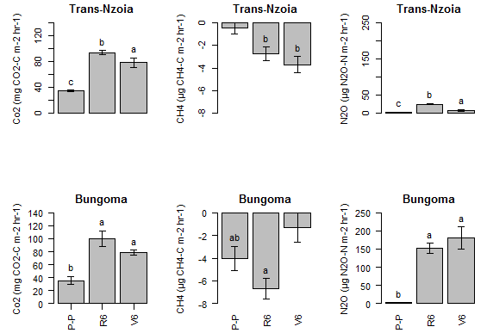
Figure1: Seasonal fluxes of CO2, CH4 and N2O from Trans-nzoia (unimodal) and Bungoma (bi-modal) growing conditions. Vegetative growth (V6), physiological maturity (R6) and Pre-plant (P-P .Lower case letters represent significant differences at (P<0.05).
Acknowledgments
The project was funded by USAID through SANREM-CRSP
Contact Information
Judith Odhiambo at jodhiamb@uwyo.edu or 307-703-0549.
Key words: disturbance, bimodal climate, soil tilth

