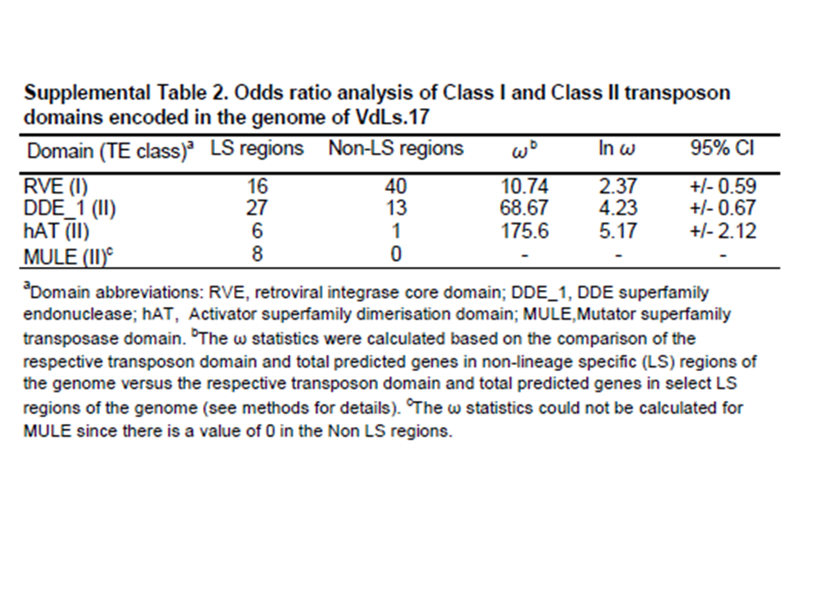Supplemental Table 2
Amyotte et al., 2012

