Numerically Trained Ultrasound AI for Monitoring Tool Degradation

Yuqi Jin^{1,2}, Xinyue Wang³, Edward A. Fox³, Zhiwu Xie⁴, Arup Neogi², Rajiv S. Mishra⁵ and Tianhao Wang^{6*}
¹ Center for Agile and Adaptive Additive Manufacturing, University of North Texas, Denton, TX 76207 USA
² Department of Physics, University of North Texas, Denton, P.O. Box 311427, Denton, TX 76203, USA
³ Department of Computer Science, Virginia Tech, Blacksburg, VA 24061, USA
⁴ University Libraries, Virginia Tech, Blacksburg, VA 24061, USA
⁵ Advanced Materials and Manufacturing Processes Institute, University of North Texas, Denton, TX 76207, USA
⁶ Energy and Environment Directorate, Pacific Northwest National Laboratory, 902 Battelle Blvd., Richland, WA, 99352, USA
* Correspondence author: Tianhao Wang: Tianhao.Wang@pnnl.gov

Keywords: tool wear, ultrasonic detection, machine learning, sub-wavelength accuracy

Abstract: Monitoring tool degradation during manufacturing can ensure product accuracy and reliability. However, due to variations in degradation conditions and complexity in signal analysis, effective and broadly applicable monitoring is still challenging to achieve. In this paper, we report a novel monitoring method using ultrasound signals augmented with a numerically trained machine learning technique to monitor the wear condition of friction stir welding and processing tools. Ultrasonic signals travel axially inside the tools, and even minor tool wear will change the bounced-back signals in terms of time and amplitude. An artificial intelligence (AI) algorithm was selected as a suitable referee to identify the small variations in the tool conditions based on the bounced-back ultrasound signals. To properly train the AI referee, we generated a human-error-free data bank using numerical simulation. The simulation models the experimental conditions with high fidelity and can provide comparable ultrasound signals. As a result, the trained AI model can recognize the tool wear from real experiments with sub-wavelength accuracy prediction of the worn amount on the tool pins.

1. Introduction
Friction stir welding and processing (FSW/P) is a modern manufacturing technique, which has widespread application in the aerospace, aviation, automotive, railcar, shipbuilding, oil & gas, and electronics industries. A great amount of attention relating to FSW/P have been attracted since FSW was invented in 1991 [1], and the global FSW&P market revenue will exceed 1.04 billion dollars by 2026 [2]. Compared with laser welding and processing, another widely applied modern manufacturing method which relies on local melting to join or modify the microstructure of metallic materials, FSW/P depends on friction-induced heat and strain. The maximum temperature during FSW/P ranges from ~80-90% of the melting point of the workpiece [3, 4, 5] so that the common problems occurring in fusion-based manufacturing methods (i.e., laser welding and processing), such as hot cracks and inclusions, can be avoided. Furthermore, favorable microstructures such as refined grains and second phases can be obtained from the severe plastic deformation introduced by the FSW/P tool involving temperature, mechanics, metallurgy, and interactions [6].
However, FSW/P tools are subjected to severe stress and high temperatures, leading to tool wear (degradation) [7] or fracture [8] which causes concerns about consistency of product quality. For example, a reduction in FSW/P tool length can lead to the lack of penetration (Supplementary Figure S1 (C₁) and (C₂)); the inadequate material flow can manifest as volumetric defects in the weld and process zone (Supplementary Figure S1 (D₁₋₃), (E₁₋₃) and (F₁₋₃)). Highly durable tools still are under development; their lack limits broader industrial applications of FSW/P, especially when workpieces are high-strength materials such as high-strength aluminum alloys, steel, nickel and titanium alloys, and metallic-based composites [9, 10]. An even more crucial barrier to popularizing FSW/P in industries is that there is no practical and convenient method for monitoring or measuring tool wear during the manufacturing process. Presently, most researchers applied ex-situ methods to measure tool wear, which requires FSW/P tools being removed from the machine and being cleaned in highly corrosive chemicals for several hours. This is impractical for industrial applications. In recent years, researchers have also developed several in-situ methods for monitoring tool wear. One of the more promising in-situ methods is to extract information regarding tool geometry degradation based on weld and process forces [11, 12]. However, the weld and process forces are not only related to tool geometry but also associated with weld and process parameters (change in temperature) and workpiece materials. Another possible direction is to apply X-ray [13] or laser profilometer [14] monitoring of tool wear, but these are too complicated for industrial adoption.
In FSW/P quality controlled filed, AI programs were also applied with some sensing techniques for correlating the detected information with desired outputs without clear logic connections in human sense. In the literature, some existing suggestions were focused on the AI assisted monitoring of the temperature distribution [15], welding machine feedback [16], and processed surface imaging [17]. All of the factors were necessary to include in a monitoring loop for a better production quality. Besides the machine and workpiece feedback, the tool wearing also impacted the FSW/P quality which was barely discussed in the existing literature. In practical cases, the tool wear or degradation is a more direct factor leading to flawed products. To make the instant tool length inspection feasible, we use the ultrasound time-of-flight to reduce the application dimension from 3D (tools) to 1D (temporal signals), and integrated machine learning to approach the goal.
In this study, we propose a novel technique, which uses ultrasonic signals along with a numerically trained AI system to monitor the tool geometry variance. Any minor tool wear will change boundary shape and further influence the bounced-back signals, making this approach a promising solution for controlling quality in manufacturing industries. Figure 1 schematically shows the scope of current study. By varying the pin shape (profile), the corresponding ultrasonic signals for varying wear stage are obtained through finite element analysis (FEA) based COMSOL simulation. Due to the pin tip curvature, the non-linearity was introduced in the relationship pin length and time-of-flight values. The difficulty limited the conventional ultrasound distance estimations but can be overcome by an AI program. Considering many interval points, in accordance with pin shape, the finite FSW/P tool life can be described in the form of a numerical data bank produced by simulations (as displayed in the purple rectangle of Figure 1). From the comparison between 16 different machine learning models, a suitable machine-learning regression algorithm was selected based on the performance in terms of accuracy. The model was trained by the processed simulation data bank. The trained model was further applied to predict the numerical ultrasonic result according to the correlated pin shape of the matching tools (as displayed in the green rectangle of Figure 1). Once the trained model has accumulated experience, the experimentally collected ultrasonic data is able to be recognized and coupled to the studied conditions existing in the training database in order to predict the health of the current tool (as displayed in the red rectangle of Figure 1).
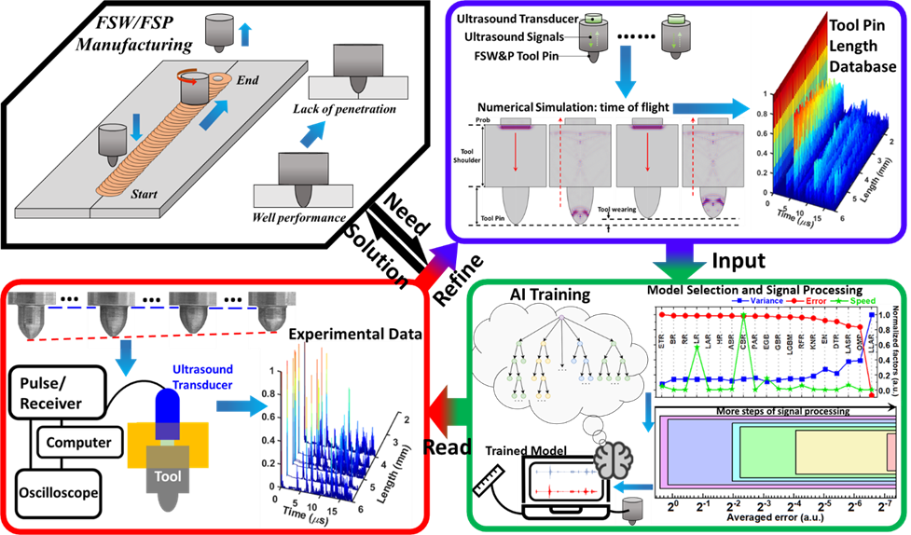
Figure 1. Background and method overview: Schematic flow chart of the entire method including background, simulation, machine learning and experiment parts.

2. Feasibility and equipment selection of ultrasonic monitoring
Ultrasound techniques are becoming prevalent in the manufacturing industry for instant flaw detection and non-destructive elasticity estimation of a target without advanced sample preparation. Compared with electromagnetic non-destructive testing (NDT) methods such as eddy current or thermal imaging, ultrasound has more balanced penetration depth, testing speed, and accuracy.
In this study, the tool wear difference was measured by ultrasound time-of-flight along with the depth with the constant mechanical and physical properties on the material, H13 tool steel. To properly apply ultrasound techniques, precise equipment selection including frequency, pulse shape, attenuation, dispersion, and scattering needs to be conducted. The current commercialized normal-incidence single element piezo-electric ultrasound transducers cover a broad frequency range from about 50 kHz to 200 MHz. Within the transducer effective bandwidth, we expected to avoid frequency-dependent speed of sound difference. As Figure 2 (A) shows, frequency dispersion experimentally determined in H13 steel over the bandwidth of the transducer below 30 MHz was low enough to be negligible. Between the range from 30 to 50 MHz, the dispersion effect from the internal microstructure was non-negligible which would elongate the acoustic pulse introducing uncertainty in time-of-flight measurements. Moreover, the spatial pulse width of the available transducers ranged from the scale of centimeter (cm) to micrometer (µm). The operating pulse width in a tool must be substantially smaller than the typical length of the tool pin to induce better spatial resolution. The pulse width needs to be greater than the grain size in the H13 tool steel to eliminate additional attenuation and scattering effects due to the existence of grain boundaries [18] as illustrated in Figure 2 (B). By this methodology, as long as the grain size in friction stir welding/processing tool is smaller than the wavelength, the impact of grain size variation would not be significant. The tool grain size and shape in the tool might change under significant heat and stress. However, unlike the annealing process providing the enlargement of grain size, during the FSW/P, the thermo-mechanical effect on the tool pin does not increase the grain size significantly. Detailed equipment selection procedures were described in Supplementary Section 2.1. The final selection was a 20 MHz fundamental frequency transducer. The detectable smallest feature with that frequency is about 0.3 mm, on the tool with non-significant attenuation, as shown in Figure 2 (C). The pulse envelope of the transducer in H13 steel was experimentally acquired by the setup described in Supplementary Section 2.4.1. To ensure high similarity between numerical time-of-flight signals and practical experiments, a specifically designed analytical pulse function was applied as an acoustic source in our numerical simulation which was comparable with the experimentally recorded pulse shape (Figure 2 (D)).
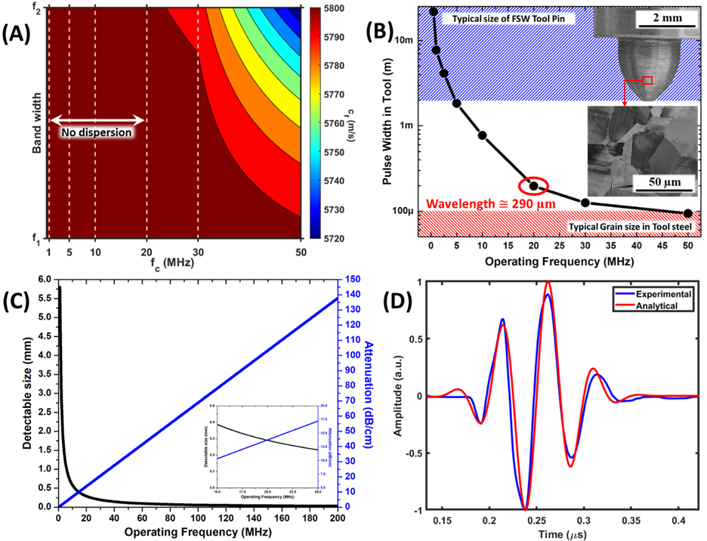
Figure 2. Equipment selection: (A) Experimental measured ultrasound dispersion of the studied transducers in H13 tool steel. f₁, f₂, and f_{c} indicated the lower band edge, higher band edge, and fundamental frequency of the applied transducers from 0.5 MHz to 50 MHz. The information was experimental characterization of the Olympus single element transducers. (B) The calculated pulse width of various transducers with different center frequencies from 0.5 MHz to 50 MHz. The pulse width was obtained from the frequency-temporal translated bandwidth of the transducers. The sub-figure is a comparison of the long enough operating wavelength for the typical microstructure in tool steel. (C) The potentially detectable size by the ultrasound wave along with the operating frequency and frequency-dependent attenuation in tool steel. The sub-figure illustrates the zoom-in view of frequency-dependent detectable size and attenuation around the range around 20 MHz. (D) High similarity between the experimentally recorded pulse envelope and the analytical pulse function which was further applied in numerical simulation as the source.

3. Training databank from numerical simulation
Even though time-of-flight measurement is one of the classic acoustic techniques, the non-standardized data analysis method established additional human errors. In time-of-flight measurements, the wave arrival time or speed-of-sound can be highly deviated based on the methods of peak selection. The accuracy of experimental output is highly dependent on the peak selection which must be done independently according to the systems to decrease the impact of dispersion. Alternatively, machine learning techniques are highly suitable to recognize data reliability.
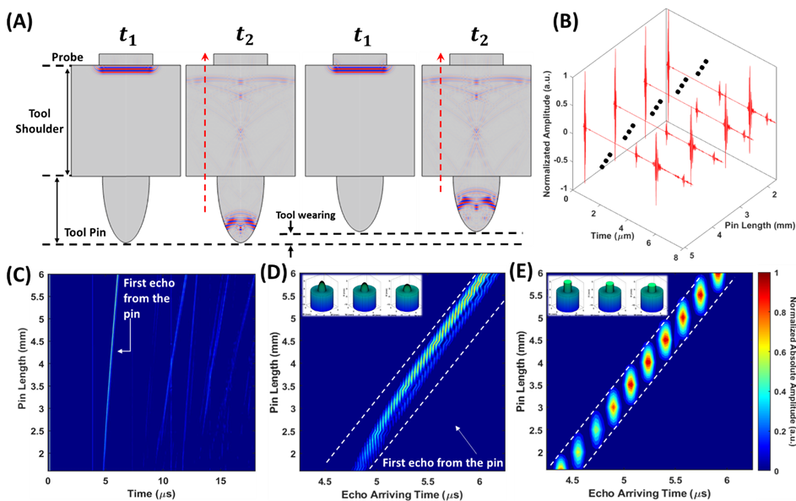
Figure 3. Simulated database: (A) Example time of flight simulation of 6mm and 4mm pin length tool. At the same time point, the pulse traveled a short path in the 4mm pin tool. (B) Example temporal signal from the numerical simulation of various pin length tools. (C) Normalized absolute amplitude of the temporal time of flight database from numerical simulation of the tools with varying length of the pin from 1.6 mm to 6 mm. (D) Zoomed in view of (C) around the time at the completion of the first round-trip. In the database, a total of 108 sets of temporal signals were calculated. (E) Comparison for (D) by simulating flat head tools highlighted the non-linearity of the relation between pin length and echo arrival time in the round head database where the relation was fully linear in flat head tools.
In the case of FSW/P tool wear, axial symmetry exists in the ultrasound transducer, tool geometry, and tool motion which leads to axial symmetric wear or degradation in the tool. Detailed explanation of the asymmetricity of tool wear is presented in Supplementary Section 1.1 and Figures S1(A₁₋₃), (B₁₋₃), (G₁₋₂), and (H₁₋₃). Based on this premise, the numerical model can be simplified, and the calculation time significantly reduced. In the numerically calculated training database, the model was 2-dimensional as the cross-section of the FSW tool (see Figure 3 (A)). The generated results were a 1-dimensional echo signal versus time (see Figure 3 (B)). To approach the numerical model of the wear process closer to the practical situation, we built a simple model for tool pin wear. The tool pin was defined as a tall semi-ellipse which was defined by only two factors, width and height. The shortening (wear) of the pin was achieved by decreasing the ellipse height with constant width, which automatically adjusted the curvature of the pin. The change of the curvature induced non-linear tool-length to travel-time relation of the echoes (Supplementary Section 2.2). The complexity in the model and simulated signals are extremely challenging for humans to identify.
In the database, the simulated model varied the height of the semi-ellipse tool pin from 1.6 to 6 mm. The calculated time window was wide enough for the pulse to complete more than 3 roundtrips in the longest pin-length tool. In Figure 3 (C), after the initial trigger signal at around time 0, the actual first echo is shown as the vertical line at around 4 $μs$. This is due to the constant tool shoulder height in all the cases. Between 4.25 to 6.25 $μs$, the second reflection traveled back from the tip region of the pin. Due to the tool pin wear and the resultant broadening curvature on the semi-ellipse tool pin, the arrival time and amplitude of the second echo is not fully related to pin length as a linear function shown in Figure 3 (D), compared with the flat head tool cases in Figure 3 (E) (detailed in Supplementary Section 2.3).

4. Data preprocessing with numerical databank and model selection and training in simulation environment
In supplementary material, Tables S1 and S2 show the preliminary results given AI models trained from the raw databank: the training phase can achieve high accuracy results. However, the real sample testing shows significant error rate, which reveals that the difference between the simulation data and real samples has significant influence over the trained model. In this case, we designed a series of preprocessing steps to reduce the impact of the data differences and enhance the model performance: noise augmentation, differential conversion, aggregation, and dimension reduction. Details are described in Supplementary Section 3.1.1. The goal of such data preprocessing steps is to find methods to strengthen the connection between real-world data and the simulated data with our limited databank size. Our results show that the preprocessing stage is vital to achieving the desired performance for our prediction.
Our tool wear monitor problem is a typical prediction problem in AI modeling. In the following, we explore conventional algorithm-based AI prediction models, i.e., regression prediction algorithms, to verify our concept. To explore the performance of different regression models, we compared 16 common regression algorithms. Details are described in Supplementary Section 3.1.2. In Figure 4 we report the best fit model: random forest algorithm (subfigure (A)) [19]. The residual plot and validation plot in Figure 4 (B and C) show that the model fits well within the simulation environment and the training scores. Figure 4 (D) shows the performance of predicted results against the actual targets in the simulation dataset. The measurements show that the regression modeling for tool wear prediction is reliable in the simulated environment. In the next section, we report our model verification over the real-world data.
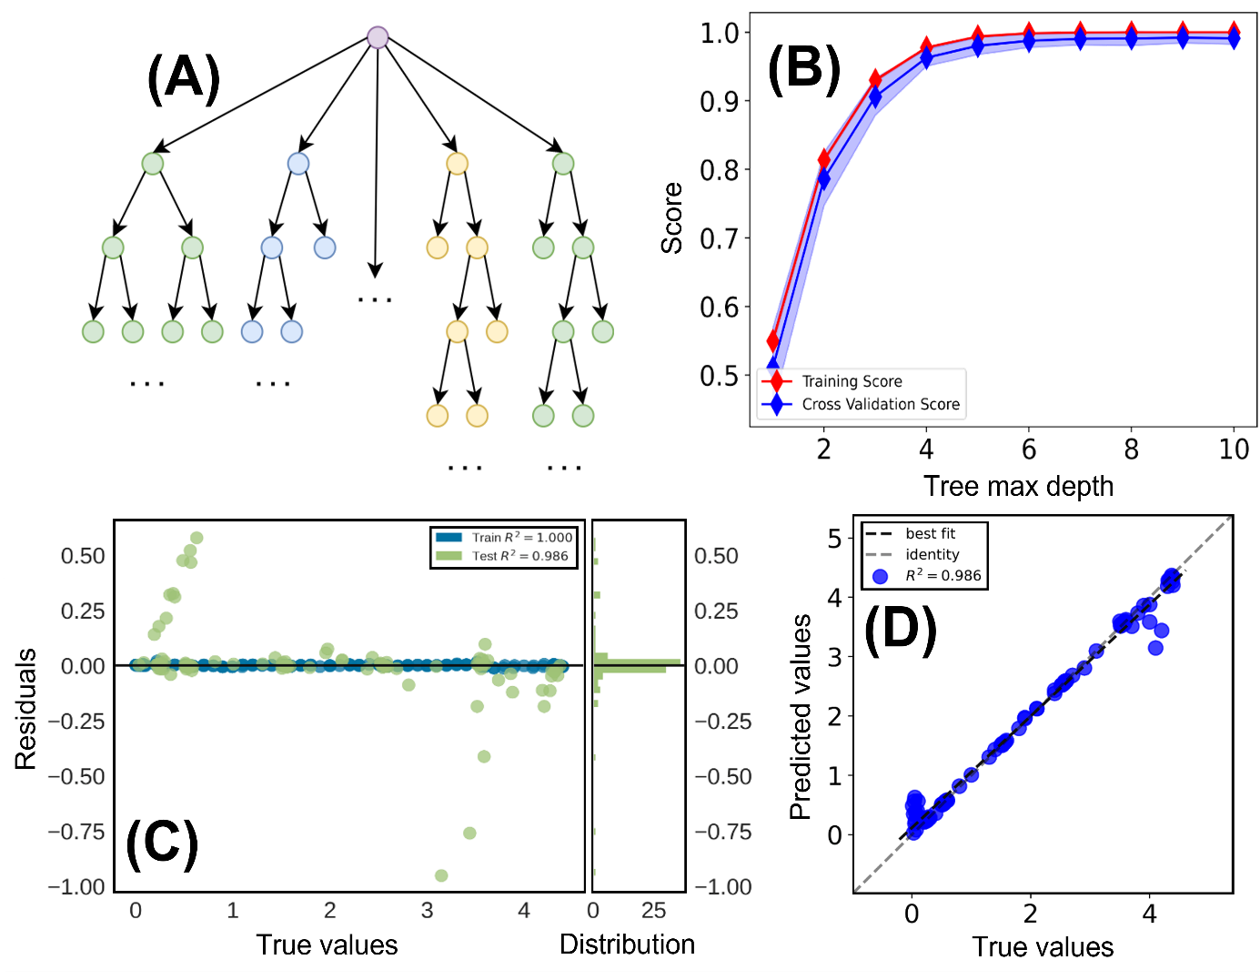
Figure 4. AI model training and examination. (A) The illustration of the random forest model. (B) The training score of the model training using the numerical simulation generated databank. (C) Residuals for the random forest model over the simulation data: The majority of the dots are close to the zero line, indicating better model reliability. The inner figure shows the validation curve for the random forest model over different tree depth: train and cross validation score are both high, which indicates that the model fits well. (D) Prediction error for the random forest model over the simulation data: The best fit line (predicted tool wear), identity line (tool wear in simulation) and the majority of the R-squared values align well together, which shows good prediction performance.

5. Experimental verification:
To verify the feasibility of recognizing the tool health condition using the trained machine learning program and ultrasonic measurement, we conducted experiments to obtain the experimental data sets illustrated in Figure 5 (A) by the experimental setup in Supplementary Section 2.4.3. The pin length varied from 4 to 6 mm as the insert photographs (left corners) show in Figure 5 (B). Comparing with numerical simulation and experiments, the numerical and experimental temporal signals were comparable during the first and second complete wave roundtrips. A weak scattering waveform was observed in the experimental signals around the first and second echoes which was absent in the simulation generated data. From the beginning of the second roundtrip, the waveform from the experiment and simulation started to diverge due to the slight difference existing in the curvature of the real tool pins versus in the simulation model.
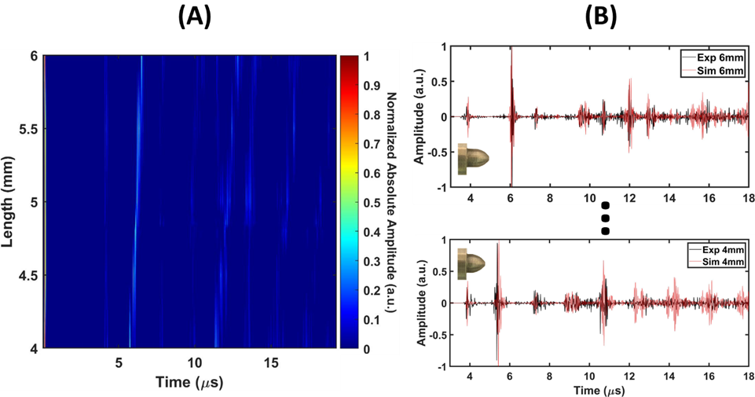
Figure 5. Experimental results: (A) Normalized absolute amplitude of the temporal time of flight database from experiments of the tools with varying length of the pin from 4 mm to 6 mm. (B) Waveform comparison between numerical and experimental time of flight signals. The red lines refer to the numerical results from simulation and the black lines were from experiments.
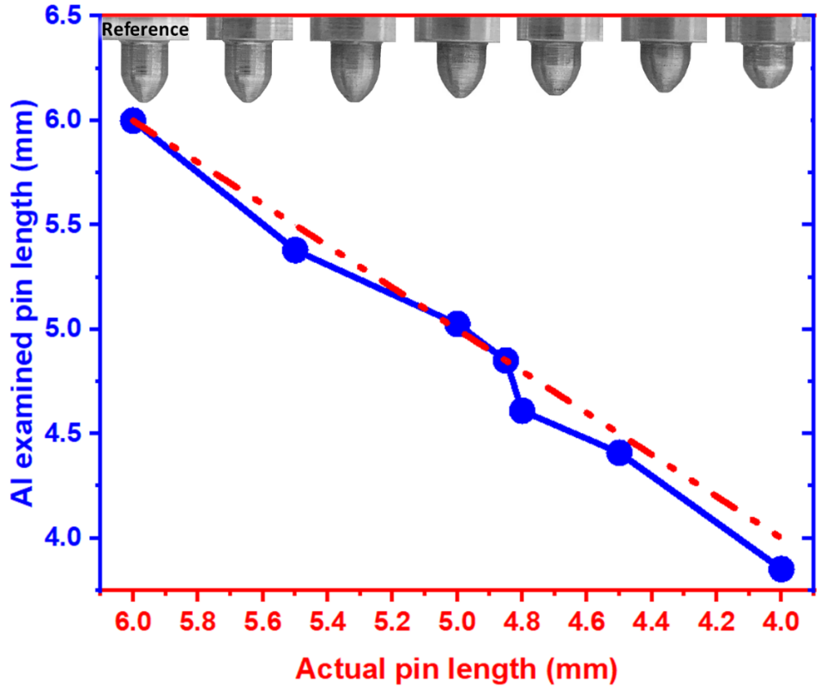
Figure 6. Machine learning identification results on the experimental data. Red line showed the actual pin length, and blue line showed the AI examined pin length.

The simulation data trained machine learning model was used to read the experimental data we produced in the last section. In Figure 6, showing 7 sets of experimental data, the full pin length (6 mm) tool experimental data was selected as a reference for estimating the wear conditions for the rest of the worn tools. The machine learning showed exceptional performance on determining the reduction in tool length with curvature variations. As Figure 6 and Supplementary Table S2 illustrate, the average error over the 6 specimens was 2.1%. The maximum error occurred on the 4.8 mm pin length case which was about 3.9% of pin length. 3.9% error referred to 189.5 µm variation which was smaller than our ultrasound operating wavelength (λ), 290 µm. The average prediction error was 96 µm which was approximately one-third of λ.

6. Discussion and conclusion:
As FSW/P research is blooming in academia and manufacturing industries, the feasibility of broadly applying FSW/P in industries is still a long-standing challenge due to the lack of reliable quality-controlled methods. Machine learning techniques have been applied in the friction stir welding manufacturing for monitoring the vision profile of welding path [20] or the machine feedback information such as force and torque [16]. However, the methods can barely prevent flaw formation before it happens, since the vision or feedback outlier data that arose were both caused by the flaw initiation [16]. Additionally, to obtain a proper training bank of vision or machine feedback data experimentally is also challenging due to the unavoidable human/equipment errors and high degree-of-freedom interference of involved factors. The presence of the errors in a training bank can significantly impact the identification accuracy of machine learning programs [21]. Multi-factors induced high degree-of-freedom machine learning required a correspondingly increased amount of training data as the number of factors increased [22]. The tremendous amount of training data from experiments raised the possibility of more errors in the training data bank. Hence, we realized the proper fit of a training data bank produced using numerical simulation. With the intentional simulations and experiments design, the condition of simulation and experiments converged to be similar enough to provide comparable output data. Consequently, an accurate and cost-friendly machine learning program was trained with simulation data to successfully recognize practical data from experiments with sub-wavelength accuracy.
The current stage of this study was proof-of-concept. But the system can be applied in practice in the future, working approximately in real-time. As Table S1 (in supplementary file) showed, the AI program only needs less than 0.1 second to make the decision. On the signal acquisition side, the required time was experimentally determined as 1.3 seconds with the temporal averaging processing under a high sampling rate (sampling was much higher than wave frequency). Hence, in principle, the system can achieve tool monitoring with around 1.5 seconds refreshing rate. The typical FSW/P pin moving speed (on the welding direction) are around 8 IPM (inch per min). In another words, the pin length can be monitored every 5 mm distance on the welding axis. The typical tool lifetime was counted on a meter scale. The monitoring refreshing rate is adequate to serve as an approximate real-time process.
The current study offers a demonstration to resolve one of the technical limitations existing in the friction stir welding/processing field. In the supplementary materials section 4, more discussion and cases studies were posted about the thread features detection and feasibility over the different tool/workpiece materials selection. However, the significance of the method is not limited to tool wear or FSW field. Most of the acoustic time-of-flight measurable quality monitoring with numerically modellable conditions can be managed better with our proposed method, which has potential to provide reliable alternative solutions for better production quality in the related industrial fields.

Supporting Information
Supporting Information is available from the Wiley Online Library or from the author.

Acknowledgements
The authors acknowledge the infrastructure and support of the Center for Agile & Adaptive and Additive Manufacturing (CAAAM) funded through the State of Texas Appropriation (#190405-105-805008-220). The authors also acknowledge the Emerging Frontiers in Research and Innovation (EFRI) grant from the National Science Foundation (NSF), Grant No. 1741677, and Advanced Materials and Manufacturing Processes Institute (AMMPI) 2019 SEED grants as well as Institute of Museum and Library Services (IMLS) LG-37-19-0078-19 and NSF OAC-1835660. Deep acknowledgement goes to Mr. Mark Lanier and Mr. Tracy Lynch for the nice work on tool fabrication in the Physics machine shop at the University of North Texas.

Received: ((will be filled in by the editorial staff))
Revised: ((will be filled in by the editorial staff))
Published online: ((will be filled in by the editorial staff))

References

[1] W. M. Thomas, E. D. Nicholas, J. C. Needham, M. G. Murch, P. Temple-Smith and C. J. Dawes, "Friction Stir Butt Welding". Patent PCT/GB92/02203; US9125978.8, December 1991.
[2] C. Smith, "Global Friction Stir Welding Market to Exceed US$ 1.04 Bn by 2026," Credence Research, [Online]. Available: https://www.credenceresearch.com/press/global-friction-stir-welding-market.
[3] Y. J. Chao, X. Qi and W. Tang, "Heat transfer in friction stir welding—experimental and numerical studies," J. Manuf. Sci. Eng., vol. 125, no. 1, pp. 138-145, 2003.
[4] W. Tang, X. Guo, J. McClure, L. Murr and A. Nunes, "Heat input and temperature distribution in friction stir welding," Journal of Materials Processing and Manufacturing Science, vol. 7, pp. 163-172, 1998.
[5] P. Colegrove, M. Painter, D. Graham and T. Miller, "3 Dimensional Flow and Thermal Modeling of the Friction Stir Welding Process," in Proceedings of the Second International Symposium on Friction Stir Welding, Gothenburg, Sweden, 2000.
[6] X. Meng, Y. Huang, J. Cao, J. Shen and J. F. dos Santos, "Recent progress on control strategies for inherent issues in friction stir welding," Progress in Materials Science, vol. 115, p. 100706, 2021.
[7] S. Du, H. Liu, M. Jiang, L. Zhou, D. Li and Y. Gao, "Effects of tool wear on the microstructure evolution and mechanical properties of friction stir welded TA5 alloy," The International Journal of Advanced Manufacturing Technology, pp. 1-13, 2021.
[8] Y. Huang, Y. Xie, X. Meng, Z. Lv and J. Cao, "Numerical design of high depth-to-width ratio friction stir welding," Journal of Materials Processing Technology, vol. 252, pp. 233-241, 2018.
[9] R. Rai, A. De, H. Bhadeshia and T. DebRoy, "Friction stir welding tools," Science and Technology of Welding and Joining, vol. 16, no. 4, pp. 325-342, 2011.
[10] Y. Zhang, X. Cao, S. Larose and P. Wanjara, "Review of tools for friction stir welding and processing," Canadian Metallurgical Quarterly, vol. 51, no. 3, pp. 250-261, 2012.
[11] B. Sick, "On-line and indirect tool wear monitoring in turning with artificial neural networks: a review of more than a decade of research," Mechanical systems and signal processing, vol. 16, no. 4, pp. 487-546, 2002.
[12] Y. Shaban, S. Yacout and M. Balazinski, "Tool wear monitoring and alarm system based on pattern recognition with Logical Analysis of Data," Journal of manufacturing science and engineering, vol. 137, no. 4, 2015.
[13] Y. Morisada, H. Fujii, Y. N. K. Kawahito and M. Tanaka, "Three-dimensional visualization of material flow during friction stir welding by two pairs of X-ray transmission systems," Scripta Materialia, vol. 65, no. 12, pp. 1085-1088, 2011.
[14] B. Gibson, W. Tang, A. Peterson, Z. Feng and G. Frederick, "Evaluating the potential for remote in-process monitoring of tool wear in friction stir welding of stainless steel," Journal of Manufacturing Science and Engineering, vol. 140, no. 2, 2018.
[15] D. Dehelean, V. Safta, R. Cojocaru, T. Hälker and C. Ciuca, "Monitoring the quality of friction stir welded joints by infrared thermography," 2008.
[16] D. Mishra, A. Gupta, P. Raj, A. Kumar, S. Anwer, S. K. Pal, D. Chakravarty et al., "Real time monitoring and control of friction stir welding process using multiple sensors," CIRP Journal of Manufacturing Science and Technology, vol. 30, pp. 1-11, 2020.
[17] R. Hartl, J. Landgraf, J. Spahl, A. Bachmann and M. F. Zaeh, "Automated visual inspection of friction stir welds: a deep learning approach," Multimodal Sensing: Technologies and Applications, vol. 11059, p. 1105909, 2019.
[18] T. Wan, T. Naoe, T. Wakui, M. Futakawa, H. Obayashi and T. Sasa, "Effects of grain size on ultrasonic attenuation in type 316L stainless steel," Materials, vol. 10, no. 7, p. 753, 2017.
[19] L. Breiman, J. H. Friedman, R. A. Olshen and C. J. Stone, "Classification and regression trees," 2017.
[20] S. Sudhagar, M. Sakthivel and P. Ganeshkumar, "Monitoring of friction stir welding based on vision system coupled with Machine learning algorithm," Measurement, vol. 144, pp. 135-143, 2019.
[21] P. Wu and T. G. Dietterich, "Improving SVM accuracy by training on auxiliary data sources," Proceedings of the twenty-first international conference on Machine learning, p. 110, 2004.
[22] G. E. Batista, R. C. Prati and M. C. Monard, "A study of the behavior of several methods for balancing machine learning training data," ACM SIGKDD explorations newsletter, vol. 6, no. 1, pp. 20-29, 2004.

Supplementary materials
Numerically Trained Ultrasound AI for Monitoring Tool Degradation
Yuqi Jin^{1,2}, Xinyue Wang³, Edward A. Fox³, Zhiwu Xie⁴, Arup Neogi², Rajiv S. Mishra⁵ and Tianhao Wang^{6*}
¹Center for Agile and Adaptive Additive Manufacturing, University of North Texas, Denton, TX 76207 USA
² Department of Physics, University of North Texas, Denton, P.O. Box 311427, Denton, TX 76203, USA
³Department of Computer Science, Virginia Tech, Blacksburg, VA 24061, USA
⁴University Libraries, Virginia Tech, Blacksburg, VA 24061, USA
⁵Advanced Materials and Manufacturing Processes Institute, University of North Texas, Denton, TX 76207, USA
⁶Energy and Environment Directorate, Pacific Northwest National Laboratory, 902 Battelle Blvd., Richland, WA, 99352, USA
* Correspondence author: Tianhao Wang: Tianhao.Wang@pnnl.gov

1.1. Visualized wear conditions of FSW/P tools
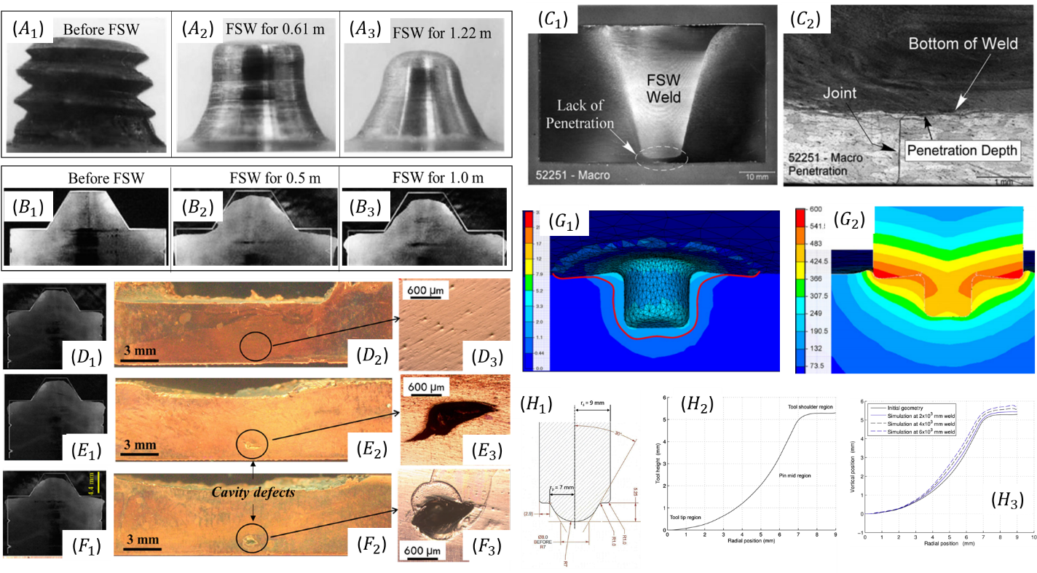
The current section is used to verify one presumption that the tool wear is axisymmetric according to the literature. The images of tools before and after FSW collected from the literature [1,2] are displayed in Figure S1. It can be concluded that tool wear is axisymmetric such that the one-dimensional ultrasonic signals can be used to represent the three-dimensional tool wear or degradation. Common characteristic defects during friction stir welding and processing are due to tool wear [1]. Reduction in tool pin length can lead to a lack of penetration or cavity defects. As shown in Supplementary Figures 1(C₁) and (C₂), lack of penetration will lead to un-bonding regions between welding partners during friction stir welding [2], while the reduction in tool pin length can lead to cavity defects during friction stir processing [3].
Figure S1. Pictures of tools before and after FSW collected from the literature [1-6]: (A₁₋₃) tool material is 01 AISI oil hardened steel and base material is Al 6061 + 20 vol.% Al₂O₃ composites; (B₁₋₃) tool material is H13 tool steel, and base material is Cu-0.8wt%Cr-0.1wt%Zr alloy. (C₁) and (C₂) Cross-section of friction stir welded sample showing lack of penetration; (D₁), (E₁) and (F₁) showing tool wear condition and (D_{2,3}), (E_{2,3}) and (F_{2,3}) showing the correlated processed region. (F₁) Simulated equivalent strain and (F₂) simulated temperature field distribution on friction stir welding during friction stir welding process; (H₁) tool geometry (H₂) tool initial dimensional profile and (H₃) tool profile after different welding distances.
The rotation movement of FSW/P tools is more dominant than traverse movement. Thus the tool wear is mainly influenced by the rotation movement. Therefore, the tool wear tends to be axisymmetric according to the central axis of FSW/P tools (this is one presumption of the current study). As displayed in Figure S1, the experiment implies that tool wear is axisymmetric [1,2]. Additionally, simulation of the FSW process and tool wear conducted by previous researchers can also verify the axisymmetriciy of FSW/P wear. It showed that both strain and temperature distribution on FSW tools are axisymmetric (Figures S1(G₁) and (G₂), [5]) and tool wear is axisymmetric according to the central axis of FSW/P tools (Figures S1(H₁₋₃), [6]). In summary, both experiments and simulation can verify the axisymmetricity of tool wear during FSW/P such that the one-dimensional ultrasonic signals can be used to represent the three-dimensional tool wear or degradation.

2.1. Material characterization and acoustic equipment selection
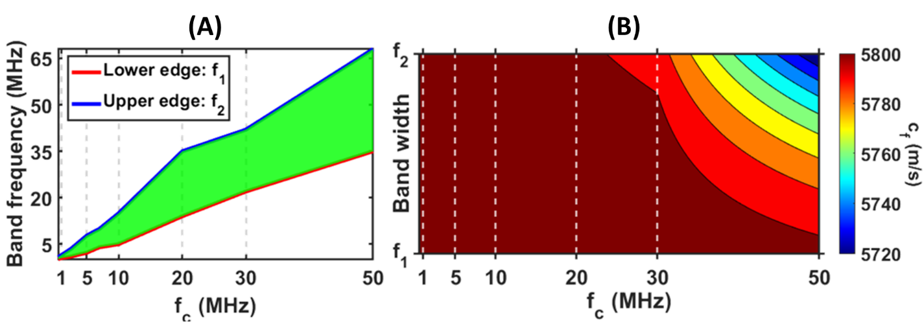
In order to obtain optimized wear-reading results from the acoustic time of flight measurements, a thorough characterization is needed of potential experimental equipment and the acoustic properties of the sample material. The commercialized piezoelectric ultrasound transducers have different active surface areas, effective pulse width, and power/gain dependent frequency band distortion which provides various applicable tool size, amount of scattering from the tool pins, detection resolution, and maximum tool length. In addition to the tool material characterization of the acoustic properties, the frequency-dependent longitudinal speed of sound, attenuation, and dispersion play significant roles in the agreement between numerical simulation and experimental results. In the main text, the ultrasound selection range was narrowed down to 10MHz to 30MHz fundamental frequency by avoiding the selection on the pulse width which was comparable to tool size or internal grain size.
Figure S2. Experimental characterization of equipment and material: (A). Effective bandwidth of potential candidate transducers from low to high center frequency. The shadow green infilled region indicated the effective bandwidth. (B). Experimentally measured frequency dependent speed of sound in tool steel H13. f_{c}, f_{1,} and f₂ refer to center frequency, lower band edge frequency, and upper band edge frequency.

To properly estimate the pulse dispersion and signal distortion of the potential candidate transducers, we experimentally measured the effective bandwidth using a pulse-echo configuration on an immersed steel H13 sample. As Figure S2(A) illustrates, the frequency $f$ band distribution${\left|X\left(f\right)\right|}^{2}$ was obtained from the Fourier transformation of the temporal reflection envelope $x\left(t\right)$ that occurred from the interface between steel surface and surrounding de-ionized (DI) water as $X\left(f\right)$=$\int{x\left(t\right) e^{-2πit}dt}$. With the obtained effective bandwidth, the frequency-dependent speed of sound was calculated by phase delay over the determined effective bandwidth existing in transmitted pulses traveling between steel H13 sample and non-dispersive DI-water with the same thickness by experiments expressed as $c_{f}\left(f\right)=d_{ H13}{\left(1480+\frac{γ(f)-δ(f)}{2πf}\right)}^{-1}$, where $c_{f}$, $d_{ H13}$, $γ(f)$ and $δ(f)$ are frequency-dependent sound velocity, the thickness of the sample, and the phase of the frequency components in the steel sample and DI-water. The results are shown in Figure S2 (B). With 30MHz and 50MHz fundamental frequency transducers, the speed of sound was frequency dependent on the effective bandwidth which would introduce a non-negligible pulse dispersion in the typical tool steel H13. From 0.5MHz to 20MHz center frequency, the dependence on frequency and averaged sound velocity was about 0.8% which was small enough to eliminate. In other words, the characterized transducers with fundamental frequency at 20MHz or 10MHz would not induce a dispersion effect on the ultrasound pulse in tool steel H13.

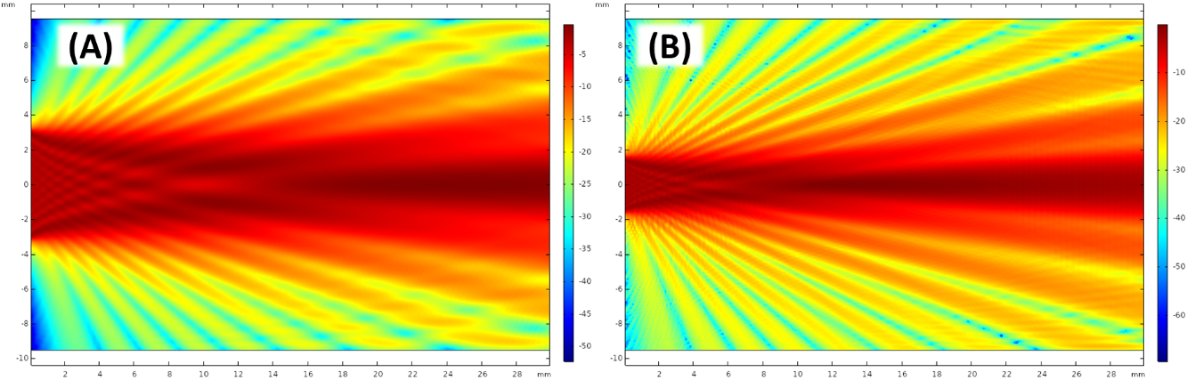
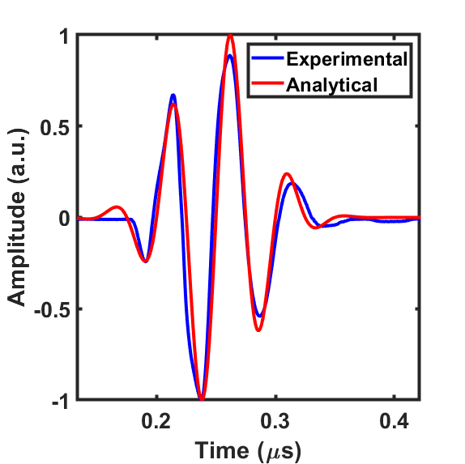
To further select a compatible transducer for this study between 10MHz and 20MHz, we analyzed the beam width, spreading and near field effect in tool steel H13. Beam spreading angle and near field length were two common terms to estimate the acoustic beam behavior as $\sin{θ}=1.2c{\left(Df\right)}^{-1}$ and $N=D^{2}f{\left(4c\right)}^{-1}$, where $θ$, $c$, $f$ and $D$ are beam spreading angle, speed of sound, operating frequency, and transducer diameter. Analytically, the spreading angle of both transducers was 6.35º and near field length was 17.3mm on 10 MHz and 8.7mm on 20MHz which agree with the sound pressure level field numerically calculated from finite element analysis based simulation; see Figure S3. The analytical and numerical beam behaviors of both transducers provide exceptional information for selecting the probe. The near field effect length of the 10 MHz was overlengthened or comparable as the typical FSW/FSP tool length (10 to 20mm) even including the shoulder thickness. Alternatively, the 20 MHz transducer had a near field length at 8.7mm shorter than the typical tool length which was acceptable.
Figure S3. Numerical simulation of the sound pressure field of the 10 and 20 MHz transducers: (A). Sound pressure level map of 0.25 inch diameter 10 MHz transducer. (B). Sound pressure level map of 0.125 inch diameter 20 MHz transducer. The color map indicated sound pressure level in dB scale.
Figure S4. Pulse waveform comparison: Experimentally measured pulse envelope. Analytical modelled pulse waveform for further simulation as source.
For time-domain time of flight measurement, the comparable experimental record and numerical modeled source waveform significantly contributed to the similarity in time of flight behavior between measurement and simulation. We experimentally recorded the transmitted pulse envelope in an H13 tool steel sample as the blue line illustrated in Figure S4. The analytical equation of the temporal $t$ pulse envelope $x\left(t\right)$ could be further written as $x\left(t\right)=\sin\left({2πf}_{0}t\right)e^{-f_{0}{\left(t-δT_{0}\right)}^{2}}$, where $f_{0}$, $T_{0}$ and $δ$ were the fundamental frequency, period, and delay of the pulse signal. The analytical waveform shown as a red line in Figure S4 had high similarity with the experimentally measured pulse. The analytical equation was further input into the finite element analysis simulation as signal source for generating the numerical experiments data bank for AI training purpose.

2.2. Numerical modeling of FSW/FSP tool wear with ultrasonic setup
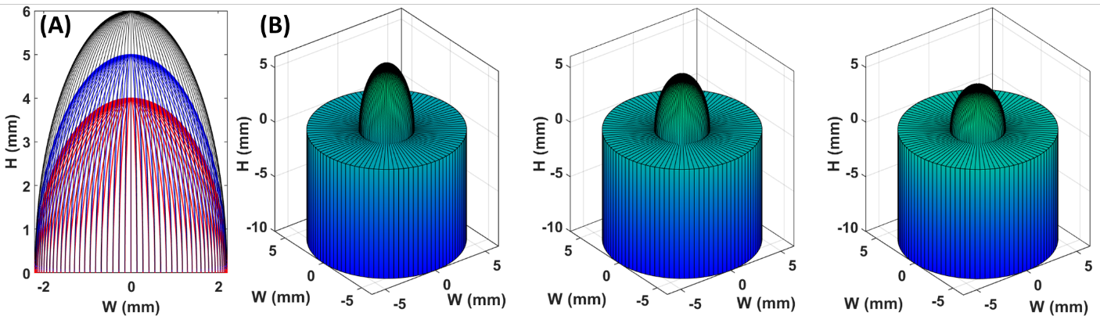
As a central axial rotating motion, the tool wear behavior of FSW/FSP was generally axial symmetry. We realized an ellipsoid shape to represent the tool pin which is defined by its width w and height h. Wear was modeled as reducing h, which automatically adjusted the tool pin curvature as Figure S5(A) illustrates. In the studied model, the width of the tool pin was fixed to 4.4 mm with the decreasing height from 6mm to 1.5mm with 0.01mm interval from 6mm to 4.5mm and 0.1 interval from 4.5 to 1.5mm. Figure S5(B) illustrates the entire tool including the shoulder and pin at 6mm, 5mm, and 4mm. Vertically, the shoulder of the tool located from -10mm to 0mm, from 0mm to positive direction, were the pins. The size and shape of the shoulders were consistent in all cases of pin length. The ultrasound transducer contacting placed under the bottom of the shoulder part excites acoustic pulse vertically propagation in the positive direction on the H axis.
Figure S5. Tool pin wear and tool modelling: (A). self-curvature adjusting on the modelled tool pin with fixed width and decreasing height at 6mm (black), 5mm (blue), and 4mm (red). (B). Designed entire tool with fixed shoulder and reducing pin height at 6mm (left), 5mm (middle), and 4mm (right).
The designed tool was input into finite element analysis based on COMSOL Multiphysics software. In the study, the temporal time of flight acoustic signal was calculated by an acoustic wave equation in the time domain. The wave equation was expressed as $\frac{1}{ρc^{2}}\frac{∂^{2}p_{t}}{∂t^{2}}+∇∙(-\frac{1}{ρ}\left(∇p_{t}-q_{d}\right))=Q_{m}$. The expression was the standard linear elastic wave equation with the assumption that the acoustic pressure was much smaller than the bulk modulus without any entropy difference production. In this equation, $ρ$ was density, $c$ was speed of sound, $p$ was pressure, $t$ was time, $q_{d}$ was dipole source (the transducer), and $Q_{m}$ was monopole source (equal to 0 in our case). The outer boundary of the tool was assigned as full reflection walls to represent the tool steel/air interface which had 9 orders of magnitude difference providing approximately all energy reflection. In the model, the material properties of H13 tool steel were experimentally measured by ultrasonic shear wave assisted effective density and dynamic modulus estimation at 20MHz [7-9]. The effective density, longitudinal speed of sound, dynamic Young’s modulus, and dynamic Poisson’s ratio were $ρ_{eff}$=7789 kgm⁻³,$c$ =5802 ms⁻¹, $E_{dyn}$=182 GPa, and $υ_{dyn}$=0.275. The 20 MHz ultrasound experimentally measured dynamic and effective material properties indicated the realistic mechanical response from the elastic oscillation of the material at the frequency which leads to the numerical simulated acoustic temporal data converging to the experimentally recorded signal. The parametric sweep was set on the pin height h to complete a bank of temporal data for further AI training.

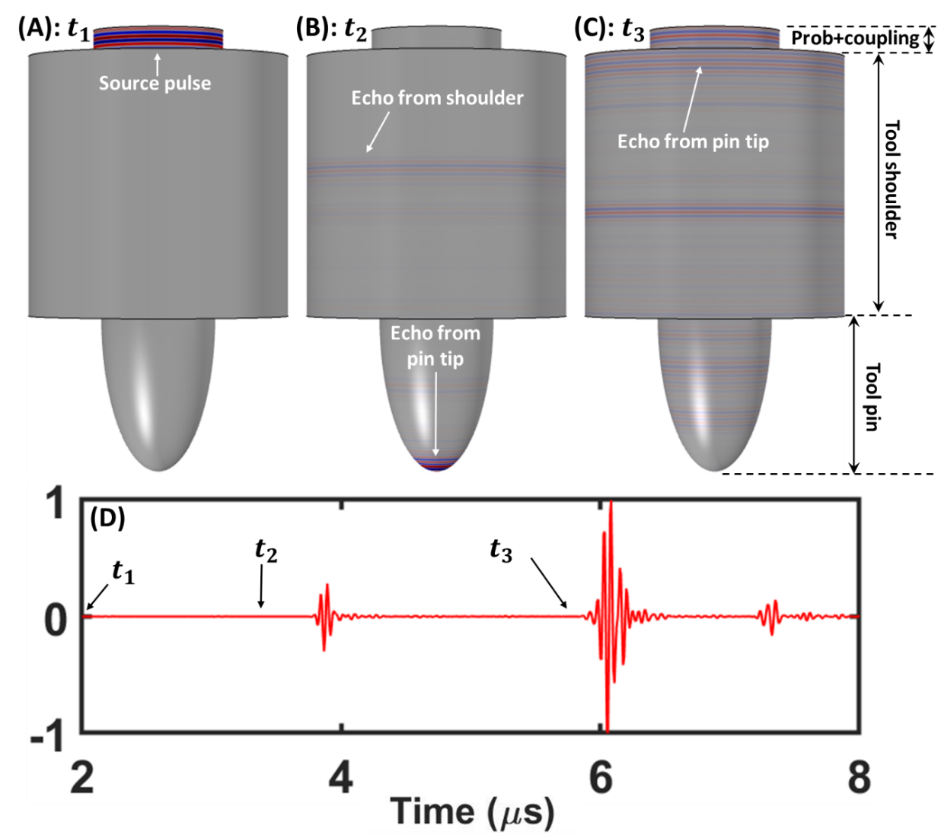
Figure S6 illustrates acoustic pulse propagation inside the tool with 6mm pin length as an example. In the illustration, the upper disc shape was modeled as an ultrasonic transducer with 1 mm coupling material (aloe gel, water-like acoustic properties). The middle wider diameter cylinder was indicated to shoulder part H13 steel tool. The lower zone semi-ellipsoid was the target tool pin. Figures S6(A), (B), and (C) refer to 3 time points at $t_{1}$, $t_{2}$, $t_{3}$ where $t_{1}$<$t_{2}$<$t_{3}$. At $t_{1}$ (Figure S6(A)), an acoustic pulse was excited from the transducer surface (upper surface of the top disc), propagating in the coupling material to the interface between coupling material and higher boundary of the tool shoulder. In Figure S6(B) ($t_{2}$), the target reflection occurred around the pin tip of the tool. In the meantime, a minor reflected echo was propagated back to the transducer shown in the middle region on the tool shoulder. At $t_{3}$, the pin tip induced reflection arrived at the upper transducer surface as a received echo signal in Figure S6(C). In Figure S6(D), the transducer collected temporal reflection data was illustrated for the 6mm pin length case. Time points $t_{1}$, $t_{2}$, $t_{3}$ were indicated on the timeline.
Figure S6. Time of flight example animation with 6mm pin length: (A). Initial acoustic pulse excited from the ultrasound transducer at $t_{1}$. (B). Reflected pulse energy occurred around the tool pin tip at $t_{2}$. (C). The reflected pulse envelope from the pin tip arrived at the surface of the transducer at $t_{3}$. Time scale: $t_{1}$<$t_{2}$<$t_{3}$. The acoustic wave was indicated by negative and positive pressure as blue and red color illustrated. (D). The top disc surface transducer received signal in the time domain.

2.3. Nonlinearity between wave reflection time and tool wear
With the numerical simulation model described in the last section, we were able to generate a complete data bank with various pin length conditions to offer enough data for AI program training purposes. It was obvious that the reflection traveling time to tool pin length was not linear as Figure S7 right illustrates. The nonlinearity was miniature as the two parallel white dash lines indicate, which introduced a significant challenge on the pin length reading accuracy, by manually recognizing or with simple algorithms. For comparison, we generated another data bank with flat head tools (Figure S7 left). The flat head tool data contour showed a perfect linear relation with the reflection arriving time and tool length. The echo envelope was individually clean and clear without additional minor scattering signals around the main echo. On the other hand, in the semi-ellipsoid tool pin data bank, the main reflection obtained from the pin tip propagated back to the transducer along with some minor scattering signal (tail signals) in the front or after it, due to the curvature of the pin head along the horizontal axis. Additionally, with the various curvatures of the pin head along with the reduction of the pin length, the relative temporal position of minor reflection envelopes was shifted, respectively. With the complexity of the reflection signal in the semi-ellipsoid tool pin data bank, it was verified as necessary to involve a machine learning program to read the wear conditions of the tool with ultrasound signals.
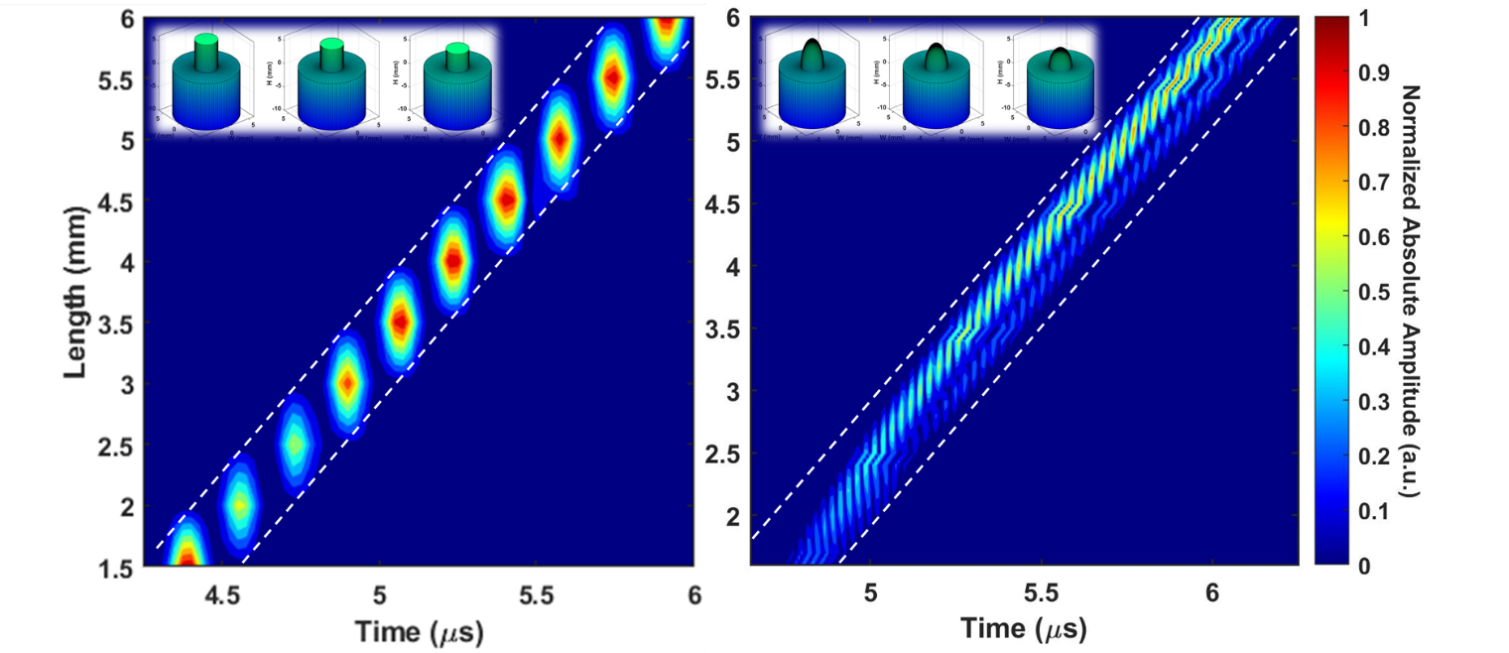
Figure S7. Nonlinearity in semi-ellipsoid tool pin numerical data bank comparing with the linear flat head numerical data bank: (Left). Pin head occurred reflection signal arrival time to pin length relation for flat head tools. (Right). Pin head occurred reflection signal arrival time to pin length relation for semi-ellipsoid head tools.

2.4. Experimental setup and specimen preparation
2.4.1 Bistatic transmission test
The frequency-dependent speed of sound of the H13 tool steel was measured by a bistatic transmission experimental setup. For the velocity measurements, a JSR Ultrasonic DPR 500 Pulse/ Receiver and Tektronix MDO 3024b oscilloscope were used to generate and acquire data. Olympus planar transducers were used in a bistatic (through-transmission) arrangement as illustrated in Figure S8(A). In order to map a wider frequency range dispersive speed of sound distribution (Figure S2(B)), we used multiple ultrasound transducers from low center frequency to high, including 0.5, 1, 5, 10, 20, 30, and 50 MHz (V301, V302, V308, V312, V316, V213, and V215). To eliminate the temperature variation induced sound velocity difference in the steel sample, the sample temperature was verified at room temperature 20.4 °C (± 0.2°C) before each run of experiments. Speed of sound propagation in the known thickness H13 tool steel sample using standard time of flight techniques was calculated from the ratio of specimen thickness to sound wave propagation time. The accuracy of the setup was verified for DI water with the results comparing favorably to existing literature.

2.4.2 Immersion monostatic test for effective density and dynamic elastic constants
The effective density and dynamic elastic constants estimation tests were performed in a 550 mm by 550 mm by 550 mm homemade acrylic water tank filled with DI water, fully immersing the ultrasound 20 MHz transducer and tested sample indicated in Figure S8(B). The scanned area on the tool steel sample was 4 mm by 4 mm with a 1 mm step interval. The final effective density and dynamic elastic constants were the averaged values over the scanned area. The temporal data was acquired and recorded individually at each position in the scanned area by square array arrangement. The Olympus V316 0.125-inch diameter 20 MHz unfocused emersion pencil style transducer was involved in offering a broadband pulse from 16.5 MHz to 35 MHz every 100 μs during the raster scan of samples and collected the reflection from the samples. The raster scan was controlled by MATLAB® script defined motion completed by 3 Universal Motion Controller/Driver Model ESP 300 controlled by a Newport UE41PP translation stage controller. A JSR Ultrasonic DPR 500 Pulse/ Receiver internally operated the pulse source and time trigger, and the data was collected by a Tektronix MDO 3024b. The scanning rate was 512 signals per 20 seconds. This test offered effective density and dynamic bulk modulus values.

In order to calculate the dynamic Young’s modulus, the dynamic shear modulus test was necessary. The shear wave velocity experiment was performed with Olympus V222 0.125-inch diameter 20 MHz unfocused normal incidence transverse transducers in the H13 tool steel sample. The shear wave velocity value was averaged from three tested angles -- 0º, 45º, and 90º -- controlled by a Thorlabs DC motor controller driven Motorized Continuous Rotation Stage. The angles are between the horizontal building plane and the shear wave oscillating plane. The dynamic shear modulus was estimated by the shear speed of sound and effective density values.

The dynamic elastic constants and effective density can be calculated by the measured acoustic impedance and sound velocity of the tested sample. The acoustic impedance ratio between the sample and known ambient reference fluid (DI-water) is: $\frac{Z_{1}}{Z_{0}}=\frac{-1-α-\sqrt{4α+1}}{α-2}$, where $α$=$\frac{P_{1}}{P_{e}-sgn(Z_{1}-Z_{0})\left|P_{0}\right|}$ from experimental measurement. $P_{e}$, $P_{1}$, and $P_{2}$ are the amplitude of the transducer emitted pulse, first reflection, and second reflection. $Z_{0}$is the known acoustic impedance of ambient material. $Z_{1}$ is the target impedance of tested samples. Sub-number 0 and 1 are referred to as the ambient material (DI water) and the samples. The dynamic bulk modulus is $K_{dyn}=c_{L}Z_{0}\frac{-1-α-\sqrt{4α+1}}{α-2}$. Effective density can be expressed as $ρ_{eff}=\frac{Z_{0}}{c_{L}}\frac{-1-α-\sqrt{4α+1}}{α-2}$, where $c_{L}$ is the speed of the longitudinal wave in the time domain of the two recorded reflections. Dynamic shear modulus can be obtained by effective density and transverse mode speed of sound $G_{dyn}(θ) =ρ_{eff}{c_{T}}^{2}$, where $c_{T}$ is the angle-dependent speed of the transverse sound wave measured by monostatic time of flight method, and $θ$ is the angle is defined as the inclined angles between the printed layers and the shear wave oscillation plane. The angle-dependent dynamic Young’s modulus and dynamic Poisson’s ratio can be calculated as $E_{dyn}=\frac{9K_{dyn} G_{dyn} }{3K_{dyn} + G_{dyn} }$ and $ν_{dyn}=\frac{3K_{dyn}-2 G_{dyn} }{6K_{dyn} + 2G_{dyn} }$.

2.4.3 Monostatic test for detecting the tool pin length
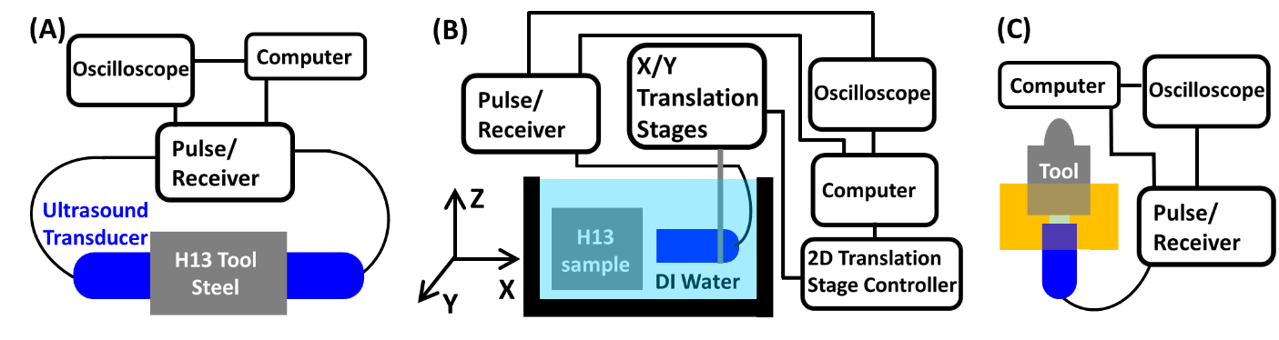
The main experiments in this study were the monostatic FSW/FSP tool pin length detection with the time of flight measurement. 7 samples (H13 tool steel FSW/FSP tools) with various pin lengths were fabricated by CNC machining based on a 3 foot (914.4mm) long 0.5 inch (12.7mm) diameter rod from McMASTER-CARR. The cylindrical shoulder parts of the samples were identical in length with different pin lengths and head curvatures. A resin adaptor was printed by stereolithography (SLA) printer Formlab Form 2 with 0.025 mm resolution as the yellow part illustrated in Figure S8(C). The adapter worked as the alignment between tool and transducer vertically and horizontally in the detection experiment. The adapter was a cylindrical part formed with 3 disc shape defects. From the upper side to lower, the first was 5mm deep with 12.7mm diameter. The second hollow part was 1mm thick with 3.175mm diameter which was the size of the effective piezoelectrical element on the 20 MHz transducer. In the experiments, this defect was filled with aloe gel as a coupling material which has water-like acoustic properties at $ρ_{eff}$=1045 kgm⁻³,$c$ =1432 ms⁻¹. The last defect on the adapter was an 8mm deep disc with 6.35 mm diameter which was the size of the transducer. The acoustic pulse exited from the Olympus V316 0.125-inch diameter 20 MHz unfocused transducer from JSR Ultrasonic DPR 500 Pulse/ Receiver with an active high-pass filter at 7.5 MHz every 100 μs during the raster scan of samples and collected the reflection from the samples. The reflected acoustic waveform was collected by the emission transducer, and the converted electrical signal was sent to a Tektronix MDO 3024b oscilloscope. The oscilloscope averaged 512 signals in the same time window for further recording.
Figure S8. Experimental setup: (A). Bistatic ultrasound transmission experimental setup. (B). Monostatic ultrasound effective density and dynamic modulus estimation testing with immersion experimental setup. (C). Monostatic ultrasound time of flight experimental setup for measuring the tool pin length.

3.1 Simulation data, preprocessing and AI model configuration
3.1.1 AI model selection and performance on raw data
The temporal data from the simulation was calculated with the same time length, time interval, and acoustic source. The window length was 18$μs$ with 4.165$ns$ intervals. The amplitude of the collected numerical signals (center frequency at 20 MHz) was in the unit of pascal as acoustic pressure.

We compared 16 standard regression algorithms to explore the performance of regression models. We first attempted to use raw data as the training data for our chosen algorithms. The results are shown in Table S1. Among all the algorithms, the random forest model shows the best overall performance. From this initial experiment, the error rate reported from the random forest model has already fulfilled the requirement for measuring the amount of tool wear. At this stage, we can conclude that our tool monitor prediction problem is solvable through AI techniques under the ideal simulated environment.
Table S1. Regression model performance with raw databank: The table demonstrated some statistical output factors of 16 different existing AI models. Column 1 included the model names and corresponding citations. MAE: mean absolute error. MSE: mean square error. RMSE: root mean square error. R²: r-square. RMSLE: root mean squared log error. MAPE: mean absolute percentage error. Also, TT: training time. The final selection was highlighted.
Model | MAE | MSE | RMSE | R2 | RMSLE | MAPE | TT (sec)
Extra Trees Regressor [10] | 0.0535 | 0.0106 | 0.0957 | 0.9951 | 0.0485 | 0.3292 | 0.088
K Neighbors Regressor [11] | 0.0638 | 0.0147 | 0.1046 | 0.9331 | 0.0512 | 0.3138 | 0.017
CatBoost Regressor [12] | 0.0895 | 0.0272 | 0.1565 | 0.9864 | 0.0708 | 0.5522 | 0.856
Extreme Gradient Boosting [13] | 0.0857 | 0.0776 | 0.2263 | 0.9641 | 0.0864 | 0.7778 | 0.031
Random Forest Regressor [14] | 0.1017 | 0.1078 | 0.2579 | 0.9506 | 0.1003 | 1.2268 | 0.086
Gradient Boosting Regressor [15] | 0.1255 | 0.1278 | 0.3024 | 0.9408 | 0.1183 | 0.952 | 0.016
Decision Tree Regressor [16] | 0.0872 | 0.143 | 0.2627 | 0.9362 | 0.1111 | 0.6736 | 0.007
Bayesian Ridge [17] | 0.301 | 0.1543 | 0.3869 | 0.9269 | 0.1679 | 1.7341 | 0.006
Linear Regression [18] | 0.3014 | 0.1544 | 0.387 | 0.9268 | 0.1675 | 1.7181 | 0.007
Least Angle Regression [19] | 0.3014 | 0.1544 | 0.387 | 0.9268 | 0.1675 | 1.7181 | 0.008
Ridge Regression [20] | 0.3014 | 0.1544 | 0.387 | 0.9268 | 0.1675 | 1.7181 | 0.007
Huber Regression [21] | 0.2967 | 0.1572 | 0.3901 | 0.9258 | 0.1646 | 1.5643 | 0.007
AdaBoost Regressor [22] | 0.1438 | 0.1659 | 0.3003 | 0.9246 | 0.1119 | 0.8377 | 0.019
Elastic Net [23] | 0.3468 | 0.2082 | 0.4505 | 0.9026 | 0.1893 | 1.9307 | 0.007
Passive Aggressive Regressor [24] | 0.3643 | 0.2239 | 0.4669 | 0.8952 | 0.1984 | 1.3685 | 0.007
Lasso Regression [25] | 0.4487 | 0.3511 | 0.5846 | 0.8362 | 0.2313 | 2.153 | 0.007

Next, we move to the evaluation of our real sample dataset. Here we choose the best-performing model: the random forest model. Table S2 shows the result of our real data evaluation.
From the result, we can see a considerable increase in errors compared with the simulation testing. This result is not good enough to fulfill the requirement for tool monitoring purposes.
The real sample testing results reveal that the real data still carries significant differences relative to the raw simulation data.

Table S2. This table shows the random forest model performance on recognizing real experimental data trained on the raw databank. The table shows some statistical output factors of the reorganizations. MAE: mean absolute error. MSE: mean square error. R2: r-square.
Model | MAE | MSE | RMSE | R2 | RMSLE
Extra Trees Regressor | 1.5035 | 0.69354 | 0.83279 | -0.907575 | 0.140574

To address the model performance on real testing data, we decided to refine our training simulation data to better mirror real-world conditions. The next section covers the data preprocessing and augmentation steps for the model performance improvement.

3.1.2 Simulation data preprocessing and augmentation
From our analysis of the real data and simulation data, we can see that the real data carries more noise than the simulation data. Furthermore, we also consider that the original form of data might not be sensitive enough for the model to generate the correlation between signal changes and tool wear condition changes.

Noise Augmentation: The nature of simulation data brings almost zero influences from different kinds of environmental noise sources. The collected raw ultrasonic data includes various kinds of noise. We observe that real sample data tends to have a consistent noise effect on a small scale. We also find occasional random noise with high spikes in other points of real sample data. In this scenario, we introduce a noise augmentation step to augment simulated data with noise so that the model would learn from a more similar environment and be able to resist the effect of the noise.

Our noise augmentation specifically targets the consistent pattern of noise that we observe from the real data: we add a random normal (Gaussian) distributed sequence with different scales upon the original simulation data with the same length. The “raw” plot in Figure S9 shows the MAE score of the noise augmented raw dataset based upon the random forest regressor. We can observe a significant improvement of the model accuracy by adding our designated noise, and the optimal one can achieve nearly two times better accuracy on real sample prediction.

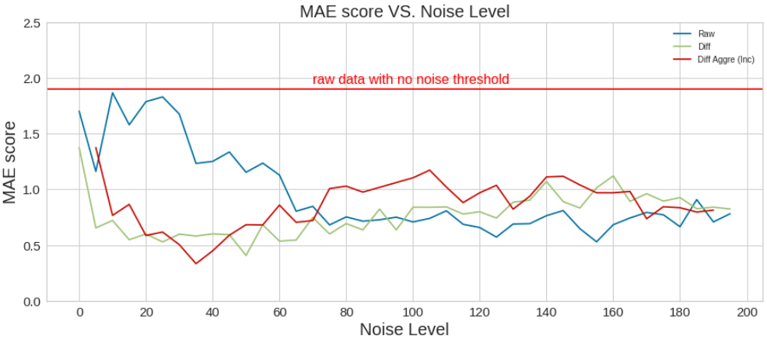
Figure S9. MAE scores versus different levels of noise augmentation applied for real testing samples: 1) Raw: raw simulation training data; 2) Diff: differential converted training data; 3) Diff Aggre (Inc): Aggregated differential converted training data where each point represents aggregated data with a combination of noise augmentation from 0 to the point of noise level with incremental step of 5. MAE score is reported based upon the AI model.

Differential Conversion: This step aims to strengthen the connection of input data with the corresponding prediction: the wear amount of the tool pin demonstrates a difference between its current condition from its original condition. Similarly, we can convert the raw input data to represent the difference of the current data point from the original data point: For each tool condition (data point), we subtract the data point with no wear from each point and take the absolute value. Then, we get the differentiated data from each point against the tool pin with good condition. In Figure S9, the ``Raw" and ``Diff" data point at the noise level of 0 shows the MAE score for raw data and differential converted data. We can observe a substantial improvement in accuracy from such data conversion. We further explore the influence of noise augmentation and differential conversion together as shown in the entire “Diff” plot in Figure S9. We first apply noise augmentation, and then differential conversion of the data. We can observe that a specific range of noise levels with differential conversion can improve the quality prediction accuracy.

Data Aggregation: We have observed that the model performs differently given the different scales of noise augmentation. We assume that multiple levels of noise together can further improve the robustness of the model against different levels of noise. In this case, we aggregate different sets of noise augmented data with different noise scales as training data. We first experiment with such aggregation of noise levels in a continuous incremental way. We take a noise scale of 5 as a step and continuously add noise augmented data sets to test the model performance. In Figure S9 the “Diff Aggre (Inc)” plot demonstrates the results. We see that such aggregation generally follows the trend as noise augmented without aggregation. So far, we get our best result from the “Diff Aggre (Inc)” experiment with noise augmentation up to 35, where the MAE is 0.3331.

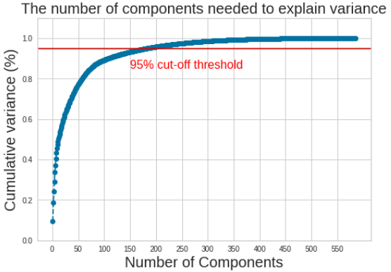
Figure S10. PCA variance explained by number of components

PCR Dimension Reduction: Principal component regression (PCR) is a dimension reduction
technique for regression problems where the dataset is pre-processed with principal component analysis (PCA) to reduce the number of input dimensions to a designated value. PCA can simplify the high-dimensional data while retaining the inner patterns and producing summarized features with fewer dimensions. For our data, each time point represents a unique feature in one data point. We know that different parts of the signal contribute differently to the tool wear prediction: the signal reflected from the tool wear should contribute more, where we may reduce less important features to improve the model performance. On choosing the number of components, we follow the general rule where the number of components can account for 95 percent of the overall variability of the original data. Figure S10 shows the plot for PCA variance explained by the number of components given the best training dataset we obtained from previous experiments. We expect the following advantages from using such a technique for the model: (a) Reduce the effect from noise features; (b) Better model fit by reducing the data complexity with fewer features. Our result shows that PCR can substantially improve the performance, confirming our expectations. Our best-reported model can have an MAE score on testing samples as low as 0.0591. In this case, our final accuracy of the model is now acceptable as a monitoring metric for our purpose. One thing to be aware of while using PCR in our experiments is that the training data shuffling can significantly influence the result positively or negatively. This is because PCA is applied after the training data shuffling. We run several hundred random shuffle tests to get the best-performing model.

3.1.3 Final results on the AI predicted real tool wear
Table S3 shows the evaluation details of all the chosen models during the training stage. All the results are based upon the finalized data from the preprocessing step. All the evaluation metrics are averaged results with 10 fold cross validation.

In the real experiments, a total of 7 cases were examined by the numerically trained AI model. The case of new tool 6mm pin length tool with 0mm wear was used as a comparison reference. The wear condition was categorized with varying significance in wear. With 0.5mm wear interval, we performed the experiments with 0.5, 1.0, 1.5, and 2.0mm. Small step intervals were also involved as 1.15 and 1.2 mm wear which indicated the wear steps as 0.15 and 0.05mm interval. The prediction wear values by the AI of all performed cases are listed in Table S3. The recognizing errors were small, and the r-square value was high, as Table S3 shows. The performance of the numerical AI model was exceptional which had a maximum error of 189.5 µm which was smaller than our typical ultrasound operating wavelength ($λ$), 290 µm. The average prediction error was 96 µm which was approximately $λ/3$.
Table S3. Main results of this study: The following table includes the results of recognizing real experiments performed using the numerical databank trained AI model. The plotted figure version of this table is in the main text as Fig. 6.
Tool wear condition in real experiments (mm) | Predictions by AI (mm) | Prediction error (µm)
0 | 0 | 0
0.5 | 0.6202 | 120.2
1.0 | 0.9740 | 26.0
1.15 | 1.1488 | 1.2
1.2 | 1.3895 | 189.5
1.5 | 1.5912 | 91.2
2.0 | 2.1481 | 148.1

4. Additional cases
Due to interest in studying more detail in the tool wear, we have also studied the wear condition of thread on the tool pin and sticking workpiece material on the tool.

4.1. Tool with thread
For optimizing the friction stir welding/process performance, using the tool pin with thread was a common option to increase the material flow for minimizing flaws or defects in the welded or processed zone. The thread on the tool pin is usually worn to disappear in a very limited number of workpieces before the length of the tool pin is reduced significantly. Here, we conducted the case study to determine the tool thread wear condition. To achieve the goal, we realized the method notated as one wavelength thread monitoring. The operating frequency of this method can be selected based on the acceptable minimum thread height. The wavelength of the selected operating frequency in the tool material was needed to be approximately equal to the acceptable minimum thread height. When the thread height was larger than the operating wavelength, additional reflected pulse envelopes were able to be observed in front of the major echo from the pin tip. The additional reflection disappeared once the wear reduced the thread height to less than the operating wavelength.
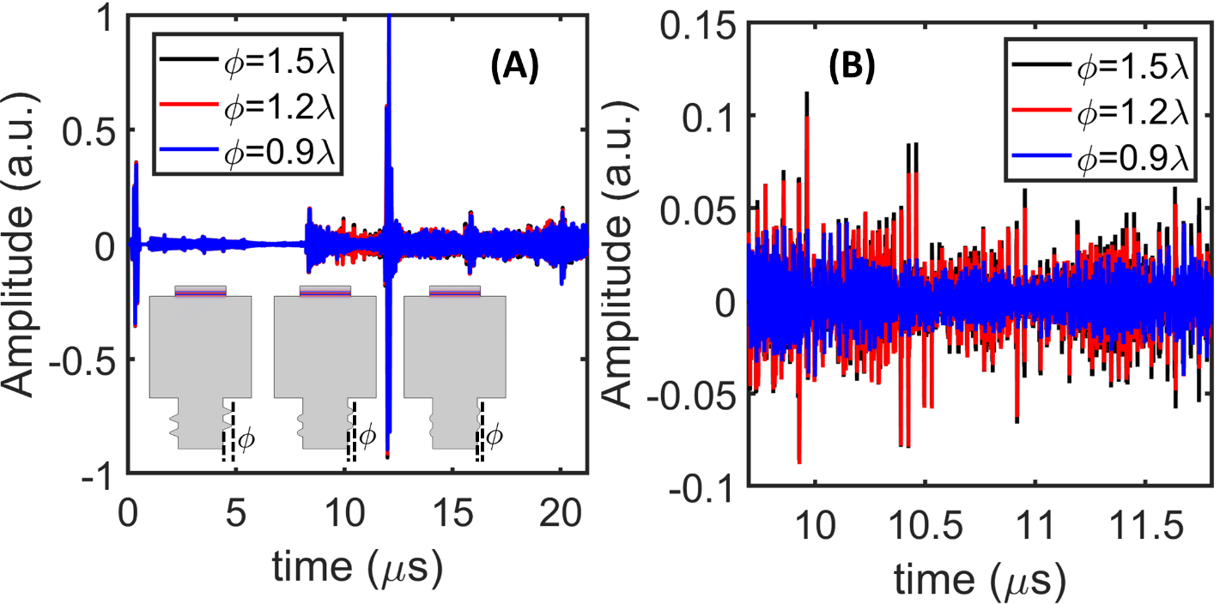
For proof of the concept, we collected time-of-flight signals on a tool with three different thread height conditions, shown in Figure S10. The desired thread height alarm was selected as 290$μm$ which was the typical wavelength $λ$ of the 20MHz ultrasound wave in H13 tool steel. We simulated the thread sizes at 1.5$λ$ (black line), 1.2$λ$ (red line), and 0.9$λ$ (blue line) with identical tool pin length. In (A), we observed similar time of flight behavior as the pin length study results. After the trigger signal around time 0s, the first and second major reflections were observed at around 8$μs$ and 12$μs$ from the tool shoulder and pin tip. It was obvious to locate the additional reflection envelopes between the first and second major echoes. In (B), the zoomed in view illustrated the additional reflections in a clear presentation. In the range from 9.75$μs$ to 11.75$μs$, comparing with the case of the 0.9$λ$ thread height, 1.5$λ$ and 1.2$λ$ cases showed clear additional echo due to the presence of the thread with the larger height values comparing with the operating wavelength. The reduction of the thread height from 1.5$λ$ to 1.2$λ$ induced a small amount of the reflection amplitude deduction. Once the thread height values became smaller than the operating frequency, the scattering-liked signal was collected instead of the additional reflection.
Figure S9. Numerical simulation signal of wear of tool thread: (A). Numerically simulated time-of-flight signal of FSW tool with thread on the tool pin with three thread height $ϕ$which are equal to 1.5$λ$, 1.2$λ$ and 0.9$λ$, where the $λ$ was the typical wavelength of our selected operating frequency 20MHz in H13 tool steel, 290$μm$. The tool pin length of all three cases were identical. (B). Zoomed-in time window from 9.75$μs$ to 11.75$μs$.
4.2. Workpiece and tool materials selection
Friction stirring is a thermomechanical deformation process where the tool temperature approaches the solidus temperature of base materials. Production of a quality friction stir weld or product requires the proper tool material selection for the desired application. Material characteristics such as (1) elevated temperature strength, wear resistance, fracture toughness and stability; (2) chemical reactivity; and (3) machinability are generally considered for tool material choice. To achieve the tool wear monitoring in this study for more general cases, one more requirement needs to be fulfilled as the acoustic impedance difference between tool materials and workpiece material needs to be large enough to provide a reflection signal with exceptional amplitude in experiments. In Figure S11, we have plotted the impedance mismatching induced reflection energy remaining amount with the combination of the broadly applied workpiece and tool materials.
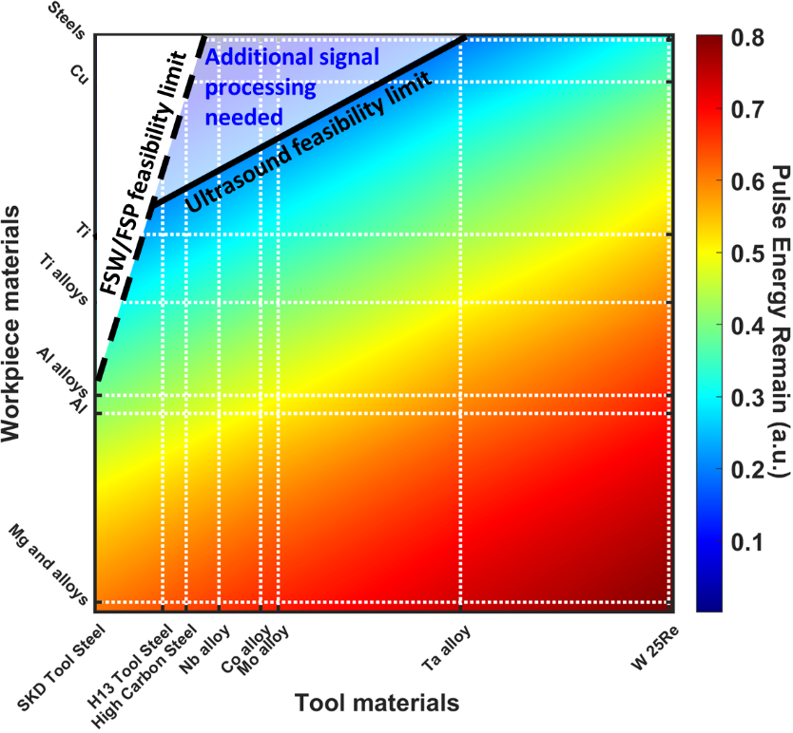
The mechanical properties difference between tool and workpiece materials introduced the limitation region plotted by the black dash line on the contour. In the white area, the workpiece/tool combination was not machinable. The black solid line illustrated the ultrasound feasibility limit line over the combinations. We set the limitation line at the pulse energy remaining amount at 0.2 based on our experimental observation. In the experimental tested data, the small signal feature around the major reflection envelopes was averaged -46dB without any workpiece material adherence on the tool pin. With energy transmission to the additional workpiece material in the sticking cases, we considered totally -60dB was the minimum acceptable intensity level with confidence to record detail, where the noise level of our equipment was averaged at
Figure S10. Pulse reflection energy remaining ratio in the cases of the tool sticking with workpiece materials. Data from references [26-34].
-90dB. The feasibility limitation line could be extended to an even lower energy remaining region with better electronics. Between two limitation lines, the low reflection pulse energy remaining region provided averaged 10% energy back, which limited our methodology introduced in this study but is resolvable with additional signal processing and amplifying techniques. For practical applications for the industrial field in the future, the material adherence problem is necessary to be studied comprehensively, leading to a series of new models.

Reference for supplementary material
- Arbegast, W.J., 2008. A flow-partitioned deformation zone model for defect formation during friction stir welding. Scripta materialia, 58(5), pp.372-376.
- Na, J., Spencer, R., Todorov, E., Gleeson, S. and White, P., 2011. Nondestructive Evaluation of Solid-State Welds, ASM Handbook, Volume 6A, Welding Fundamentals and Processes.
- Sahlot, P., Jha, K., Dey, G.K. and Arora, A., 2018. Wear-induced changes in FSW tool pin profile: effect of process parameters. Metallurgical and Materials Transactions A, 49(6), pp.2139-2150.
- Rai, R., De, A., Bhadeshia, H.K.D.H. and DebRoy, T., 2011. Friction stir welding tools. Science and Technology of Welding and Joining, 16(4), pp.325-342.
- Guerdoux, S. and Fourment, L., 2009. A 3D numerical simulation of different phases of friction stir welding. Modelling and simulation in materials science and engineering, 17(7), p.075001.
- Hasan, A.F., Bennett, C.J., Shipway, P.H., Cater, S. and Martin, J., 2017. A numerical methodology for predicting tool wear in Friction Stir Welding. Journal of Materials Processing Technology, 241, pp.129-140.
- Jin, Yuqi, Ezekiel Walker, Arkadii Krokhin, Hyeonu Heo, Tae-Youl Choi, and Arup Neogi. "Enhanced instantaneous elastography in tissues and hard materials using bulk modulus and density determined without externally applied material deformation." IEEE Transactions on Ultrasonics, Ferroelectrics, and Frequency Control 67, no. 3 (2019): 624-634.
- Jin, Yuqi, Ezekiel Walker, Hyeonu Heo, Arkadii Krokhin, Tae-Youl Choi, and Arup Neogi. "Nondestructive ultrasonic evaluation of fused deposition modeling based additively manufactured 3D-printed structures." Smart Materials and Structures 29, no. 4 (2020): 045020.
- Jin, Yuqi, Teng Yang, Hyeonu Heo, Arkadii Krokhin, Sheldon Q. Shi, Narendra Dahotre, Tae-Youl Choi, and Arup Neogi. "Novel 2D Dynamic Elasticity Maps for Inspection of Anisotropic Properties in Fused Deposition Modeling Objects." Polymers 12, no. 9 (2020): 1966.
- Geurts, Pierre, Damien Ernst, and Louis Wehenkel. "Extremely randomized trees." Machine learning 63, no. 1 (2006): 3-42.
- Altman, Naomi S. "An introduction to kernel and nearest-neighbor nonparametric regression." The American Statistician 46, no. 3 (1992): 175-185.
- Dorogush, Anna Veronika, Vasily Ershov, and Andrey Gulin. "CatBoost: gradient boosting with categorical features support." arXiv preprint arXiv:1810.11363 (2018).
- Chen, Tianqi, and Carlos Guestrin. "XGBoost: A scalable tree boosting system." In Proceedings of the 22nd ACM SIGKDD international conference on knowledge discovery and data mining, pp. 785-794. 2016.
- Friedman, Jerome H. "Stochastic gradient boosting." Computational statistics & data analysis 38, no. 4 (2002): 367-378.
- Breiman, Leo. "Random forests." Machine learning 45, no. 1 (2001): 5-32.
- Gordon, A. D. "Classification and Regression Trees." Wadsworth Inc 67, (1984): 874-874.
- Tipping, Michael E. "Sparse Bayesian learning and the relevance vector machine." Journal of machine learning research 1, no. Jun (2001): 211-244.
- Galton, Francis. "Regression towards mediocrity in hereditary stature." The Journal of the Anthropological Institute of Great Britain and Ireland 15 (1886): 246-263.
- Efron, Bradley, Trevor Hastie, Iain Johnstone, and Robert Tibshirani. "Least angle regression." The Annals of Statistics 32, no. 2 (2004): 407-499.
- Hoerl, Arthur E., and Robert W. Kennard. "Ridge regression: Biased estimation for nonorthogonal problems." Technometrics 12, no. 1 (1970): 55-67.
- Huber, Peter J. Robust statistics. Vol. 523. John Wiley & Sons, 2004.
- Drucker, Harris. "Improving regressors using boosting techniques." In ICML, vol. 97, pp. 107-115. 1997.
- Zou, Hui, and Trevor Hastie. "Regularization and variable selection via the elastic net." Journal of the Royal Statistical Society: series B (statistical methodology) 67, no. 2 (2005): 301-320.
- Crammer, Koby, Ofer Dekel, Joseph Keshet, Shai Shalev-Shwartz, and Yoram Singer. "Online passive-aggressive algorithms." Journal of Machine Learning Research 7, no. Mar (2006): 551-585.
- Tibshirani, Robert. "Regression shrinkage and selection via the lasso." Journal of the Royal Statistical Society: Series B (Methodological) 58, no. 1 (1996): 267-288.
- Engineering ToolBox, (2004). Solids and Metals - Speed of Sound. [online] Available at: https://www.engineeringtoolbox.com/sound-speed-solids-d_713.html
- https://www.ndeed.org/GeneralResources/MaterialProperties/UT/ut_matlprop_metals.htm (2020), Center for Nondestructive Evaluation Iowa State University.
- http://www.matweb.com/search/datasheet.aspx?matguid=65f65c787723483d904e642d0a6d8576&ckck=1, (2020), MatWeb's searchable database.
- Blessing, G. V. "Ultrasonic Measurements of Titanium Elasticity and Attenuation in Welds and Plate." (1982): 1-22.
- https://www.rshydro.co.uk/sound-speeds/, (2021), RS Hydro.
- https://www.classltd.com/sound-velocity-table/, (2020), Class Instrumentation Ltd.
- Chu, F., T. E. Mitchell, B. Majumdar, D. Miracle, T. K. Nandy, and D. Banerjee. "Elastic properties of the O phase in Ti-Al-Nb alloys." Intermetallics 5, no. 2 (1997): 147-156.
- https://www.plansee.com/en/materials, (2020), Plansee SE.
- https://periodictable.com/Elements, (2020), Index of /Elements.

