Text Mining

By Jianchi Wei, Chenyu Mao, Chongyu He
Final Report
Client: Aman Ahuja
CS 4624, Professor Edward Fox
May 10, 2022
Virginia Tech, Blacksburg, VA 24061
Table of Contents
List of Figures 2
List of Tables 4
1. Abstract 5
2. Introduction 6
3. Requirements 8
4. Design 10
5. Implementation 13
6. Testing & Evaluation 19
7. User’s Manual 22
8. Developer’s Manual 28
9. Lessons Learned 30
10. Acknowledgments 33
11. References 34

List of Figures

Figure 1: An overview of ETD-Topics 7

Figure 2: A snapshot of different user services. (a) Documents per Topic Distribution and Topic List, (b) Similar Topics and Topic Specific Documents for one topic, (c) Document page showing Related Topics and Similar Documents for one document, (d) Trend Analysis 9

Figure 3: Code for the required package 13

Figure 4: Code for dataset type, model type, and the number of topics 14

Figure 5: Code for standardization 14

Figure 6: Code for preprocessing 15

Figure 7: Code for training process 16

Figure 8: Dividing elements 21

Figure 9: FigureIndex Page 22

Figure 10: Topic Page 23

Figure 11: Topic Selected Page 23

Figure 12: Shore More Button 24

Figure 13: Document Page 24

Figure 14: Full Text URI 25

Figure 15: Filter Document Page 25

List of Tables

Table 1: Description of services 12
Table 2: Quantitative Comparison of Different Models (under 50,000 documents), with underlined values indicating best performing models (*NeuLDA denotes NeuralLDA). 20

Table 3: Quantitative Comparison of Different Models (under all documents), with underlined values indicating best performing models (*NeuLDA denotes NeuralLDA). 26

Table 4: Corresponding Words for a Topic from Different Models 28

1. Abstract
Part of the abstract comes from a recently submitted paper sent to ETD 2022, listed as [1] in the reference section.
Electronic theses and dissertations (ETDs) contain valuable knowledge that can be useful in a wide range of research areas. Accordingly, we are building electronic infrastructure leveraging advanced work on digital libraries, for discovering and accessing the knowledge buried in ETDs. We focus on our work to incorporate topic modeling into digital libraries for ETDs. We present ETD-Topics, a framework that extracts topics from a large text corpus in an unsupervised way. The representations learnt from topic models can be useful for downstream tasks such as searching and/or browsing documents by topic, document recommendation, topic recommendation, and describing temporal topic trends (e.g., from the perspective of disciplines or universities).
We provide four modes (LDA, NeuralLDA, ProdLDA, and CTM) to serve user groups with different browsing and searching requirements. Our job was to import the preprocessed database and to apply the four trained models, and then to accurately display key information (such as topics, document title, abstract, etc.) on web pages. We chose Python as the main language to implement the back-end, while using Flask as a bridge connecting the back-end and front-end. While using HTML for displaying data, we were able to employ JavaScript and CSS to make web pages that include graphic bars, buttons (like “Submit”, “Show more”, etc.), and tables.

2. Introduction

Scholarly documents like ETDs contain important research findings, which are of value to diverse digital library users. Examples of such users include students and researchers who want to review work related to their research area, as well as librarians and university administration who want an overview of recent research in their institutions. [1]
With the vast amount of research being conducted across a variety of domains, millions of ETDs are now publicly available online. However, digital library services for ETDs have not evolved past simple search and browse at the metadata level, thus rendering the vast amount of information from these documents underutilized. [1]
In recent years, there have been many advances in the fields of text mining and natural language processing (NLP). One line of work of value in the analysis of ETDs is topic modeling, which aims to extract thematic collections of words that could represent topics, from a large corpus of text documents. Several topic modeling algorithms have been proposed over the years. Probabilistic Latent Semantic Indexing (PLSI) [2] and Latent Dirichlet Allocation (LDA) [3] were among the earliest works in this domain. Recent works in the domain of topic modeling include neural topic models such as NeuralLDA [4], ProdLDA [4], and CTM [5]. The representations learned from topic models can be used for downstream tasks that rely on document representations, such as finding similar documents (document recommendation), finding similar topics, analyzing the variation of topics over time, etc. [1]
In this work, we propose ETD-Topics, a topic modeling based framework for analyzing and discovering information contained in ETDs using several state-of-the-art topic models. Our framework allows users to extract topics present in an ETD collection using one of the several topic models provided. Users can then select a topic of interest, and do further analysis of the topic using multiple end-user services supported in our framework. Supported services include searching documents associated with a particular topic, calculating the distribution of the documents w.r.t. topics, document recommendation, topic recommendation, and topic trend analysis based on time range and/or university. Moreover, since topic models are fully unsupervised in nature, our framework does not require any handcrafted labels such as categories, thereby making it easily deployable and scalable for new document collections. [1]
Figure 1 shows the architecture of our framework. The system pipeline components are described below.

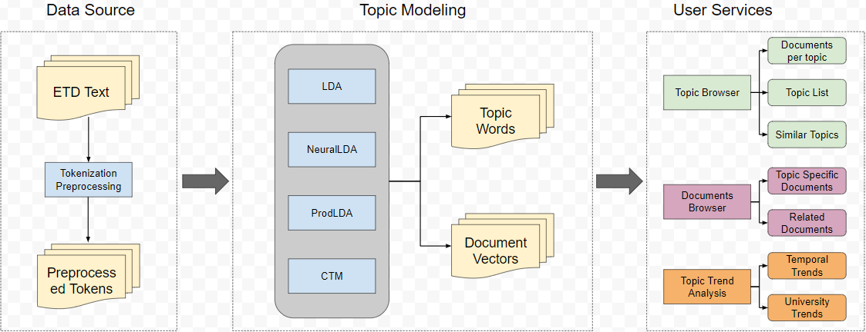
Figure 1: An overview of ETD-Topics [1]

3. Requirements

3.1 Data Source
Since our framework aims to assist in analysis of massive amounts of ETD data, we require a large collection of text ETDs. For each ETD, we use its title and abstract as the corresponding text. This text is then tokenized and goes through a series of preprocessing steps, such as stop word and punctuation removal, removing terms with low document frequency (infrequent words), and lemmatization. We also drop documents whose token count is less than a certain threshold number, as these are likely to be documents with limited or missing text. Finally, we obtain a list of tokens for each document that can be sent to the topic modeling module. [1]

3.2 Topic Modeling
This module forms the main backbone of our system. It takes the preprocessed data as input and uses topic modeling algorithms to extract the topics from the document corpus. The topic modeling algorithms currently supported are:
• LDA [3]: LDA is one of the earliest topic models, that uses Bayesian priors as the initial document-topic and topic-word assignments, and then updates these distributions based on the probability with which a document or a word is associated with a certain topic.
• NeuralLDA [4]: This is the neural network based version of LDA, that utilizes a variational inference [6] method for learning document-topic representations.
• ProdLDA [4]: This is an improved version of NeuralLDA, that is designed to give more coherent and interpretable topics.
• CTM [5]: In contrast to other topic models that use bag-of-words representations for text and hence ignore the order of words, this model combines representations from language models like BERT [7] in the topic modeling process, thus incorporating word context. [1]

Since topic models require several iterations over the dataset for training, we train all the models offline, using different numbers of topics for each model. We set the number of topics (denoted as K) to {10, 25, 50, 100} while training the models, thus resulting in 16 pre-trained models (4 models, each with a different value of K, for each of the 4 algorithms listed above). [1] Figure 2 shows screenshots of what features have been complemented.

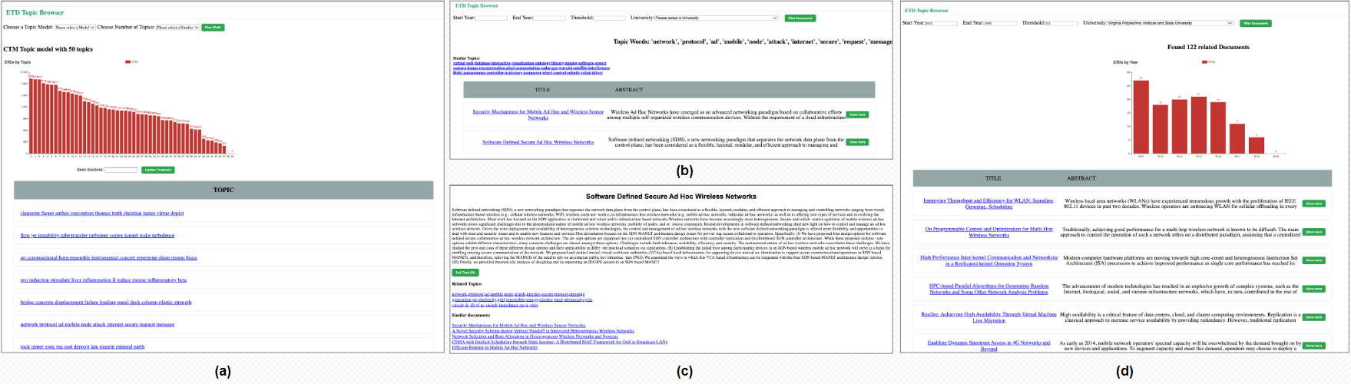
Figure 2: A snapshot of different user services. (a) Documents per Topic Distribution and Topic List, (b) Similar Topics and Topic Specific Documents for one topic, (c) Document page showing Related Topics and Similar Documents for one document, (d) Trend Analysis [1]

All topic models typically give two types of outputs. The first is a K × V topic-word distribution matrix, where V is the vocabulary size. Each row of this matrix represents the importance of each of the words in the vocabulary for the respective topic. The second is an M×K document-topic distribution matrix, where M is the number of documents in the corpus, where each row represents the proportion of each of the topics in the respective document. [1]

4. Design
In this project, we are required to build a website that helps with visualizing the backend data. In the Python language, there are many excellent web frameworks, such as Django, Tornado, and Flask. According to “Take Stock of the Advantages and Disadvantages of These Seven Python Open Source Frameworks” [9], Django is good for big projects while Tornado is good for high traffic projects. Based upon analysis of different frameworks and our client needs, the most suitable one for this project was found to be Flask.
In the first meeting with our client, we basically understood the requirements of this project. It could be divided into 4 main functions, which are: Documents per Topic Distribution and Topic List, Similar Topics and Topic Specific Documents for one topic, Document page showing Related Topics and Similar Documents for one document, and Trend Analysis. We initially decided to make 4 main pages, index page, topic page, document page, and advanced searching document page. The index page shall allow users to enter their interest model and number of topics, and then leads to the topic distribution page, which contains a bar graph of the number of documents in each topic, and a descending list of topics. Users shall choose their interested topic, which leads them to the document page, and it shall contain an overview of the document with title and abstract. If the user would like to find more information about the selected document, the user shall click the document title hyperlink and it shall lead to the document page, and show full text of abstract and URI. Additionally, if the user would like to filter the document, we plan to put a search box at the top of the topic page, which allows the user to filter documents with year range, threshold, and university.
Since the website would contain tons of research documents, we are prone to make the font and size readable. Thus, we use the Google font and green color as the overall style of the website.
4.1 Methodology
Personas:
- Viewers (typical users): Want to find the latest reports and conclusions about COVID-19 for better disease prevention.
- Professional scholars: Find theories or knowledge related to the scholars’ own research and learn from each other.
- Reporters: Dedicated to exploring the research trajectory of disease and reporting them step by step in chronological order.
Goals:
- Show the document topics based on different analysis models and chosen topics number.
The user needs first to select the model and the number of topics and press the button for “select topic,” which will lead the user to the topic page that displays several topics with an index. After the user selects and presses the index of the topic, a page with documents that are topics related will be displaced.

- Show related documents needed by users through topic models and indexes.
The users need first to finish goal 1 part, then all relevant topics with index will be shown on a webpage. Users can visit all topics and choose what they are interested in by clicking on the specific index hyperlink.

- Show documents by a timeline search engine on specific topics.
The user needs first to select the model and the number of topics and press the button for “select topic,” which will lead the user to the topic page that displays several topics with an index. After the user selects and presses the index of the topic, a page with documents that are topics related will be displaced. The user can enter the starting year, end year, and threshold on this page to search on the paper he wants.

Table 1 shows specific details for each service.

Service ID | Service Name | Input file name(s) | Input file Ids (comma-sep) | Libraries; Functions; Environments
G11 | select model | ETDS_Modelname_Number | F1 | html,flask,input
G12 | Select topic number | ETDS_Modelname_Number | F1 | html,flask,input
G13 | Press “Select topics” Button | ETDS_Modelname_Number, URI.txt, preprocessed.txt | F1, F2, F3 | html,flask,button
G21 | Select index by hyperlink | output.p | F4 | html,flask,hyperlink
G31 | Input start year | Year.txt | F5 | html,flask,input
G32 | Input end year | Year.txt | F5 | html,flask,input
G33 | Input threshold | N/A | N/A | html,flask,input
G34 | Press “Advanced search topic” Button | URI.txt,  Preprocessed.txt, Year.txt | F2, F3, F5 | html,flask,button

Table 1: Description of services

Goal 1: Workflow 1 = Service G11 + Service G12 + Service G13
Goal 2: Workflow 1 = Service G11 + Service G12 + Service G21
Goal 3: Workflow 1 = Service G31 + Service G32 + Service G33 + Service G34

5. Implementation
This project is based on Python, Flask, HTML, CSS, and JavaScript. There are two parts to this project. The first part is the backend that includes the data preprocessing, model training, and result generation. The second part of this project is the frontend web application including UI design, and data visualization.
5.1 Backend
Figure 3 shows the code for the required package. We are using the OCTIS package provided from the client.
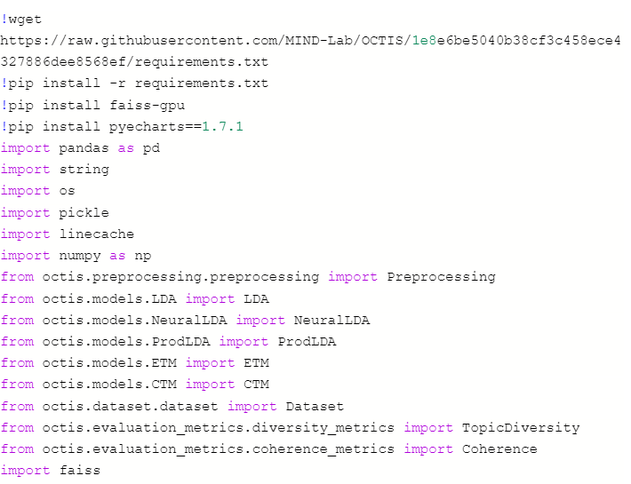
Figure 3: Code for the required package
Figure 4 shows code for the dataset type, model type, and the number of topics provided as parameter values.
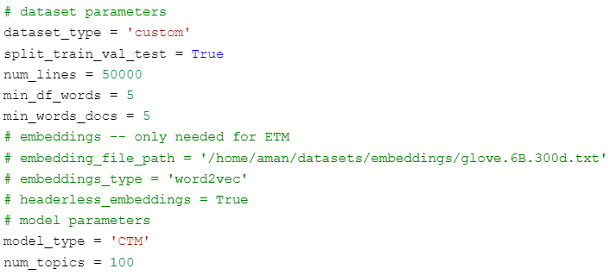
Figure 4: Code for dataset type, model type, and the number of topics
There are some standardization problems with the dataset. The standardize_data function is used to solve the standardization problems. The code for solving the standardization problems is shown in Figure 5.
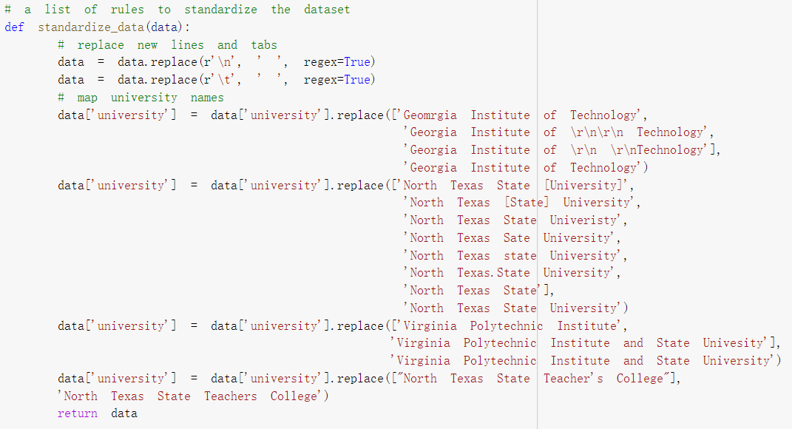
Figure 5: Code for standardization
Figure 6 shows the preprocessing of data. The data are separated into four files with title, URI, year, and university information. The project uses the pre-build preprocessor from the OCTIS package. The parameter and settings of the preprocessor are also shown in Figure 6.
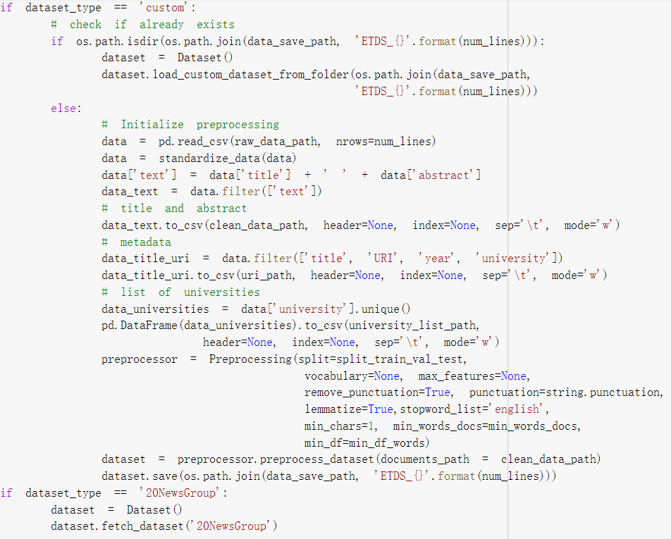
Figure 6: Code for preprocessing

Figure 7 shows the code for the training process. The program will first check if the training model exists based on the given model type and number of topics. If the result already exists, the program will load the model; otherwise the program will train based on the parameter.
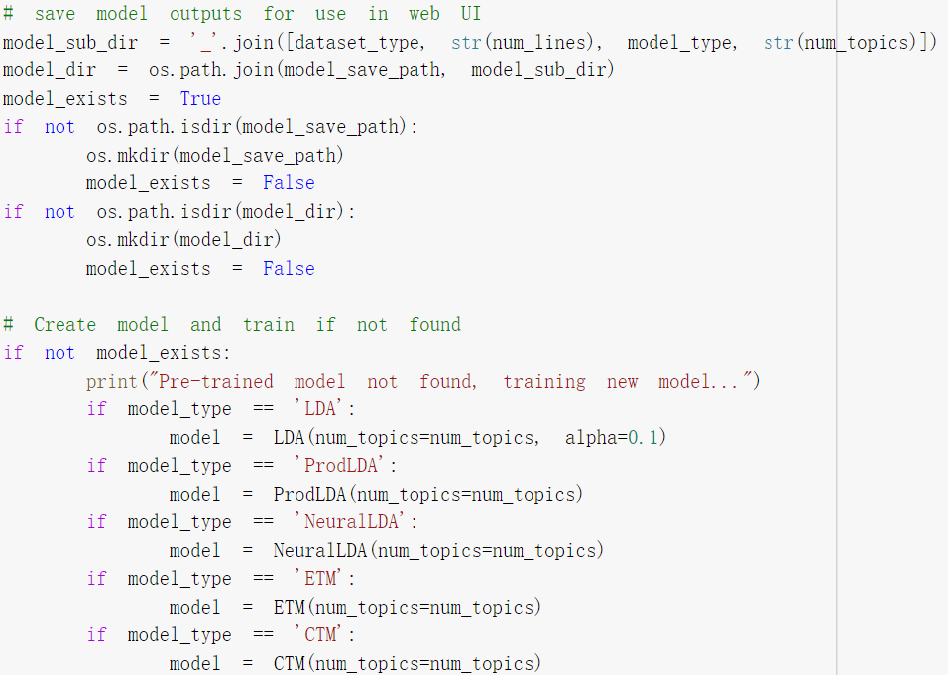
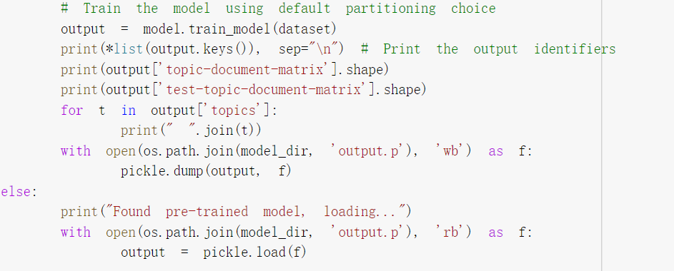
Figure 7: Code for training process
5.2 Frontend
There are four major files for the frontend. There is one Python file using Flask, two HTML files corresponding to the main page of the website, and one CSS file for the CSS style of the HTML. The main function and data visualization are implemented in the Python file.
The data is uploaded to the server.

app = Flask(__name__)
dataset = Dataset()
dataset.load_custom_dataset_from_folder('/home/aman/topic_models_new/datasets/ETDS_None')
clean_data_path ="/home/aman/topic_models_new/preprocessed_None.txt"
path_title = "/home/aman/topic_models_new/titles_None.txt"
path_uri = "/home/aman/topic_models_new/uris_None.txt"
path_year = "/home/aman/topic_models_new/years_None.txt"
path_university = "/home/aman/topic_models_new/univs_None.txt"

The index function takes care of the index page when the user first gets to the website.
@app.route('/')
def index():
return render_template('index.html')

The success function takes care of the Topic Page when the user selects the model type and topic number.
@app.route('/<name>',methods = ['POST', 'GET'])
def success(name):

The thirdPage function takes care of the Topic Selected Page when the user selects the topic. There are two parts of the topic selected page. The first part is the general page after the user selects the topic from the last page. The second part is the search result after the user enters the year range and threshold.
@app.route('/<selected>/<number>',methods = ['POST', 'GET'])
def thirdPage(selected,number):

The documentPage function takes care of the document page when the user has clicked on one of the document names from the table.
@app.route('/Doc/<num>/<document>',methods = ['POST', 'GET'])
def documentPage(num, document):

The searchPage function takes care of the searching and returns the search result table.
@app.route('/Search/<keyWord>/<method>',methods = ['POST', 'GET'])
def searchPage(keyWord,method):

6. Testing & Evaluation

Demonstrating the Diversity and Coherence of the data is the requirement of our testing and evaluation.

6.1 The Diversity and Coherence of the data

6.1.1 Whether the Diversity and Coherence of the trained models’ topics can be acceptable.

We initially processed a small number of documents and trained the model in order to save time and increase efficiency. However, this also caused some unsatisfactory results in training, such as repeated topics and inaccurate topics while describing documents. Therefore, in the subsequent large-scale data processing, we were able to record Diversity and Coherence to ensure the acceptability of models, and we provided tables of Diversity and Coherence for users to browse as a tip to choose different models and number of topics according to their personal circumstances.

Here is the code of how we determined the Diversity and Coherence.

# Initialize metrics
npmi = Coherence(texts=dataset.get_corpus(), topk=10, measure='c_npmi')
topic_diversity = TopicDiversity(topk=10)
# Retrieve metrics score
topic_diversity_score = topic_diversity.score(output)
print("Topic diversity: "+str(topic_diversity_score))
npmi_score = npmi.score(output)
print("Coherence: "+str(npmi_score))

Diversity and Coherence from processing 50,000 documents and all documents are given in Table 2.

Table 2: Quantitative Comparison of Different Models (for 50,000 documents), with underlined values indicating best performing models (*NeuLDA denotes NeuralLDA).

 | Diversity |  |  |  | Coherence
Topics | LDA | NeuLDA | ProdLDA | CTM | LDA | NeuLDA | ProdLDA | CTM
10  25  50  100 | 0.77  0.752  0.784  0.833 | 0.733  0.996  0.98  0.911 | 0.78  0.784  0.782  0.733 | 0.84  0.816  0.872  0.784 | 0.061  0.062  0.063  0.019 | -0.050  -0.075  -0.052  -0.088 | 0.030  0.003  0.031  0.05 | 0.005  0.025  0.084  0.077

6.1.2 Whether document title, abstract, year, and URI match with each other.

In order to better get the various information of documents from the database, we took a segmentation method to divide document title, abstract, year, and URI into different elements.

Figure 8 shows the code that we employed to divide elements.

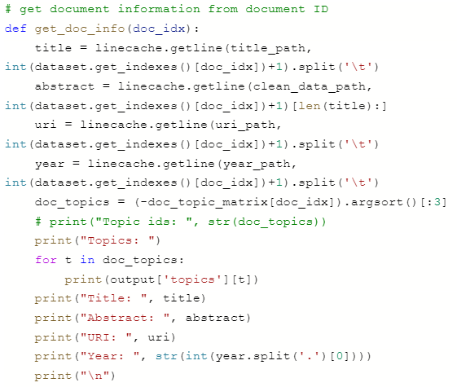
Figure 8. Dividing elements

7. User’s Manual

The frontend user interface (UI) encapsulates multiple downstream tasks and services for users of a digital library. Figure 9 shows searching topic by selecting topic model and number of topics.

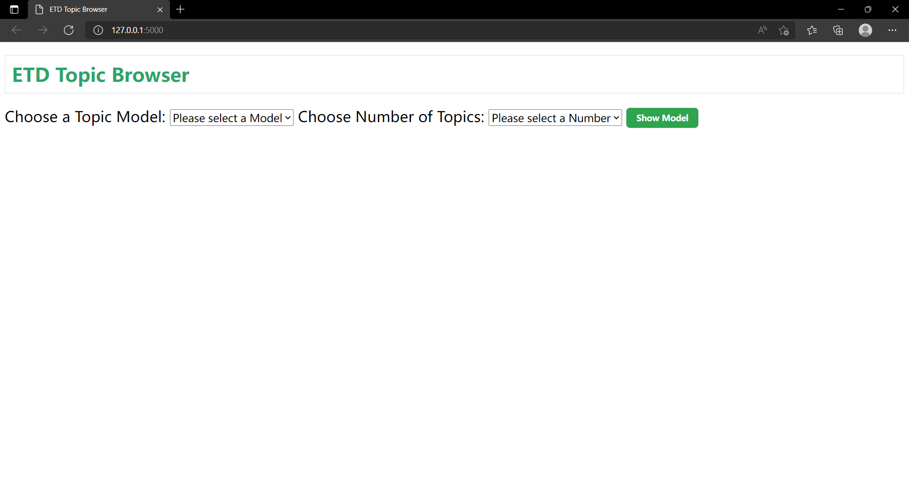
Figure 9: Figure Index Page

Figure 10 shows browsing topics, which are ranked by number of documents.
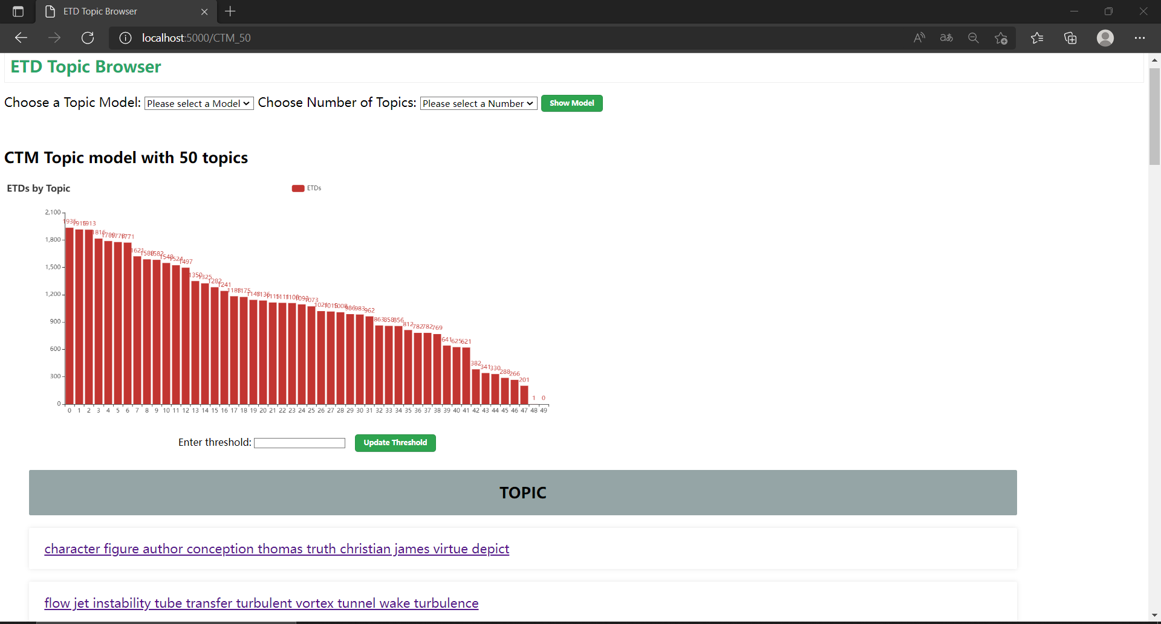
Figure 10: Topic Page

Figure 11 shows browsing documents in a selected topic.
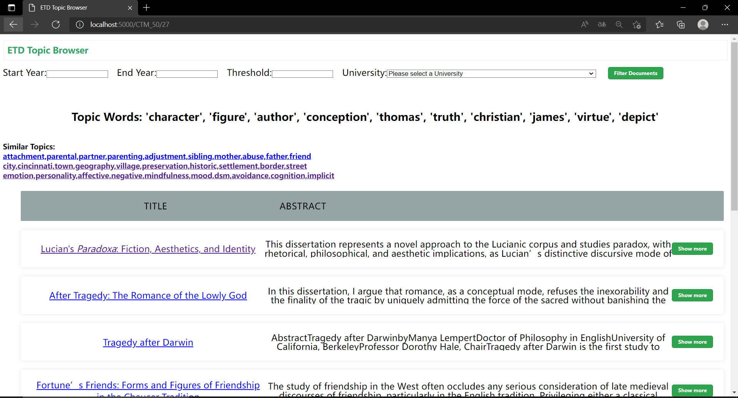
Figure 11: Topic Selected Page
Figure 12 shows showing full text of an abstract.
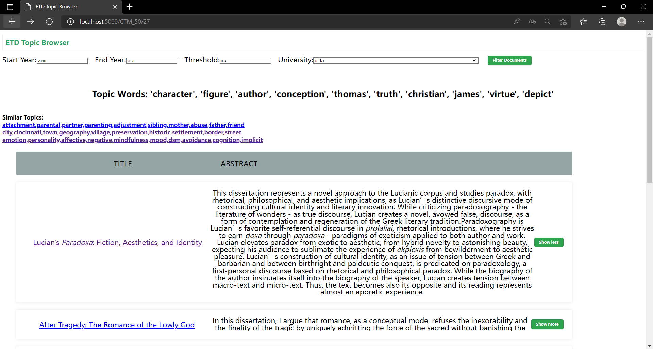
Figure 12: Shore More Button
Figure 13 shows specific information about the selected document.
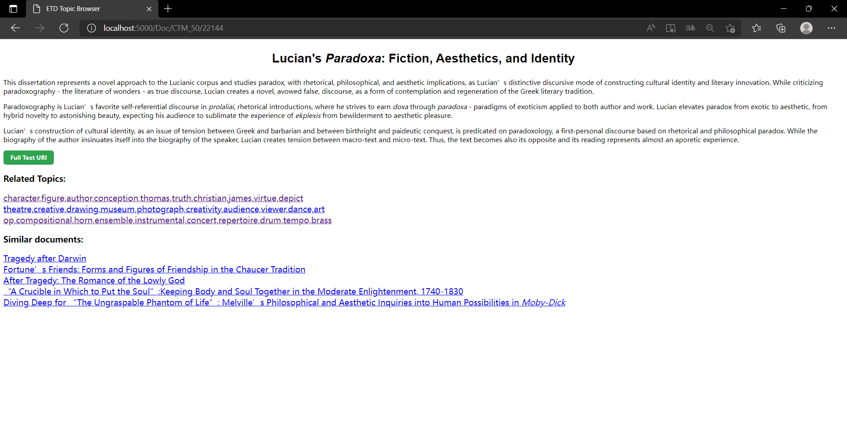
Figure 13: Document Page
Figure 14 shows the full text source of the selected document.
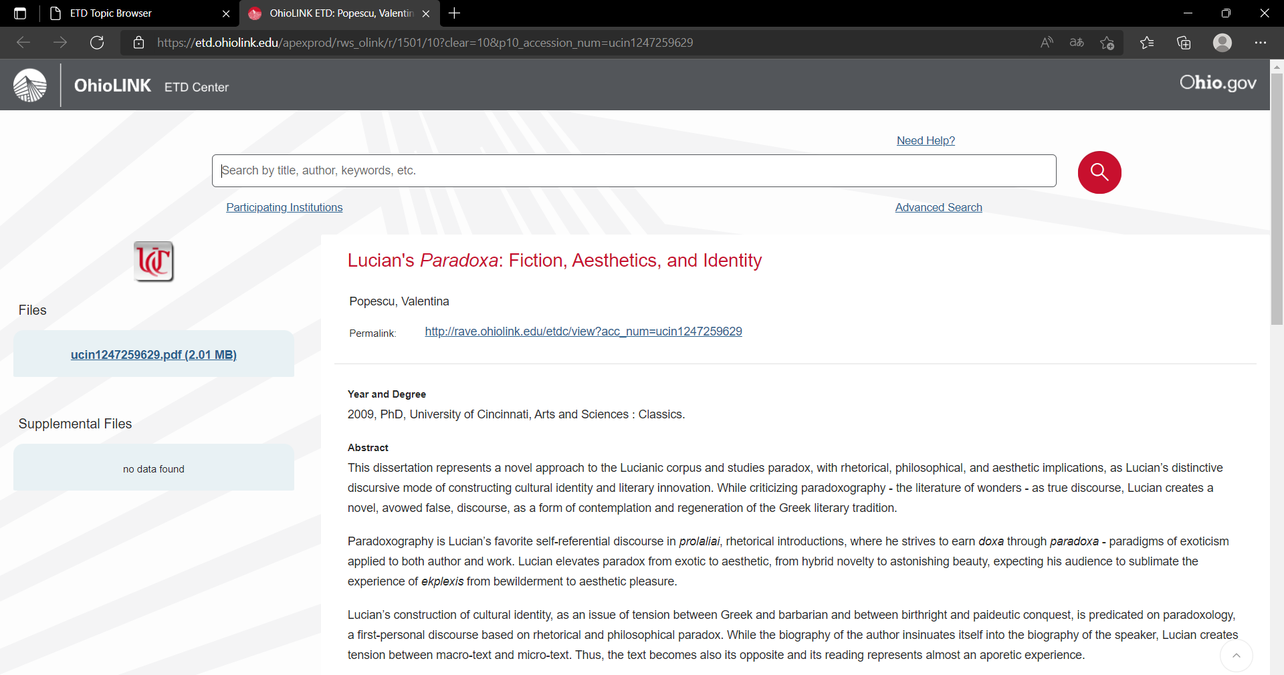
Figure 14: Full Text URI
Figure 15 shows filtering documents by start year, end year, threshold and university.
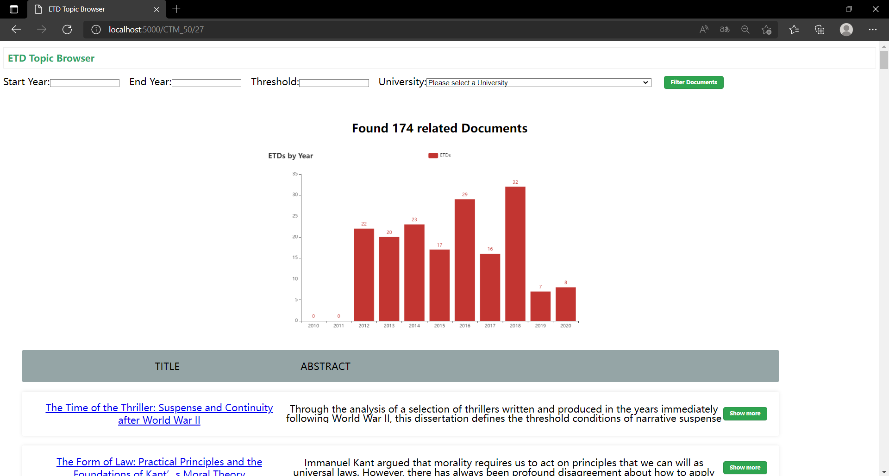
Figure 15: Filter Document Page

7.1 Topic Browser

Our framework allows users to select one of the topic modeling techniques, and the number of topics, and to get the resultant topics. This service includes three major components: [1]
- Documents per Topic Distribution: This module helps users find the most popular topics in the document collection. Given a threshold value (on a scale of [0, 1], default = 0.3) and a topic, this component calculates the number of documents in the entire database for which the given topic constituted more than the threshold. The overall results are displayed as a histogram, where each bar shows the number of documents for that respective topic. [1]
- Topic List: For every topic, this module shows the top 10 words that are representative of that topic; the set thus serves as a type of label. [1]
- Similar Topics: Some users work in interdisciplinary fields. In such instances, it is often desirable to show a list of related topics to the user. This is done based on similarities between different rows of the topic-word matrix. [1]

7.2 Document Browser

The document browser allows users to get specific documents based on their interests. It
mainly consists of two modules: [1]
 | Diversity |  |  |  | Coherence
Topics | LDA | NeuLDA | ProdLDA | CTM | LDA | NeuLDA | ProdLDA | CTM
10  25  50  100 | 0.75  0.752  0.792  0.831 | 1  1  0.988  0.937 | 0.96  0.94  0.92  0.858 | 1  0.94  0.948  0.879 | 0.044  0.080  0.076  0.076 | -0.057  -0.038  -0.037  -0.039 | 0.037  0.077  0.116  0.117 | 0.104  0.114  0.136  0.130

Table 3: Quantitative Comparison of Different Models (under all documents), with underlined values indicating best performing models (*NeuLDA denotes NeuralLDA). [1]

- Topic Specific Documents: This module allows users to get relevant documents for one of the many topics shown in the Topic Browser. It selects the documents based on the presence of the selected topic in the document using the corresponding values of the document-topic vectors. It then displays the title and abstract of the selected document. It also allows users to get more details of a specific document by clicking on it. [1]
- Related Documents: This module assists users in finding documents that are similar to a selected document. This is especially useful in the case of scholarly documents, since users are typically interested in finding multiple related works. [1]

7.3 Topic Trend Analysis
- Temporal Analysis: Many users of a digital library, such as university administrators and faculty members, are interested in analyzing how different research areas trend over time. This module allows users to filter documents associated with a topic in a given time range. [1]
- University-Specific Analysis: In some instances, users are interested in analyzing research trends in their institution, or in peer institutions. This module shows users research trends by university. Additionally, users can combine this feature with temporal analysis to get institution-specific research trends over time. [1]

8. Developer’s Manual

8.1 Dataset and System Details

Our dataset has ∼320K ETDs from over 42 universities. They come from 1845 – 2020, with most published after 1945. Our topic models are from open source implementations included in OCTIS [8]. The UI was developed using Flask1 with a Python backend. [1]

8.2 Comparison of Different Topic Models

Table 3 shows the performance of different topic models on our collection, for two commonly used metrics. Diversity is a measure of how diverse the top words of a topic are w.r.t. top words in other topics. A score of 0 indicates redundancy, while 1 indicates very diverse topics. Coherence measures how likely words from the same topic tend to occur in the same document. Models with high coherence tend to give more interpretable topics. We observe that NeuralLDA produces more diverse topics than other models, indicated by its high diversity score, with CTM being the second best performing model in terms of diversity. [1]

Table 4: Corresponding Words for a Topic from Different Models [1]
Model | Words
LDA  NeuralLDA ProdLDA  CTM | network communication user channel mobile security node wireless protocol thesis network perform introduce efficient end describe integrate linear network problem challenge approach base provide system design framework network protocol ad mobile node attack internet secure request

However, the coherence scores for CTM are much better than other models, indicating more interpretable topics. A good topic model should ideally have high coherence and diversity scores, since high diversity and low coherence could also mean that the topics are composed of unique, yet unrelated words which do not indicate any themes. In Table 4 we also show the corresponding words for one topic obtained from all the models. The topic produced by NeuralLDA is less coherent, indicated by words like thesis and introduction, in line with its low coherence scores. In contrast, the topics produced by LDA and ProdLDA are cleaner, though they do have some open-ended words like user and provide. CTM produces the most coherent topic, which is also reflected by its high coherence scores. It appears that CTM is the best overall performing model on our ETD corpus. [1]

9. Lessons Learned

We presented a framework for using topic models for extracting topics from a large ETD
corpus in an unsupervised way. The framework also supports several downstream tasks and
a rich user interface to assist users of a digital library. In the future, we plan to improve the
framework by adding support for more topic models, more services such as search, mapping
topics to existing ontologies like from ProQuest, and improvements to the user interface. [1]

9.1 Timeline

Feb 23
Front end version-1
- Use the notebook provided to do the following:
- set the number of documents to 5000
- train ProdLDA with 10 and 25 topics
- train LDA with 10 and 25 topics
- save all the matrices returned by training the model as separate pickle objects
- Create a simple UI that can do the following:
- display the title “VT ETD browser.”
- have 2 drop-down menus:
- topic model (LDA, ProdLDA)
- number of topics (10, 25)
- when a user selects the topic model and the number of topics, load the corresponding “topics” pickle file and display words for each topic on a separate line.

Mar 4
Front end version-2
- Show documents for a specific topic after the user clicks on a topic

Mar 20
Front-end version 3
- Add advanced search for topics with date range.
- Given a topic, start year and end year, and threshold, show the documents for that date range.
- Also, display the total number of documents that appear in that time range.

Mar 27
Front-end version 4
- Add functionality to support document recommendation.
- For documents that show on pages 2 and 3, add an option to show similar documents.
- On each row, add an option to show similar documents for the document shown in that row.

Mar 31
Train all models on 50K documents
- Models: LDA, prodLDA, NeuralLDA, CTM
- Number of Topics: 10, 25, 50, 100
- Total 16 models (4 models * 4 num_topics)
- Plug in all the models in the UI

Mar 31
Front-end editing
- Improve the font and UI of all the front-end pages made so far
- In the tables on pages 2 and 3, display the first 200 characters of the abstract and show a “more” button to expand the full abstract
- Remove the URI column from pages 2 and 3
- Show URI under the abstract on Page-4 (that shows similar documents).

Apr 6
Re-train all 16 models on a 50k dataset
- Re-train all models to incorporate changes in code resulting from university-related parts
Front-end enhancements
- Documents per topic histogram on the page that shows a list of topics.
- Similar topics on the page that appears after you select a topic.
- Add the filter by university option on the page that shows the time range.
- Minor edits: update column names in tables, remove [ ] while showing topic words, fix the show more option, show topic model and # topics on top of a table that shows topics.

Apr 9
UI on the full dataset
- Run UI on the full dataset using the pre-trained models and dataset provided CSS updates

Apr 21
Add search functionality based on topic similarity
- Add fields and buttons on the first page to support search
- Create a page that will show search terms on top and a table that will have the title and abstract for matching documents

Apr 28
- Add a load more button at the bottom of the search results table to allow users to load the next batch of 10 results every time a user clicks on it.
- The next 10 results after “each” click.

10. Acknowledgments

Aman Ahuja: Client
Email: aahuja@vt.edu

Dr. Edward Fox: Professor
Email: fox@vt.edu

Part of the report comes from a recently submitted paper sent to ETD 2022, listed as [1] in the reference section. The paper is still under review. A preprint of the paper is uploaded as part of the submission to VTechWorks that includes this report.

11. References

[1] Aman Ahuja, Chenyu Mao, Chongyu He, Jianchi Wei, Edward A. Fox, 25th International Symposium on Electronic Theses and Dissertations – ETD 2022, Novi Sad, Serbia,
September 7 - 9, 2022, under review for possible publication

[2] T. Hofmann, Probabilistic latent semantic indexing, in Proceedings of the 22nd annual international ACM SIGIR conference on Research and development in information retrieval (1999), pp. 50–57

[3] D.M. Blei, A.Y. Ng, M.I. Jordan, Latent Dirichlet Allocation, Journal of machine learning research 3, 993 (2003)

[4] A. Srivastava, C. Sutton, Autoencoding Variational Inference for Topic Models, in 5th International Conference on Learning Representations (2017)

[5] F. Bianchi, S. Terragni, D. Hovy, Pre-training is a Hot Topic: Contextualized Document Embeddings Improve Topic Coherence, in Proceedings of the 59th Annual Meeting of the Association for Computational Linguistics and the 11th International Joint Conference on Natural Language Processing (Volume 2: Short Papers) (2021), pp. 759–766

[6] D.P. Kingma, M. Welling, Auto-encoding variational Bayes, in The International Conference on Learning Representations (ICLR) (2014)

[7] J. Devlin, M.W. Chang, K. Lee, K. Toutanova, BERT: Pre-training of Deep Bidirectional Transformers for Language Understanding, in Proceedings of NAACL-HLT (2019), pp. 4171–4186

[8] S. Terragni, E. Fersini, B.G. Galuzzi, P. Tropeano, A. Candelieri, OCTIS: Comparing and Optimizing Topic models is Simple!, in Proceedings of the 16th Conference of the European Chapter of the Association for Computational Linguistics: System Demonstrations (2021), pp. 263–270

[9] Develop Paper, “Take Stock of the Advantages and Disadvantages of These Seven Python Open Source Frameworks.”, 8 Jan. 2022, https://developpaper.com/take-stock-of-the-advantages-and-disadvantages-of-these-seven-python-open-source-frameworks/.

