Integrating Cybersecurity and Agricultural Innovation
1 - 2 credit Undergraduate Course

Course Description
This 1-2 credit undergraduate course, as presented, is designed to provide an interdisciplinary, experiential-learning-based background and exposure to working on and completing a team project in cyberbiosecurity in agriculture and the life sciences. These modules and capstone are designed for you to learn about cyberbiosecurity and how your agriculture knowledge can provide employment opportunities related to cyberbiosecurity. This course will provide knowledge and training on cyberbiosecurity, issues with online data and security, how we might protect our biological data, and ethical implications of biological data sharing and ownership. The course will teach critical thinking and problem-solving in a team environment, professional presentations, and writing skills in the context of completing the capstone project. You will use these skills to complete the capstone project and present your work in person to the class.
Learning Objectives
Having successfully completed this course, students will be able to:

1. Understand and apply knowledge related to cyberbiosecurity in agriculturally based settings.
2. Design and implement solutions related to cyberbiosecurity in agriculture and the life sciences in a team setting.
3. Synthesize results and communicate data to stakeholders.
4. Create a report that will enhance the ability to inform practice and conduct inquiry within multiple agriculture and life sciences settings.

Required Texts
There is no required textbook for this course. Documents containing information about useful writing and presenting tips and rubrics for grading will be provided via [INSERT HERE] Journal articles are available online and shared via [INSERT]. If you have questions or cannot access journal articles/resources, ask one of the instructors for help. You are encouraged to dive into your project's background literature early as it may require additional readings in scholarly, peer-reviewed journals.

All additional materials for this course will be provided online via Canvas as needed.


This work was supported [in part] by the Commonwealth Cyber Initiative, an investment in the advancement of cyber R&D, innovation, and workforce development. For more information about CCI, visit www.cyberinitiative.org.

Weekly Reading Schedule and Assignments
Weekly readings and viewings must be completed before class to be prepared for in-class discussion.

Week 1: Introduction to Cyberbiosecurity
Murch, R. S., So, W. K., Buchholz, W. G., Raman, S., & Peccoud, J. (2018). Cyberbiosecurity: a new discipline to help safeguard the bioeconomy. Frontiers in Bioengineering and Biotechnology, 39. https://doi.org/10.3389/fbioe.2018.00039

Carniero, R., et al. (2021). Cyber attacks in agriculture: protecting your farm and small business with cyberbiosecurity. Virginia Cooperative Extension: 1. bit.ly/3ddUJnQ

Week 2: The Enterprise of Cyberbiosecurity
Peccoud, J., Gallegos, J. E., Murch, R., Buchholz, W. G., & Raman, S. (2018).
Cyberbiosecurity: from naive trust to risk awareness. Trends in Biotechnology,
36(1), 4-7. https://doi.org/10.1016/j.tibtech.2017.10.012

Murch, R., & DiEuliis, D. (2019). Mapping the cyberbiosecurity enterprise.
Frontiers in Bioengineering and Biotechnology, 235. https://doi.org/10.3389/fbioe.2019.00235

Week 3: Food System Vulnerabilities
George, A. M. (2019). The national security implications of cyberbiosecurity.
Frontiers in Bioengineering and Biotechnology, 7, 51
https://www.frontiersin.org/articles/10.3389/fbioe.2019.00051/full.
​​Cox, J. (2022, June). Agriculture industry on alert after string of cyber attacks. GovTech. https://www.govtech.com/security/agriculture-industry-on-alert-after-string-of-cyber-attacks .

Stitzner, L. M. (2021, June). Cyberattack at JBS: understanding meat technology. Dirt to Dinner. https://dirt-to-dinner.com/cyberattack-at-jbs-understanding-meat-technology/.

Week 4: Data-driven Farming
Ellixson, A., & Griffin, T. (2020) Farmers must actively protect data to secure trade secret protections. University of Maryland Department of Agricultural and Resource Economics. bit.ly/3QqvhcU

Duncan, S. E., Reinhard, R., Williams, R. C., Ramsey, F., Thomason, W., Lee, K.,Dudek, N., Mostaghimi, S., Colbert, E., & Murch, R. (2019). Cyberbiosecurity: a new perspective on protecting US food and agricultural system. Frontiers in Bioengineering and Biotechnology, 7, 63. https://doi.org/10.3389/fbioe.2019.00063

Week 5: Data and Agricultural Research
Youtube: Precision Technologies for Agroforestry (5:54)
https://youtu.be/DO35QIAPrtg

Caswell, J., Gans, J. D., Generous, N., Hudson, C. M., Merkley, E., Johnson, C., Oehmen, C., Omberg, K., Purvine, E., Taylor, K., Ting, C., Wolinsky, M., & Xie, G. (2019). Defending our public biological databases as a global critical infrastructure. Frontiers in Bioengineering and Biotechnology, 7, 58. https://doi.org/10.3389/fbioe.2019.00058

Murch, R. and T. Drape (2022). Cyberbiosecurity threats: potential scenarios. Virginia Tech. Commonwealth Cyber Initiative.

Week 6: Ag Industry and Big Data
Doering, C. (2014, May). Big data means big profits, risks for farmers. USA Today. bit.ly/3dcHFz3

Anonymous. (2019). Big data in agriculture - smart farming made easy. Datahen. bit.ly/3zBuCic

Week 7: Data Control and Ownership
Goeringer, P. (2020, February). Who really owns your farm data? American Agriculturalist. bit.ly/3dfRA6X
McClain, S. D. (2022, June 7). Senate bill would boost Agricultural Data Collection. Capital Press. bit.ly/3A6b0nQ

Week 8: Ethics of Data Control and Ownership
Berger, K. M., & Schneck, P. A. (2019). National and transnational security implications of asymmetric access to and use of biological data. Frontiers in Bioengineering and Biotechnology, 7, 21. https://doi.org/10.3389/fbioe.2019.00021

Ryan, M. (2020). Agricultural big data analytics and the ethics of power. Journal of Agricultural and Environmental Ethics, 33(1), 49-69. https://link.springer.com/article/10.1007/s10806-019-09812-0

Week 9: Capstone Prep - Visualizing Data
Youtube: The Art of Data Visualization | Off Book | PBS Digital Studios (7:47)
https://youtu.be/AdSZJzb-aX8

Week 10: Capstone Prep - Communicating Science
No assignments.

Week 11: Exploring Internships and Careers
Richardson, L. C., Lewis, S. M., & Burnette, R. N. (2019). Building capacity for cyberbiosecurity training. Frontiers in Bioengineering and Biotechnology, 7, 112. https://doi.org/10.3389/fbioe.2019.00112

Weeks 12+: Capstone Presentations
No reading assignments.

INSTRUCTOR GUIDE
Supplemental Material and Suggested Assignments

Suggested Guidance for Weekly Readings
Students read assigned material in the weekly reading schedule before class each week.

Weekly lesson plan guidance can be found in each week’s folder listed as W#_readings.doc or W#_readings.pdf. In these files, instructors may find guiding discussion questions, in-class activities, and outside assignments.

Folders also include open source versions of articles, as available. For others, links are provided.

Reading reflections
Students submit a reflective XX-word* commentary to at least one reading or viewing from the week’s assignment. The reflection will be posted no later than XX hours* before class.

Peer responses
Students will provide XX-word* responses to at least one (1) of the reading reflections for the assigned week. Responses will be submitted no later than XX hours* before class.

Post-class feedback
Following each class, students submit a 3 to 5-sentence commentary describing the most interesting point or lingering question from the week’s in-class discussion. Commentary will be posted no later than XX hours* following the end of the class period.

*To be determined by instructor

Capstone project
Recommended team-centered capstone projects provide students with two options: 1) industry-focused and 2) political action. Capstone details include guidance for project papers and in-class presentations. The capstone project also includes a rubric framework. Capstone is designed for a 1-2 credit course and may be modified based on class schedule and/or instructor and class needs.

Copyright and sharing
This course is copyright protected and released under a Creative Commons Attribution ShareAlike license. End users may modify and share content but must follow the terms of the license, which requires giving attribution, indicating if changes are made and released under the same license. End users must include all attributions and logos in the modules (below). Please note that illustrations and images are used by permission of Canva, not subject to Creative Commons licensing, and may not be modified or used outside of this course package.
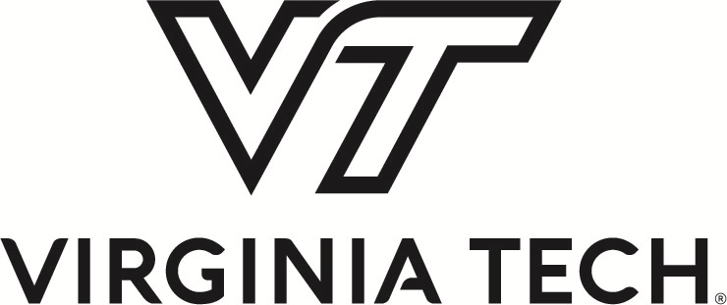
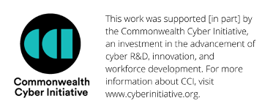
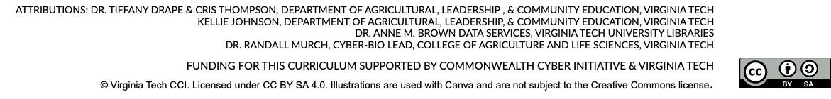

Instructor Notes

Week 1 Introduction to Cyberbiosecurity
- Powerpoint.
- Readings discussion (slides 7-8).

Week 2 The Enterprise of Cyberbiosecurity
- Readings Discussion.
  - Optional additional reading: Stroh, D. P. (2015). Systems thinking for social change: A practical guide to solving complex problems, avoiding unintended consequences, and achieving lasting results. Chelsea Green Publishing.
  - bit.ly/3PchEwU
Week 3 Food System Vulnerabilities
- In-class discussion with guiding questions.

Week 4 Data-driven Farming
- In-class discussion with guiding questions.
- In-class videos:
  - View: Youtube - Data-driven Farming (7:22) https://youtu.be/EePxkSb0Wp8
  - Youtube - Data-driven Agriculture and Role of AI in Farming (4:52) https://youtu.be/OeQEbaSWNRA

Week 5 Data and Agricultural Research
- In-class discussion with guiding questions.
- In-class activity.
  - Case Study Analysis.
    - File: Scenarios.doc in Week 5 folder.
    - Instructor details in file W5_readings.doc in Week 5 folder.
    - Print/email instructions for students: Scenario_analysis.pdf in Week 5 folder.
- Optional additional reading for applied research context: Sarkar, S., Cazenave, A. B., Oakes, J., McCall, D., Thomason, W., Abbot, L., & Balota, M. (2020). High‐throughput measurement of peanut canopy height using digital surface models. The Plant Phenome Journal, 3(1), e20003.

Week 6 Ag Industry and Big Data
- In-class discussion with guiding questions.
Week 7 Data Control and Ownership
- No readings discussion.
- In-class activity.

Week 8 Ethics of Data Control and Ownership
- Powerpoint (18 slides).
- In-class activity and discussion.

Week 9 Capstone Prep: Visualizing Data
- Powerpoint.
- In-class activity (suggested).

Week 10 Capstone Prep: Communicating Science
- Powerpoint.
  - Slides include 2 in-class activities.
    - Note: One activity requires students to individually access an internet browser through their laptop or mobile device.
- In-class viewing:
  - Youtube: Foot, Greg -How to explain a science idea clearly | ‘Talking Science’ Course #6 (11:21) https://youtu.be/u9cqwQQqHoU

Week 11 Exploring Internships and Careers
- In-class discussion.

Weeks 12+ Capstone Presentations
- Guidance for capstone projects in Week 12 folder.

